Incidence/Prevalence Trend Report
Hypertriglyceridemia (NCEP TG>=150) · NHANES · 2005-2021 · survey-weighted

Figure. Incidence/prevalence trend
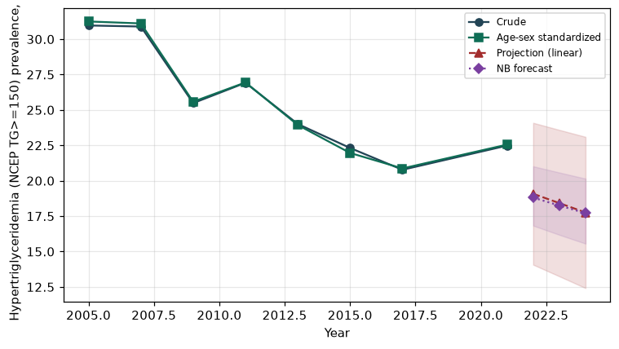

Counts by period
period | count
2005 | 705
2007 | 830
2009 | 755
2011 | 608
2013 | 594
2015 | 492
2017 | 479
2021 | 680

Crude and age-sex standardized rate (%)
year | crude | standardized
2005.00 | 30.97 | 31.25
2007.00 | 30.89 | 31.11
2009.00 | 25.48 | 25.58
2011.00 | 26.92 | 26.94
2013.00 | 24.01 | 23.94
2015.00 | 22.32 | 21.96
2017.00 | 20.77 | 20.87
2021.00 | 22.48 | 22.55

Projection (linear, standardized rate)
year | forecast | lo95 | hi95
2022.00 | 19.08 | 14.07 | 24.09
2023.00 | 18.42 | 13.25 | 23.59
2024.00 | 17.76 | 12.42 | 23.10

Stratified trend by sex (%)
year | men | women
2005.00 | 35.95 | 26.13
2007.00 | 35.85 | 26.25
2009.00 | 27.78 | 23.47
2011.00 | 32.08 | 22.02
2013.00 | 27.83 | 20.39
2015.00 | 25.32 | 19.50
2017.00 | 25.12 | 16.54
2021.00 | 26.14 | 19.13

Joinpoint regression — segment APC (%) with bootstrap 95% CI
segment | period | APC(%) | lo95 | hi95
1 | 2005-2015 | -3.51 | -4.83 | -2.34
2 | 2015-2021 | 0.66 | -2.52 | 1.96

Negative binomial (NB) forecast (%)
year | NB_forecast | lo95 | hi95
2022.00 | 18.81 | 16.83 | 21.02
2023.00 | 18.25 | 16.18 | 20.58
2024.00 | 17.71 | 15.56 | 20.15

Interpretation
The age-sex standardized prevalence of Hypertriglyceridemia (NCEP TG>=150) showed an annual percent change of 0.66% (95% CI -2.52 to 1.96) in the latest segment.

