Incidence/Prevalence Trend Report
Insulin resistance (HOMA-IR>=2.5) · NHANES · 2005-2021 · survey-weighted

Figure. Incidence/prevalence trend
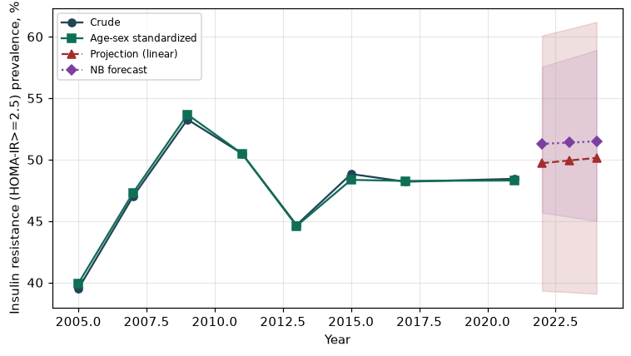

Counts by period
period | count
2005 | 923
2007 | 1324
2009 | 1559
2011 | 1224
2013 | 1164
2015 | 1225
2017 | 1254
2021 | 1497

Crude and age-sex standardized rate (%)
year | crude | standardized
2005.00 | 39.51 | 39.94
2007.00 | 46.99 | 47.29
2009.00 | 53.26 | 53.67
2011.00 | 50.49 | 50.49
2013.00 | 44.68 | 44.61
2015.00 | 48.83 | 48.35
2017.00 | 48.20 | 48.27
2021.00 | 48.44 | 48.30

Projection (linear, standardized rate)
year | forecast | lo95 | hi95
2022.00 | 49.71 | 39.33 | 60.09
2023.00 | 49.93 | 39.22 | 60.63
2024.00 | 50.14 | 39.08 | 61.20

Stratified trend by sex (%)
year | men | women
2005.00 | 42.41 | 36.67
2007.00 | 51.61 | 42.66
2009.00 | 58.89 | 48.28
2011.00 | 53.28 | 47.84
2013.00 | 45.58 | 43.81
2015.00 | 52.47 | 45.44
2017.00 | 48.95 | 47.47
2021.00 | 53.02 | 44.26

Joinpoint regression — segment APC (%) with bootstrap 95% CI
segment | period | APC(%) | lo95 | hi95
1 | 2005-2009 | 7.66 | 6.54 | 8.80
2 | 2009-2021 | -0.65 | -2.47 | 1.04

Negative binomial (NB) forecast (%)
year | NB_forecast | lo95 | hi95
2022.00 | 51.28 | 45.68 | 57.56
2023.00 | 51.38 | 45.34 | 58.23
2024.00 | 51.49 | 45.00 | 58.91

Interpretation
The age-sex standardized prevalence of Insulin resistance (HOMA-IR>=2.5) showed an annual percent change of -0.65% (95% CI -2.47 to 1.04) in the latest segment.

