Incidence/Prevalence Trend Report
Leukocytosis (WBC>11) · NHANES · 2005-2021 · survey-weighted

Figure. Incidence/prevalence trend
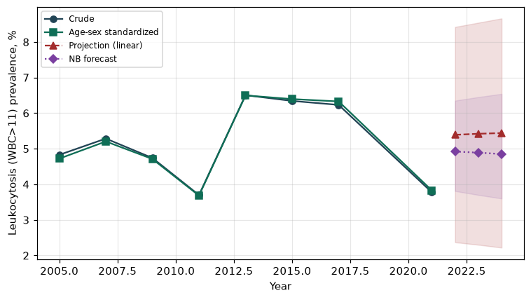

Counts by period
period | count
2005 | 252
2007 | 281
2009 | 292
2011 | 196
2013 | 342
2015 | 324
2017 | 283
2021 | 227

Crude and age-sex standardized rate (%)
year | crude | standardized
2005.00 | 4.83 | 4.72
2007.00 | 5.28 | 5.20
2009.00 | 4.74 | 4.71
2011.00 | 3.70 | 3.68
2013.00 | 6.50 | 6.50
2015.00 | 6.34 | 6.40
2017.00 | 6.23 | 6.33
2021.00 | 3.78 | 3.83

Projection (linear, standardized rate)
year | forecast | lo95 | hi95
2022.00 | 5.39 | 2.37 | 8.42
2023.00 | 5.42 | 2.30 | 8.54
2024.00 | 5.44 | 2.22 | 8.66

Stratified trend by sex (%)
year | men | women
2005.00 | 4.22 | 5.38
2007.00 | 4.79 | 5.74
2009.00 | 4.89 | 4.60
2011.00 | 3.29 | 4.07
2013.00 | 5.20 | 7.71
2015.00 | 5.31 | 7.30
2017.00 | 5.15 | 7.23
2021.00 | 2.94 | 4.56

Joinpoint regression — segment APC (%) with bootstrap 95% CI
segment | period | APC(%) | lo95 | hi95
1 | 2005-2015 | 2.81 | -4.86 | 9.53
2 | 2015-2021 | -8.71 | -11.80 | -0.52

Negative binomial (NB) forecast (%)
year | NB_forecast | lo95 | hi95
2022.00 | 4.92 | 3.81 | 6.35
2023.00 | 4.89 | 3.70 | 6.45
2024.00 | 4.85 | 3.60 | 6.54

Interpretation
The age-sex standardized prevalence of Leukocytosis (WBC>11) showed an annual percent change of -8.71% (95% CI -11.8 to -0.52) in the latest segment.

