Incidence/Prevalence Trend Report
Low HDL cholesterol · NHANES · 2005-2021 · survey-weighted

Figure. Incidence/prevalence trend
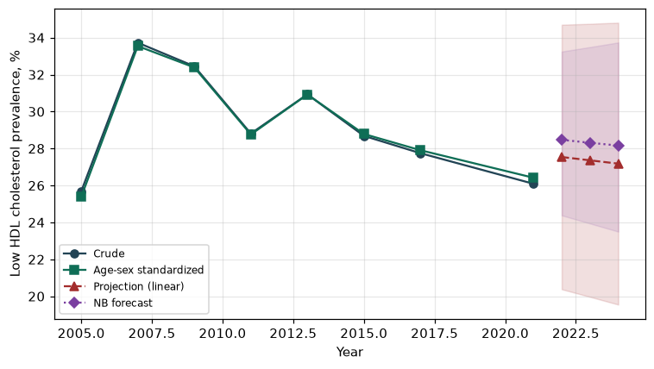

Counts by period
period | count
2005 | 1114
2007 | 1798
2009 | 1897
2011 | 1481
2013 | 1710
2015 | 1606
2017 | 1461
2021 | 1402

Crude and age-sex standardized rate (%)
year | crude | standardized
2005.00 | 25.69 | 25.39
2007.00 | 33.73 | 33.55
2009.00 | 32.45 | 32.39
2011.00 | 28.81 | 28.76
2013.00 | 30.93 | 30.92
2015.00 | 28.68 | 28.79
2017.00 | 27.75 | 27.91
2021.00 | 26.09 | 26.42

Projection (linear, standardized rate)
year | forecast | lo95 | hi95
2022.00 | 27.54 | 20.38 | 34.70
2023.00 | 27.36 | 19.97 | 34.75
2024.00 | 27.18 | 19.55 | 34.81

Stratified trend by sex (%)
year | men | women
2005.00 | 24.99 | 26.33
2007.00 | 32.34 | 35.03
2009.00 | 31.32 | 33.51
2011.00 | 26.48 | 30.97
2013.00 | 29.30 | 32.45
2015.00 | 28.34 | 29.01
2017.00 | 24.80 | 30.48
2021.00 | 21.33 | 30.57

Joinpoint regression — segment APC (%) with bootstrap 95% CI
segment | period | APC(%) | lo95 | hi95
1 | 2005-2007 | 14.94 | 14.94 | 14.94
2 | 2007-2021 | -1.61 | -1.98 | -0.89

Negative binomial (NB) forecast (%)
year | NB_forecast | lo95 | hi95
2022.00 | 28.47 | 24.38 | 33.25
2023.00 | 28.31 | 23.94 | 33.49
2024.00 | 28.16 | 23.50 | 33.74

Interpretation
The age-sex standardized prevalence of Low HDL cholesterol showed an annual percent change of -1.61% (95% CI -1.98 to -0.89) in the latest segment.

