Incidence/Prevalence Trend Report
Low muscle mass (low ASMI, AWGS cut) · NHANES · 2005-2017 · survey-weighted

Figure. Incidence/prevalence trend
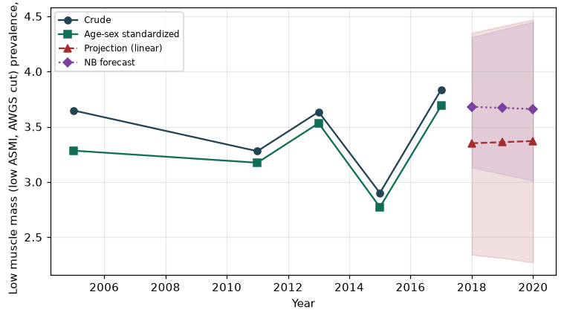

Counts by period
period | count
2005 | 127
2011 | 105
2013 | 135
2015 | 93
2017 | 77

Crude and age-sex standardized rate (%)
year | crude | standardized
2005.00 | 3.65 | 3.28
2011.00 | 3.28 | 3.17
2013.00 | 3.63 | 3.53
2015.00 | 2.90 | 2.77
2017.00 | 3.84 | 3.69

Projection (linear, standardized rate)
year | forecast | lo95 | hi95
2018.00 | 3.35 | 2.34 | 4.35
2019.00 | 3.36 | 2.31 | 4.41
2020.00 | 3.37 | 2.27 | 4.47

Stratified trend by sex (%)
year | men | women
2005.00 | 2.56 | 4.73
2011.00 | 2.97 | 3.60
2013.00 | 3.25 | 4.03
2015.00 | 2.57 | 3.22
2017.00 | 3.92 | 3.75

Joinpoint regression — segment APC (%) with bootstrap 95% CI
segment | period | APC(%) | lo95 | hi95
1 | 2005-2011 | -0.56 | -0.56 | -0.56
2 | 2011-2017 | 1.05 | -11.42 | 15.39

Negative binomial (NB) forecast (%)
year | NB_forecast | lo95 | hi95
2018.00 | 3.68 | 3.13 | 4.31
2019.00 | 3.67 | 3.07 | 4.38
2020.00 | 3.66 | 3.01 | 4.45

Interpretation
The age-sex standardized prevalence of Low muscle mass (low ASMI, AWGS cut) showed an annual percent change of 1.05% (95% CI -11.42 to 15.39) in the latest segment.

