Incidence/Prevalence Trend Report
Metabolic syndrome · NHANES · 2005-2021 · survey-weighted

Figure. Incidence/prevalence trend
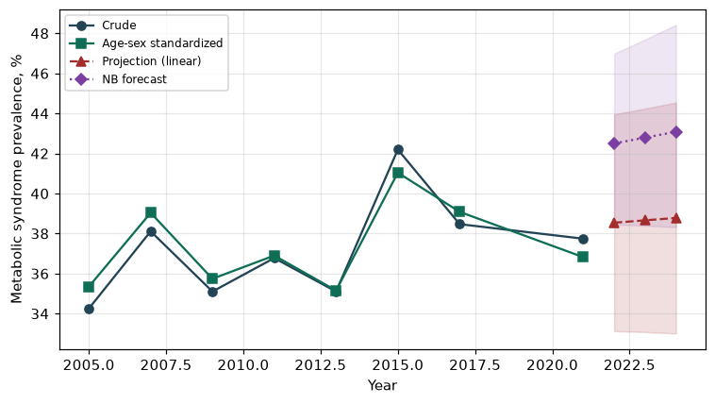

Counts by period
period | count
2005 | 643
2007 | 1000
2009 | 988
2011 | 799
2013 | 838
2015 | 871
2017 | 897
2021 | 1173

Crude and age-sex standardized rate (%)
year | crude | standardized
2005.00 | 34.25 | 35.35
2007.00 | 38.11 | 39.03
2009.00 | 35.10 | 35.74
2011.00 | 36.78 | 36.90
2013.00 | 35.11 | 35.15
2015.00 | 42.19 | 41.04
2017.00 | 38.47 | 39.08
2021.00 | 37.74 | 36.82

Projection (linear, standardized rate)
year | forecast | lo95 | hi95
2022.00 | 38.54 | 33.13 | 43.95
2023.00 | 38.66 | 33.08 | 44.24
2024.00 | 38.78 | 33.01 | 44.54

Stratified trend by sex (%)
year | men | women
2005.00 | 36.84 | 31.68
2007.00 | 38.84 | 37.40
2009.00 | 35.57 | 34.68
2011.00 | 38.34 | 35.23
2013.00 | 34.65 | 35.54
2015.00 | 42.55 | 41.86
2017.00 | 39.53 | 37.39
2021.00 | 37.87 | 37.63

Joinpoint regression — segment APC (%) with bootstrap 95% CI
segment | period | APC(%) | lo95 | hi95
1 | 2005-2015 | 0.67 | -1.54 | 2.37
2 | 2015-2021 | -1.75 | -2.41 | -1.48

Negative binomial (NB) forecast (%)
year | NB_forecast | lo95 | hi95
2022.00 | 42.50 | 38.45 | 46.98
2023.00 | 42.79 | 38.39 | 47.69
2024.00 | 43.08 | 38.32 | 48.42

Interpretation
The age-sex standardized prevalence of Metabolic syndrome showed an annual percent change of -1.75% (95% CI -2.41 to -1.48) in the latest segment.

