Incidence/Prevalence Trend Report
Obesity (KSSO >=25 / WHO >=30, country-specific) · NHANES · 2005-2021 · survey-weighted

Figure. Incidence/prevalence trend
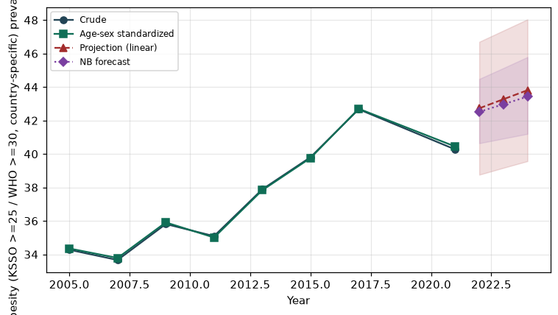

Counts by period
period | count
2005 | 1647
2007 | 2049
2009 | 2285
2011 | 1873
2013 | 2083
2015 | 2188
2017 | 2171
2021 | 2455

Crude and age-sex standardized rate (%)
year | crude | standardized
2005.00 | 34.28 | 34.36
2007.00 | 33.67 | 33.79
2009.00 | 35.81 | 35.91
2011.00 | 35.09 | 35.01
2013.00 | 37.89 | 37.83
2015.00 | 39.81 | 39.76
2017.00 | 42.67 | 42.70
2021.00 | 40.27 | 40.45

Projection (linear, standardized rate)
year | forecast | lo95 | hi95
2022.00 | 42.73 | 38.76 | 46.70
2023.00 | 43.27 | 39.17 | 47.37
2024.00 | 43.81 | 39.57 | 48.04

Stratified trend by sex (%)
year | men | women
2005.00 | 32.91 | 35.55
2007.00 | 32.01 | 35.21
2009.00 | 35.28 | 36.31
2011.00 | 33.71 | 36.37
2013.00 | 35.17 | 40.40
2015.00 | 37.96 | 41.50
2017.00 | 42.98 | 42.39
2021.00 | 39.20 | 41.28

Joinpoint regression — segment APC (%) with bootstrap 95% CI
segment | period | APC(%) | lo95 | hi95
1 | 2005-2015 | 1.50 | 0.46 | 2.24
2 | 2015-2021 | 0.05 | -1.35 | 3.64

Negative binomial (NB) forecast (%)
year | NB_forecast | lo95 | hi95
2022.00 | 42.52 | 40.64 | 44.48
2023.00 | 42.97 | 40.92 | 45.13
2024.00 | 43.43 | 41.20 | 45.79

Interpretation
The age-sex standardized prevalence of Obesity (KSSO >=25 / WHO >=30, country-specific) showed an annual percent change of 0.05% (95% CI -1.35 to 3.64) in the latest segment.

