Incidence/Prevalence Trend Report
Osteoporosis (T-score<=-2.5, age>=50) · NHANES · 2005-2017 · survey-weighted

Figure. Incidence/prevalence trend
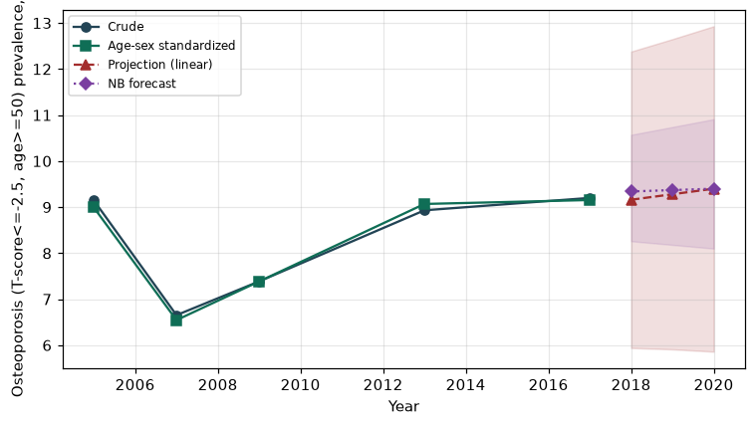

Counts by period
period | count
2005 | 177
2007 | 205
2009 | 225
2013 | 225
2017 | 219

Crude and age-sex standardized rate (%)
year | crude | standardized
2005.00 | 9.15 | 8.99
2007.00 | 6.65 | 6.55
2009.00 | 7.39 | 7.39
2013.00 | 8.93 | 9.07
2017.00 | 9.20 | 9.15

Projection (linear, standardized rate)
year | forecast | lo95 | hi95
2018.00 | 9.16 | 5.94 | 12.38
2019.00 | 9.28 | 5.91 | 12.65
2020.00 | 9.40 | 5.86 | 12.93

Stratified trend by sex (%)
year | men | women
2005.00 | 3.50 | 14.22
2007.00 | 2.55 | 10.20
2009.00 | 2.64 | 11.68
2013.00 | 3.85 | 13.66
2017.00 | 3.37 | 14.60

Joinpoint regression — segment APC (%) with bootstrap 95% CI
segment | period | APC(%) | lo95 | hi95
1 | 2005-2007 | -14.68 | -14.68 | -14.68
2 | 2007-2017 | 3.50 | 0.24 | 6.23

Negative binomial (NB) forecast (%)
year | NB_forecast | lo95 | hi95
2018.00 | 9.34 | 8.26 | 10.57
2019.00 | 9.37 | 8.18 | 10.74
2020.00 | 9.40 | 8.10 | 10.91

Interpretation
The age-sex standardized prevalence of Osteoporosis (T-score<=-2.5, age>=50) showed an annual percent change of 3.5% (95% CI 0.24 to 6.23) in the latest segment.

