Incidence/Prevalence Trend Report
Overweight (KSSO >=23 / WHO >=25, country-specific) · NHANES · 2005-2021 · survey-weighted

Figure. Incidence/prevalence trend
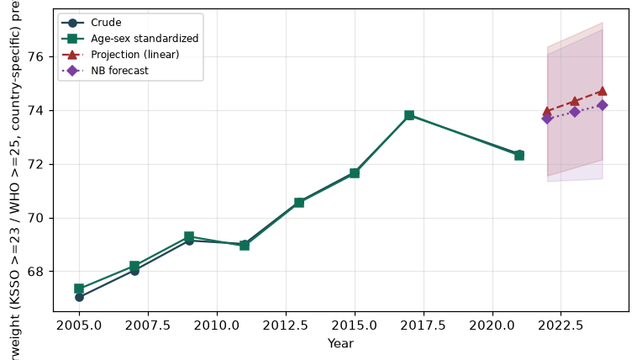

Counts by period
period | count
2005 | 3251
2007 | 3982
2009 | 4312
2011 | 3557
2013 | 3851
2015 | 3921
2017 | 3838
2021 | 4372

Crude and age-sex standardized rate (%)
year | crude | standardized
2005.00 | 67.03 | 67.35
2007.00 | 68.03 | 68.20
2009.00 | 69.14 | 69.29
2011.00 | 69.02 | 68.94
2013.00 | 70.59 | 70.56
2015.00 | 71.68 | 71.63
2017.00 | 73.80 | 73.82
2021.00 | 72.36 | 72.31

Projection (linear, standardized rate)
year | forecast | lo95 | hi95
2022.00 | 73.96 | 71.56 | 76.36
2023.00 | 74.33 | 71.86 | 76.81
2024.00 | 74.71 | 72.16 | 77.27

Stratified trend by sex (%)
year | men | women
2005.00 | 73.05 | 61.46
2007.00 | 71.99 | 64.34
2009.00 | 73.96 | 64.67
2011.00 | 71.63 | 66.59
2013.00 | 73.96 | 67.48
2015.00 | 74.71 | 68.89
2017.00 | 77.35 | 70.50
2021.00 | 74.95 | 69.91

Joinpoint regression — segment APC (%) with bootstrap 95% CI
segment | period | APC(%) | lo95 | hi95
1 | 2005-2015 | 0.58 | 0.37 | 0.71
2 | 2015-2021 | 0.06 | -0.52 | 1.52

Negative binomial (NB) forecast (%)
year | NB_forecast | lo95 | hi95
2022.00 | 73.67 | 71.35 | 76.08
2023.00 | 73.93 | 71.40 | 76.54
2024.00 | 74.18 | 71.45 | 77.01

Interpretation
The age-sex standardized prevalence of Overweight (KSSO >=23 / WHO >=25, country-specific) showed an annual percent change of 0.06% (95% CI -0.52 to 1.52) in the latest segment.

