Incidence/Prevalence Trend Report
Prediabetes · NHANES · 2005-2021 · survey-weighted

Figure. Incidence/prevalence trend
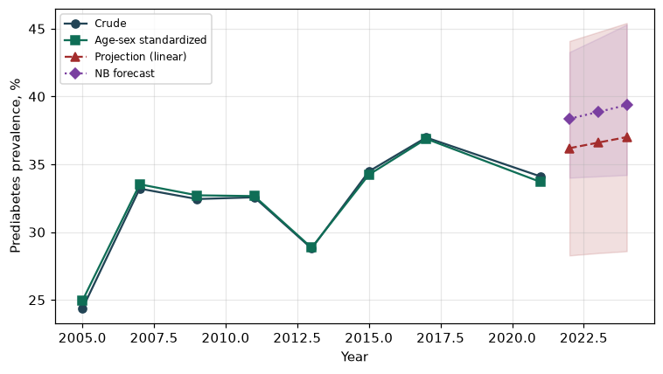

Counts by period
period | count
2005 | 1186
2007 | 1907
2009 | 2009
2011 | 1700
2013 | 1727
2015 | 1874
2017 | 1895
2021 | 2090

Crude and age-sex standardized rate (%)
year | crude | standardized
2005.00 | 24.35 | 24.94
2007.00 | 33.21 | 33.52
2009.00 | 32.44 | 32.71
2011.00 | 32.57 | 32.66
2013.00 | 28.79 | 28.85
2015.00 | 34.48 | 34.24
2017.00 | 36.98 | 36.88
2021.00 | 34.10 | 33.69

Projection (linear, standardized rate)
year | forecast | lo95 | hi95
2022.00 | 36.19 | 28.28 | 44.09
2023.00 | 36.60 | 28.45 | 44.75
2024.00 | 37.01 | 28.59 | 45.42

Stratified trend by sex (%)
year | men | women
2005.00 | 28.13 | 20.89
2007.00 | 36.84 | 29.86
2009.00 | 34.71 | 30.33
2011.00 | 35.54 | 29.83
2013.00 | 30.04 | 27.64
2015.00 | 35.65 | 33.39
2017.00 | 41.68 | 32.64
2021.00 | 36.45 | 31.90

Joinpoint regression — segment APC (%) with bootstrap 95% CI
segment | period | APC(%) | lo95 | hi95
1 | 2005-2007 | 15.94 | 15.94 | 15.94
2 | 2007-2021 | 0.46 | -0.94 | 1.93

Negative binomial (NB) forecast (%)
year | NB_forecast | lo95 | hi95
2022.00 | 38.36 | 34.01 | 43.28
2023.00 | 38.86 | 34.11 | 44.28
2024.00 | 39.37 | 34.21 | 45.31

Interpretation
The age-sex standardized prevalence of Prediabetes showed an annual percent change of 0.46% (95% CI -0.94 to 1.93) in the latest segment.

