Incidence/Prevalence Trend Report
Vitamin D deficiency (<20 ng/mL) · NHANES · 2005-2021 · survey-weighted

Figure. Incidence/prevalence trend
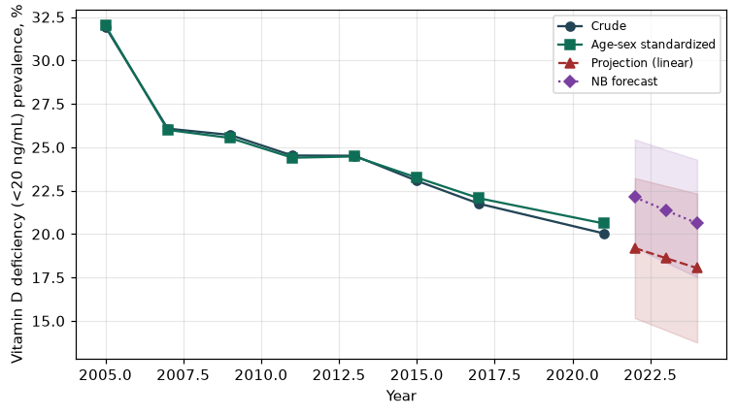

Counts by period
period | count
2005 | 1825
2007 | 1599
2009 | 1853
2011 | 1675
2013 | 1627
2015 | 1689
2017 | 1436
2021 | 1084

Crude and age-sex standardized rate (%)
year | crude | standardized
2005.00 | 31.93 | 32.01
2007.00 | 26.07 | 26.00
2009.00 | 25.71 | 25.53
2011.00 | 24.52 | 24.40
2013.00 | 24.51 | 24.47
2015.00 | 23.07 | 23.25
2017.00 | 21.75 | 22.06
2021.00 | 20.04 | 20.61

Projection (linear, standardized rate)
year | forecast | lo95 | hi95
2022.00 | 19.19 | 15.16 | 23.22
2023.00 | 18.61 | 14.46 | 22.77
2024.00 | 18.04 | 13.75 | 22.33

Stratified trend by sex (%)
year | men | women
2005.00 | 30.45 | 33.30
2007.00 | 24.31 | 27.69
2009.00 | 24.30 | 27.03
2011.00 | 24.74 | 24.32
2013.00 | 25.79 | 23.32
2015.00 | 23.55 | 22.62
2017.00 | 23.09 | 20.50
2021.00 | 21.88 | 18.30

Joinpoint regression — segment APC (%) with bootstrap 95% CI
segment | period | APC(%) | lo95 | hi95
1 | 2005-2007 | -9.87 | -9.87 | -9.87
2 | 2007-2021 | -1.67 | -1.93 | -1.25

Negative binomial (NB) forecast (%)
year | NB_forecast | lo95 | hi95
2022.00 | 22.12 | 19.23 | 25.45
2023.00 | 21.36 | 18.36 | 24.85
2024.00 | 20.62 | 17.52 | 24.28

Interpretation
The age-sex standardized prevalence of Vitamin D deficiency (<20 ng/mL) showed an annual percent change of -1.67% (95% CI -1.93 to -1.25) in the latest segment.

