Machine Learning Prediction Model Report
Outcome: Abdominal obesity · KNHANES · 3 models compared · tuning, full metrics, threshold, SHAP, PDP
[ML] outcome = abdominal_obesity

Data summary
Item | Value
N | 6000
Outcome prevalence (%) | 32.2
Features | 43
Models compared | 3
Train/test | 4200/1800 (70/30 stratified)
Auto-excluded leakage | None

Hyperparameter search space
Model | Search space
LogisticRegression | {'C': [0.01, 0.1, 1, 10], 'penalty': ['l1', 'l2']}
HistGradientBoosting | {'learning_rate': [0.03, 0.1], 'max_iter': [200, 400], 'max_depth': [3, 6, None]}
XGBoost | {'n_estimators': [300, 500], 'max_depth': [3, 5], 'learning_rate': [0.03, 0.1], 'subsample': [0.8, 1.0]}

Tuning and model selection — training-partition cross-validation
Hyperparameter search and between-model selection both use these training-partition cross-validated scores. The selection criterion is CV_combined, the mean of the cross-validated auROC and auPRC. The held-out partition is not consulted at this stage.
model | CV_auROC | CV_auPRC | CV_combined | best_params
LogisticRegression | 0.9005 | 0.8067 | 0.8536 | {'penalty': 'l1', 'C': 10}
HistGradientBoosting | 0.9097 | 0.827 | 0.8684 | {'max_iter': 200, 'max_depth': 3, 'learning_rate': 0.1}
XGBoost | 0.9135 | 0.8335 | 0.8735 | {'subsample': 0.8, 'n_estimators': 500, 'max_depth': 3, 'learning_rate': 0.03}

Held-out performance metrics
Reported for every candidate for transparency; only the model selected by CV_combined above is the prespecified final model. Rows are ordered by the CV selection criterion.
model | CV_combined | TP | TN | FP | FN | sensitivity | specificity | PPV | NPV | accuracy | balanced_accuracy | f1 | MCC | kappa | auROC | auPRC | logloss | brier | combined
XGBoost | 0.8735 | 418 | 1098 | 123 | 161 | 0.7219 | 0.8993 | 0.7726 | 0.8721 | 0.8422 | 0.8106 | 0.7464 | 0.6329 | 0.6321 | 0.9191 | 0.849 | 0.3328 | 0.1069 | 0.8841
HistGradientBoosting | 0.8684 | 408 | 1103 | 118 | 171 | 0.7047 | 0.9034 | 0.7757 | 0.8658 | 0.8394 | 0.804 | 0.7385 | 0.6245 | 0.623 | 0.9196 | 0.8492 | 0.3301 | 0.1061 | 0.8844
LogisticRegression | 0.8536 | 387 | 1108 | 113 | 192 | 0.6684 | 0.9075 | 0.774 | 0.8523 | 0.8306 | 0.7879 | 0.7173 | 0.6005 | 0.5973 | 0.9098 | 0.8392 | 0.353 | 0.112 | 0.8745

ROC · Precision-Recall
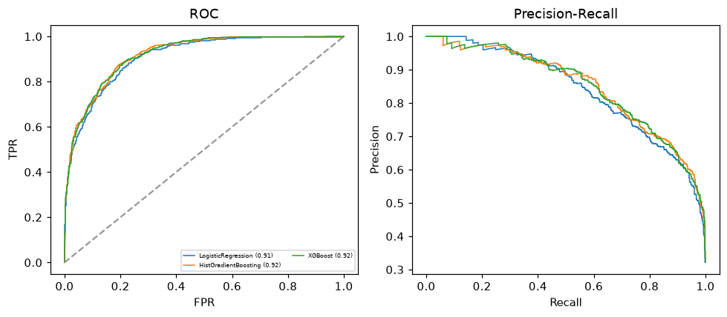

Selected final model — XGBoost (CV combined=0.8735; held-out auROC=0.9191)
Among 3 candidate models, XGBoost achieved the highest cross-validated combined score (0.8735) within the training partition and was selected on that basis. Refitted on the complete training partition and evaluated once on the untouched held-out partition, it reached an area under the receiver operating characteristic curve of 0.9191 and an area under the precision-recall curve of 0.849.

Threshold analysis (0.1-0.9)
threshold | TP | TN | FP | FN | sensitivity | specificity | PPV | NPV | f1 | accuracy
0.1 | 563.0 | 728.0 | 493.0 | 16.0 | 0.972 | 0.596 | 0.533 | 0.978 | 0.689 | 0.717
0.2 | 539.0 | 856.0 | 365.0 | 40.0 | 0.931 | 0.701 | 0.596 | 0.955 | 0.727 | 0.775
0.3 | 516.0 | 954.0 | 267.0 | 63.0 | 0.891 | 0.781 | 0.659 | 0.938 | 0.758 | 0.817
0.4 | 474.0 | 1027.0 | 194.0 | 105.0 | 0.819 | 0.841 | 0.71 | 0.907 | 0.76 | 0.834
0.5 | 418.0 | 1098.0 | 123.0 | 161.0 | 0.722 | 0.899 | 0.773 | 0.872 | 0.746 | 0.842
0.6 | 362.0 | 1145.0 | 76.0 | 217.0 | 0.625 | 0.938 | 0.826 | 0.841 | 0.712 | 0.837
0.7 | 304.0 | 1188.0 | 33.0 | 275.0 | 0.525 | 0.973 | 0.902 | 0.812 | 0.664 | 0.829
0.8 | 209.0 | 1206.0 | 15.0 | 370.0 | 0.361 | 0.988 | 0.933 | 0.765 | 0.521 | 0.786
0.9 | 114.0 | 1218.0 | 3.0 | 465.0 | 0.197 | 0.998 | 0.974 | 0.724 | 0.328 | 0.74

Calibration
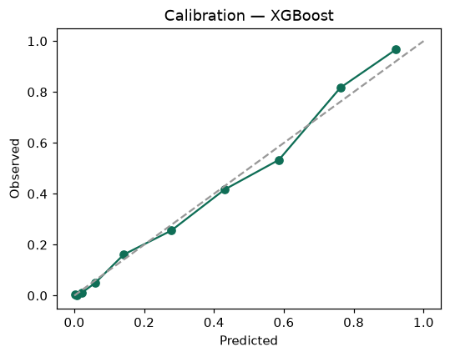

SHAP feature contributions
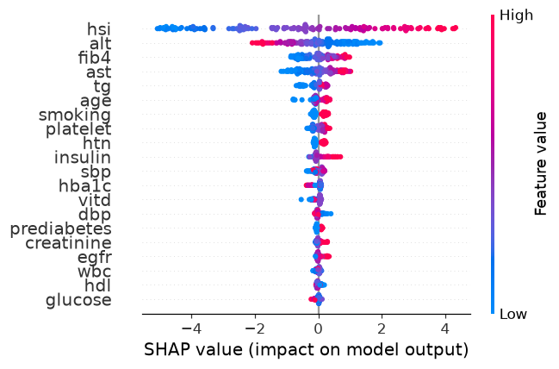

Partial dependence (PDP)
