Machine Learning Prediction Model Report
Outcome: Advanced liver fibrosis (FIB-4>2.67) · KNHANES · 3 models compared · tuning, full metrics, threshold, SHAP, PDP
[ML] outcome = adv_fibrosis

Data summary
Item | Value
N | 6000
Outcome prevalence (%) | 3.8
Features | 43
Models compared | 3
Train/test | 4200/1800 (70/30 stratified)
Auto-excluded leakage | None

Hyperparameter search space
Model | Search space
LogisticRegression | {'C': [0.01, 0.1, 1, 10], 'penalty': ['l1', 'l2']}
HistGradientBoosting | {'learning_rate': [0.03, 0.1], 'max_iter': [200, 400], 'max_depth': [3, 6, None]}
XGBoost | {'n_estimators': [300, 500], 'max_depth': [3, 5], 'learning_rate': [0.03, 0.1], 'subsample': [0.8, 1.0]}

Tuning and model selection — training-partition cross-validation
Hyperparameter search and between-model selection both use these training-partition cross-validated scores. The selection criterion is CV_combined, the mean of the cross-validated auROC and auPRC. The held-out partition is not consulted at this stage.
model | CV_auROC | CV_auPRC | CV_combined | best_params
LogisticRegression | 0.8256 | 0.1849 | 0.5052 | {'penalty': 'l1', 'C': 1}
HistGradientBoosting | 0.7903 | 0.144 | 0.4672 | {'max_iter': 200, 'max_depth': 6, 'learning_rate': 0.03}
XGBoost | 0.8111 | 0.1619 | 0.4865 | {'subsample': 0.8, 'n_estimators': 300, 'max_depth': 5, 'learning_rate': 0.03}

Held-out performance metrics
Reported for every candidate for transparency; only the model selected by CV_combined above is the prespecified final model. Rows are ordered by the CV selection criterion.
model | CV_combined | TP | TN | FP | FN | sensitivity | specificity | PPV | NPV | accuracy | balanced_accuracy | f1 | MCC | kappa | auROC | auPRC | logloss | brier | combined
LogisticRegression | 0.5052 | 6 | 1724 | 8 | 62 | 0.0882 | 0.9954 | 0.4286 | 0.9653 | 0.9611 | 0.5418 | 0.1463 | 0.1815 | 0.1352 | 0.8402 | 0.2315 | 0.1302 | 0.0332 | 0.5359
XGBoost | 0.4865 | 3 | 1728 | 4 | 65 | 0.0441 | 0.9977 | 0.4286 | 0.9637 | 0.9617 | 0.5209 | 0.08 | 0.1281 | 0.0735 | 0.8496 | 0.2148 | 0.1312 | 0.0333 | 0.5322
HistGradientBoosting | 0.4672 | 3 | 1729 | 3 | 65 | 0.0441 | 0.9983 | 0.5 | 0.9638 | 0.9622 | 0.5212 | 0.0811 | 0.1402 | 0.0754 | 0.838 | 0.2092 | 0.1336 | 0.0334 | 0.5236

ROC · Precision-Recall
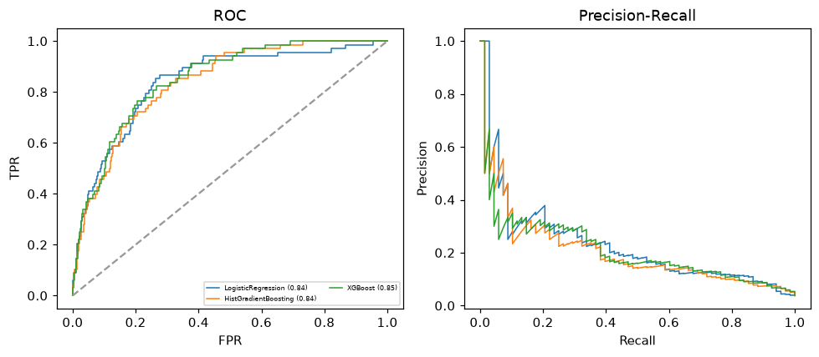

Selected final model — LogisticRegression (CV combined=0.5052; held-out auROC=0.8402)
Among 3 candidate models, LogisticRegression achieved the highest cross-validated combined score (0.5052) within the training partition and was selected on that basis. Refitted on the complete training partition and evaluated once on the untouched held-out partition, it reached an area under the receiver operating characteristic curve of 0.8402 and an area under the precision-recall curve of 0.2315.

Threshold analysis (0.1-0.9)
threshold | TP | TN | FP | FN | sensitivity | specificity | PPV | NPV | f1 | accuracy
0.1 | 34.0 | 1573.0 | 159.0 | 34.0 | 0.5 | 0.908 | 0.176 | 0.979 | 0.261 | 0.893
0.2 | 19.0 | 1684.0 | 48.0 | 49.0 | 0.279 | 0.972 | 0.284 | 0.972 | 0.281 | 0.946
0.3 | 10.0 | 1710.0 | 22.0 | 58.0 | 0.147 | 0.987 | 0.312 | 0.967 | 0.2 | 0.956
0.4 | 6.0 | 1716.0 | 16.0 | 62.0 | 0.088 | 0.991 | 0.273 | 0.965 | 0.133 | 0.957
0.5 | 6.0 | 1724.0 | 8.0 | 62.0 | 0.088 | 0.995 | 0.429 | 0.965 | 0.146 | 0.961
0.6 | 4.0 | 1730.0 | 2.0 | 64.0 | 0.059 | 0.999 | 0.667 | 0.964 | 0.108 | 0.963
0.7 | 1.0 | 1732.0 | 0.0 | 67.0 | 0.015 | 1.0 | 1.0 | 0.963 | 0.029 | 0.963
0.8 | 1.0 | 1732.0 | 0.0 | 67.0 | 0.015 | 1.0 | 1.0 | 0.963 | 0.029 | 0.963
0.9 | 0.0 | 1732.0 | 0.0 | 68.0 | 0.0 | 1.0 | nan | 0.962 | 0.0 | 0.962

Calibration
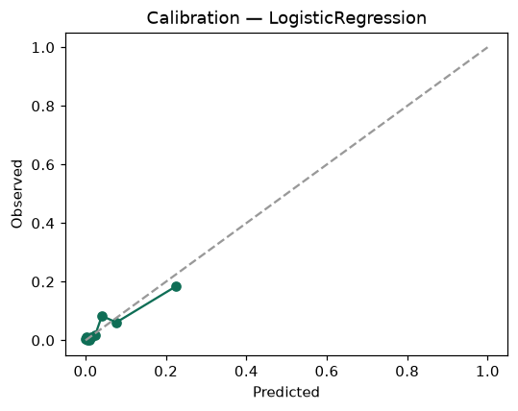

SHAP feature contributions
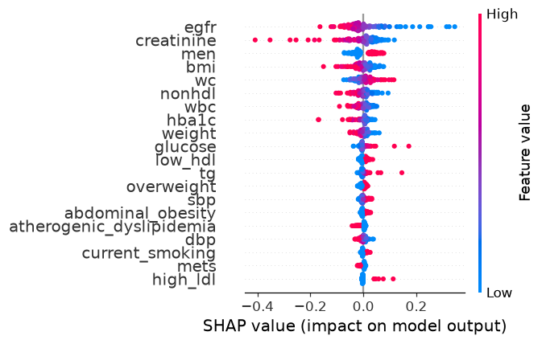

Partial dependence (PDP)
