Machine Learning Prediction Model Report
Outcome: Central obesity (WHtR>=0.5) · KNHANES · 3 models compared · tuning, full metrics, threshold, SHAP, PDP
[ML] outcome = central_obesity

Data summary
Item | Value
N | 6000
Outcome prevalence (%) | 54.0
Features | 43
Models compared | 3
Train/test | 4200/1800 (70/30 stratified)
Auto-excluded leakage | None

Hyperparameter search space
Model | Search space
LogisticRegression | {'C': [0.01, 0.1, 1, 10], 'penalty': ['l1', 'l2']}
HistGradientBoosting | {'learning_rate': [0.03, 0.1], 'max_iter': [200, 400], 'max_depth': [3, 6, None]}
XGBoost | {'n_estimators': [300, 500], 'max_depth': [3, 5], 'learning_rate': [0.03, 0.1], 'subsample': [0.8, 1.0]}

Tuning and model selection — training-partition cross-validation
Hyperparameter search and between-model selection both use these training-partition cross-validated scores. The selection criterion is CV_combined, the mean of the cross-validated auROC and auPRC. The held-out partition is not consulted at this stage.
model | CV_auROC | CV_auPRC | CV_combined | best_params
LogisticRegression | 0.9272 | 0.9323 | 0.9298 | {'penalty': 'l1', 'C': 1}
HistGradientBoosting | 0.9261 | 0.9333 | 0.9297 | {'max_iter': 200, 'max_depth': 3, 'learning_rate': 0.1}
XGBoost | 0.9264 | 0.9331 | 0.9298 | {'subsample': 0.8, 'n_estimators': 500, 'max_depth': 3, 'learning_rate': 0.03}

Held-out performance metrics
Reported for every candidate for transparency; only the model selected by CV_combined above is the prespecified final model. Rows are ordered by the CV selection criterion.
model | CV_combined | TP | TN | FP | FN | sensitivity | specificity | PPV | NPV | accuracy | balanced_accuracy | f1 | MCC | kappa | auROC | auPRC | logloss | brier | combined
LogisticRegression | 0.9298 | 826 | 680 | 148 | 146 | 0.8498 | 0.8213 | 0.848 | 0.8232 | 0.8367 | 0.8355 | 0.8489 | 0.6712 | 0.6712 | 0.9248 | 0.9325 | 0.3493 | 0.1108 | 0.9287
XGBoost | 0.9298 | 847 | 674 | 154 | 125 | 0.8714 | 0.814 | 0.8462 | 0.8436 | 0.845 | 0.8427 | 0.8586 | 0.6876 | 0.6872 | 0.9268 | 0.9367 | 0.3415 | 0.1094 | 0.9317
HistGradientBoosting | 0.9297 | 842 | 675 | 153 | 130 | 0.8663 | 0.8152 | 0.8462 | 0.8385 | 0.8428 | 0.8407 | 0.8561 | 0.6831 | 0.6829 | 0.9272 | 0.9372 | 0.3394 | 0.1088 | 0.9322

ROC · Precision-Recall
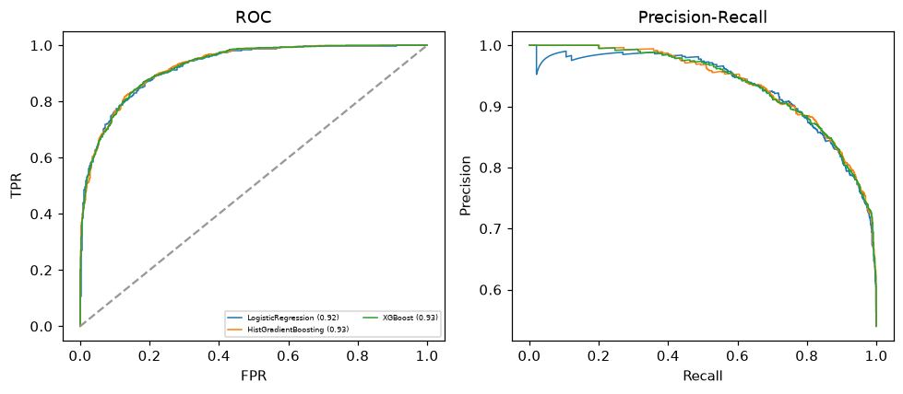

Selected final model — LogisticRegression (CV combined=0.9298; held-out auROC=0.9248)
Among 3 candidate models, LogisticRegression achieved the highest cross-validated combined score (0.9298) within the training partition and was selected on that basis. Refitted on the complete training partition and evaluated once on the untouched held-out partition, it reached an area under the receiver operating characteristic curve of 0.9248 and an area under the precision-recall curve of 0.9325.

Threshold analysis (0.1-0.9)
threshold | TP | TN | FP | FN | sensitivity | specificity | PPV | NPV | f1 | accuracy
0.1 | 960.0 | 396.0 | 432.0 | 12.0 | 0.988 | 0.478 | 0.69 | 0.971 | 0.812 | 0.753
0.2 | 932.0 | 521.0 | 307.0 | 40.0 | 0.959 | 0.629 | 0.752 | 0.929 | 0.843 | 0.807
0.3 | 903.0 | 584.0 | 244.0 | 69.0 | 0.929 | 0.705 | 0.787 | 0.894 | 0.852 | 0.826
0.4 | 875.0 | 633.0 | 195.0 | 97.0 | 0.9 | 0.764 | 0.818 | 0.867 | 0.857 | 0.838
0.5 | 826.0 | 680.0 | 148.0 | 146.0 | 0.85 | 0.821 | 0.848 | 0.823 | 0.849 | 0.837
0.6 | 782.0 | 715.0 | 113.0 | 190.0 | 0.805 | 0.864 | 0.874 | 0.79 | 0.838 | 0.832
0.7 | 728.0 | 753.0 | 75.0 | 244.0 | 0.749 | 0.909 | 0.907 | 0.755 | 0.82 | 0.823
0.8 | 637.0 | 783.0 | 45.0 | 335.0 | 0.655 | 0.946 | 0.934 | 0.7 | 0.77 | 0.789
0.9 | 503.0 | 814.0 | 14.0 | 469.0 | 0.517 | 0.983 | 0.973 | 0.634 | 0.676 | 0.732

Calibration
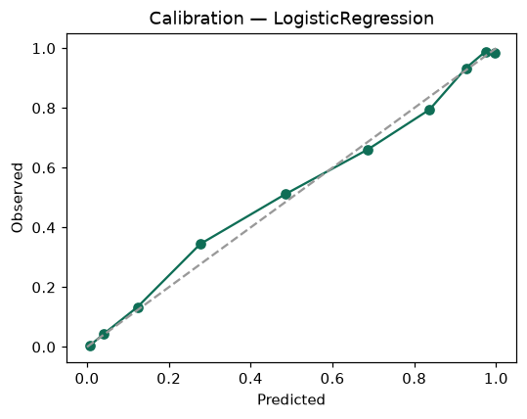

SHAP feature contributions
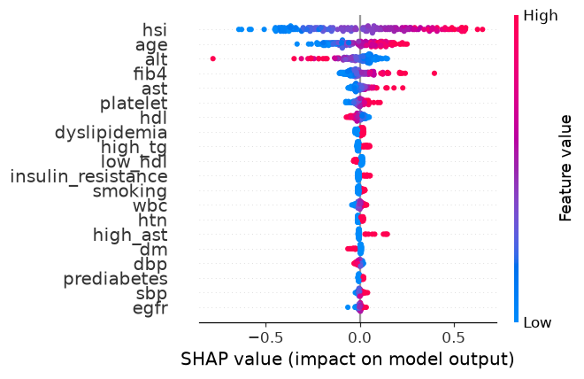

Partial dependence (PDP)
