Machine Learning Prediction Model Report
Outcome: Chronic kidney disease (KDIGO: eGFR<60 or ACR>=30) · KNHANES · 3 models compared · tuning, full metrics, threshold, SHAP, PDP
[ML] outcome = ckd

Data summary
Item | Value
N | 6000
Outcome prevalence (%) | 9.6
Features | 44
Models compared | 3
Train/test | 4200/1800 (70/30 stratified)
Auto-excluded leakage | None

Hyperparameter search space
Model | Search space
LogisticRegression | {'C': [0.01, 0.1, 1, 10], 'penalty': ['l1', 'l2']}
HistGradientBoosting | {'learning_rate': [0.03, 0.1], 'max_iter': [200, 400], 'max_depth': [3, 6, None]}
XGBoost | {'n_estimators': [300, 500], 'max_depth': [3, 5], 'learning_rate': [0.03, 0.1], 'subsample': [0.8, 1.0]}

Tuning and model selection — training-partition cross-validation
Hyperparameter search and between-model selection both use these training-partition cross-validated scores. The selection criterion is CV_combined, the mean of the cross-validated auROC and auPRC. The held-out partition is not consulted at this stage.
model | CV_auROC | CV_auPRC | CV_combined | best_params
LogisticRegression | 0.7861 | 0.3181 | 0.5521 | {'penalty': 'l2', 'C': 0.01}
HistGradientBoosting | 0.7687 | 0.3298 | 0.5492 | {'max_iter': 400, 'max_depth': 3, 'learning_rate': 0.03}
XGBoost | 0.7777 | 0.3334 | 0.5556 | {'subsample': 1.0, 'n_estimators': 300, 'max_depth': 3, 'learning_rate': 0.03}

Held-out performance metrics
Reported for every candidate for transparency; only the model selected by CV_combined above is the prespecified final model. Rows are ordered by the CV selection criterion.
model | CV_combined | TP | TN | FP | FN | sensitivity | specificity | PPV | NPV | accuracy | balanced_accuracy | f1 | MCC | kappa | auROC | auPRC | logloss | brier | combined
XGBoost | 0.5556 | 18 | 1613 | 15 | 154 | 0.1047 | 0.9908 | 0.5455 | 0.9128 | 0.9061 | 0.5477 | 0.1756 | 0.2091 | 0.1494 | 0.8007 | 0.3337 | 0.2605 | 0.075 | 0.5672
LogisticRegression | 0.5521 | 12 | 1622 | 6 | 160 | 0.0698 | 0.9963 | 0.6667 | 0.9102 | 0.9078 | 0.533 | 0.1263 | 0.1952 | 0.1102 | 0.8128 | 0.3523 | 0.274 | 0.0758 | 0.5826
HistGradientBoosting | 0.5492 | 19 | 1611 | 17 | 153 | 0.1105 | 0.9896 | 0.5278 | 0.9133 | 0.9056 | 0.55 | 0.1827 | 0.21 | 0.1547 | 0.7955 | 0.3254 | 0.263 | 0.0754 | 0.5604

ROC · Precision-Recall
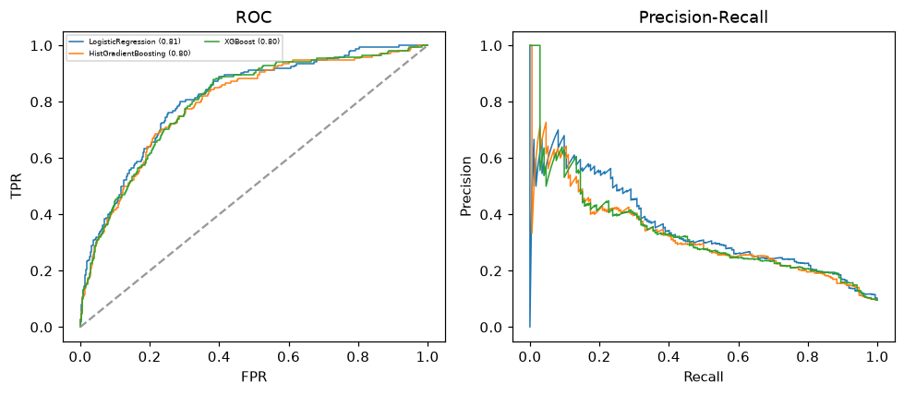

Selected final model — XGBoost (CV combined=0.5556; held-out auROC=0.8007)
Among 3 candidate models, XGBoost achieved the highest cross-validated combined score (0.5556) within the training partition and was selected on that basis. Refitted on the complete training partition and evaluated once on the untouched held-out partition, it reached an area under the receiver operating characteristic curve of 0.8007 and an area under the precision-recall curve of 0.3337.

Threshold analysis (0.1-0.9)
threshold | TP | TN | FP | FN | sensitivity | specificity | PPV | NPV | f1 | accuracy
0.1 | 125.0 | 1184.0 | 444.0 | 47.0 | 0.727 | 0.727 | 0.22 | 0.962 | 0.337 | 0.727
0.2 | 71.0 | 1480.0 | 148.0 | 101.0 | 0.413 | 0.909 | 0.324 | 0.936 | 0.363 | 0.862
0.3 | 42.0 | 1565.0 | 63.0 | 130.0 | 0.244 | 0.961 | 0.4 | 0.923 | 0.303 | 0.893
0.4 | 26.0 | 1597.0 | 31.0 | 146.0 | 0.151 | 0.981 | 0.456 | 0.916 | 0.227 | 0.902
0.5 | 18.0 | 1613.0 | 15.0 | 154.0 | 0.105 | 0.991 | 0.545 | 0.913 | 0.176 | 0.906
0.6 | 8.0 | 1622.0 | 6.0 | 164.0 | 0.047 | 0.996 | 0.571 | 0.908 | 0.086 | 0.906
0.7 | 5.0 | 1626.0 | 2.0 | 167.0 | 0.029 | 0.999 | 0.714 | 0.907 | 0.056 | 0.906
0.8 | 2.0 | 1628.0 | 0.0 | 170.0 | 0.012 | 1.0 | 1.0 | 0.905 | 0.023 | 0.906
0.9 | 0.0 | 1628.0 | 0.0 | 172.0 | 0.0 | 1.0 | nan | 0.904 | 0.0 | 0.904

Calibration
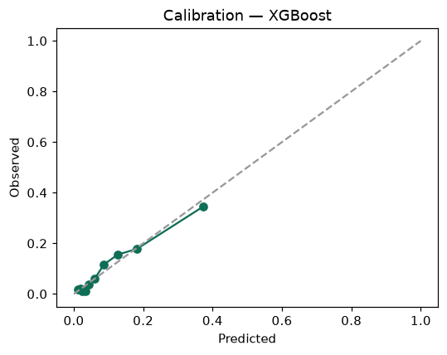

SHAP feature contributions
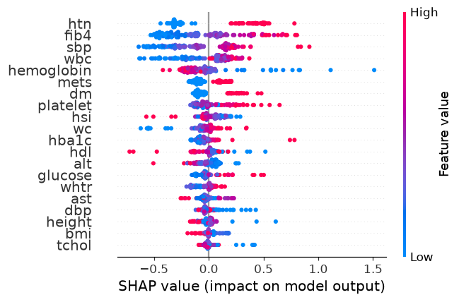

Partial dependence (PDP)
