Machine Learning Prediction Model Report
Outcome: Elevated ALT (>40 IU/L) · KNHANES · 3 models compared · tuning, full metrics, threshold, SHAP, PDP
[ML] outcome = high_alt

Data summary
Item | Value
N | 6000
Outcome prevalence (%) | 8.4
Features | 45
Models compared | 3
Train/test | 4200/1800 (70/30 stratified)
Auto-excluded leakage | None

Hyperparameter search space
Model | Search space
LogisticRegression | {'C': [0.01, 0.1, 1, 10], 'penalty': ['l1', 'l2']}
HistGradientBoosting | {'learning_rate': [0.03, 0.1], 'max_iter': [200, 400], 'max_depth': [3, 6, None]}
XGBoost | {'n_estimators': [300, 500], 'max_depth': [3, 5], 'learning_rate': [0.03, 0.1], 'subsample': [0.8, 1.0]}

Tuning and model selection — training-partition cross-validation
Hyperparameter search and between-model selection both use these training-partition cross-validated scores. The selection criterion is CV_combined, the mean of the cross-validated auROC and auPRC. The held-out partition is not consulted at this stage.
model | CV_auROC | CV_auPRC | CV_combined | best_params
LogisticRegression | 0.7841 | 0.3543 | 0.5692 | {'penalty': 'l1', 'C': 0.1}
HistGradientBoosting | 0.7712 | 0.3219 | 0.5465 | {'max_iter': 400, 'max_depth': 3, 'learning_rate': 0.03}
XGBoost | 0.7785 | 0.3319 | 0.5552 | {'subsample': 1.0, 'n_estimators': 300, 'max_depth': 3, 'learning_rate': 0.03}

Held-out performance metrics
Reported for every candidate for transparency; only the model selected by CV_combined above is the prespecified final model. Rows are ordered by the CV selection criterion.
model | CV_combined | TP | TN | FP | FN | sensitivity | specificity | PPV | NPV | accuracy | balanced_accuracy | f1 | MCC | kappa | auROC | auPRC | logloss | brier | combined
LogisticRegression | 0.5692 | 11 | 1636 | 12 | 141 | 0.0724 | 0.9927 | 0.4783 | 0.9207 | 0.915 | 0.5325 | 0.1257 | 0.1611 | 0.1059 | 0.8162 | 0.3173 | 0.2359 | 0.0668 | 0.5667
XGBoost | 0.5552 | 21 | 1625 | 23 | 131 | 0.1382 | 0.986 | 0.4773 | 0.9254 | 0.9144 | 0.5621 | 0.2143 | 0.2236 | 0.1833 | 0.8023 | 0.3314 | 0.2383 | 0.0669 | 0.5669
HistGradientBoosting | 0.5465 | 21 | 1627 | 21 | 131 | 0.1382 | 0.9873 | 0.5 | 0.9255 | 0.9156 | 0.5627 | 0.2165 | 0.231 | 0.1868 | 0.8007 | 0.3166 | 0.2405 | 0.0676 | 0.5587

ROC · Precision-Recall
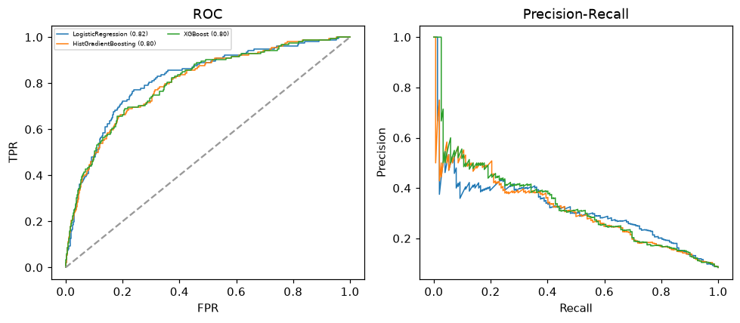

Selected final model — LogisticRegression (CV combined=0.5692; held-out auROC=0.8162)
Among 3 candidate models, LogisticRegression achieved the highest cross-validated combined score (0.5692) within the training partition and was selected on that basis. Refitted on the complete training partition and evaluated once on the untouched held-out partition, it reached an area under the receiver operating characteristic curve of 0.8162 and an area under the precision-recall curve of 0.3173.

Threshold analysis (0.1-0.9)
threshold | TP | TN | FP | FN | sensitivity | specificity | PPV | NPV | f1 | accuracy
0.1 | 111.0 | 1284.0 | 364.0 | 41.0 | 0.73 | 0.779 | 0.234 | 0.969 | 0.354 | 0.775
0.2 | 62.0 | 1522.0 | 126.0 | 90.0 | 0.408 | 0.924 | 0.33 | 0.944 | 0.365 | 0.88
0.3 | 38.0 | 1590.0 | 58.0 | 114.0 | 0.25 | 0.965 | 0.396 | 0.933 | 0.306 | 0.904
0.4 | 20.0 | 1618.0 | 30.0 | 132.0 | 0.132 | 0.982 | 0.4 | 0.925 | 0.198 | 0.91
0.5 | 11.0 | 1636.0 | 12.0 | 141.0 | 0.072 | 0.993 | 0.478 | 0.921 | 0.126 | 0.915
0.6 | 3.0 | 1644.0 | 4.0 | 149.0 | 0.02 | 0.998 | 0.429 | 0.917 | 0.038 | 0.915
0.7 | 3.0 | 1647.0 | 1.0 | 149.0 | 0.02 | 0.999 | 0.75 | 0.917 | 0.038 | 0.917
0.8 | 0.0 | 1648.0 | 0.0 | 152.0 | 0.0 | 1.0 | nan | 0.916 | 0.0 | 0.916
0.9 | 0.0 | 1648.0 | 0.0 | 152.0 | 0.0 | 1.0 | nan | 0.916 | 0.0 | 0.916

Calibration
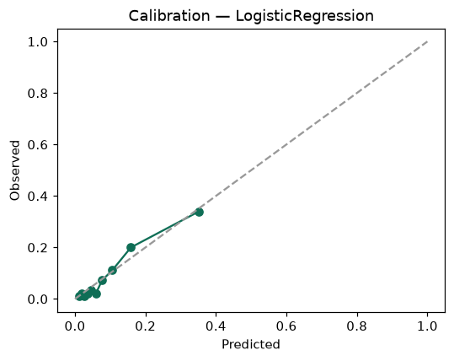

SHAP feature contributions
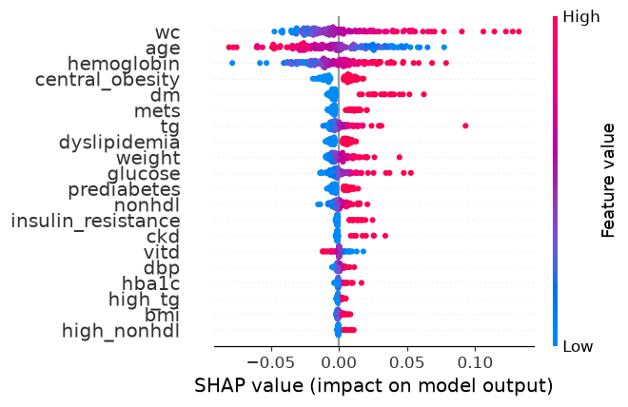

Partial dependence (PDP)
