Machine Learning Prediction Model Report
Outcome: High non-HDL cholesterol (>=190) · KNHANES · 3 models compared · tuning, full metrics, threshold, SHAP, PDP
[ML] outcome = high_nonhdl

Data summary
Item | Value
N | 6000
Outcome prevalence (%) | 8.9
Features | 43
Models compared | 3
Train/test | 4200/1800 (70/30 stratified)
Auto-excluded leakage | None

Hyperparameter search space
Model | Search space
LogisticRegression | {'C': [0.01, 0.1, 1, 10], 'penalty': ['l1', 'l2']}
HistGradientBoosting | {'learning_rate': [0.03, 0.1], 'max_iter': [200, 400], 'max_depth': [3, 6, None]}
XGBoost | {'n_estimators': [300, 500], 'max_depth': [3, 5], 'learning_rate': [0.03, 0.1], 'subsample': [0.8, 1.0]}

Tuning and model selection — training-partition cross-validation
Hyperparameter search and between-model selection both use these training-partition cross-validated scores. The selection criterion is CV_combined, the mean of the cross-validated auROC and auPRC. The held-out partition is not consulted at this stage.
model | CV_auROC | CV_auPRC | CV_combined | best_params
LogisticRegression | 0.7859 | 0.3081 | 0.547 | {'penalty': 'l2', 'C': 0.01}
HistGradientBoosting | 0.7672 | 0.2416 | 0.5044 | {'max_iter': 200, 'max_depth': None, 'learning_rate': 0.03}
XGBoost | 0.7779 | 0.2628 | 0.5204 | {'subsample': 0.8, 'n_estimators': 500, 'max_depth': 3, 'learning_rate': 0.03}

Held-out performance metrics
Reported for every candidate for transparency; only the model selected by CV_combined above is the prespecified final model. Rows are ordered by the CV selection criterion.
model | CV_combined | TP | TN | FP | FN | sensitivity | specificity | PPV | NPV | accuracy | balanced_accuracy | f1 | MCC | kappa | auROC | auPRC | logloss | brier | combined
LogisticRegression | 0.547 | 8 | 1635 | 5 | 152 | 0.05 | 0.997 | 0.6154 | 0.9149 | 0.9128 | 0.5235 | 0.0925 | 0.1578 | 0.0802 | 0.8074 | 0.3247 | 0.2646 | 0.0725 | 0.5661
XGBoost | 0.5204 | 9 | 1628 | 12 | 151 | 0.0562 | 0.9927 | 0.4286 | 0.9151 | 0.9094 | 0.5245 | 0.0994 | 0.1297 | 0.0805 | 0.8145 | 0.3095 | 0.2445 | 0.0708 | 0.562
HistGradientBoosting | 0.5044 | 13 | 1632 | 8 | 147 | 0.0812 | 0.9951 | 0.619 | 0.9174 | 0.9139 | 0.5382 | 0.1436 | 0.2024 | 0.1256 | 0.7952 | 0.322 | 0.2559 | 0.0714 | 0.5586

ROC · Precision-Recall
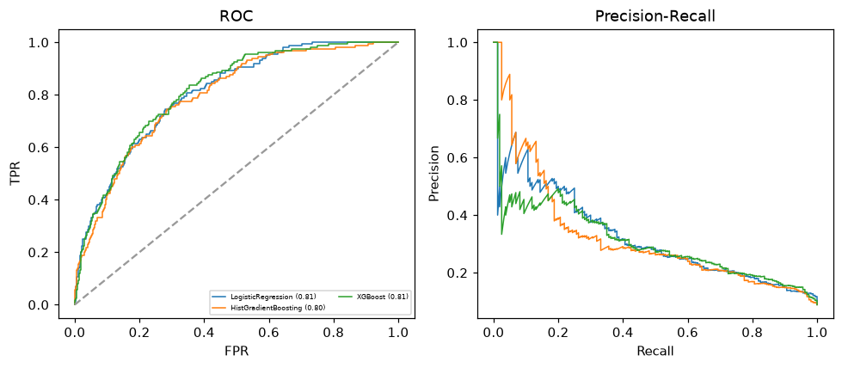

Selected final model — LogisticRegression (CV combined=0.547; held-out auROC=0.8074)
Among 3 candidate models, LogisticRegression achieved the highest cross-validated combined score (0.547) within the training partition and was selected on that basis. Refitted on the complete training partition and evaluated once on the untouched held-out partition, it reached an area under the receiver operating characteristic curve of 0.8074 and an area under the precision-recall curve of 0.3247.

Threshold analysis (0.1-0.9)
threshold | TP | TN | FP | FN | sensitivity | specificity | PPV | NPV | f1 | accuracy
0.1 | 145.0 | 805.0 | 835.0 | 15.0 | 0.906 | 0.491 | 0.148 | 0.982 | 0.254 | 0.528
0.2 | 83.0 | 1425.0 | 215.0 | 77.0 | 0.519 | 0.869 | 0.279 | 0.949 | 0.362 | 0.838
0.3 | 44.0 | 1577.0 | 63.0 | 116.0 | 0.275 | 0.962 | 0.411 | 0.931 | 0.33 | 0.901
0.4 | 17.0 | 1626.0 | 14.0 | 143.0 | 0.106 | 0.991 | 0.548 | 0.919 | 0.178 | 0.913
0.5 | 8.0 | 1635.0 | 5.0 | 152.0 | 0.05 | 0.997 | 0.615 | 0.915 | 0.092 | 0.913
0.6 | 3.0 | 1636.0 | 4.0 | 157.0 | 0.019 | 0.998 | 0.429 | 0.912 | 0.036 | 0.911
0.7 | 2.0 | 1640.0 | 0.0 | 158.0 | 0.012 | 1.0 | 1.0 | 0.912 | 0.025 | 0.912
0.8 | 2.0 | 1640.0 | 0.0 | 158.0 | 0.012 | 1.0 | 1.0 | 0.912 | 0.025 | 0.912
0.9 | 0.0 | 1640.0 | 0.0 | 160.0 | 0.0 | 1.0 | nan | 0.911 | 0.0 | 0.911

Calibration
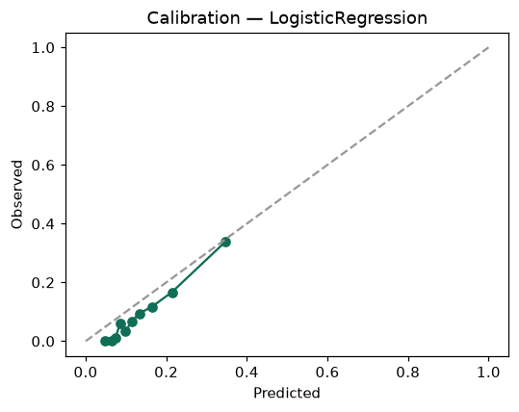

SHAP feature contributions
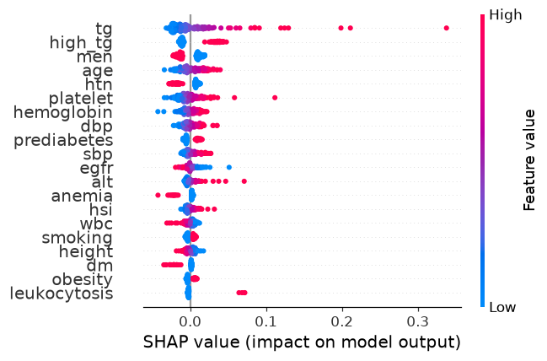

Partial dependence (PDP)
