Machine Learning Prediction Model Report
Outcome: Leukocytosis (WBC>11) · KNHANES · 3 models compared · tuning, full metrics, threshold, SHAP, PDP
[ML] outcome = leukocytosis

Data summary
Item | Value
N | 6000
Outcome prevalence (%) | 1.5
Features | 53
Models compared | 3
Train/test | 4200/1800 (70/30 stratified)
Auto-excluded leakage | None

Hyperparameter search space
Model | Search space
LogisticRegression | {'C': [0.01, 0.1, 1, 10], 'penalty': ['l1', 'l2']}
HistGradientBoosting | {'learning_rate': [0.03, 0.1], 'max_iter': [200, 400], 'max_depth': [3, 6, None]}
XGBoost | {'n_estimators': [300, 500], 'max_depth': [3, 5], 'learning_rate': [0.03, 0.1], 'subsample': [0.8, 1.0]}

Tuning and model selection — training-partition cross-validation
Hyperparameter search and between-model selection both use these training-partition cross-validated scores. The selection criterion is CV_combined, the mean of the cross-validated auROC and auPRC. The held-out partition is not consulted at this stage.
model | CV_auROC | CV_auPRC | CV_combined | best_params
LogisticRegression | 0.7221 | 0.05 | 0.386 | {'penalty': 'l1', 'C': 10}
HistGradientBoosting | 0.6772 | 0.0587 | 0.3679 | {'max_iter': 400, 'max_depth': 3, 'learning_rate': 0.03}
XGBoost | 0.678 | 0.0379 | 0.3579 | {'subsample': 1.0, 'n_estimators': 300, 'max_depth': 3, 'learning_rate': 0.03}

Held-out performance metrics
Reported for every candidate for transparency; only the model selected by CV_combined above is the prespecified final model. Rows are ordered by the CV selection criterion.
model | CV_combined | TP | TN | FP | FN | sensitivity | specificity | PPV | NPV | accuracy | balanced_accuracy | f1 | MCC | kappa | auROC | auPRC | logloss | brier | combined
LogisticRegression | 0.386 | 3 | 1771 | 3 | 23 | 0.1154 | 0.9983 | 0.5 | 0.9872 | 0.9856 | 0.5568 | 0.1875 | 0.2353 | 0.1831 | 0.8025 | 0.1878 | 0.0683 | 0.0135 | 0.4951
HistGradientBoosting | 0.3679 | 0 | 1774 | 0 | 26 | 0.0 | 1.0 | nan | 0.9856 | 0.9856 | 0.5 | 0.0 | 0.0 | 0.0 | 0.826 | 0.1216 | 0.0633 | 0.0136 | 0.4738
XGBoost | 0.3579 | 0 | 1774 | 0 | 26 | 0.0 | 1.0 | nan | 0.9856 | 0.9856 | 0.5 | 0.0 | 0.0 | 0.0 | 0.8632 | 0.1566 | 0.0593 | 0.0132 | 0.5099

ROC · Precision-Recall
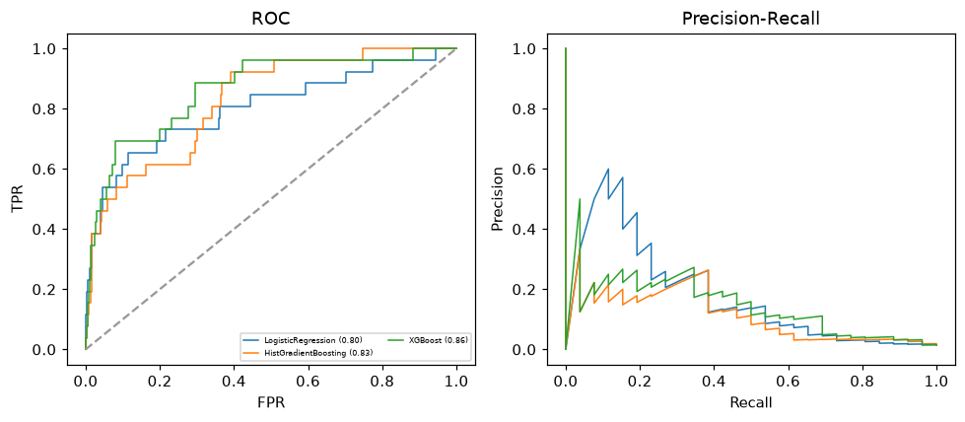

Selected final model — LogisticRegression (CV combined=0.386; held-out auROC=0.8025)
Among 3 candidate models, LogisticRegression achieved the highest cross-validated combined score (0.386) within the training partition and was selected on that basis. Refitted on the complete training partition and evaluated once on the untouched held-out partition, it reached an area under the receiver operating characteristic curve of 0.8025 and an area under the precision-recall curve of 0.1878.

Threshold analysis (0.1-0.9)
threshold | TP | TN | FP | FN | sensitivity | specificity | PPV | NPV | f1 | accuracy
0.1 | 10.0 | 1729.0 | 45.0 | 16.0 | 0.385 | 0.975 | 0.182 | 0.991 | 0.247 | 0.966
0.2 | 6.0 | 1756.0 | 18.0 | 20.0 | 0.231 | 0.99 | 0.25 | 0.989 | 0.24 | 0.979
0.3 | 5.0 | 1765.0 | 9.0 | 21.0 | 0.192 | 0.995 | 0.357 | 0.988 | 0.25 | 0.983
0.4 | 4.0 | 1770.0 | 4.0 | 22.0 | 0.154 | 0.998 | 0.5 | 0.988 | 0.235 | 0.986
0.5 | 3.0 | 1771.0 | 3.0 | 23.0 | 0.115 | 0.998 | 0.5 | 0.987 | 0.188 | 0.986
0.6 | 2.0 | 1772.0 | 2.0 | 24.0 | 0.077 | 0.999 | 0.5 | 0.987 | 0.133 | 0.986
0.7 | 0.0 | 1772.0 | 2.0 | 26.0 | 0.0 | 0.999 | 0.0 | 0.986 | 0.0 | 0.984
0.8 | 0.0 | 1772.0 | 2.0 | 26.0 | 0.0 | 0.999 | 0.0 | 0.986 | 0.0 | 0.984
0.9 | 0.0 | 1772.0 | 2.0 | 26.0 | 0.0 | 0.999 | 0.0 | 0.986 | 0.0 | 0.984

Calibration
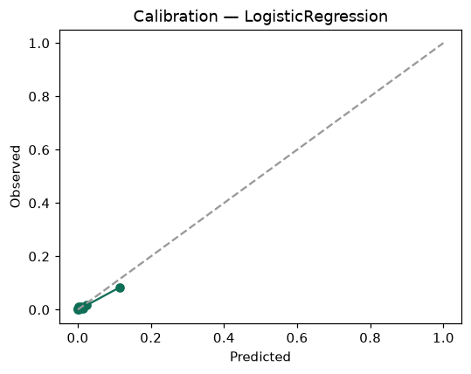

SHAP feature contributions
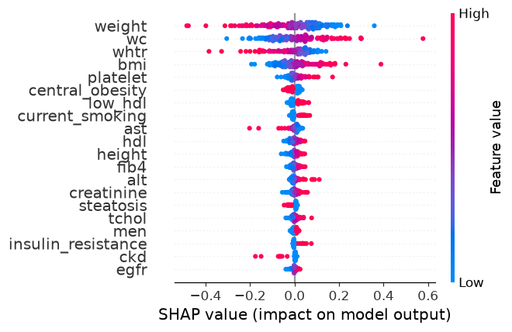

Partial dependence (PDP)
