Machine Learning Prediction Model Report
Outcome: Low muscle mass (low ASMI, AWGS cut) · KNHANES · 3 models compared · tuning, full metrics, threshold, SHAP, PDP
[ML] outcome = sarcopenia

Data summary
Item | Value
N | 6000
Outcome prevalence (%) | 12.2
Features | 43
Models compared | 3
Train/test | 4200/1800 (70/30 stratified)
Auto-excluded leakage | None

Hyperparameter search space
Model | Search space
LogisticRegression | {'C': [0.01, 0.1, 1, 10], 'penalty': ['l1', 'l2']}
HistGradientBoosting | {'learning_rate': [0.03, 0.1], 'max_iter': [200, 400], 'max_depth': [3, 6, None]}
XGBoost | {'n_estimators': [300, 500], 'max_depth': [3, 5], 'learning_rate': [0.03, 0.1], 'subsample': [0.8, 1.0]}

Tuning and model selection — training-partition cross-validation
Hyperparameter search and between-model selection both use these training-partition cross-validated scores. The selection criterion is CV_combined, the mean of the cross-validated auROC and auPRC. The held-out partition is not consulted at this stage.
model | CV_auROC | CV_auPRC | CV_combined | best_params
LogisticRegression | 0.8434 | 0.46 | 0.6517 | {'penalty': 'l1', 'C': 0.1}
HistGradientBoosting | 0.8507 | 0.4662 | 0.6585 | {'max_iter': 200, 'max_depth': 6, 'learning_rate': 0.03}
XGBoost | 0.8538 | 0.4741 | 0.6639 | {'subsample': 0.8, 'n_estimators': 500, 'max_depth': 3, 'learning_rate': 0.03}

Held-out performance metrics
Reported for every candidate for transparency; only the model selected by CV_combined above is the prespecified final model. Rows are ordered by the CV selection criterion.
model | CV_combined | TP | TN | FP | FN | sensitivity | specificity | PPV | NPV | accuracy | balanced_accuracy | f1 | MCC | kappa | auROC | auPRC | logloss | brier | combined
XGBoost | 0.6639 | 58 | 1554 | 27 | 161 | 0.2648 | 0.9829 | 0.6824 | 0.9061 | 0.8956 | 0.6239 | 0.3816 | 0.3818 | 0.3364 | 0.876 | 0.5173 | 0.2573 | 0.078 | 0.6967
HistGradientBoosting | 0.6585 | 57 | 1547 | 34 | 162 | 0.2603 | 0.9785 | 0.6264 | 0.9052 | 0.8911 | 0.6194 | 0.3677 | 0.3563 | 0.3191 | 0.8649 | 0.4942 | 0.2662 | 0.0803 | 0.6795
LogisticRegression | 0.6517 | 47 | 1563 | 18 | 172 | 0.2146 | 0.9886 | 0.7231 | 0.9009 | 0.8944 | 0.6016 | 0.331 | 0.3561 | 0.2915 | 0.8589 | 0.4806 | 0.2773 | 0.0815 | 0.6697

ROC · Precision-Recall
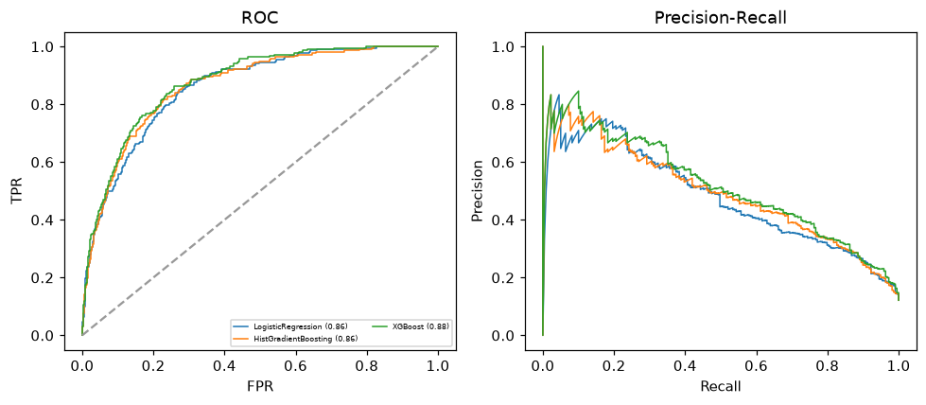

Selected final model — XGBoost (CV combined=0.6639; held-out auROC=0.876)
Among 3 candidate models, XGBoost achieved the highest cross-validated combined score (0.6639) within the training partition and was selected on that basis. Refitted on the complete training partition and evaluated once on the untouched held-out partition, it reached an area under the receiver operating characteristic curve of 0.876 and an area under the precision-recall curve of 0.5173.

Threshold analysis (0.1-0.9)
threshold | TP | TN | FP | FN | sensitivity | specificity | PPV | NPV | f1 | accuracy
0.1 | 184.0 | 1192.0 | 389.0 | 35.0 | 0.84 | 0.754 | 0.321 | 0.971 | 0.465 | 0.764
0.2 | 145.0 | 1395.0 | 186.0 | 74.0 | 0.662 | 0.882 | 0.438 | 0.95 | 0.527 | 0.856
0.3 | 103.0 | 1481.0 | 100.0 | 116.0 | 0.47 | 0.937 | 0.507 | 0.927 | 0.488 | 0.88
0.4 | 79.0 | 1527.0 | 54.0 | 140.0 | 0.361 | 0.966 | 0.594 | 0.916 | 0.449 | 0.892
0.5 | 58.0 | 1554.0 | 27.0 | 161.0 | 0.265 | 0.983 | 0.682 | 0.906 | 0.382 | 0.896
0.6 | 38.0 | 1565.0 | 16.0 | 181.0 | 0.174 | 0.99 | 0.704 | 0.896 | 0.278 | 0.891
0.7 | 17.0 | 1577.0 | 4.0 | 202.0 | 0.078 | 0.997 | 0.81 | 0.886 | 0.142 | 0.886
0.8 | 5.0 | 1579.0 | 2.0 | 214.0 | 0.023 | 0.999 | 0.714 | 0.881 | 0.044 | 0.88
0.9 | 1.0 | 1580.0 | 1.0 | 218.0 | 0.005 | 0.999 | 0.5 | 0.879 | 0.009 | 0.878

Calibration
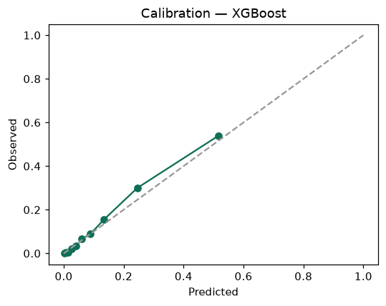

SHAP feature contributions
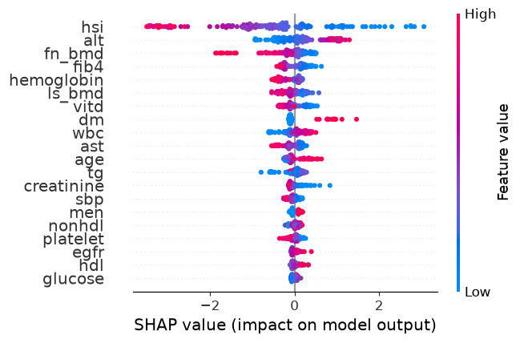

Partial dependence (PDP)
