Machine Learning Prediction Model Report
Outcome: MASLD · KNHANES · 3 models compared · tuning, full metrics, threshold, SHAP, PDP
[ML] outcome = masld

Data summary
Item | Value
N | 6000
Outcome prevalence (%) | 21.2
Features | 16
Models compared | 3
Train/test | 4200/1800 (70/30 stratified)
Auto-excluded leakage | None

Hyperparameter search space
Model | Search space
LogisticRegression | {'C': [0.01, 0.1, 1, 10], 'penalty': ['l1', 'l2']}
HistGradientBoosting | {'learning_rate': [0.03, 0.1], 'max_iter': [200, 400], 'max_depth': [3, 6, None]}
XGBoost | {'n_estimators': [300, 500], 'max_depth': [3, 5], 'learning_rate': [0.03, 0.1], 'subsample': [0.8, 1.0]}

Tuning and model selection — training-partition cross-validation
Hyperparameter search and between-model selection both use these training-partition cross-validated scores. The selection criterion is CV_combined, the mean of the cross-validated auROC and auPRC. The held-out partition is not consulted at this stage.
model | CV_auROC | CV_auPRC | CV_combined | best_params
LogisticRegression | 0.6882 | 0.3503 | 0.5193 | {'penalty': 'l1', 'C': 0.1}
HistGradientBoosting | 0.7149 | 0.3913 | 0.5531 | {'max_iter': 400, 'max_depth': 3, 'learning_rate': 0.03}
XGBoost | 0.7208 | 0.4 | 0.5604 | {'subsample': 0.8, 'n_estimators': 500, 'max_depth': 3, 'learning_rate': 0.03}

Held-out performance metrics
Reported for every candidate for transparency; only the model selected by CV_combined above is the prespecified final model. Rows are ordered by the CV selection criterion.
model | CV_combined | TP | TN | FP | FN | sensitivity | specificity | PPV | NPV | accuracy | balanced_accuracy | f1 | MCC | kappa | auROC | auPRC | logloss | brier | combined
XGBoost | 0.5604 | 63 | 1367 | 51 | 319 | 0.1649 | 0.964 | 0.5526 | 0.8108 | 0.7944 | 0.5645 | 0.254 | 0.2165 | 0.1734 | 0.724 | 0.4199 | 0.4621 | 0.1487 | 0.572
HistGradientBoosting | 0.5531 | 59 | 1380 | 38 | 323 | 0.1545 | 0.9732 | 0.6082 | 0.8103 | 0.7994 | 0.5638 | 0.2463 | 0.2312 | 0.1755 | 0.7265 | 0.4212 | 0.4599 | 0.1482 | 0.5738
LogisticRegression | 0.5193 | 21 | 1406 | 12 | 361 | 0.055 | 0.9915 | 0.6364 | 0.7957 | 0.7928 | 0.5233 | 0.1012 | 0.1418 | 0.0698 | 0.6871 | 0.3721 | 0.4801 | 0.1547 | 0.5296

ROC · Precision-Recall
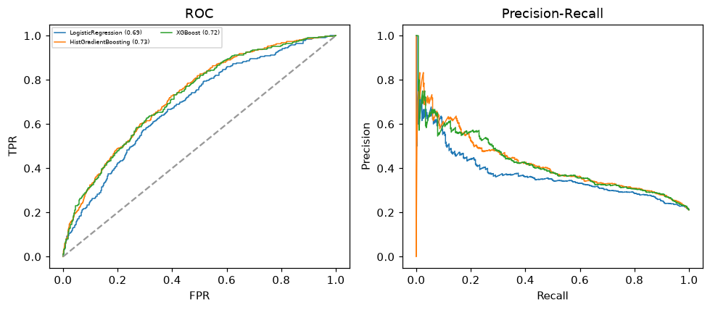

Selected final model — XGBoost (CV combined=0.5604; held-out auROC=0.724)
Among 3 candidate models, XGBoost achieved the highest cross-validated combined score (0.5604) within the training partition and was selected on that basis. Refitted on the complete training partition and evaluated once on the untouched held-out partition, it reached an area under the receiver operating characteristic curve of 0.724 and an area under the precision-recall curve of 0.4199.

Threshold analysis (0.1-0.9)
threshold | TP | TN | FP | FN | sensitivity | specificity | PPV | NPV | f1 | accuracy
0.1 | 348.0 | 495.0 | 923.0 | 34.0 | 0.911 | 0.349 | 0.274 | 0.936 | 0.421 | 0.468
0.2 | 262.0 | 875.0 | 543.0 | 120.0 | 0.686 | 0.617 | 0.325 | 0.879 | 0.441 | 0.632
0.3 | 166.0 | 1169.0 | 249.0 | 216.0 | 0.435 | 0.824 | 0.4 | 0.844 | 0.417 | 0.742
0.4 | 106.0 | 1313.0 | 105.0 | 276.0 | 0.277 | 0.926 | 0.502 | 0.826 | 0.358 | 0.788
0.5 | 63.0 | 1367.0 | 51.0 | 319.0 | 0.165 | 0.964 | 0.553 | 0.811 | 0.254 | 0.794
0.6 | 29.0 | 1402.0 | 16.0 | 353.0 | 0.076 | 0.989 | 0.644 | 0.799 | 0.136 | 0.795
0.7 | 13.0 | 1409.0 | 9.0 | 369.0 | 0.034 | 0.994 | 0.591 | 0.792 | 0.064 | 0.79
0.8 | 2.0 | 1418.0 | 0.0 | 380.0 | 0.005 | 1.0 | 1.0 | 0.789 | 0.01 | 0.789
0.9 | 0.0 | 1418.0 | 0.0 | 382.0 | 0.0 | 1.0 | nan | 0.788 | 0.0 | 0.788

Calibration
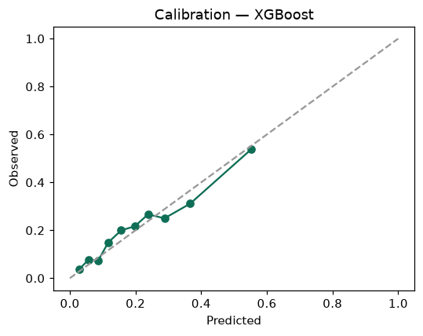

SHAP feature contributions
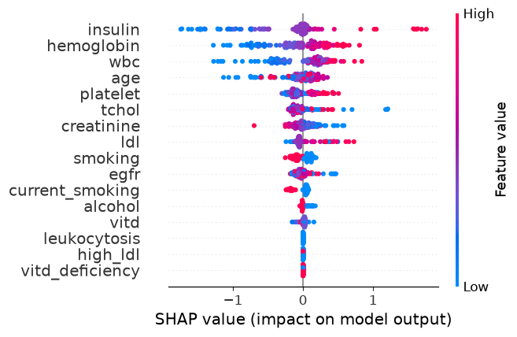

Partial dependence (PDP)
