Machine Learning Prediction Model Report
Outcome: Atherogenic dyslipidemia (high TG + low HDL) · NHANES · 3 models compared · tuning, full metrics, threshold, SHAP, PDP
[ML] outcome = atherogenic_dyslipidemia

Data summary
Item | Value
N | 6000
Outcome prevalence (%) | 13.1
Features | 55
Models compared | 3
Train/test | 4200/1800 (70/30 stratified)
Auto-excluded leakage | None

Hyperparameter search space
Model | Search space
LogisticRegression | {'C': [0.01, 0.1, 1, 10], 'penalty': ['l1', 'l2']}
HistGradientBoosting | {'learning_rate': [0.03, 0.1], 'max_iter': [200, 400], 'max_depth': [3, 6, None]}
XGBoost | {'n_estimators': [300, 500], 'max_depth': [3, 5], 'learning_rate': [0.03, 0.1], 'subsample': [0.8, 1.0]}

Tuning and model selection — training-partition cross-validation
Hyperparameter search and between-model selection both use these training-partition cross-validated scores. The selection criterion is CV_combined, the mean of the cross-validated auROC and auPRC. The held-out partition is not consulted at this stage.
model | CV_auROC | CV_auPRC | CV_combined | best_params
LogisticRegression | 0.806 | 0.3788 | 0.5924 | {'penalty': 'l1', 'C': 0.1}
HistGradientBoosting | 0.8008 | 0.4077 | 0.6042 | {'max_iter': 200, 'max_depth': None, 'learning_rate': 0.03}
XGBoost | 0.8104 | 0.4246 | 0.6175 | {'subsample': 0.8, 'n_estimators': 500, 'max_depth': 3, 'learning_rate': 0.03}

Held-out performance metrics
Reported for every candidate for transparency; only the model selected by CV_combined above is the prespecified final model. Rows are ordered by the CV selection criterion.
model | CV_combined | TP | TN | FP | FN | sensitivity | specificity | PPV | NPV | accuracy | balanced_accuracy | f1 | MCC | kappa | auROC | auPRC | logloss | brier | combined
XGBoost | 0.6175 | 30 | 1543 | 22 | 205 | 0.1277 | 0.9859 | 0.5769 | 0.8827 | 0.8739 | 0.5568 | 0.2091 | 0.2285 | 0.1698 | 0.7984 | 0.387 | 0.3186 | 0.0961 | 0.5927
HistGradientBoosting | 0.6042 | 28 | 1540 | 25 | 207 | 0.1191 | 0.984 | 0.5283 | 0.8815 | 0.8711 | 0.5516 | 0.1944 | 0.2056 | 0.1538 | 0.7983 | 0.3891 | 0.3234 | 0.0966 | 0.5937
LogisticRegression | 0.5924 | 15 | 1551 | 14 | 220 | 0.0638 | 0.9911 | 0.5172 | 0.8758 | 0.87 | 0.5274 | 0.1136 | 0.1469 | 0.0875 | 0.7877 | 0.3629 | 0.3237 | 0.0981 | 0.5753

ROC · Precision-Recall
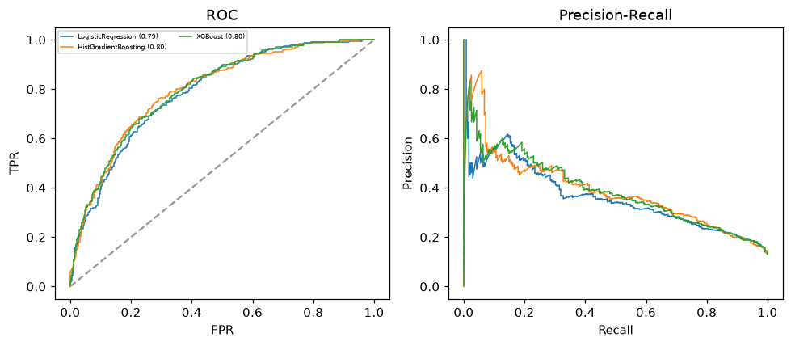

Selected final model — XGBoost (CV combined=0.6175; held-out auROC=0.7984)
Among 3 candidate models, XGBoost achieved the highest cross-validated combined score (0.6175) within the training partition and was selected on that basis. Refitted on the complete training partition and evaluated once on the untouched held-out partition, it reached an area under the receiver operating characteristic curve of 0.7984 and an area under the precision-recall curve of 0.387.

Threshold analysis (0.1-0.9)
threshold | TP | TN | FP | FN | sensitivity | specificity | PPV | NPV | f1 | accuracy
0.1 | 184.0 | 1020.0 | 545.0 | 51.0 | 0.783 | 0.652 | 0.252 | 0.952 | 0.382 | 0.669
0.2 | 138.0 | 1300.0 | 265.0 | 97.0 | 0.587 | 0.831 | 0.342 | 0.931 | 0.433 | 0.799
0.3 | 92.0 | 1427.0 | 138.0 | 143.0 | 0.391 | 0.912 | 0.4 | 0.909 | 0.396 | 0.844
0.4 | 57.0 | 1507.0 | 58.0 | 178.0 | 0.243 | 0.963 | 0.496 | 0.894 | 0.326 | 0.869
0.5 | 30.0 | 1543.0 | 22.0 | 205.0 | 0.128 | 0.986 | 0.577 | 0.883 | 0.209 | 0.874
0.6 | 13.0 | 1557.0 | 8.0 | 222.0 | 0.055 | 0.995 | 0.619 | 0.875 | 0.102 | 0.872
0.7 | 5.0 | 1564.0 | 1.0 | 230.0 | 0.021 | 0.999 | 0.833 | 0.872 | 0.041 | 0.872
0.8 | 3.0 | 1564.0 | 1.0 | 232.0 | 0.013 | 0.999 | 0.75 | 0.871 | 0.025 | 0.871
0.9 | 0.0 | 1564.0 | 1.0 | 235.0 | 0.0 | 0.999 | 0.0 | 0.869 | 0.0 | 0.869

Calibration
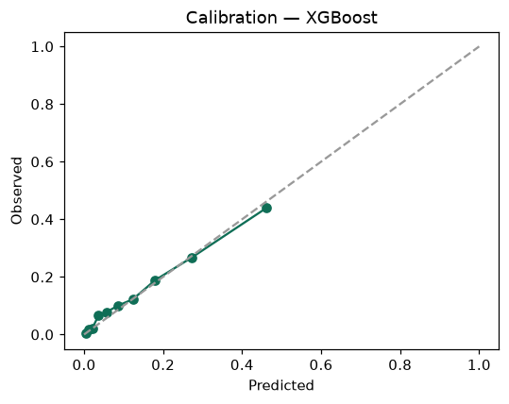

SHAP feature contributions
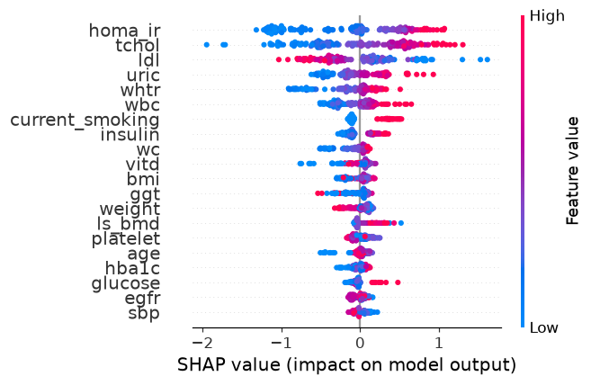

Partial dependence (PDP)
