Machine Learning Prediction Model Report
Outcome: Central obesity (WHtR>=0.5) · NHANES · 3 models compared · tuning, full metrics, threshold, SHAP, PDP
[ML] outcome = central_obesity

Data summary
Item | Value
N | 6000
Outcome prevalence (%) | 83.7
Features | 46
Models compared | 3
Train/test | 4200/1800 (70/30 stratified)
Auto-excluded leakage | None

Hyperparameter search space
Model | Search space
LogisticRegression | {'C': [0.01, 0.1, 1, 10], 'penalty': ['l1', 'l2']}
HistGradientBoosting | {'learning_rate': [0.03, 0.1], 'max_iter': [200, 400], 'max_depth': [3, 6, None]}
XGBoost | {'n_estimators': [300, 500], 'max_depth': [3, 5], 'learning_rate': [0.03, 0.1], 'subsample': [0.8, 1.0]}

Tuning and model selection — training-partition cross-validation
Hyperparameter search and between-model selection both use these training-partition cross-validated scores. The selection criterion is CV_combined, the mean of the cross-validated auROC and auPRC. The held-out partition is not consulted at this stage.
model | CV_auROC | CV_auPRC | CV_combined | best_params
LogisticRegression | 0.8549 | 0.9639 | 0.9094 | {'penalty': 'l1', 'C': 10}
HistGradientBoosting | 0.8507 | 0.9642 | 0.9074 | {'max_iter': 400, 'max_depth': 3, 'learning_rate': 0.03}
XGBoost | 0.8573 | 0.9663 | 0.9118 | {'subsample': 0.8, 'n_estimators': 500, 'max_depth': 3, 'learning_rate': 0.03}

Held-out performance metrics
Reported for every candidate for transparency; only the model selected by CV_combined above is the prespecified final model. Rows are ordered by the CV selection criterion.
model | CV_combined | TP | TN | FP | FN | sensitivity | specificity | PPV | NPV | accuracy | balanced_accuracy | f1 | MCC | kappa | auROC | auPRC | logloss | brier | combined
XGBoost | 0.9118 | 1442 | 131 | 162 | 65 | 0.9569 | 0.4471 | 0.899 | 0.6684 | 0.8739 | 0.702 | 0.927 | 0.4787 | 0.4661 | 0.8853 | 0.9736 | 0.2898 | 0.0893 | 0.9294
LogisticRegression | 0.9094 | 1449 | 123 | 170 | 58 | 0.9615 | 0.4198 | 0.895 | 0.6796 | 0.8733 | 0.6907 | 0.9271 | 0.4681 | 0.4507 | 0.8804 | 0.9725 | 0.2971 | 0.092 | 0.9264
HistGradientBoosting | 0.9074 | 1459 | 111 | 182 | 48 | 0.9681 | 0.3788 | 0.8891 | 0.6981 | 0.8722 | 0.6735 | 0.9269 | 0.4514 | 0.4253 | 0.883 | 0.9732 | 0.2923 | 0.09 | 0.9281

ROC · Precision-Recall
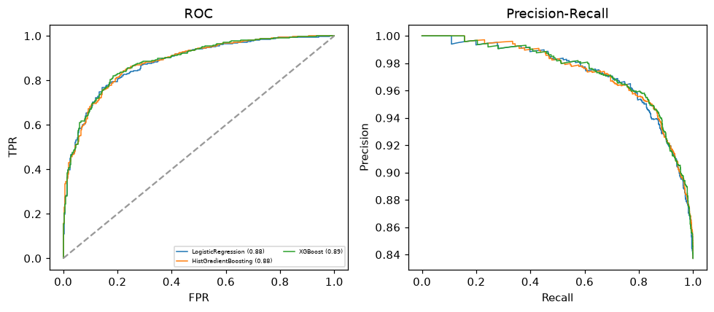

Selected final model — XGBoost (CV combined=0.9118; held-out auROC=0.8853)
Among 3 candidate models, XGBoost achieved the highest cross-validated combined score (0.9118) within the training partition and was selected on that basis. Refitted on the complete training partition and evaluated once on the untouched held-out partition, it reached an area under the receiver operating characteristic curve of 0.8853 and an area under the precision-recall curve of 0.9736.

Threshold analysis (0.1-0.9)
threshold | TP | TN | FP | FN | sensitivity | specificity | PPV | NPV | f1 | accuracy
0.1 | 1507.0 | 6.0 | 287.0 | 0.0 | 1.0 | 0.02 | 0.84 | 1.0 | 0.913 | 0.841
0.2 | 1505.0 | 30.0 | 263.0 | 2.0 | 0.999 | 0.102 | 0.851 | 0.938 | 0.919 | 0.853
0.3 | 1492.0 | 54.0 | 239.0 | 15.0 | 0.99 | 0.184 | 0.862 | 0.783 | 0.922 | 0.859
0.4 | 1479.0 | 94.0 | 199.0 | 28.0 | 0.981 | 0.321 | 0.881 | 0.77 | 0.929 | 0.874
0.5 | 1442.0 | 131.0 | 162.0 | 65.0 | 0.957 | 0.447 | 0.899 | 0.668 | 0.927 | 0.874
0.6 | 1393.0 | 159.0 | 134.0 | 114.0 | 0.924 | 0.543 | 0.912 | 0.582 | 0.918 | 0.862
0.7 | 1338.0 | 197.0 | 96.0 | 169.0 | 0.888 | 0.672 | 0.933 | 0.538 | 0.91 | 0.853
0.8 | 1250.0 | 234.0 | 59.0 | 257.0 | 0.829 | 0.799 | 0.955 | 0.477 | 0.888 | 0.824
0.9 | 1046.0 | 262.0 | 31.0 | 461.0 | 0.694 | 0.894 | 0.971 | 0.362 | 0.81 | 0.727

Calibration
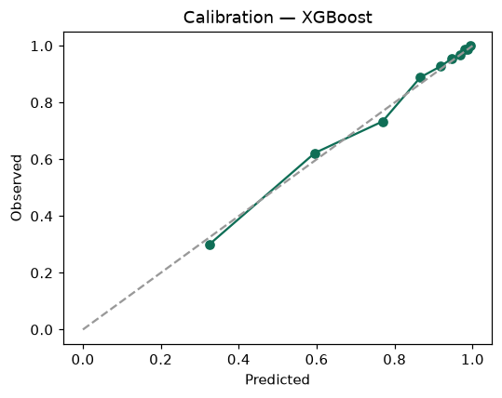

SHAP feature contributions
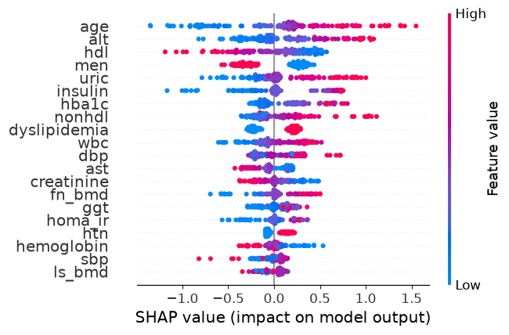

Partial dependence (PDP)
