Machine Learning Prediction Model Report
Outcome: Elevated ALT (>40 IU/L) · NHANES · 3 models compared · tuning, full metrics, threshold, SHAP, PDP
[ML] outcome = high_alt

Data summary
Item | Value
N | 6000
Outcome prevalence (%) | 9.0
Features | 57
Models compared | 3
Train/test | 4200/1800 (70/30 stratified)
Auto-excluded leakage | None

Hyperparameter search space
Model | Search space
LogisticRegression | {'C': [0.01, 0.1, 1, 10], 'penalty': ['l1', 'l2']}
HistGradientBoosting | {'learning_rate': [0.03, 0.1], 'max_iter': [200, 400], 'max_depth': [3, 6, None]}
XGBoost | {'n_estimators': [300, 500], 'max_depth': [3, 5], 'learning_rate': [0.03, 0.1], 'subsample': [0.8, 1.0]}

Tuning and model selection — training-partition cross-validation
Hyperparameter search and between-model selection both use these training-partition cross-validated scores. The selection criterion is CV_combined, the mean of the cross-validated auROC and auPRC. The held-out partition is not consulted at this stage.
model | CV_auROC | CV_auPRC | CV_combined | best_params
LogisticRegression | 0.8448 | 0.4265 | 0.6356 | {'penalty': 'l1', 'C': 0.1}
HistGradientBoosting | 0.8643 | 0.4696 | 0.667 | {'max_iter': 400, 'max_depth': 3, 'learning_rate': 0.03}
XGBoost | 0.87 | 0.4868 | 0.6784 | {'subsample': 1.0, 'n_estimators': 300, 'max_depth': 3, 'learning_rate': 0.03}

Held-out performance metrics
Reported for every candidate for transparency; only the model selected by CV_combined above is the prespecified final model. Rows are ordered by the CV selection criterion.
model | CV_combined | TP | TN | FP | FN | sensitivity | specificity | PPV | NPV | accuracy | balanced_accuracy | f1 | MCC | kappa | auROC | auPRC | logloss | brier | combined
XGBoost | 0.6784 | 37 | 1621 | 16 | 126 | 0.227 | 0.9902 | 0.6981 | 0.9279 | 0.9211 | 0.6086 | 0.3426 | 0.3688 | 0.312 | 0.8605 | 0.4626 | 0.2185 | 0.0623 | 0.6616
HistGradientBoosting | 0.667 | 32 | 1618 | 19 | 131 | 0.1963 | 0.9884 | 0.6275 | 0.9251 | 0.9167 | 0.5924 | 0.2991 | 0.3195 | 0.2674 | 0.857 | 0.452 | 0.2215 | 0.063 | 0.6545
LogisticRegression | 0.6356 | 14 | 1629 | 8 | 149 | 0.0859 | 0.9951 | 0.6364 | 0.9162 | 0.9128 | 0.5405 | 0.1514 | 0.2116 | 0.1327 | 0.8355 | 0.4101 | 0.2409 | 0.0672 | 0.6228

ROC · Precision-Recall
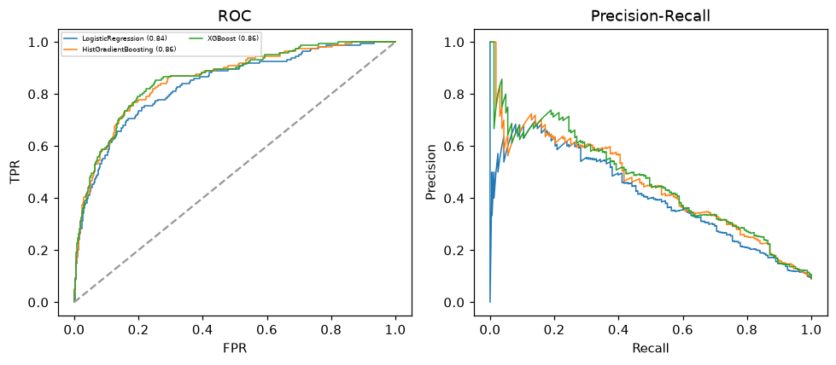

Selected final model — XGBoost (CV combined=0.6784; held-out auROC=0.8605)
Among 3 candidate models, XGBoost achieved the highest cross-validated combined score (0.6784) within the training partition and was selected on that basis. Refitted on the complete training partition and evaluated once on the untouched held-out partition, it reached an area under the receiver operating characteristic curve of 0.8605 and an area under the precision-recall curve of 0.4626.

Threshold analysis (0.1-0.9)
threshold | TP | TN | FP | FN | sensitivity | specificity | PPV | NPV | f1 | accuracy
0.1 | 126.0 | 1322.0 | 315.0 | 37.0 | 0.773 | 0.808 | 0.286 | 0.973 | 0.417 | 0.804
0.2 | 94.0 | 1506.0 | 131.0 | 69.0 | 0.577 | 0.92 | 0.418 | 0.956 | 0.485 | 0.889
0.3 | 69.0 | 1569.0 | 68.0 | 94.0 | 0.423 | 0.958 | 0.504 | 0.943 | 0.46 | 0.91
0.4 | 51.0 | 1604.0 | 33.0 | 112.0 | 0.313 | 0.98 | 0.607 | 0.935 | 0.413 | 0.919
0.5 | 37.0 | 1621.0 | 16.0 | 126.0 | 0.227 | 0.99 | 0.698 | 0.928 | 0.343 | 0.921
0.6 | 21.0 | 1627.0 | 10.0 | 142.0 | 0.129 | 0.994 | 0.677 | 0.92 | 0.216 | 0.916
0.7 | 9.0 | 1632.0 | 5.0 | 154.0 | 0.055 | 0.997 | 0.643 | 0.914 | 0.102 | 0.912
0.8 | 2.0 | 1637.0 | 0.0 | 161.0 | 0.012 | 1.0 | 1.0 | 0.91 | 0.024 | 0.911
0.9 | 0.0 | 1637.0 | 0.0 | 163.0 | 0.0 | 1.0 | nan | 0.909 | 0.0 | 0.909

Calibration
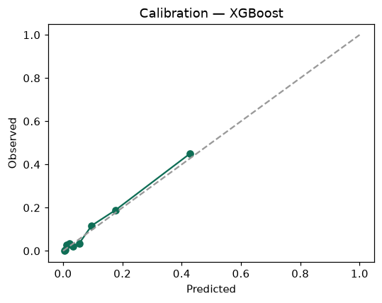

SHAP feature contributions
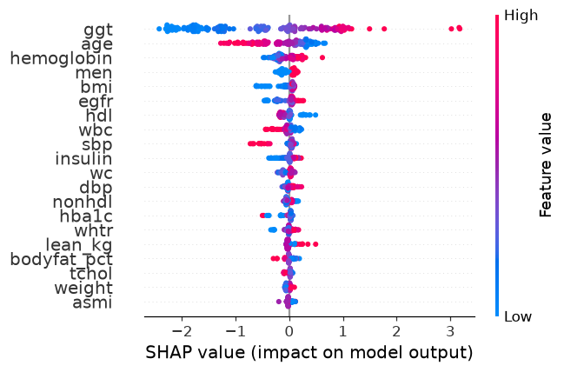

Partial dependence (PDP)
