Machine Learning Prediction Model Report
Outcome: Low muscle mass (low ASMI, AWGS cut) · NHANES · 3 models compared · tuning, full metrics, threshold, SHAP, PDP
[ML] outcome = sarcopenia

Data summary
Item | Value
N | 6000
Outcome prevalence (%) | 3.6
Features | 47
Models compared | 3
Train/test | 4200/1800 (70/30 stratified)
Auto-excluded leakage | None

Hyperparameter search space
Model | Search space
LogisticRegression | {'C': [0.01, 0.1, 1, 10], 'penalty': ['l1', 'l2']}
HistGradientBoosting | {'learning_rate': [0.03, 0.1], 'max_iter': [200, 400], 'max_depth': [3, 6, None]}
XGBoost | {'n_estimators': [300, 500], 'max_depth': [3, 5], 'learning_rate': [0.03, 0.1], 'subsample': [0.8, 1.0]}

Tuning and model selection — training-partition cross-validation
Hyperparameter search and between-model selection both use these training-partition cross-validated scores. The selection criterion is CV_combined, the mean of the cross-validated auROC and auPRC. The held-out partition is not consulted at this stage.
model | CV_auROC | CV_auPRC | CV_combined | best_params
LogisticRegression | 0.7304 | 0.1286 | 0.4295 | {'penalty': 'l1', 'C': 0.1}
HistGradientBoosting | 0.7237 | 0.1 | 0.4118 | {'max_iter': 200, 'max_depth': None, 'learning_rate': 0.03}
XGBoost | 0.7415 | 0.109 | 0.4253 | {'subsample': 0.8, 'n_estimators': 300, 'max_depth': 5, 'learning_rate': 0.03}

Held-out performance metrics
Reported for every candidate for transparency; only the model selected by CV_combined above is the prespecified final model. Rows are ordered by the CV selection criterion.
model | CV_combined | TP | TN | FP | FN | sensitivity | specificity | PPV | NPV | accuracy | balanced_accuracy | f1 | MCC | kappa | auROC | auPRC | logloss | brier | combined
LogisticRegression | 0.4295 | 0 | 1736 | 0 | 64 | 0.0 | 1.0 | nan | 0.9644 | 0.9644 | 0.5 | 0.0 | 0.0 | 0.0 | 0.7572 | 0.1323 | 0.1384 | 0.0328 | 0.4447
XGBoost | 0.4253 | 0 | 1735 | 1 | 64 | 0.0 | 0.9994 | 0.0 | 0.9644 | 0.9639 | 0.4997 | 0.0 | -0.0045 | -0.0011 | 0.7583 | 0.1354 | 0.1415 | 0.033 | 0.4469
HistGradientBoosting | 0.4118 | 0 | 1734 | 2 | 64 | 0.0 | 0.9988 | 0.0 | 0.9644 | 0.9633 | 0.4994 | 0.0 | -0.0064 | -0.0022 | 0.7177 | 0.0962 | 0.1637 | 0.0343 | 0.4069

ROC · Precision-Recall
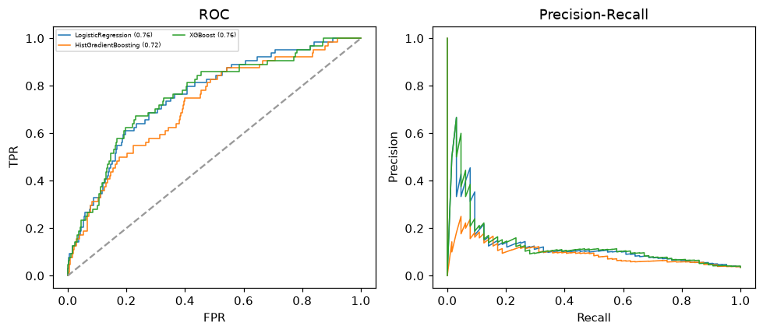

Selected final model — LogisticRegression (CV combined=0.4295; held-out auROC=0.7572)
Among 3 candidate models, LogisticRegression achieved the highest cross-validated combined score (0.4295) within the training partition and was selected on that basis. Refitted on the complete training partition and evaluated once on the untouched held-out partition, it reached an area under the receiver operating characteristic curve of 0.7572 and an area under the precision-recall curve of 0.1323.

Threshold analysis (0.1-0.9)
threshold | TP | TN | FP | FN | sensitivity | specificity | PPV | NPV | f1 | accuracy
0.1 | 9.0 | 1673.0 | 63.0 | 55.0 | 0.141 | 0.964 | 0.125 | 0.968 | 0.132 | 0.934
0.2 | 4.0 | 1730.0 | 6.0 | 60.0 | 0.062 | 0.997 | 0.4 | 0.966 | 0.108 | 0.963
0.3 | 1.0 | 1735.0 | 1.0 | 63.0 | 0.016 | 0.999 | 0.5 | 0.965 | 0.03 | 0.964
0.4 | 0.0 | 1736.0 | 0.0 | 64.0 | 0.0 | 1.0 | nan | 0.964 | 0.0 | 0.964
0.5 | 0.0 | 1736.0 | 0.0 | 64.0 | 0.0 | 1.0 | nan | 0.964 | 0.0 | 0.964
0.6 | 0.0 | 1736.0 | 0.0 | 64.0 | 0.0 | 1.0 | nan | 0.964 | 0.0 | 0.964
0.7 | 0.0 | 1736.0 | 0.0 | 64.0 | 0.0 | 1.0 | nan | 0.964 | 0.0 | 0.964
0.8 | 0.0 | 1736.0 | 0.0 | 64.0 | 0.0 | 1.0 | nan | 0.964 | 0.0 | 0.964
0.9 | 0.0 | 1736.0 | 0.0 | 64.0 | 0.0 | 1.0 | nan | 0.964 | 0.0 | 0.964

Calibration
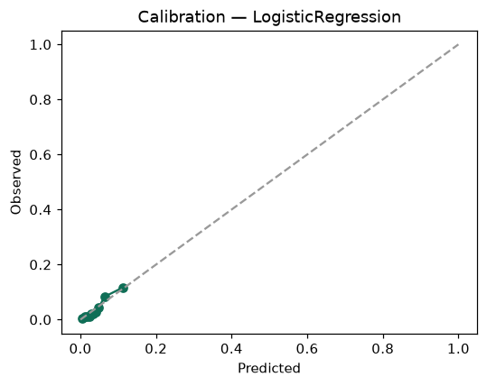

SHAP feature contributions
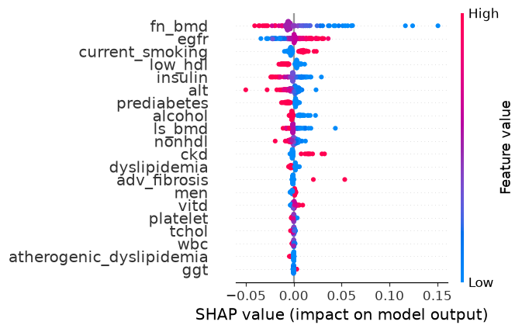

Partial dependence (PDP)
