Machine Learning Prediction Model Report
Outcome: MASLD · NHANES · 3 models compared · tuning, full metrics, threshold, SHAP, PDP
[ML] outcome = masld

Data summary
Item | Value
N | 4575
Outcome prevalence (%) | 55.4
Features | 27
Models compared | 3
Train/test | 3202/1373 (70/30 stratified)
Auto-excluded leakage | None

Hyperparameter search space
Model | Search space
LogisticRegression | {'C': [0.01, 0.1, 1, 10], 'penalty': ['l1', 'l2']}
HistGradientBoosting | {'learning_rate': [0.03, 0.1], 'max_iter': [200, 400], 'max_depth': [3, 6, None]}
XGBoost | {'n_estimators': [300, 500], 'max_depth': [3, 5], 'learning_rate': [0.03, 0.1], 'subsample': [0.8, 1.0]}

Tuning and model selection — training-partition cross-validation
Hyperparameter search and between-model selection both use these training-partition cross-validated scores. The selection criterion is CV_combined, the mean of the cross-validated auROC and auPRC. The held-out partition is not consulted at this stage.
model | CV_auROC | CV_auPRC | CV_combined | best_params
LogisticRegression | 0.7654 | 0.7742 | 0.7698 | {'penalty': 'l1', 'C': 1}
HistGradientBoosting | 0.7689 | 0.7771 | 0.773 | {'max_iter': 400, 'max_depth': 3, 'learning_rate': 0.03}
XGBoost | 0.7723 | 0.7815 | 0.7769 | {'subsample': 0.8, 'n_estimators': 500, 'max_depth': 3, 'learning_rate': 0.03}

Held-out performance metrics
Reported for every candidate for transparency; only the model selected by CV_combined above is the prespecified final model. Rows are ordered by the CV selection criterion.
model | CV_combined | TP | TN | FP | FN | sensitivity | specificity | PPV | NPV | accuracy | balanced_accuracy | f1 | MCC | kappa | auROC | auPRC | logloss | brier | combined
XGBoost | 0.7769 | 641 | 374 | 238 | 120 | 0.8423 | 0.6111 | 0.7292 | 0.7571 | 0.7393 | 0.7267 | 0.7817 | 0.4696 | 0.4621 | 0.8069 | 0.8172 | 0.5278 | 0.1769 | 0.812
HistGradientBoosting | 0.773 | 645 | 371 | 241 | 116 | 0.8476 | 0.6062 | 0.728 | 0.7618 | 0.74 | 0.7269 | 0.7832 | 0.4714 | 0.463 | 0.8037 | 0.8183 | 0.5321 | 0.1784 | 0.811
LogisticRegression | 0.7698 | 642 | 361 | 251 | 119 | 0.8436 | 0.5899 | 0.7189 | 0.7521 | 0.7305 | 0.7167 | 0.7763 | 0.4519 | 0.4428 | 0.7959 | 0.8064 | 0.546 | 0.1814 | 0.8012

ROC · Precision-Recall
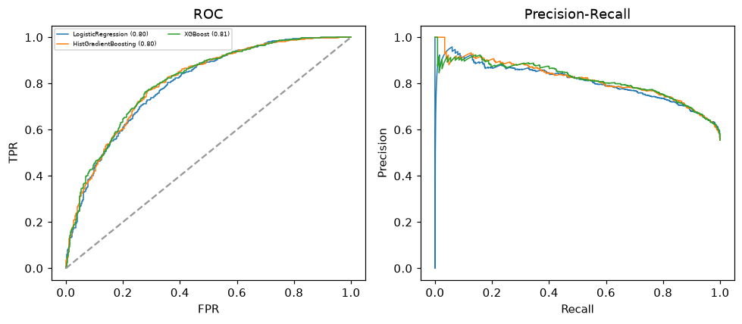

Selected final model — XGBoost (CV combined=0.7769; held-out auROC=0.8069)
Among 3 candidate models, XGBoost achieved the highest cross-validated combined score (0.7769) within the training partition and was selected on that basis. Refitted on the complete training partition and evaluated once on the untouched held-out partition, it reached an area under the receiver operating characteristic curve of 0.8069 and an area under the precision-recall curve of 0.8172.

Threshold analysis (0.1-0.9)
threshold | TP | TN | FP | FN | sensitivity | specificity | PPV | NPV | f1 | accuracy
0.1 | 754.0 | 118.0 | 494.0 | 7.0 | 0.991 | 0.193 | 0.604 | 0.944 | 0.751 | 0.635
0.2 | 740.0 | 181.0 | 431.0 | 21.0 | 0.972 | 0.296 | 0.632 | 0.896 | 0.766 | 0.671
0.3 | 719.0 | 228.0 | 384.0 | 42.0 | 0.945 | 0.373 | 0.652 | 0.844 | 0.771 | 0.69
0.4 | 690.0 | 292.0 | 320.0 | 71.0 | 0.907 | 0.477 | 0.683 | 0.804 | 0.779 | 0.715
0.5 | 641.0 | 374.0 | 238.0 | 120.0 | 0.842 | 0.611 | 0.729 | 0.757 | 0.782 | 0.739
0.6 | 555.0 | 451.0 | 161.0 | 206.0 | 0.729 | 0.737 | 0.775 | 0.686 | 0.752 | 0.733
0.7 | 415.0 | 517.0 | 95.0 | 346.0 | 0.545 | 0.845 | 0.814 | 0.599 | 0.653 | 0.679
0.8 | 217.0 | 583.0 | 29.0 | 544.0 | 0.285 | 0.953 | 0.882 | 0.517 | 0.431 | 0.583
0.9 | 58.0 | 606.0 | 6.0 | 703.0 | 0.076 | 0.99 | 0.906 | 0.463 | 0.141 | 0.484

Calibration
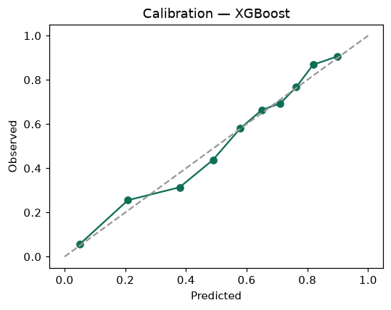

SHAP feature contributions
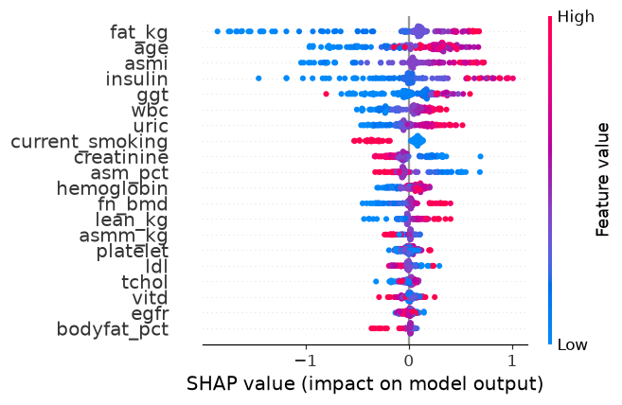

Partial dependence (PDP)
