Machine Learning Prediction Model Report
Outcome: Overweight (KSSO >=23 / WHO >=25, country-specific) · NHANES · 3 models compared · tuning, full metrics, threshold, SHAP, PDP
[ML] outcome = overweight

Data summary
Item | Value
N | 6000
Outcome prevalence (%) | 71.0
Features | 47
Models compared | 3
Train/test | 4200/1800 (70/30 stratified)
Auto-excluded leakage | None

Hyperparameter search space
Model | Search space
LogisticRegression | {'C': [0.01, 0.1, 1, 10], 'penalty': ['l1', 'l2']}
HistGradientBoosting | {'learning_rate': [0.03, 0.1], 'max_iter': [200, 400], 'max_depth': [3, 6, None]}
XGBoost | {'n_estimators': [300, 500], 'max_depth': [3, 5], 'learning_rate': [0.03, 0.1], 'subsample': [0.8, 1.0]}

Tuning and model selection — training-partition cross-validation
Hyperparameter search and between-model selection both use these training-partition cross-validated scores. The selection criterion is CV_combined, the mean of the cross-validated auROC and auPRC. The held-out partition is not consulted at this stage.
model | CV_auROC | CV_auPRC | CV_combined | best_params
LogisticRegression | 0.7983 | 0.9012 | 0.8498 | {'penalty': 'l1', 'C': 1}
HistGradientBoosting | 0.8066 | 0.904 | 0.8553 | {'max_iter': 400, 'max_depth': 3, 'learning_rate': 0.03}
XGBoost | 0.8132 | 0.9092 | 0.8612 | {'subsample': 0.8, 'n_estimators': 500, 'max_depth': 3, 'learning_rate': 0.03}

Held-out performance metrics
Reported for every candidate for transparency; only the model selected by CV_combined above is the prespecified final model. Rows are ordered by the CV selection criterion.
model | CV_combined | TP | TN | FP | FN | sensitivity | specificity | PPV | NPV | accuracy | balanced_accuracy | f1 | MCC | kappa | auROC | auPRC | logloss | brier | combined
XGBoost | 0.8612 | 1165 | 253 | 268 | 114 | 0.9109 | 0.4856 | 0.813 | 0.6894 | 0.7878 | 0.6982 | 0.8591 | 0.4463 | 0.4345 | 0.8228 | 0.9135 | 0.455 | 0.1476 | 0.8682
HistGradientBoosting | 0.8553 | 1190 | 225 | 296 | 89 | 0.9304 | 0.4319 | 0.8008 | 0.7166 | 0.7861 | 0.6811 | 0.8608 | 0.4329 | 0.4106 | 0.8201 | 0.9105 | 0.4587 | 0.1488 | 0.8653
LogisticRegression | 0.8498 | 1154 | 238 | 283 | 125 | 0.9023 | 0.4568 | 0.8031 | 0.6556 | 0.7733 | 0.6795 | 0.8498 | 0.4058 | 0.3945 | 0.803 | 0.9043 | 0.4739 | 0.1553 | 0.8536

ROC · Precision-Recall
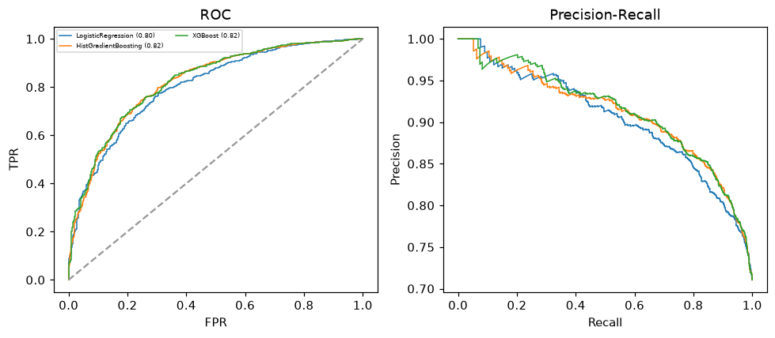

Selected final model — XGBoost (CV combined=0.8612; held-out auROC=0.8228)
Among 3 candidate models, XGBoost achieved the highest cross-validated combined score (0.8612) within the training partition and was selected on that basis. Refitted on the complete training partition and evaluated once on the untouched held-out partition, it reached an area under the receiver operating characteristic curve of 0.8228 and an area under the precision-recall curve of 0.9135.

Threshold analysis (0.1-0.9)
threshold | TP | TN | FP | FN | sensitivity | specificity | PPV | NPV | f1 | accuracy
0.1 | 1278.0 | 14.0 | 507.0 | 1.0 | 0.999 | 0.027 | 0.716 | 0.933 | 0.834 | 0.718
0.2 | 1266.0 | 47.0 | 474.0 | 13.0 | 0.99 | 0.09 | 0.728 | 0.783 | 0.839 | 0.729
0.3 | 1253.0 | 121.0 | 400.0 | 26.0 | 0.98 | 0.232 | 0.758 | 0.823 | 0.855 | 0.763
0.4 | 1222.0 | 178.0 | 343.0 | 57.0 | 0.955 | 0.342 | 0.781 | 0.757 | 0.859 | 0.778
0.5 | 1165.0 | 253.0 | 268.0 | 114.0 | 0.911 | 0.486 | 0.813 | 0.689 | 0.859 | 0.788
0.6 | 1095.0 | 325.0 | 196.0 | 184.0 | 0.856 | 0.624 | 0.848 | 0.639 | 0.852 | 0.789
0.7 | 984.0 | 370.0 | 151.0 | 295.0 | 0.769 | 0.71 | 0.867 | 0.556 | 0.815 | 0.752
0.8 | 797.0 | 437.0 | 84.0 | 482.0 | 0.623 | 0.839 | 0.905 | 0.476 | 0.738 | 0.686
0.9 | 485.0 | 487.0 | 34.0 | 794.0 | 0.379 | 0.935 | 0.934 | 0.38 | 0.539 | 0.54

Calibration
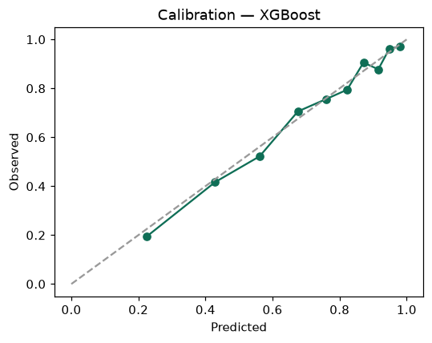

SHAP feature contributions
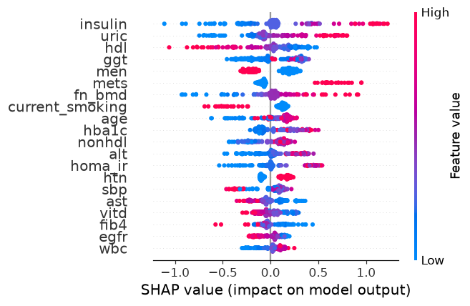

Partial dependence (PDP)
