Machine Learning Prediction Model Report
Outcome: Vitamin D deficiency (<20 ng/mL) · NHANES · 3 models compared · tuning, full metrics, threshold, SHAP, PDP
[ML] outcome = vitd_deficiency

Data summary
Item | Value
N | 6000
Outcome prevalence (%) | 31.0
Features | 62
Models compared | 3
Train/test | 4200/1800 (70/30 stratified)
Auto-excluded leakage | None

Hyperparameter search space
Model | Search space
LogisticRegression | {'C': [0.01, 0.1, 1, 10], 'penalty': ['l1', 'l2']}
HistGradientBoosting | {'learning_rate': [0.03, 0.1], 'max_iter': [200, 400], 'max_depth': [3, 6, None]}
XGBoost | {'n_estimators': [300, 500], 'max_depth': [3, 5], 'learning_rate': [0.03, 0.1], 'subsample': [0.8, 1.0]}

Tuning and model selection — training-partition cross-validation
Hyperparameter search and between-model selection both use these training-partition cross-validated scores. The selection criterion is CV_combined, the mean of the cross-validated auROC and auPRC. The held-out partition is not consulted at this stage.
model | CV_auROC | CV_auPRC | CV_combined | best_params
LogisticRegression | 0.6961 | 0.5072 | 0.6016 | {'penalty': 'l1', 'C': 0.1}
HistGradientBoosting | 0.6892 | 0.489 | 0.5891 | {'max_iter': 200, 'max_depth': 6, 'learning_rate': 0.03}
XGBoost | 0.6977 | 0.498 | 0.5979 | {'subsample': 0.8, 'n_estimators': 500, 'max_depth': 3, 'learning_rate': 0.03}

Held-out performance metrics
Reported for every candidate for transparency; only the model selected by CV_combined above is the prespecified final model. Rows are ordered by the CV selection criterion.
model | CV_combined | TP | TN | FP | FN | sensitivity | specificity | PPV | NPV | accuracy | balanced_accuracy | f1 | MCC | kappa | auROC | auPRC | logloss | brier | combined
LogisticRegression | 0.6016 | 102 | 1149 | 92 | 457 | 0.1825 | 0.9259 | 0.5258 | 0.7154 | 0.695 | 0.5542 | 0.2709 | 0.1617 | 0.132 | 0.6718 | 0.4632 | 0.583 | 0.1986 | 0.5675
XGBoost | 0.5979 | 123 | 1132 | 109 | 436 | 0.22 | 0.9122 | 0.5302 | 0.7219 | 0.6972 | 0.5661 | 0.311 | 0.1826 | 0.1575 | 0.6744 | 0.4678 | 0.5812 | 0.1987 | 0.5711
HistGradientBoosting | 0.5891 | 131 | 1117 | 124 | 428 | 0.2343 | 0.9001 | 0.5137 | 0.723 | 0.6933 | 0.5672 | 0.3219 | 0.1784 | 0.158 | 0.6684 | 0.4532 | 0.5867 | 0.2009 | 0.5608

ROC · Precision-Recall
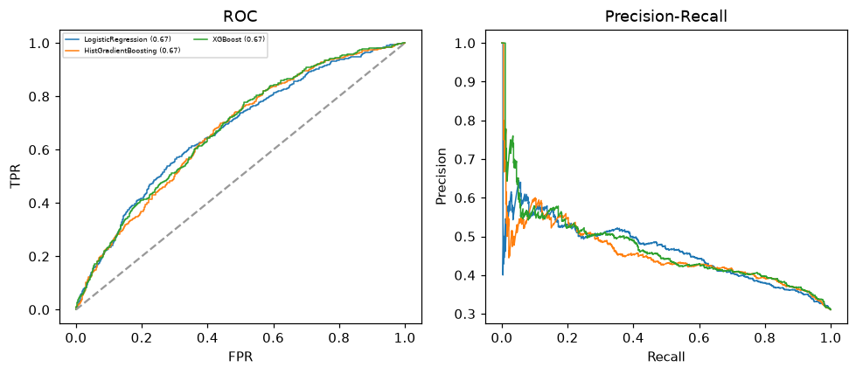

Selected final model — LogisticRegression (CV combined=0.6016; held-out auROC=0.6718)
Among 3 candidate models, LogisticRegression achieved the highest cross-validated combined score (0.6016) within the training partition and was selected on that basis. Refitted on the complete training partition and evaluated once on the untouched held-out partition, it reached an area under the receiver operating characteristic curve of 0.6718 and an area under the precision-recall curve of 0.4632.

Threshold analysis (0.1-0.9)
threshold | TP | TN | FP | FN | sensitivity | specificity | PPV | NPV | f1 | accuracy
0.1 | 555.0 | 54.0 | 1187.0 | 4.0 | 0.993 | 0.044 | 0.319 | 0.931 | 0.482 | 0.338
0.2 | 487.0 | 384.0 | 857.0 | 72.0 | 0.871 | 0.309 | 0.362 | 0.842 | 0.512 | 0.484
0.3 | 351.0 | 762.0 | 479.0 | 208.0 | 0.628 | 0.614 | 0.423 | 0.786 | 0.505 | 0.618
0.4 | 218.0 | 1025.0 | 216.0 | 341.0 | 0.39 | 0.826 | 0.502 | 0.75 | 0.439 | 0.691
0.5 | 102.0 | 1149.0 | 92.0 | 457.0 | 0.182 | 0.926 | 0.526 | 0.715 | 0.271 | 0.695
0.6 | 46.0 | 1205.0 | 36.0 | 513.0 | 0.082 | 0.971 | 0.561 | 0.701 | 0.144 | 0.695
0.7 | 18.0 | 1227.0 | 14.0 | 541.0 | 0.032 | 0.989 | 0.562 | 0.694 | 0.061 | 0.692
0.8 | 3.0 | 1237.0 | 4.0 | 556.0 | 0.005 | 0.997 | 0.429 | 0.69 | 0.011 | 0.689
0.9 | 2.0 | 1240.0 | 1.0 | 557.0 | 0.004 | 0.999 | 0.667 | 0.69 | 0.007 | 0.69

Calibration
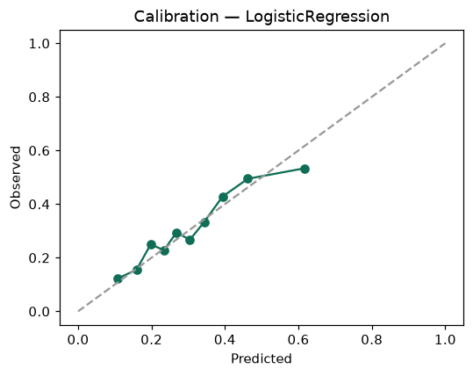

SHAP feature contributions
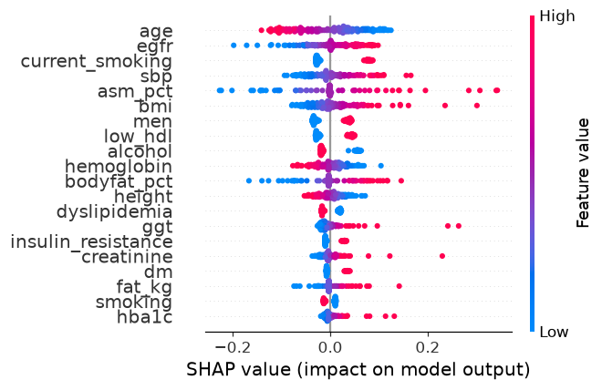

Partial dependence (PDP)
