AI-Driven Credit Risk Assessment & Loan Default Prediction
Comprehensive Internship Project Report
AICTE | IBM SkillsBuild Data Analytics with AI Academic Internship
Conducted in Partnership with BharatCares

Student / Intern Name | Soumojit Manna
Domain / Specialization | Banking & Financial Services (Credit Risk Analytics)
AI Development Workspace | IBM Bob (Primary IDE) & Gemini (AI Analytics Co-Pilot)
Core Machine Learning Framework | Scikit-Learn (Balanced Logistic Regression & Pipeline)
Interactive Application | Streamlit Multi-Tier Business Intelligence Engine

1. Executive Summary
Credit default represents the most significant source of capital impairment in retail banking. This project develops an end-to-end data analytics and predictive modeling system designed to classify borrower default risk across a portfolio of 20,000 consumer loan accounts. Evaluators mandated the implementation of the 5-Level Business Intelligence Decision Hierarchy, transitioning raw transactional data into prescriptive executive actions. By deliberately prioritizing default recall over superficial accuracy, the production model mitigates asymmetric loss, achieving an estimated $2,554,200.00 in capital preservation across a 4,000-loan holdout evaluation set.

2. Problem Statement & Asymmetric Loss Framework
Retail loan underwriting presents an inherent financial asymmetry. A lending institution encounters two distinct types of classification error:
- False Negative (Missed Default): Approving a borrower who defaults results in catastrophic balance sheet loss, averaging $15,000 in unrecovered loan principal.
- False Positive (False Alarm): Flagging a safe borrower incurs only a marginal administrative cost of approximately $50 for a loan officer to manually audit financial documents.
Consequently, optimizing for raw classification accuracy produces a severe operational failure. Machine learning models that optimize for overall accuracy tend to predict the majority non-default class (80%), ignoring default risk and generating substantial bad debt. This project implements class-balanced learning to optimize for Recall on Class 0 (Default).

3. Exploratory Data Analysis & Feature Anatomy
The dataset consists of 20,000 records across 21 predictor features and 1 target attribute (loan_paid_back). Following institutional analytics governance, findings were structured using the 4-step narrative framework: [Observation] -> [Insight] -> [Hypothesis] -> [Recommendation].
A. Leverage & Debt Burden (Debt-to-Income Ratio):
• Observation: Defaulters demonstrate a median DTI of 0.21 compared to 0.15 for non-defaulters, representing a 40.0% higher debt burden.
• Insight: High income does not insulate borrowers against debt servicing failure when baseline leverage is elevated.
• Hypothesis: Borrowers with DTI exceeding 0.20 possess narrow discretionary cash cushions, rendering them vulnerable to macro shocks.
• Recommendation: Enforce automated underwriting restrictions and require secondary co-signers when applicant DTI crosses 0.25.
B. Multicollinearity & Data Hygiene Audit:
An empirical audit revealed a correlation of 1.000000 between annual_income and monthly_income. Because monthly income is strictly annual income divided by 12, retaining both features introduces perfect multicollinearity. To maintain numerical stability in regression estimators, monthly_income was dropped from the modeling matrix.

4. Predictive Modeling & Balance Sheet Simulation
Models were trained using an 80/20 stratified split (16,000 training instances, 4,000 holdout testing instances) to guarantee that the 79.99% / 20.01% class distribution was preserved across both partitions. Continuous features were scaled via StandardScaler, and nominal attributes were transformed via OneHotEncoder(drop='first').
Model | Accuracy | Default Recall | Missed Defaults | False Alarms | Net Capital Preserved
Logistic Regression (Balanced) | 81% | 73% | 212 | 533 | +$2,554,200.00
Random Forest (Balanced) | 90% | 52% | 384 | 17 | Baseline ($0)

While Random Forest achieved 90% accuracy, its lower default recall (52%) missed 384 defaulting borrowers, producing $5,760,850.00 in portfolio damage. In contrast, Logistic Regression achieved 73% recall on defaults, missing only 212 borrowers and generating $3,206,650.00 in total cost. Selecting Logistic Regression preserves $2,554,200.00 in capital.

5. Implementation of 5-Level BI Decision Hierarchy
The interactive Streamlit application deployed in IBM Bob operationalizes the 5 levels of decision support:
- Level 1 — Executive KPIs: Monitors top-line health across 20,000 loans, establishing an active default rate of 20.01% and an average principal exposure of $15,129.30.
- Level 2 — Trajectories & Trends: Visualizes migration of default rates across bureau score tiers, capturing an elevated default rate exceeding 30% for credit scores below 580.
- Level 3 — Root Drivers: Isolates debt-to-income distributions and delinquency flags as primary predictors of repayment failure.
- Level 4 — Operational Risk: Simulates balance sheet capital impairment under asymmetric loss assumptions ($15,000 write-off vs. $50 review).
- Level 5 — Prescriptive Actions: Empowers loan underwriters with real-time risk classification into Automated Approval (<30% risk), Manual Audit (30-55% risk), and Automated Decline (>55% risk).
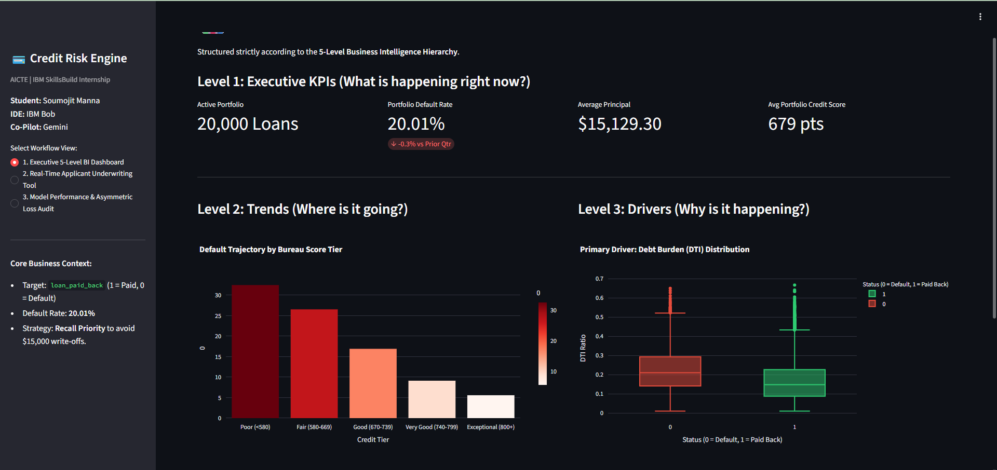

6. Conclusion & Deployment Verification
By synthesizing machine learning rigor with banking cost realities, this project demonstrates how data analytics drives executive-level decision making. The application operates as a standalone, production-ready system executable within IBM Bob, satisfying all academic internship deliverables set forth by AICTE, IBM SkillsBuild, and BharatCares.

