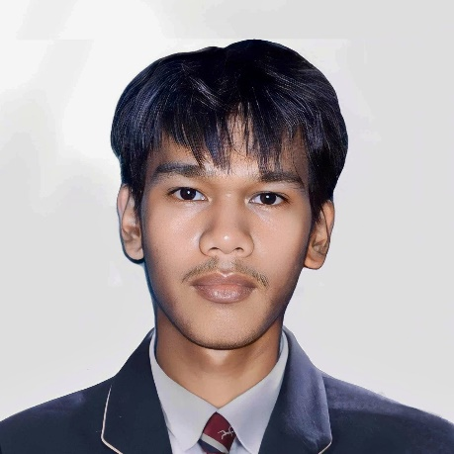

 `

**Bachelor of Science in**

**Information Technology**

Isabela State University

2023

**Reference**

**DEE JAY CRISTOBAL**

Photojournalist

Naguilian, Isabela, Philippines

(63) 936 3822 159

Deejay.cristobal@protonmail.com

**Contact Details**

* Contributed photography services for local community events, charities, or student organizations.

Ms. Rhea Jane Valle Bernardino

Cabaruan Integrated School Journalism Instructor

**Objectives**

**Volunteer Experience**

**Projects**

* Documented community events and issues through photography for Media Club or personal projects.
* Produced photo essays and multimedia projects as part of work, demonstrating storytelling skills and technical proficiency.
* Proficient in digital photography techniques, including composition, lighting, and a basic post-processing.
* Strong visual story telling abilities with a knack for capturing compelling moments and emotions.
* Excellent communication and teamwork skills to collaborate effectively with colleagues and subjects.
* Familiarity with multimedia storytelling tools and platform, such as adobe creative suite.
* Commitment to learning and adhering to ethical standards and legal considerations in photojournalism.

**Skills**

Aspiring Photojournalist with a strong passion for storytelling through visual media. Eager to embark on a care er in photojournalism and contribute creative perspectives to news and storytelling. Seeking an entry level opportunity to learn and grow in a dynamic media environment.

**Education**