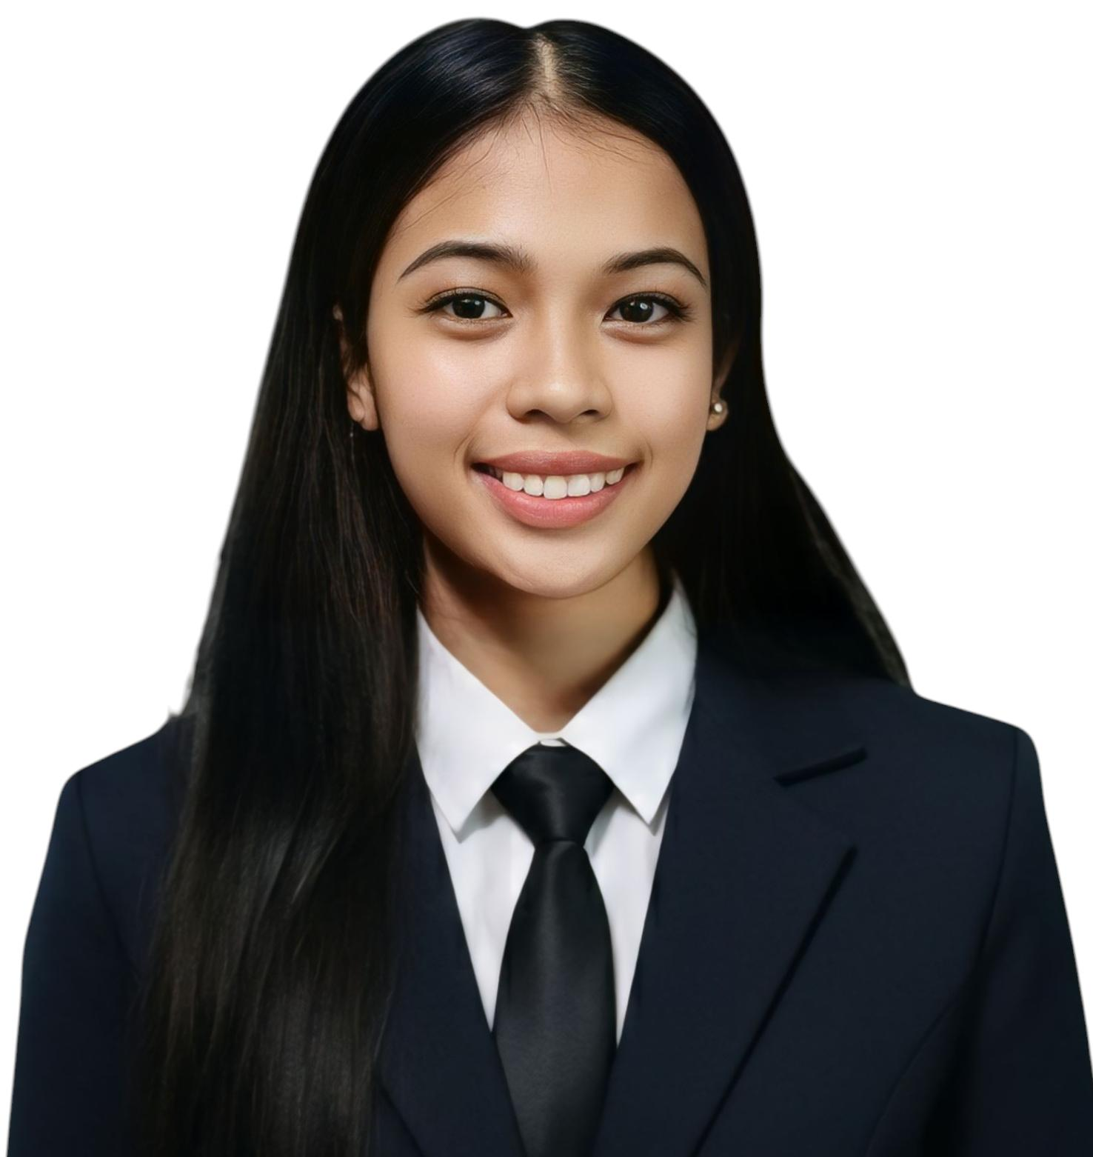
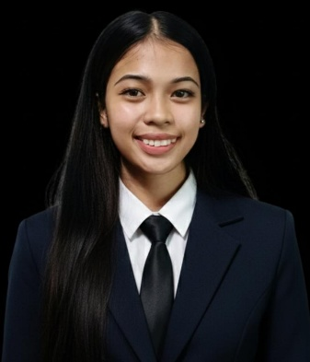
KRISTEL JOY V. TEJADA
Purok 11B, Villa Luna, Cauayan City, Isabela
📞 0909 789 9177
✉️ tejadakristeljoy04@gmail.com

CAREER OBJECTIVE
To obtain a position where I can use my strong communication skills, professionalism, and positive work attitude to provide excellent customer service and contribute to a productive and welcoming work environment.
EDUCATIONAL BACKGROUND
Tertiary
Isabela State University
Bachelor of Science in Information Technology
4th Year
Secondary
Cauayan City Science and Technology High School
(2023- 2024)
Primary
Villa Luna Elementary School
(2016-2017)
SKILLS
- Strong customer service and interpersonal communication
- Able to work under pressure with minimal supervision
- Fast learner and highly adaptable
- Good time management and multitasking abilities
- Organized and detail-oriented

WORK EXPERIENCE
Service Crew (Part-Time)
Peri-Peri Charcoal Chicken – SM Cauayan
Dishwasher / Server

TEJADA, KRISTEL JOY V.
Applicant

