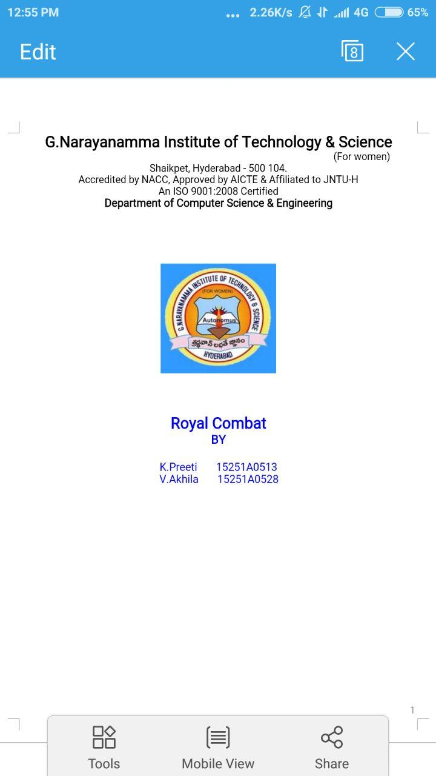

Pollutio Imperium

**BY**

D. Sahithi

M. Dheekshitha

K. Chamundeshwari

17251A0597

17251A05B0

17251A1210

**ABSTRACT**

Air is getting polluted because of release of Toxic gases by industries, vehicular emissions. When the vehicles are stopped at traffic signals, they emit hazardous gases even when not moving. People don't turn their vehicles off even if the traffic is 5 minutes long. Even industries emit lot of harmful gases which contribute in pollution. To address this issue, we came up with “*Pollutio Imperium* ”.

Our device monitors the pollution level and sends an alert to the user reminding them about the fuel wastage and their contribution in pollution. It suggests to turn the vehicle off at traffic signals. In case of industries, an alert will be sent to all the industries nearby by tracking GPS. The alert is sent to mobile application which is set in front of them. Along with alert message, a challan will also be sent.

This uses gas sensors which senses the pollutant levels, thus making the public get easy access to the pollution level in their area. This is of wide use to factories, if installed in their premises.

**SYSTEM REQUIREMENTS:**

**Software Requirements:**

Platform - Windows 10 or Windows 7

Tool Kit - Arduino

**Hardware Requirements:**

Name of the Processor - Windows 10 intel® core™ i5

RAM Capacity - 8GB

Components - Arduino Uno

Connecting chords

MQ 135 Gas Sensor-1