Ship to Ship Transfer Operations Plan
(STS Plan)

Ship Name | CHAFA
IMO Number | 9215036
Call Sign | AWST
Ship Type | OIL TANKER
Port of Registry | MUMBAI
Flag | INDIA
Deadweight | 150678
Max Manifold height  (BALLAST CONDITION) | 16.69 Meters

Record of changes

Change Number | Revision details/description | Revised Part | Title / Name | Date

This document is to be circulated to the ship’s staff that will be responsible for ship to ship transfer operations. After reading, the STS Plan is to be signed.

Name | Rank | Date Joined | Signature and date

Table of contents
Introduction

Scope and objectives

Part A: STS Transfer Operations Plan

Section 1: Conditions and requirements for vessels involved in ship to ship transfer operations
  - Control of Operations
  - Transfer area and weather conditions
  - Notification to Authorities
  - Communication
  - Ship compatibility and cargo handling
  - STS Equipment

Section 2: Safety and emergencies
2.1 Risk assessment
2.2 Contingency planning and emergency procedures
2.3 Precautions against Pollution

Section 3: Preparation for operations
  - Operational Preparations Before Manoeuvring
  - Manoeuvring and Mooring
  - Joint Plan of Operation
  - Considerations Before Commencing Cargo Transfer Operations

Section 4: Performance of cargo transfer operations
  - Cargo Transfer Operation
  - Vapour Balancing Considerations
  - Completion of Cargo Transfer Operations

Section 5: Unmooring

Section 6: Suspension of operations

Part B: Ship specifications
General Arrangement Plan
Anchor Handling & Mooring Arrangement Plan
Capacity Plan

Appendices
Appendix A: Ship Interest Contacts
Appendix B: Checklists
Appendix C: Records of STS Operations (to be retained on board for three years)
Appendix D: Example Hose Connection Guidelines
Appendix E: Example STS Mooring Equipment Map (Compatibility Data Sheet and Guidelines for data entry)
Appendix F: Coastal States Contact (MSC-MEPC.6/Circ.X)
Appendix G: Glossary of Terms
Appendix H: Reference to STS GUIDE

Introduction
- The STS Transfer Operations Plan (STS Plan) has been developed in accordance with the standards describe in MARPOL Annex I, as amended by Resolution MEPC.186(59), Chapter 8: Prevention of Pollution during Transfer of Oil Cargo between OIL tankers at Sea, Regulations 40, 41, 42.

- The STS Plan has been developed taking into account the information contained in the best practice guidelines for STS operations as identified by the International Maritime Organization (IMO). The STS operations Plan may be incorporated into an existing Safety Management System required by Chapter IX of the International Convention for the Safety of Life at Sea, 1974, as amended, if that requirement is applicable to the OIL tankers in question. Any OIL tankers subject to this chapter and engaged in STS operations shall comply with its STS Plan.

- The Person in Overall Advisory Control (POAC) of STS operations shall be qualified to perform all relevant duties, taking into account the qualifications contained in the best practice guidelines for STS operations identified by the Organization¹, as required by MARPOL Annex I, Chapter 8, Regulation 41.4

- Records of STS operations shall be retained on board for three years and be readily available for inspection by a party to the MARPOL Convention, as required by MARPOL Annex I, Chapter 8, Regulation 41.5.

- The purpose of the plan is to provide guidance to the Master and officers directly involved in Ship to Ship Transfer (STS) Operations with respect to the steps to be followed when this operation is likely to occur.

- The Plan contains guidance on general conditions and operational requirements for vessel involved in Ship to Ship Transfer Operations. The Appendices contain list of contact points for the Notification of STS operations, Records of STS operations, hose connection guide, mooring arrangements and other reference material.

- In ship to ship transfers, both tankers should comply fully with the safety precautions required for normal cargo operations.

- Changes to the Appendices will not be required to be approved by the classification society. The Appendices should be maintained up to date by the vessel's managers, owners and operators.

- Routine drills conducted on board will not only ensure that the ship’s staff are familiar with their duties but will assist in forming a proficient team to combat all pollution incidents in an efficient manner.

Scope

- Each OIL tankers involved in the cargo transfer operation should have on board a plan prescribing how to conduct STS transfer operations.

- The Manual should be written in the English

- A copy of the STS Plan should be available at the following locations on each OIL tankers:

- Bridge,
- Cargo Transfer Control Station,
- Engine Room

Objectives

The Master of each OIL tankers should ensure that the STS Plan on board is current and should require all personnel on board to follow the procedures described therein.
The STS Plan should contain the following information:

- a step-by-step description of the entire STS operation;

- a description of the mooring and unmooring procedures and arrangements, including diagrams where necessary, and procedures for tending the OIL tankers’ moorings during the transfer of cargo;

- a description of the cargo and ballast transfer procedures, including those used while underway or anchored and procedures for connecting cargo hoses, topping off cargo tanks and disconnecting cargo hoses;

- the titles, locations and duties of all persons involved in the STS operation;

- procedures for executing the emergency shut-down and communication systems and for rapid breakaway;

- a description of the drip trays and procedures for emptying them;

- procedures for reporting spillages of OIL into the water;

- An approved contingency plan. (See section 2)

- a cargo and ballast plan;

- a description of deployment and un-deployment of fenders; and

- a description of hose connection and disconnection procedures.

Note: It is understood that some local authorities will required that an STS Operator Company intended to provide STS transfer services within their territorial waters must be licensed by the appropriate Authorities. The STS Operator Company in some cases should also have in place a Site Specific Manual for Ship to Ship transfer. This Site Specific Manual will need to be approved by the appropriate local Authority, to be able to operate in its Territorial Waters.

Part A: STS Transfer Plan
Section 1: Conditions and requirements for vessels involved in ship to ship transfer operations
This section of the Plan includes general provisions which should be supplemented by special instruction from the shipowners on how to implement procedures based on the peculiarities of design, OIL tankers equipment and operational conditions.

This Plan is intended for Masters and crews directly involved in Ship-to-Ship Transfer Operations.

1.1 Control of Operations

1.1.1 Person in Overall Advisory Control (POAC)
A ship-to-ship transfer operation should be under the advisory control of a designated Person in Overall Advisory Control (POAC). The POAC will either be one of the Masters of the vessels concerned or an STS Superintendent, Lightering Coordinator or Mooring Master employed by an STS Resource Provider. It is not intended that the POAC in any way relieves the ships’ Masters of any of their duties, requirements or responsibilities.

1.1.2 The Administration, cargo owners or OIL tanker’s operators should agree and designate/appoint the POAC for each and every transfer. As a minimum requirement, the POAC shall be qualified as follows:

.1 holds an appropriate management level deck licence or certificate meeting international certification standards, with all STCW and dangerous cargo endorsements up to date and appropriate for the ships engaged in the STS operation;

.2 by attendance at a recognized ship-handling course which may include cargo familiarization course and GMDSS licence;

.3 by conduct of a suitable number of mooring/unmooring operations in similar circumstances and with similar vessels;

.4 having experience in OIL tankers cargo loading and unloading operations;

In addition, the POAC should be able to demonstrate:

.5 a thorough knowledge of the transfer area and surrounding areas;

.6 a knowledge of spill clean-up techniques, including familiarity with the equipment and resources available in the STS contingency plan; and

.7 thorough knowledge of the STS Plan.

1.1.3 The POAC should:

- Ensure that the ships scheduled to conduct an STS are dimensionally compatible for the operation and that the STS Equipment mobilised for the operation is appropriate for them and record this is ISM Checklists No D-TNKR-01, STS C-02, D-TNKR-03, D-TNKR-04, D-TNKR-05 and D-TNKR-06

- Ensure that the cargo transfer, mooring and unmooring operations are conducted in accordance with the required STS Plan, the content of chapter 6 of the Manual on Oil Pollution Section 1, and take into account the recommendations contained in the industry publication “Ship to Ship Transfer Guide – Petroleum”;

- Ensure that fenders appropriate for the size of ships involved in the STS operation are deployed so as to provide most effective standoff between the structure of both ships;

- Eupport the Master(s) in identifying of the critical phases of the cargo transfer, mooring and unmooring operation;

- Support the Master (s) in ensuring the provisions of the contingency plan are carried out in the event of a spill;

- Support the Master (s) in ensuring that all required reports are made to the appropriate authorities;

- Ensure that crewmembers involved in each aspect of the operation are properly briefed and understand their responsibilities;

- Ensure that approach and mooring operations are not attempted until proper effective communication has been confirmed between the two OIL tankers and appropriate pre-mooring checks have been completed and recorded in to the ISM Checklists D-TNKR-04C

- Ensure that pre-transfer STS safety checks are undertaken and recorded in to the ISM check lists D-TNKR-04A, D-TNKR-04B, D-TNKR-04C, D-TNKR-04D.

- Monitor the continued integrity of equipment associated with the cargo transfer throughout the operation;

- Closely monitor prevailing environmental conditions and weather forecasts relevant to the location at which the STS is being conducted;

- Ensure connection and disconnection of cargo hoses and fenders is conducted in a manner which will prevent the potential for loss of containment.

- Support the Master(s) and recommend any adjustment to the STS Plan for the particular operation.

- Ensure that appropriate checks are undertaken prior to unmooring and recorded in ISM check list D-TNKR-05.

1.1.4 The POAC and the Master(s) of the vessels should have the authority to:

.1 Request suspension or termination of the STS operation should they have any concerns regarding the safety and/or operational integrity of the operation; and
.2 If such concerns relate to the location at which the STS is scheduled to be conducted, propose an alternative location for such operation to take place.

1.1.5 Each OIL tankers should have a person in charge of the cargo transfer operation on board, during each watch, throughout the operation. Each person in charge shall:

.1 Inspect the cargo transfer system before transfer;

.2 Supervise all aspects of the transfer operation on board the OIL tanker;

.3 Conduct the transfer operation in accordance with the STS Plan; and

.4 Ensure that all moorings, fenders and safety measures are checked on a regular basis.

1.1.6 Provisions may need to be made to ensure that the hours of work and hours of rest for the 'Person
inOverall Advisory Control' are in accordance with Regulation 2.3 Standard A2.3 of the 'Maritime
Labour Convention 2006' in reference to SMS Opr. Manual 1.2.3 or equivalent. For STS operations of
prolonged duration such compliance may require that the duties and accountability for the role is
shared between two persons under an agreed rota system.

1.2. Transfer Area and Weather Conditions

1.2.1 The STS transfer area should be specially selected for safe operations, in co-ordination with appropriate authorities. In selecting the area for STS transfer, the following should be taken into account:
- Notify and obtain agreement or where applicable request permission from the applicable
coastal authority
- The degree of shelter afforded from the prevailing weather conditions, particularly from sea
and swell
- Forecast weather conditions and the availability of shelter at an alternative location should such an option prove to be available and preferable
- Prevailing Tidal and/or current streams
- Safe distances from offshore installations
- The availability of a designated lightering area
- The need for sufficient sea-room and water depth required for manoeuvring during berthing and unberthing
- The need for sufficient sea-room to be available to allow for safe passing distance from traffic navigating the area, anchorages and fixed navigational hazards when cargo transfer operations are conducted whilst both ships are underway
- Proximity to environmentally sensitive areas
- The locations of underwater pipelines, cables, artificial reefs or historic sites
- The selection of a safe anchorage with sufficiently good holding ground
- The availability of emergency and oil spill response capability
- Distance from shore logistical support
- Security threat.
1.2.2 Weather conditions
Weather conditions play a critical role during STS operations; applicable weather forecasts should be obtained before and during STS operations. Manoeuvres should only start when relevant personnel are satisfied that conditions are suitable for mooring and cargo transfer.

If cargo transfer is to take place at anchor the combined effect of current and weather conditions on the yawing movements of the anchored ship and the ultimate strain on the anchor cable should be considered.

Notification to Authorities

1.3.1 Each OIL tankers subject to Regulation 42, of Chapter 8, MARPOL Annex I, as amended, that plans STS operations within the territorial sea, or the exclusive economic zone (EEZ) of a Party to the Convention, shall notify that Party not less than 48 hours in advance of the scheduled STS operations. The following information shall be provided to the Party at the earliest opportunity:

- Name, flag, call sign, IMO Number and estimated time of arrival (ETA) of the OIL tankers involved in the STS operations;
- Date, time and geographical location at the commencement of the planned STS operations;
- Whether STS operations are to be conducted at anchor or underway;
- Oil type and quantity;
- planned duration of the STS operations;
- Identification of the STS Resource Provider and/or POAC and their contact details information; and
- Confirmation that the OIL tankers has on board an STS operations Plan meeting the requirements of regulation 41.

Where, in an exceptional case, all of the information required to be provided is not available not less than 48 hours in advance, the OIL tankers discharging the oil cargo shall notify the Party to the Convention, not less than 48 hours in advance that an STS operation will occur and the information specified above shall be provided to the Party at the earliest opportunity.

1.3.2 Once the initial report for any Estimated Time of Arrival (ETA) has been made, it should, if possible, be updated when a variance of more than six hours is expected from the time given in the latest report. Each time stated in a report required by this section must be given in Greenwich Mean Time (GMT).

1.3.3 When STS transfers are to be conducted in an area in international waters, one of the ships involved in the operation should transmit by radio a navigational warning (security) to all ships stating:

.1 The name and nationality of the vessels involved in the operation;

.2 The geographical position of operations and general headings;

.3 Nature of operations;

.4 The planned start time of the operations and expected duration; and

.5 Request for wide berth and the need to exercise caution when navigating in the STS transfer area.

Note: the Automatic Identification System (AIS) must be operational on at least one ship.

1.3.4 On completion of the STS operation, the person having overall advisory control or his designee should cancel the navigational warning.

1.4 Communications

1.4.1 Good, safe and reliable communications between the two OIL tankers is an essential requirement for the safe and successful conduct of STS transfer operations. In order to prevent misunderstanding and possibly incorrect interpretations of commands and signals, communications between OIL tankers should be conducted in a common language mutually agreed upon and known to personnel directly involved in transfer operations.

1.4.2 The OIL tankers should establish initial communications as early as practicable to plan operations and to confirm the transfer area. During this initial communication, the POAC must be confirmed. Details of the operation, including approach, mooring, cargo transfer and unmooring plans should be discussed and agreed, together with the joint use of operational safety checklists. Company ISM check list D-TNKR-04A, D-TNKR-04B, D-TNKR-04C, D-TNKR-04D, D-TNKR-04E and D-TNKR-04F to be completed

1.4.3 Essential personnel on board both OIL tankers involved in the operation of OIL transfer should be provided with a reliable means of communication (for instance, walkie-talkies) for the duration of the operation.

1.4.4 In the event a significant failure of communication occurs during an approach manoeuvre, the manoeuvre should be aborted, if appropriate and safe to do so, and the subsequent actions taken by each OIL tankers should be indicated by the appropriate sound signals, as prescribed in the International Regulations for Preventing Collisions at Sea (COLREGS).

1.4.5 In the event of a breakdown of communications on either OIL tankers during cargo operations, the vessel should sound an agreed emergency signal. At this signal, the OIL transfer operations should be suspended and only resumed after the regular means of communication have been restored.

1.5. Ships Compatibility and Cargo Handling

1.5.1 Ship Compatibility
The safety of lightering operations depends significantly upon the dimensional compatibility of the
two vessels involved and design features that support the use of equipment specific to Ship to Ship
Transfer Operations. (See Appendix E)

1.5.2 When planning an STS transfer operation, the STS Resource Provider should ensure that the ships
to be Used are compatible in design and equipment; especially that mooring operations, hose
handling And communications can be conducted safely and efficiently. Mooring arrangements plan to
be produced by STS Resource Provider before the operation.

The following should be determined prior to berthing:
- The size and number of manifolds to be used.
- The minimum and maximum expected height of the cargo manifold from the waterline during the transfer operation, and the freeboard differences during the cargo transfer.
- Whether the cargo cranes or derricks are in a satisfactory condition and of suitable Safe Working Load (SWL).
- that hose supports at the ship's side are adequate to prevent damage to hoses through chafing.
- that both ships have manifold arrangements which comply with OCIMF Recommendations for OIL Tanker Manifolds and Associated Equipment.

1.6. STS Equipment

1.6.1 Prior to starting the STS transfer operation, the Masters of the OIL tankers should exchange information concerning the availability, readiness and compatibility of the equipment to be used in the operation.

1.6.2 Fenders (Include a description for the deployment of fender)

The OIL tanker(s) should be provided with certified and “in date” fenders (primary and secondary). These fenders should be capable of withstanding the anticipated berthing energies and should be able to distribute the forces evenly over the appropriate area of the hulls of both OIL tankers.

Except in cases where the STS transfer is conducted using a dedicated lightering ship, it is probable that fendering operations will be carried out with the assistance of an STS Resource Provider. Such companies usually have service craft available and these vessels will normally assist in positioning fenders on the relevant OIL tankers.

Fenders may be secured on either OIL tankers. However, landing on an unprotected hull section is less likely if the fenders are rigged on the manoeuvring ship and it is therefore preferable that fenders be secured to that ship. Type, number, size and location of fenders must be agreed in advance.

The POAC should advise the position and method of securing the fenders to the OIL tankers in advance of the operation.

1.6.3 Hoses

The hoses used for the STS transfer of crude oils or petroleum products should be specially designed and constructed for the product being handled and the purpose for which they are being used. Hoses used should comply with EN1765 (or latest equivalent) with regard to specification for the assemblies and with BS1435 (or latest equivalent) and OCIMF guidelines with regard to their handling, inspection and testing. Hoses should bear the following durable indelible markings:

.1 The manufacturer’s name or trademark;

.2 Identification of the standard specification for manufacture;

.3 Factory test pressure (Note: equal to rated working pressure, maximum working pressure, maximum allowable working pressure);

.4 Month and year of manufacture and manufacturer’s serial number;

.5 Indication that the hose is electrically continuous or electrically discontinuous, semi-continuous or anti-static; and

.6 The type of service for which it is intended, e.g., oil or chemical.

Test data with respect to each hose should be available and should be sighted prior to the hose being used for transfer.

Hoses should be withdrawn from service and retired against defined criteria which may include the following:

.1 The presence of defects detected during visual inspections. Defects prompting retirement could include irregularities in the outside diameter, such as kinking, damaged or exposed reinforcement or permanent deformation of the casing and damage, slippage or misalignment of end fittings;

.2 After a defined period in service, established in consultation with the manufacturer; and

.3 When the temporary elongation of the hose, measured during routine pressure tests, exceeds maximum allowable values.

In consultation with the hose manufac turer, retirement age should be defined for eac h hose type to determine when it should be removed from service, irrespective of meeting inspection and testing criteria.
The temporary elongations at which smooth bore rubber hose assemblies should be withdrawn from
service will vary with the type of hose assembly construction, such that either:

- The temporary elongation, when measured as in ISGOTT 5th ed. Sec tion 18.2.6.3 above, should not exceed 1.5 times the temporary elongation when the hose assembly was new.

for example: temporary elongation of new hose assembly: 4%
temporary elongation at test: 6% maximum

or

- For hose assemblies where the temporary elongation of a new assembly was 2.5% or less, the temporary elongation at the test should not be more that 2% more than that of the new hose assembly;

for example: temporary elongation of new hose assembly: 1%
temporary elongation of old hose assembly: 3% maximum

A visual inspection of each of the hose assemblies should be carried out before they are connected to the manifolds to determine that they are free of damage. If damage to a hose or flange is present, the hose should be withdrawn from use for further inspection, repair or retirement.

STS transfer operations require hose c onnec tions to be well made. Flanges or, if used, quick
release
Couplings should be in good condition and properly secured to ensure leak tight connections.

The POAC should ensure the connection, disconnection and drainage of the cargo hoses.
1.6.3.4 Hoses used in STS operations should be specially designed and constructed for the product
being handled and the purpose for which they are being used.
Where cargo hoses are used, they may be supplied by an STS service provider or by one of the
vessels involved in the cargo transfer,In either event, continuous control and monitoring of cargo
hoses is essential.
Hoses used should comply with requirements and, in addition , should comply with an appropriate standard, examples of which are listed below. However, these are subject to change and the most up-to-date version should be consulted.
Composite hoses -BS EN 13766:2010(reference 27)
Metallic hoses -ISO 10380:2003(reference 24)
Rubber hoses -ISO 2928:2003/BS EN 1762:2003(references 25 and 30)

1.6.4 Mooring equipment

To ensure the security of moorings, it is important that both OIL tankers are fitted with good quality mooring lines, efficient winches and sufficiently strong closed fairleads, bitts and other associated mooring equipment that is fit for purpose. Effective leads between fairleads and mooring bitts and mooring winches should be available for the handling of all mooring lines.

All fairleads used should be of the enclosed type, except on an OIL tankers that will always have a substantially greater freeboard than the other. This will ensure that the fairleads remain effective in controlling mooring line leads as the freeboard difference between the two OIL tankers changes.
Steel wire mooring lines and high modulus synthetic fibre ropes should be fitted with synthetic fibre
tails to provide The additional elasticity required for STS mooring arrangements.

A minimum of four strong rope messengers should be available on both OIL tankers, preferably made
from a buoyant synthetic fibre material.

1.6.5 Transfer of Personnel

In general it is recommended that the transfer of personnel between ships be kept to an absolute minimum. If the transfer of personnel is unavoidable the minimum requirements mentioned in (ICS/OCIMF/SIGTTO) Ship to Ship Transfer Guide –for Petroleum, Chemicals and Liquefied gases Chapter 9.4 should be followed.

1.6.5 Lighting

During STS transfers at night, normal in-port deck lighting should be adequate. The minimum recommended lighting is five footcandles (lumens) at transfer connection points and one foot-candles in OIL transfer operation work areas (measured one metre above the deck). Portable spotlights, which should be flameproof, and bridge wing spot lights are useful for night mooring and unmooring operations.

Section 2: Safety and emergencies

For all STS transfer operations each Master remains at all times responsible for the safety of his own ship, its crew, cargo and equipment and should not permit safety to be prejudiced by the actions of others. Each Master should ensure that the procedures recommended by this guide are followed and, in addition, that internationally accepted safety standards are maintained. In this regard, the most prominent international safety manual in use for cargo handling advice is the International Safety Guide for OIL tankers and Terminals and Society of international gas tanker Terminal Operators LTD (ISGOTT/SIGTTO).

In case of accidents that may arise during the transfer of oil, particularly in the case of spillages of oil, the guidance included in the ships SOPEP should be followed. A contingency plan within the SOPEB or VRP to cover such risk should be available and should be activated in the case of an oil spill.

2.1 Risk Assessment

STS operations should be subjec ted to a risk assessment in SMS Chapter 7, the scope of which should include but not limited to confirmation of the following:

.1 adequate training, preparation or qualification of OIL tanker s personnel;

.2 suitable preparations of OIL tankers for operations and sufficient control over OIL tankers
during operations;

.3 proper understanding of signals or commands;

.4 adequate number of crew assigned to controlling and performing OIL transfer operations;

.5 suitability of the agreed STS plan;

.6 adequate communications between OIL tankers or responsible person(s);

.7 proper attention given to the differences in freeboard or the listing of the OIL tankers when
transferring cargo;

.8 The condition of transfer hoses;

.9 methods of securely connecting hose(s) to the OIL tanker(s) manifold(s);

.10 recognition of the need to discontinue OIL transfer when sea and weather conditions deteriorate;
And

.11 adequacy of navigational processes.

.12 During each STS operation consideration should be given to having a tender or work vessel
available to deploy response equipment and to conduct clean-up of any oil which may be spilled during the transfer operation.

2.2 Contingency Planning and Emergency Response Procedures

2.2.1 The risk of accident and the potential scale of the consequences during STS operations require that all parties involved in such operations develop contingency plans for dealing with emergencies. Before committing to an STS transfer operation, the parties involved should carry out a risk assessment covering operational hazards and the means by which they are managed. The output from the risk assessment should be used to develop risk mitigation measures and contingency plans covering all possible emergencies and providing for a comprehensive response, including the notification of relevant authorities. The contingency plan should have relevance to the location of the operation and take into account the resources available, both at the transfer location and with regard to nearby back-up support.

2.2.2 Each OIL tanker must assign emergency duties to designated members of the crew in case of accidents that may arise during the transfer of oil, particularly in the case of spillages of oil.

2.2.3 The risk of oil pollution from STS operations is no greater than during in-port cargo transfers. However, as a transfer area may be out of range of port services, a contingency plan with the Shipboard Oil Pollution Emergency Plan (SOPEP) or Vessel Response Plan (VRP) should be available to cover such risk and should be activated in the event of an oil spill.

2.2.4 Any leak or spillage during the transfer should be reported immediately to the officers on cargo watch who should immediately stop the cargo transfer and notify the person in overall advisory control. The immediate measures set forth in the contingency plan should be implemented. The transfer should remain suspended until it is agreed between the relevant persons/authorities that it is safe to resume.

2.3 Precautions against pollution

2.3.1 All OIL transfer operations should cease should an unsafe or environmentally hazardous condition develop. Such conditions may include but are not limited to:

.1 failure of hoses or moorings;

.2 deterioration of weather and/or sea conditions;

.3 dangerous concentration of gas on the deck of the OIL tanker(s); and

.4 significant spill of oil/.

2.3.2 State of readiness for an emergency

The following arrangements should be made on both OIL tankers:

.1 main engine and steering gear maintained ready for immediate use;

.2 cargo pump and all other equipment trips relevant to the transfer are tested prior to the operation;

.3 crew are readily available and systems are prepared ready to drain and disconnect hoses at short notice;

.4 oil spill containment equipment is prepared and ready for use;

.5 mooring equipment is maintained ready for immediate use with extra mooring lines available at mooring stations as replacements in case of line failure; and

.6 fire-fighting equipment is ready for immediate use.

Section 3: Preparation for operations

Note: Specific operational guidance should be developed to address the particular hazards associated with vapour emission control activities during ship-to-ship transfer operations using vapour balancing techniques. Such transfers should only be undertaken between inerted ships. The International Safety Guide for OIL tankers and Terminals (ISGOTT) recommendations before
Commencing cargo transfer and during cargo transfer should be followed.

3.1 Operational Preparation before manoeuvring

Prior to the STS operation, the Masters of both OIL tankers and, if appointed, the POAC, should make the required preparations before manoeuvres begin in accordance with the guidance included in Ship to Ship Transfer Guide – Petroleum Chapter 5 and IMO Manual on Oil Pollution Section 1 – Prevention, Chapter 6.

3.1.1 Prior to the STS operation, the Masters of both OIL tankers and, if appointed, the POAC, should make the following preparations before manoeuvres begin:

.1 carefully study the operational guidelines contained herein and in the industry publication “Ship to Ship Transfer Guide – Petroleum”, as well as any additional guidelines provided by the shipowner and cargo owner;

.2 ensure that the crew is fully briefed on procedures and hazards, with particular reference to mooring and un-mooring;

.3 ensure that the OIL tankers conforms to relevant guidelines, is upright and at a suitable trim;

.4 confirm that the steering gear and all navigation and communications equipment is in satisfactory working order;

.5 confirm that engine controls have been tested and the main propulsion plant has been tested ahead and astern;

.6 confirm that all essential cargo and safety equipment has been tested;

.7 confirm that mooring equipment is prepared in accordance with the mooring plan;

.8 fenders and transfer hoses are correctly positioned, connected and secured;

.9 cargo manifolds and hose handling equipment is prepared;

.10 obtain a weather forecast for the STS transfer area for the anticipated period of the operation;

.11 agree the actions to be taken if the emergency signal on the OIL tanker’s whistle is sounded; and

.12 confirm completion of relevant pre-operational checklists.

.13 Confirm the Security Level at which the ship is operating in accordance with the provisions of the ISPS Code, and the requirements being undertaken on board to ensure compliance. When a ship is conducting ship to ship activities with another ship not required to have and implement and approved ship security plan a Declaration of Security should be made (ISPS Code Part A-5.5.2.5).

.14 the Navigational Signals to be shown and the sound signals made, during STS transfer operations are those required by the International Regulations for Preventing Collisions at Sea (COLREGS).

3.1.2 Communications with the master of the other OIL tankers should be established in accordance with section 1.4 at an early stage to co-ordinate the rendezvous and the method and system of approach, mooring and disengaging.

    - When the preparation of either OIL tankers has been completed, the other vessel should be so informed. The operation may proceed only when both OIL tankers have confirmed their readiness.

3.2 Manoeuvring and Mooring

This section should cover at least the following:

- manoeuvring alongside with two ships under power

- manoeuvring with one ship at anchor

- mooring preparations and description of mooring plan to be used. Indicate whether the vessel has a standard mooring plan or whether an STS Resource Provider will provide one, suitable for the particular locations.

Mooring Considerations

- Tension in Mooring Lines,
- Mooring Line Lead Angles
- Weather Thresholds
- Long Period Waves
- Direction of Wave Encounter

3.3 Joint Plan of Operation

The Joint Plan of Operation should cover the following:

.1 Mooring arrangements;

.2 Quantities and characteristics of the cargo(es) to be loaded (discharged) and identification of any toxic components;

.3 Sequence of loading (discharging) of tanks;

.4 Details of cargo transfer system, number of pumps and maximum permissible pressure;

.5 Rate of OIL transfer during operations (initial, maximum and topping-up);

.6 The time required by the discharging OIL tankers for starting, stopping and changing rate of delivery during topping-off of tanks;

.7 Normal stopping and emergency shutdown procedures;

.8 Maximum draught and freeboard anticipated during operations;

.9 Disposition and quantity of ballast and slops and disposal if applicable;

.10 Details of proposed method of venting or inerting cargo tanks;

.11 Details of crude oil washing, if applicable;

.12 Emergency and oil spill containment procedures;

.13 Sequence of actions in case of spillage of oil;

.14 Identified critical stages of the operation;

.15 Watch or shift arrangements;

.16 Environmental and operational limits that would trigger suspension of the transfer operation and disconnection and unmooring of the tankers;

.17 Local or government rules that apply to the transfer;

.18 Co-ordination of plans for cargo hose connection, monitoring, draining and disconnection; and

.19 Unmooring plan.

The cargo manifolds of the two OIL tankers should be correctly aligned.

Hoses should be suspended in such a way that excessive strain on manifold fittings is prevented and the possibility of twisting and pinching between OIL tankers are minimized. Care should be taken to ensure that hoses are not bent to a radius less than that recommended by the manufacturer and that they do not rub against the ships’ structure.

3.4 Considerations before commencing cargo transfer operations

Before commencing the cargo transfer operation, the responsible person(s) on OIL tankers should ensure:

- Proper mooring of the OIL tankers;

- Availability of reliable communication between the two OIL tankers;

- Emergency signals and shutdown signals are agreed;

- Proper connections and securing of hoses to the OIL tanker’s manifolds;

- Proper condition and position of hoses, hose saddles and supports;

- Flanged joints, where used, are fully bolted and sealed;

- Proper blanking of unused cargo and bunker connections;

- Tools required for the rapid disconnection of hoses are located at the manifold;

- Any valve through which oil could be discharged to the sea is closed and inspected and, if not used in the operation, is sealed to ensure that it is not inadvertently opened;

- Deck scuppers are properly plugged;

- Availability of empty drip trays on both OIL tankers under couplings of hoses, and means for Drip tray drainage;

- Availability of materials on OIL tankers for on-deck clean-up in case of spillage;

- Fire axes or suitable cutting equipment is in position at fore and aft mooring stations;

- An engine-room watch will be maintained throughout the transfer and the main engine will be ready for immediate use;

- A bridge watch and/or an anchor watch will be established;

- Officers in charge of the cargo transfer are identified and details are posted;

- A deck watch is established to pay particular attention to moorings, fenders, hoses and manifold integrity;

- Correct understanding of commands and signals by the responsible person(s) on OIL tankers during operations; and

- Confirm completion of relevant pre-transfer checklists.

    - The transfer operation may be started only after the responsible person(s) on both OIL tankers and the POAC have agreed to do so, either verbally or in writing.

    - The planning of STS transfers involving oil cargoes should include information on the following:
-Initial transfer rate.
-Maximum transfer rate and pressure.
-Procedures agreed for vapour management.
-Manifold valve closing time.
-contingency plans for emergencies such as leakage or spillage.
During cargo transfer, the maximum transfer rate should be kept consistent with the receiving

Section 4: Performance of cargo transfer operations

Before commencing cargo transfer operation, allocation of duties and roles of all personnel involved in the operation should be clearly identified. Procedures and instructions should be guided by (ICS/OCIMF) Ship to Ship Transfer Guide – Petroleum and checklist contained therein.

4.1 Cargo Transfer Operation

    - When the 2 ships are securely moored and before cargo transfer commences, good communication should be established between the personnel responsible for cargo operations on each ship and the pre-transfer checks should be satisfactorily completed. In addition, attention should be given to the appropriate safety check-list from ISGOTT.

The operation should be started at a slow rate in order to ensure that all connections and hoses are tight, that the oil is being directed into intended pipelines and tanks, that no excessive pressure is being built up in the hoses and pipelines and that there is no evidence of oil leakage in way of the tankers’ hulls.

Only after being satisfied there is no leakage, that the oil is being transferred into the intended pipelines and tanks and that there is no excessive pressure, may the rate of transfer be increased up to the maximum indicated in the plan of operation.

4.1.2 Throughout the cargo transfer operations, the discharging ship and the receiving ships should station a responsible person on the cargo manifold area to observe the hoses and to check for leaks. In addition, a responsible person equipped with a portable radio should be stationed at or near the cargo pump controls or in the cargo control room on the discharging ship, to take action as required.

The responsible persons on both OIL tankers should periodically check the following throughout cargo transfer operations and, if necessary, take appropriate remedial action:

.1 For any leakage from the equipment and system, or through the OIL tanker’s plating;

.2 That there is no leakage into pump-rooms, ballast or void spaces or cargo tanks not scheduled to be loaded;

.3 If there is any excessive pressure in piping and hoses;

.4 The mooring arrangements;

.5 The condition of hoses and their support arrangements; and

.6 Tank ullages and quantities transferred.

4.1.3 Care must be taken to prevent surge pressures when changing over tanks on the OIL tankers being loaded. The filling valves of the next tanks in sequence should be opened before the valves on the tank being filled are closed. The discharging ship should be advised before such tanks valves are operated. If necessary the discharging ship can gradually slow down the cargo pumps until valves have been confirmed as shut.

Information on quantities transferred should be routinely and regularly exchanged between the two OIL tankers. Any significant discrepancies between the quantity discharged and the quantity received should be promptly investigated and if necessary cargo operations should be suspended until the differences are resolved.

4.1.4 Ballast Operations

During cargo transfer, appropriate ballast operations should be performed in order to minimize the differences in freeboard between the two OIL tankers and to avoid excessive trims by the stern. Listing of either ship should be avoided, except as may be required by the discharging OIL tankers to facilitate tank draining.

Constant attention should be paid to mooring lines and fenders to avoid chafing and undue stress, particularly that caused by changes in relative freeboard. If at any time mooring lines need to be re-positioned or adjusted, this should only be done under strictly controlled conditions.

Most ships engaged in STS operations are fitted with segregated ballast tanks. However, cases may arise where ships are employed which may require the transfer of ballast to the discharging ship. During deballasting from cargo tanks the inert gas system, where fitted should be operated.

4.2 Vapour Balancing Considerations

Cargo operations should be conducted under closed conditions with ullage, sounding and sampling ports securely closed. Due regard must be given to any local regulations that may require the adoption of vapour balancing procedures.

4.2.1 Vapour balancing considerations before commencing cargo transfer:

- Equipment should be provided on at least one of the vessels to enable the oxygen content of the vapour stream to be monitored. This should draw samples continuously from a location close to the vapour manifold connection and should include the facility for audible and visual alarms in the event that the oxygen content of the vapour stream exceeds 8% by volume. The oxygen analyser and associated alarms should be tested for proper function prior to each cargo transfer operation.
- The oxygen content of the vapour space of each tank connected to the IG main in both ships should be checked and confirmed to be less than 8% by volume.
- The vapour transfer hose should be purged of air and inerted prior to commencing transfer of vapours.
- The vapour manifold valves should not be opened until the pressure in the cargo system of the receiving vessel exceeds that of the ship discharging cargo.

4.2.2 Vapour balancing considerations during cargo transfer:

- The inert gas system on the discharging ship should be kept operational and on standby, with the inert gas main deck isolating valve closed. The inert gas system should be used if the inert gas pressure in the discharging vessel falls to a low level (100 mm WG).
- The inert gas pressure on both ships should be monitored and each ship advised of the other’s pressure on a regular basis.
- Not air should be allowed to enter the cargo tanks of the discharging ship
- Transfer operations should be suspended if the oxygen content of the vapour stream exceeds 8 % by volume and should only be resumed once the oxygen content has been reduced to 8% or less by volume.
- The cargo transfer rate must not exceed the design rate for the vapour balancing hose.

4.3 Completion of cargo transfer operations

4.3.1 It should be ensured that adequate ullage space is left in each tank being filled. When it is required to stop cargo transfer operations, the responsible person should advise the pumping OIL tankers in ample time.

4.3.2 Upon completion of the oil transfer, the OIL tankers with the greatest freeboard should close the valve at the manifold and drain the oil contained in the hoses into the tank of the other OIL tankers. Any remaining oil in the hoses should be drained, after which the hoses should be disconnected and securely blanked. The cargo manifolds should also be securely blanked.

4.3.3 Following completion of hose disconnection and prior to unmooring, the POAC and masters on both the vessels should liaise to prepare a coordinated unmooring plan taking into consideration prevailing sea and weather conditions. Ship's masters should be mindful of the fact that historically a significant proportion of STS incidents have occurred during unmooring operations and should ensure that all critical manoeuvring equipment has been tested and proven as being fully operational prior to commencement of such operations. Once the unmooring plan has been agreed by all elements Company ISM check list in file 8 to be verified and completed by both vessels.

4.3.4 As soon as practicable after the transfer operation has been completed, and before unmooring, the responsible person on each OIL tankers should ensure that all valves in their system are closed and cargo tank openings are closed and secured for sea.

4.3.5 The OIL transfer documents should be completed, communications checked and the readiness of both OIL tankers established, whereupon the ships should unmoor in accordance with the plan.

Section 5: Unmooring

5.1 This section should contained guidance required for unmooring in accordance with the unmooring Plan covering at least the following conditions:

- Unmooring while One Ship is at Anchor
- Unmooring after underway transfer
- Unmooring checks
- Procedure for unberthing
- Unmooring using quick release apparatus or toggle pins

Section 6: Suspension of operations

6.1 Both OIL tankers should be prepared to immediately discontinue the STS transfer operation, and to unmoor and depart if necessary. The operation should be suspended when:

- Movement of OIL tankers alongside reaches the maximum permissible and risks placing excessive strain on the moorings;

.2 Under adverse weather and/or sea conditions;

.3 Either OIL tankers experiences a power failure;

.4 There is a failure of the main communication system between OIL tanker sand there are no proper standby communications;

.5 Any escape of oil into the sea is discovered;

.6 There is an unexplained pressure drop in the cargo system;

.7 Fire danger is discovered;

.8 Any oil leakage is discovered from hoses, couplings, or the OIL tanker’s deck piping;

.9 Overflow of oil onto the deck occurs caused by over-filling of a cargo tank;

.10 Any faults or damage threatening the escape of oil are discovered; and

.11 There is a significant, unexplained difference between the quantities of cargo delivered and received.
6.2 Operations may be resumed only after the weather and seas have abated or appropriate remedial action has been taken.
Part B – Ship specific

- General Arrangement Plan
- Mooring Arrangement
- Capacity Plan

Appendix A – Ship interest contacts

SHIP INTEREST CONTACTS

SHIP MANAGER INFORMATION

MANAGER | AZA SHIPPING
ADDRESS | 2, MIDWAY PREMISES, APPASAHEB MARATHE MARG  PRABHADEVI, MUMBAI 400025,  INDIA
TELEPHONE | +91 22 24220400
FAX | +91 22 24220401
Mail | aza@azashipping.com

Appendix B – Checklists

Ship to Ship Safety Checklist ISM check list D-TNKR-04A , D-TNKR-04B, D-TNKR-04C, D-TNKR-04D, D-TNKR-04E, D-TNKR-04F to be used.
Appendix C – Records of STS operations

Records of STS operations shall be retained onboard for three (3) years and be readily available for inspection by a Party to the Marpol Convention.

Voyage no: | Location | Other vessel | Oil Type | Remarks

Appendix D – Example instructions for connections of STS hoses

The following instructions shall be followed by ship’s personnel to connect the STS Hoses supplied by the STS Service Provider. Ideally this operation should be supervised throughout by the attending STS Superintendent, and should only be performed by the ship’s staff when requested in writing to do so by the STS Service Provider.

If it is possible to do so, ship’s staff should endeavour to complete stages 1 thru 5 of the tightening process, leaving the final stage to complete under the supervision of the attending STS Superintendent following his arrival on site.

Preparation
Prior to connection of the two hoses, the flange faces should be inspected and cleaned to ensure all residues and debris from previous gaskets or fixatives are removed completely. For best results, use a metal flange scraper and an aerosol gasket remover and inspect the flange for damage. Be sure surface finish and flatness are satisfactory. Avoid using a wire brush for cleaning flange surfaces as this could result in surface scoring.

Only the joints, nuts, bolts and torque wrench supplied with these hose sections are to be used for the purpose of hose connection.

Lubricate bolt and nut threads and nut bearing face (where it contacts the flange).
Centre the gasket on the flange. Note: standard ANSI ring gaskets, when cut properly, should centre themselves with the bolts in place. Only use new gaskets/packings.

Flange Diagram
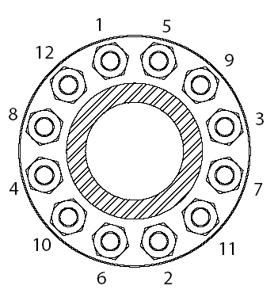

Tightening process
After flange assembly and all nuts have been run down by hand with joint in place, start wrench tightening following the sequence of the numbers indicated on the flange diagram above (marking the number on the flange with a crayon aids in keeping track of the tightening process).

During all of the following steps, keep any gap between flanges even all around the circumference, and nuts made up approximately the same amount on each end of the bolt.

- First time around just snug the nuts with a hand wrench.
- Second time around tighten the nuts firmly with the same wrench.

Use a torque wrench for the following steps:

- Third time around apply approximately 25% recommended torque**.
- Fourth time apply approximately 75% of recommended torque**.
- Fifth time around, apply 100% of recommended torque**.
- Continue tightening nuts all around until nuts do not move under 100% recommended torque**.

If possible, re-torque after completion of each transfer operation as most of the short term bolt preload loss occurs within 24 hours after initial tightening.

** The recommended torque value is dependent upon the gasket manufacturer's recommendation and for the gasket supplied is:

xxx | ft lbs / Nm

Appendix E – Example STS Mooring Equipment Map (Compatibility Data Sheet and Guidelines for data entry)

STS Plan Mooring Map - Guidelines for data entry

1 Introduction

The STS Plan Mooring Map has been developed as a tool to facilitate pre-operational verification regarding the compatibility of two vessels scheduled to conduct an STS operation.

In order to determine such compatibility the STS Plan Mooring Map captures key dimensional and mooring equipment related data for the named vessel. This enables concerned parties to compare the data captured for both vessels that are scheduled to conduct n STS operation to verify their compatibility to do so.

  - Applicability

The STS Mooring Map has been developed for tanker owners and operators and STS Resource Providers who have a vested interest in ensuring the operational integrity and safety of STS Operations conducted utilising their assets and/or for which they have accountability.

- Scope

The STS Mooring Map is an element of the STS Plan developed in accordance with the standards describes in MARPOL Annex I, as amended by Resolution MEPC. 186(59), Chapter 8: Prevention of Pollution during Transfer of Oil Cargo between OIL tankers at Sea, Regulations 40, 41, 42.

- General Guidelines

The data entry fields in both the particulars and map sheets are unprotected and have been configured to reproduce text in blue. Heading and formulated fields are protected and have been configured to reproduce data in black text.

  - Particulars Sheet

The data in the 'Particulars' sheet of the STS Plan Mooring Map can be found in the SIRE Vessel's Particulars Questionnaire. Primarily such data is of a dimensional nature and is self explanatory by virtue of their individual heading descriptions.

  - Map Sheet

The data in the 'Map' sheet of the STS Plan Mooring Map should be taken from the vessel's Mooring Arrangement Plans. The conventions for location mooring equipment items are as follows:
Longitudinal co-ordinates Measured from the aftermost extremity of the ship's structure towards the vessel's bow. Transverse co-ordinates Measured from the Vessel's Centreline towards the ship's side referred to in the specific table heading, or in the case of the 'Structural Appendages' table, as per the description.
Vertical co-ordinates Measured from the Vessel's Keel upwards.

The Table Headings are as follows:
(i) Port Fairleads
(ii) Starboard Fairleads
(iii) Port Bollards
(iv) Starboard Bollards
(v) Structural Appendages

Details that should be included in the Structural Appendages table are items that overhang or are vertically above or proximate to the vertical taken from the vessel's sheer strake at the specific location in question. Examples of these may include bridge wings, lifeboats and aft stores crane gantries.

4 Descriptions for fairleads and bollards 4.1 Fairleads

The dimensions for each type of fairlead can be determined as follows:
Panama Chock & Closed Chock
Size in mm taken from W1 x W2 as per the diagram below:

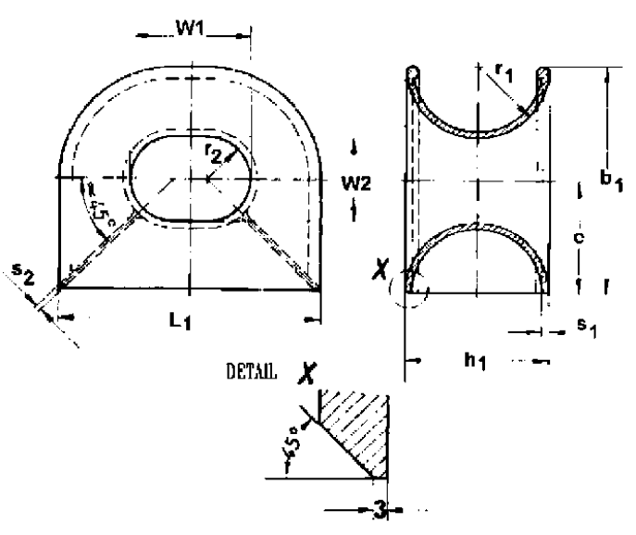

Enclosed or Universal Roller Fairlead

Size in mm taken from W x H as per the diagram below:

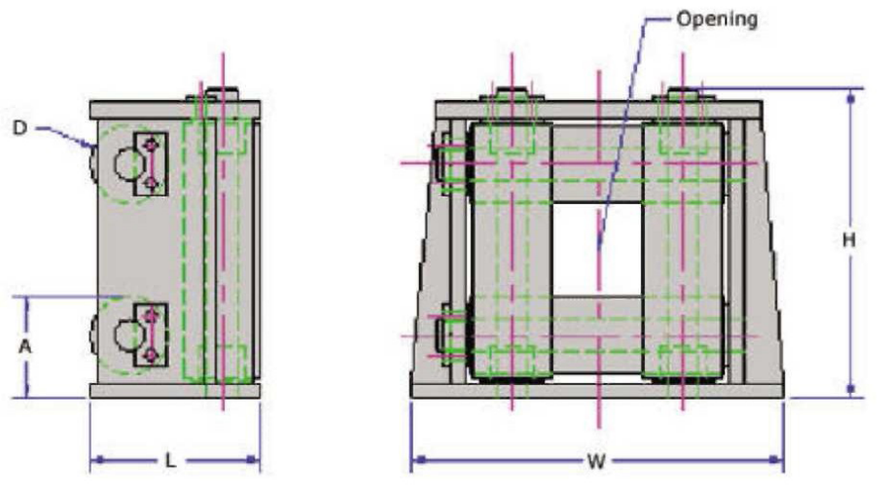

STS Plan Mooring Map - Guidelines for data entry

Open Roller Fairleads

Size in mm taken from W1 x W2 as per the image below:

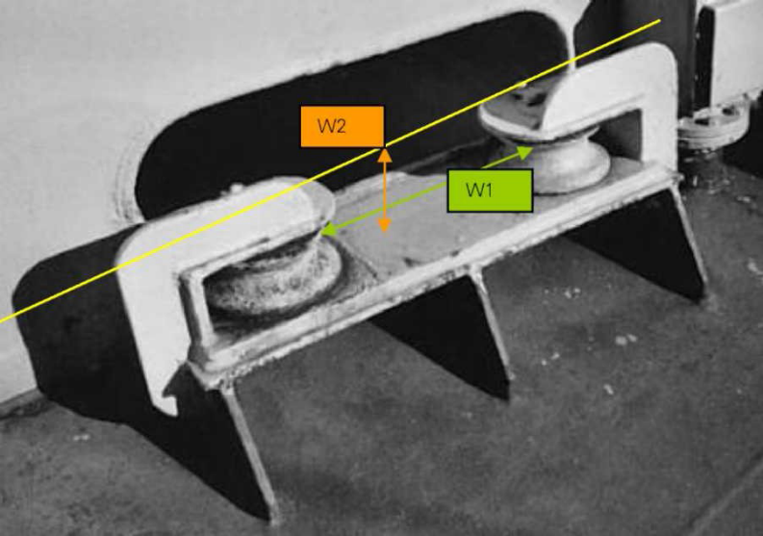

Open Chock

Size in mm taken from W1 x W2 as per the image below:

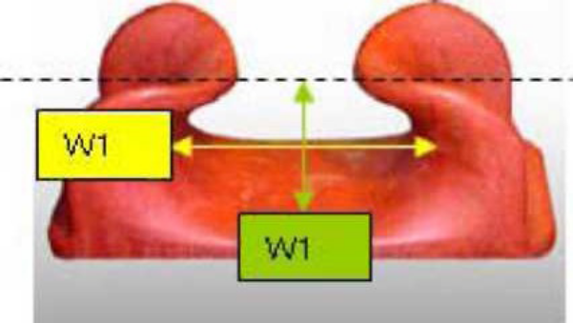

Fairlead Numbering system

Whilst there is no fixed system for numbering the fairleads, naming each fairlead with its own unique alphanumeric identity assists the user to avoid any ambiguity. Furthermore it assists in the determination of the optimum pairing of bollards with their most appropriate fairleads for the purpose of effective mooring.

For example, prefix the bollards on the Port Side with the letter P and number them from aft to forward. Similarly, fairleads on the starboard side could be prefixed with the letter S and numbered aft to forward. For fairleads on the Centreline, these could be prefixed by C/L numbered aft to forward.

  - Bitts and Bollards

Data entry for the Bollard Type is facilitated by selection of the appropriate Bollard description fro m a drop down box. An example is shown hereunder:

Bollard dimensions

Bollard size (mm) refers to the diameter of the bollard or bitt pins. Bollard Types are as follows:

Double Bollards

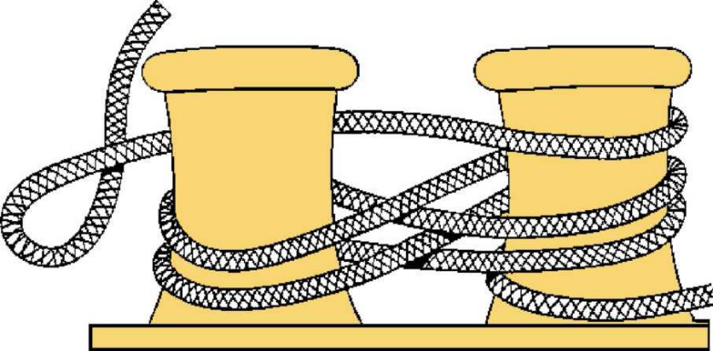

Single Cruciform Bollard

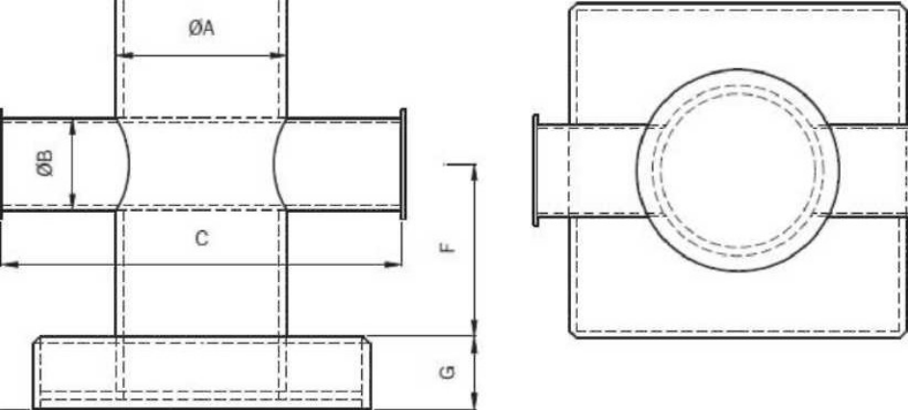

Single Cruciform Bollard

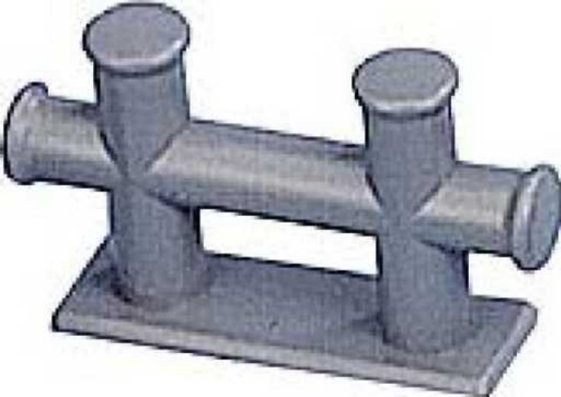

Bollard Numbering system

Whilst there is no fixed system for numbering the bollards, naming each one with its own unique phanumeric identity assists the user assists the user to avoid any ambiguity.

For example, prefix the bollards on the Port Side with the letter P and alphabetically order them from aft to forward with lower case lettering. Similarly, bollards on the starboard side could be prefixed with the letter S and alphabetically ordered using lower case letters.

For bollards on the Centreline, these could be prefixed by C/L and alphabetically ordered using lower case letters.

In order to identify optimum pairing between bollards and fairleads a data entry field is available for recording the identity number of the nearest fairlead for each set of bollards or bitts. A further data entry field is available for capturing the distance form each set of bollard or bitts to its nearest fairlead.

Note 1: The Example is applicable to ships constructed on or after January 1, 2007, as described in SOLAS II-1 / 3-8.
Owners/operators/managers should be guided by the approved mooring arrangement plan onboard (also to be included in this Manual).

Note 2: For ships constructed before January 1, 2007, having Mooring Plans onboard which may not have been approved by a classification society; it is the owner s/operator s/manager s responsibility to provide correct data when using the STS Compatibility Data Sheet. Verification of strength and loading of shipboard mooring fittings and supports would be the Owners/Master s responsibility.

Appendix F – Coastal states contact (MSC-MEPC.6/Circ.X)

(Circular is published each year in December)
Appendix G – Glossary of terms

(As applicable from ICS/OCIMF STS Guide Petroleum and Manual on Oil Pollution Section I- Prevention)

12 GLOSSARY
- AT SEA
The term “at sea” is used throughout this plan. It is intended to indicate Offshore waters or partially sheltered waters. It may be, however, that an STS transfer operation at sea is to be conducted within the jurisdiction of a local (port) authority or national government. In such cases reference has to be made to local regulations and it may also be necessary to obtain local approval.

- BALLAST
The term “ballast” covers water ballast carried in ship’s tanks.

- CLOSED OPERATIONS
Ballasting, loading or discharging operations carried out without recourse to opening ullage and sighting ports. In these cases ships will require the means to enable closed monitoring of tank contents, either by a fixed gauging system or by using portable equipment passed through a vapour lock.

- CONSTANT HEADING SHIP
During maneuvring and mooring, the ship that maintains course and Speed to allow the manoeuvring and mooring ship to approach and moor is referred to as the constant heading ship.

- DEDICATED LIGHTERING SHIP
A dedicated lightering ship is a ship designated to perform multiple STS operations. These ships are usually fitted with adequate primary and secondary fenders, which upon completion of an STS transfer are capable of being lifted and stowed in onboard cradles. They are usually fitted with their own hoses and are generally capable of performing STS operations without external assistance such as work boat or a support craft.

- DISCHARGING SHIP
The ship containing cargo to transfer to the receiving ship and which may be also known as the Ship to be Lightened (STBL)

- DISPLACEMENT
Ship’s total weight including all cargo, ballast, fuel, water, stores, and Light ship weight may be found for any draught from ship’s tables.

- MANOEUVRING SHIP
During manoeuvring and mooring, the ship that approaches the constant Heading ship for mooring operations is referred to as the manoeuvring ship.

- ORGANISERS
Organisers are shore based operators responsible for arranging an STS transfer operation. The organizer may be the STS Service provider.
- PERSON IN OVERALL ADVISORY CONTROL
The person agreed to be in overall control of an STS operation. It may be one of the Masters (generally the Master of the manoeuvring ship) or it may be the STS superintendent/ Mooring Master.

- PRIMARY FENDERS
Primary fenders are large fenders capable of absorbing the impact energy of berthing and wide enough to prevent contact between the ships should they roll while alongside one another.

- RECEIVING SHIP
The ship to which cargo is transferred from the discharging ship. The receiving ship may also be known as the lightering ship or service ship (SV).

- SECONDARY FENDERS
Secondary fenders are fenders used to prevent contact between the two ships, should they be rolling or not parallel to each other. They are especially effective when rigged towards the ends of a ship and are of most benefit during mooring and unmooring operations.

- SHIP
Throughout this plan the word ship refers to an oil tanker.

- SHIP OWNER
Includes an owner, manager or operator having day to day commercial and / or operational control of the ship.

- SHIP TO SHIP (STS) TRANSFER OPERATIONS
A STS transfer operation is an operation where crude oil or petroleum products are transferred between seagoing ships moored alongside each other. Such operations may take place when one ship is at anchor or when both are underway. In general, the expression includes the approach manoeuvre, berthing, mooring, hose connecting, safe procedures for cargo transfer, hose disconnecting, unmooring and departure manoeuvre.

- STS SERVICE PROVIDER
A STS Service provider is a company or organization that specializes in providing services for the safe control of STS operations. The service provider may also supply the essential personnel and equipment needed such as hoses, fenders and support craft.

- MOORING MASTER
A person who may be designated to assist a ship’s Master in the mooring and unmooring of the ships, and to co-ordinate and supervise the entire Ship-to-ship transfer operation. He may also be known as the Lightering Master or STS Superintendent.

- SWL
SWL or safe working load is the operating limit to which equipment is tested for day-to-day use. Equipment should never be used beyond its SWL.

- TRANSFER AREA
A transfer area is an area within which a STS transfer operation takes place. Transfer areas should be selected in safe sea areas. In coastal areas they will be agreed with nearby coastal authorities and, as appropriate, in accordance with specific port or National regulations.

- TRANSFER AT ANCHOR
The expression “transfer at anchor” describes an operation where a cargo transfer is carried out between ships when they are moored alongside each other and one of the ships is at anchor. The operation is an alternative to Underway transfer.

- UNDERWAY
By definition under the International Regulations for preventing Collisions at sea (COLREGS) a ship underway is not at anchor, made fast to the shore or aground. However, she may be either steaming or drifting freely with current and weather.

- REVERSE LIGHTERING
A lightering operation in which a loaded service vessel transfers cargo to part loaded ship to be lightered.

- WORKBOAT
Vessel which provides fenders, hose, reducers, and other equipment. Needed for lightering operation.

- MAXIMUM ALLOWABLE WORKING PRESSURE (MAWP)
This is a common oil industry reference that defines the maximum cargo system pressure capabilities. This pressure rating is not expected to account for dynamic surge pressures but does include nominal pressure variations as expected during cargo transfer operations.

- VAPOUR BALANCING
Vapour balancing means the transfer of vapor displaced by incoming cargo from the tank of a vessel receiving cargo into a tank of the vessel delivering the cargo via a vapor collection system.

- VESSEL VAPOUR CONNECTION
Vessel vapour connection means the point in a vessel's fixed vapor collection system where it connects with the vapor collection hose or arm.

Appendix H Reference to STS GUIDE

5.10 Ship To Ship Transfer

5.10.1 General principles

5.10.2 Establish Person in Overall Charge of the Sts Operation

5.10.3 Compatibility of Design of Ships Involved

5.10.4 Communications

5.10.5 Lights and Shapes

5.10.6 Manoeuvring Alongside With Two Ships under Power

5.10.7 Maneuvering With One Ship at Anchor

5.10.8 Hose Handling and Cargo Transfer Operations

5.10.9 Unmooring

  - Ship To Ship Transfer

5.10.1 General principles
The STS transfer of chemical cargoes is becoming common practice. Experience gained from these regular operations has proven that STS transfers are safe, given compliance with proper procedures, suitable weather and sea conditions. This procedure is intended to familiarize Masters and ship operators with the general principles involved. In certain port areas it will be found that local regulations apply. These local regulations should be followed and where appropriate the recommendations made in this procedure can be used as additional advice.
The basic safety requirements for a transfer operation are similar to those for a normal cargo operation as contained in the latest edition of ISGOTT.

5.10.2 Establish Person in Overall Charge of the Sts Operation
The overall control of an STS operation should be vested in the hands of one individual and will be either one of the Masters concerned, or an STS Superintendent.
If both Masters are unfamiliar with, or inexperienced in STS transfer operations then an STS superintendent to be employed to assist ship’s masters in mooring and unmooring of the ships, and to co-ordinate and supervise the entire ship-to-ship operation. There are specialized STS agencies providing such services on an international basis.
Master of the ship supposed to be involved in STS transfer operation has to inform immediately this office in order to arrange necessary assistance.
For all STS transfer operation Master remain responsible for the safety of his own ship, its crew, cargo and equipment and should not permit safety to be prejudiced by the actions of others. If another ship fails to observe any of the safety requirements during the STS transfer operation, this should be brought to the attention of the Master of the ship and operation should be suspended until the situation is rectified.

5.10.3 Compatibility of Design of Ships Involved
Master of the ship involved in STS transfer operation should ensure that the ships to be used are compatible in design and equipment and that mooring operation, hose handling and communications can be conducted safely and efficiently. The initial information will be supplied to the organizers by the Master as per Check List 1 (ICS / OCIMF SHIP TO SHIP TRANSFER GUIDE).
Additionally to Check List 1, the following should be determined prior to mooring:
- Whether approval from local authorities have been received
- The size and number of manifolds to be used
- Whether the cargo cranes or derricks are in satisfactory condition
- Whose hoses will be in use and last pressure test of the hoses
- Which ship (mother-ship or daughter-ship) has Yokohama fenders

5.10.4 Communications
Good communication between the ships is an essential requirement for successful transfer operations. A common language for communication should be agreed before operations commence. If a serious language problem be detected, then action should be taken to resolve this by transferring an experienced person from one ship to the other before operations begin.
The ships should establish initial communication as early as practicable to plan operations and to confirm the transfer area.
As the ships come into the transfer area, contact should be established on the appropriate VHF channel at the earliest opportunity, thereafter switching to a mutually agreed working channel. Approach, mooring and unmooring should not be attempted until proper effective communication has been confirmed between two ships. At this time, in accordance with the information exchanged, Check List 2 and 3 should be satisfactory completed.
If communication breakdown occurs during an approach maneuver, if appropriate and safe, the maneuver should be aborted and the subsequent actions taken by each ship should be indicated by the appropriate sound signals as prescribed in the IRPCS (colreg).
During cargo transfer operation, essential personnel on both ships should have a reliable, common means of communication at all times, including a backup system. Spare radios and batteries to be available on board.
The emergency signal should be agreed between both ships and this should be a series of short and rapid blasts on the ship whistle. It should be sounded by either ship in an emergency or in case of communication breakdown during cargo operations.
In general, operations should not be resumed until satisfactory communications have been re-established.
5.10.5 Lights and Shapes
The lights and shapes to be shown, and the sound signal made, during STS transfer operations required by the International Regulations for Preventing Collisions at Sea.

5.10.6 Manoeuvring Alongside With Two Ships under Power
One ship, normally the lager, maintains steerageway at slow speed on a constant heading. Normally the maneuver should be made with the wind and sea ahead, however local conditions and knowledge may dictate an alternative heading. It is recommended that the maneuvering ship approaches and berths with her port side to the starboard side of the constant heading ship. The Master should always be prepared to abort berthing operations if necessary. The decision should be taken in ample time while the situation is still under control.
A common method of berthing is for the maneuvering ship to approach the constant heading ship from the quarter on the side of berthing. On closer approach she should parallel the course of the constant heading ship, about 50 to100 meters off. The maneuvering ship should then position it relative to the constant heading ship. Contact is made by the maneuvering ship reducing the distance by appropriate rudder and engine movements until fenders touch.
The two ships should preferably make parallel contact at the same speed with no astern engine movements being necessary.
The effects of ship interaction should be anticipated when maneuvering at close quarters.
On completion of mooring, the constant heading ship will power all future maneuvers and, if a transfer at anchor is planned, will proceed to the agreed anchoring position. During this time the former maneuvering ship will have its engines stopped and rudder amidships. For this period the constant heading ship should not use strong astern engine movements.
Depends upon ships size and weather condition it should be decided whether only constant heading ship will anchor or both ship. The constant heading ship should use the anchor on the side opposite that on witch the other ship is moored.
Once at anchor, each ship is responsible for keeping its own anchor watch.
5.10.7 Maneuvering With One Ship at Anchor
This maneuver can be preferred for more constrained transfer area, especially when tug assistance is available.
A berthing operation should only be carried out after the anchoring ship is brought-up to her anchor and is lying on a steady heading with reference to prevailing current and wind conditions.
A careful watch should be kept on the heading of the anchored ship and the maneuvering ship should be advised immediately by the anchored ship if she has any tendency to yaw. Where there is a tendency to yaw is excessively, a tug should be employed to hold the anchored ship on a steady heading. If no tug is available, postponement of the operation should be considered.
The maneuvering ship approach and berth with her port side to the starboard side of the other ship. When approaching the ship at anchor the wider angle of approach than that adopted for maneuvers underway is recommended. A wider angle of approach helps to avoid early ship to ship contact in cases where the anchored ship might yaw unexpectedly.
When mooring to an anchored vessel care should be taken not to pull the anchored vessel quickly towards the mooring vessel.
5.10.8 Hose Handling and Cargo Transfer Operations
When two ships are securely moored the pre-transfer Check List 4 should be satisfactory completed. In addition, Ship/Shore Safety Check List to be completed as well.
Cargo transfer operations should be carried with the requirements of the receiving ship.
The cargo transfer operation should be planned and agreed in written between the two vessels and should include information on the following where applicable:
- quantity of each grade of cargo
- sequence of grade
- cargo density and temperature
- number of pumps, maximum pressure
- cargo heating requirements
- initial, maximum and topping off rate
- notice of rate change and transfer shut down procedures
- emergency and spill containment procedures
- watch or shift arrangements
- critical stage of the operation
The agreed transfer rate should not exceed the manufacturers recommended flow rate for the cargo hoses.
Throughout cargo transfer operations, the both ships should station a responsible person at the cargo manifold area to observe the hoses and to check for leaks. A responsible person equipped with portable radio should be stationed at or near the cargo pump controls on the discharging ship to take action as required.
Cargo transfer should begin at agreed slow rate to enable the receiving ship to check that the cargo pipelines system is correct set.
It should be noted that the incorrect operations of pumps and valves can produce pressure surges in a pipeline system. Consideration should be given to the prevention of pressure surges by careful planning and control of pump speeds and the operation of valves.
During cargo transfer, appropriate ballast operations should be performed in order to minimize change in freeboard, and avoid excessive trim by the stern.
Throughout the transfer, regular hourly transfer rate checks and comparisons should be made between the two vessels, and the results logged.
The transfer rate should be reduced to an agreed topping off rate when the receiving ship’s tanks are reaching their feeling limit.
After completion of cargo transfer the following operations should be carried out:
- All hoses drained into one ship prior to disconnecting
- Hoses disconnected, taking precautions to ensure that no liquid is left in the cargo transfer system
- Cargo manifolds and cargo hoses securely blanked
- Authorities informed of completion of cargo transfer and anticipated time of unmooring

5.10.9 Unmooring
Check list 5 to be completed before unmooring.
Unmooring can be achieved by singling up fore and aft, then letting go the remaining forward mooring and allowing the bow to swing away from the constant heading ship to the suitable angle, at which time the remaining stern mooring line is let to go and the maneuvering ship moves clear. After disengaging, neither ship should attempt to steam ahead nor fall astern of the other until both ships are well separated.
It should be noted that local conditions or vessel configuration may cause difficulties in separating the two ships and other alternative plans should be considered.

IMO’s” Manual on Oil Pollution, Section I, Prevention” as amended, and ICS and OCIMF “Ship to Ship Transfer Guide, Petroleum”, fourth edition, 2005.

