Project Documentation

# Project Title

Store Manager: Keep track of inventory

# 1. Introduction

• Project Title: Store Manager : Keep track of inventory

• Team ID: NM2025TMID45853

• Team Leader: DHEENASRI P

• Team Members:

JANANI SRI S

JENIFAR MARIARANI J

KIRUBA S

# 2. Project Overview

• Purpose: The Store Manager system helps businesses efficiently keep track of inventory, monitor stock levels, and streamline product management.

• Features:

– Inventory tracking and stock management

– Add, update, and delete product details

– Low-stock alerts and notifications

– Search and filter inventory items

– Generate inventory reports

– User-friendly dashboard with role-based access

# 3. Architecture

• Frontend: React.js with Bootstrap/Material UI for responsive UI

• Backend: Node.js and Express.js managing server logic and APIs

• Database: MongoDB storing inventory details, user data, and logs

# 4. Setup Instructions

• Prerequisites:

– Node.js

– MongoDB

– Git

– React.js

– Express.js

– Visual Studio Code

• Installation Steps:

– Clone the repository: git clone <repo_url>

– Install client dependencies: cd client && npm install

– Install server dependencies: cd ../server && npm install

# 5. Folder Structure

Store-Manager/

|-- client/ # React frontend

| |-- components/

| |-- pages/

|-- server/ # Node.js backend

| |-- routes/

| |-- models/

| |-- controllers/

# 6. Running the Application

• Frontend: cd client && npm start

• Backend: cd server && npm start

• Access: Visit http://localhost:3000

# 7. API Documentation

• Products: /api/products/create, /api/products/:id

• Inventory: /api/inventory/update, /api/inventory/:id

• Reports: /api/reports/generate

• Users: /api/user/register, /api/user/login

# 8. Authentication

• JWT-based authentication for secure login

• Middleware to protect private routes

# 9. User Interface

– Dashboard with inventory overview

– Product management page

– Reports generation page

– Admin panel with user roles

# 10. Testing

• Manual testing during development milestones

• Tools: Postman, Chrome Dev Tools

# 11. Screenshots or Demo

Below are realistic placeholder screenshots representing the application:

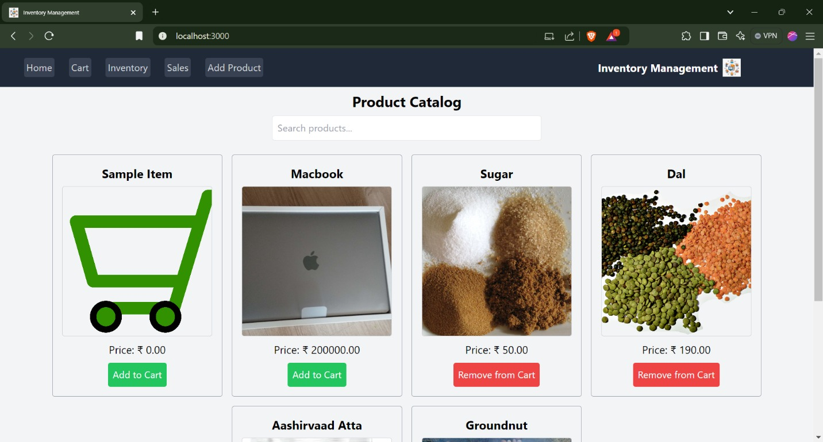

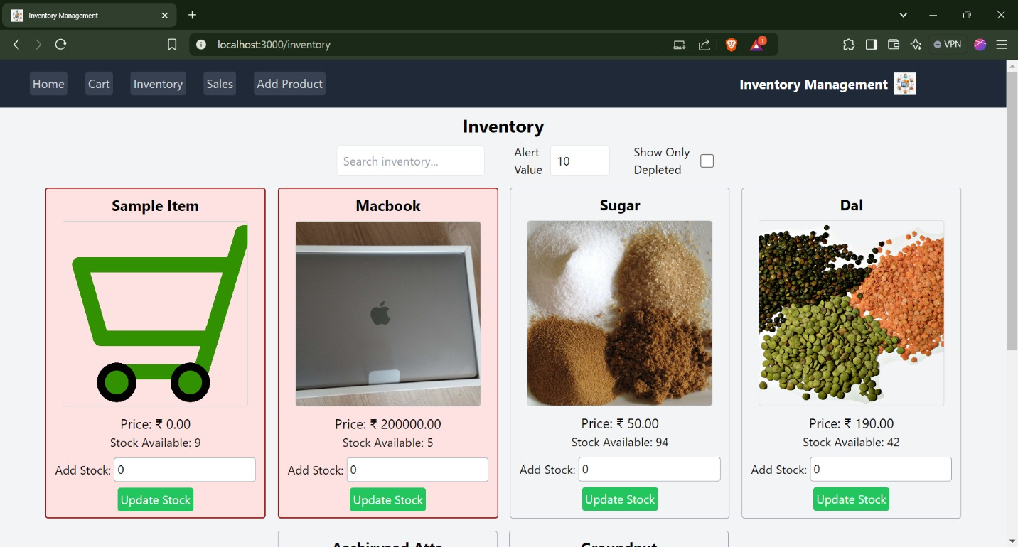

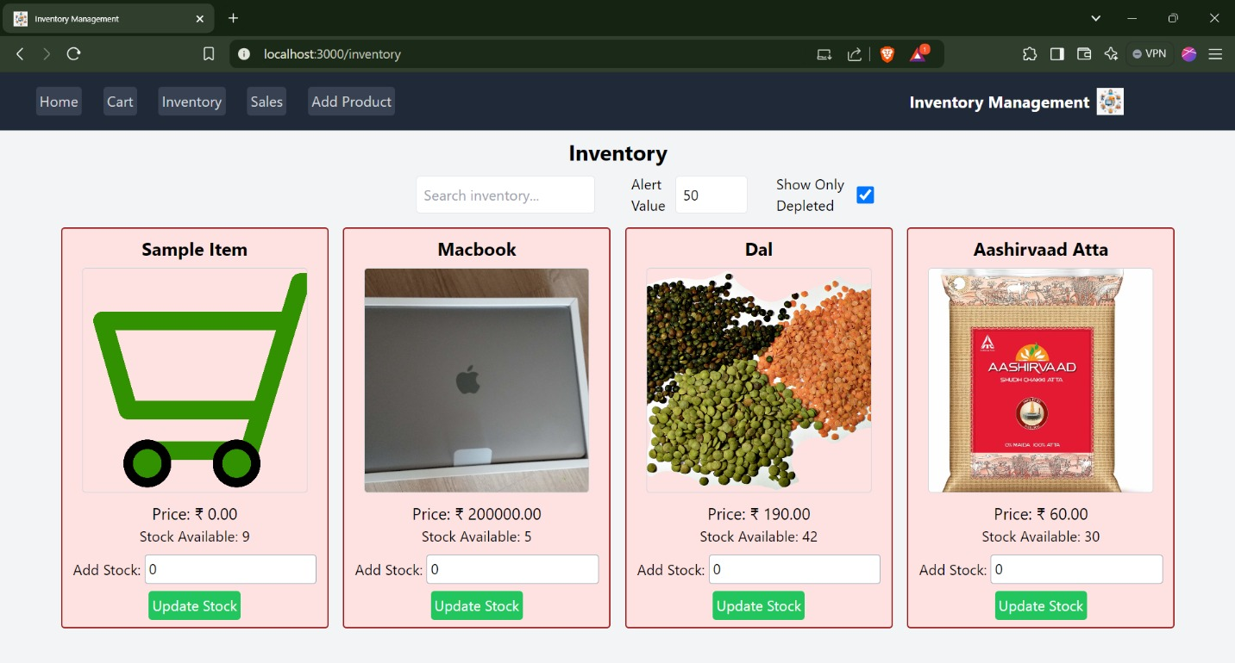

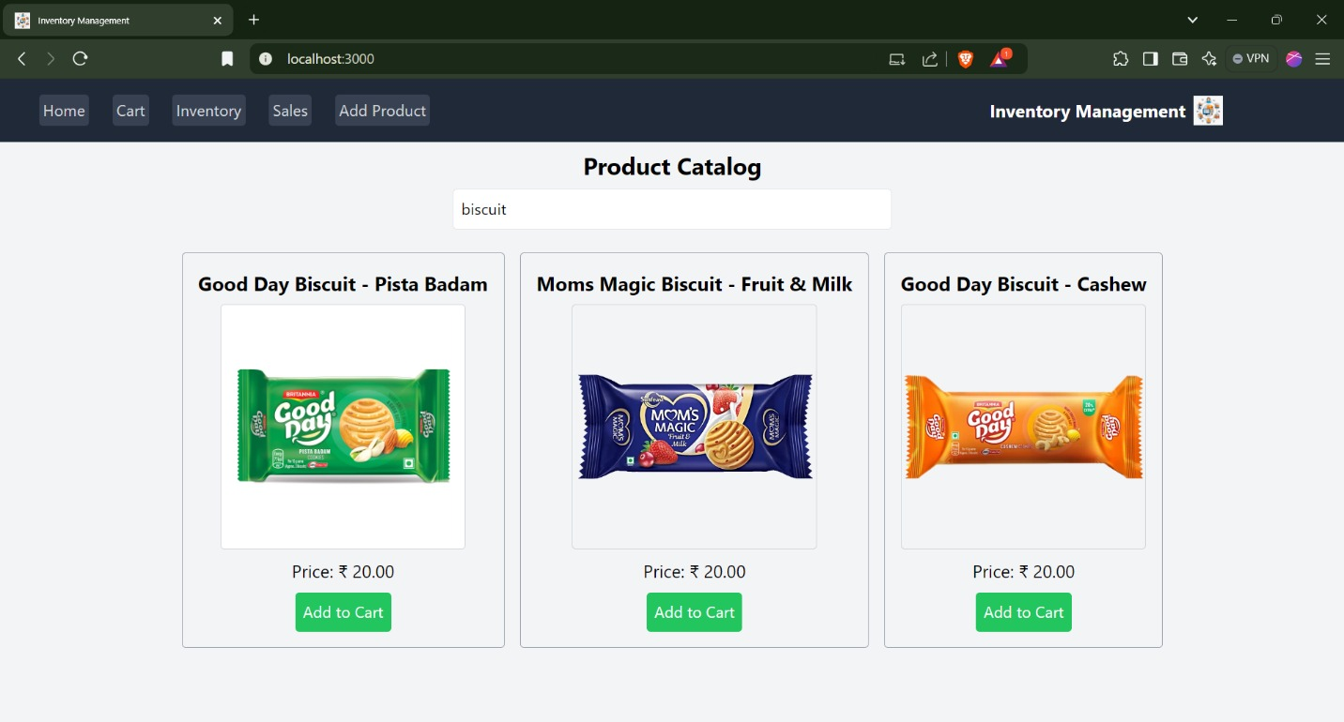

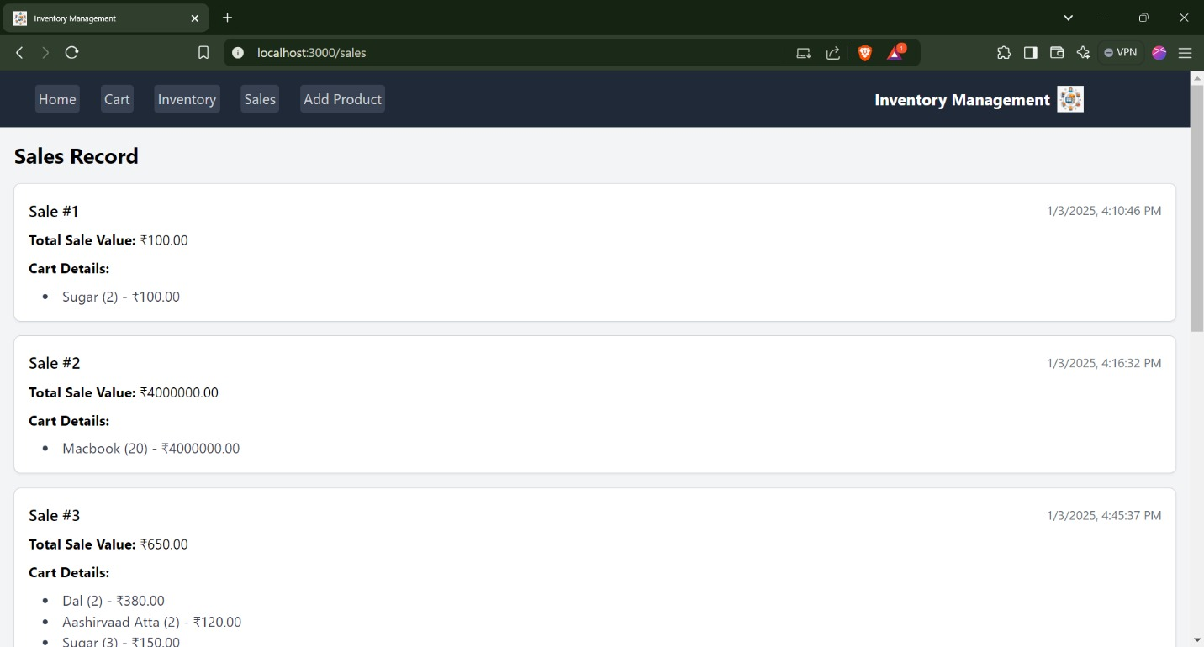

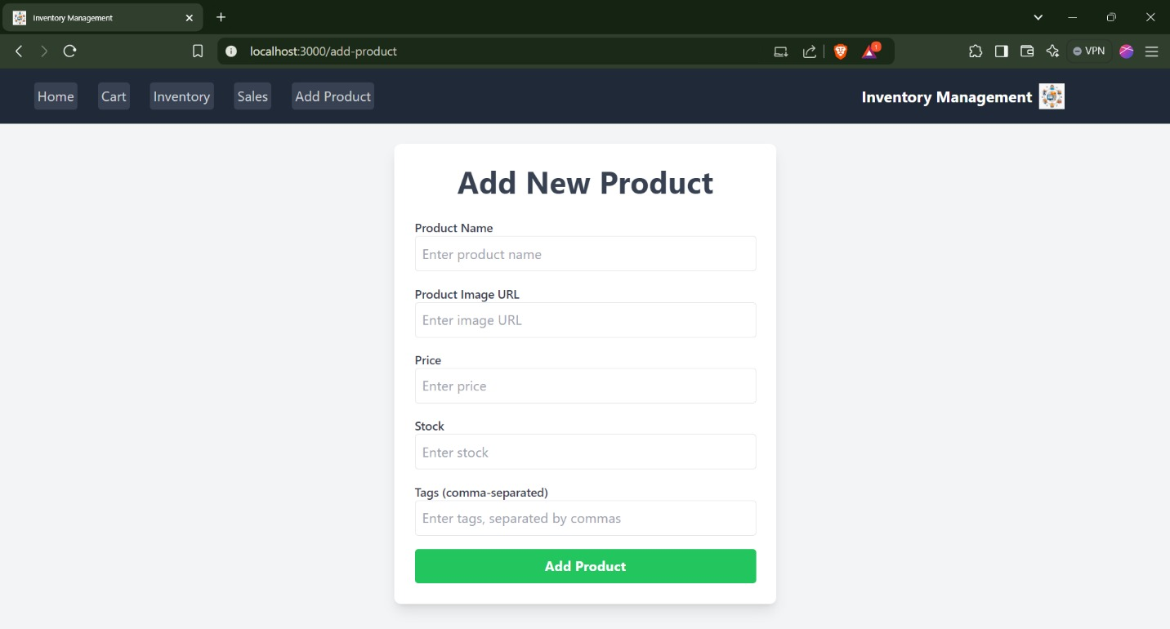

Add Product Form Page - Sample Placeholder

# 12. Known Issues

– Concurrent stock updates may cause inconsistent counts.

– Large exports may cause slow performance.

– Role permission issues in rare cases.

# 13. Future Enhancements

– Integration with barcode scanners

– Cloud backup and synchronization

– Advanced analytics and forecasting

– Mobile app support