
ATTENTION-HEAD SURGERY FOR BIAS IN CODE-MIXED TAMIL-ENGLISH TRANSFORMERS

ADA23DLU06 - RECENT TRENDS IN DEEP LEARNING
PROJECT REPORT

Submitted by
N S DHEEPAK SHAKTHI – E0323033

In partial fulfilment for the award of the degree of
BACHELOR OF TECHNOLOGY
in
COMPUTER SCIENCE AND ENGINEERING
(Artificial Intelligence and Data Analytics)
Sri Ramachandra Faculty of Engineering and Technology
Sri Ramachandra Institute of Higher Education and Research, Porur, Chennai -600116

October 2026

ATTENTION-HEAD SURGERY FOR BIAS IN CODE-MIXED TAMIL-ENGLISH TRANSFORMERS

ADA23DLU06 - RECENT TRENDS IN DEEP LEARNING
PROJECT REPORT

Submitted by
N S DHEEPAK SHAKTHI – E0323033

In partial fulfilment for the award of the degree of
BACHELOR OF TECHNOLOGY
in
COMPUTER SCIENCE AND ENGINEERING
(Artificial Intelligence and Data Analytics)
Sri Ramachandra Faculty of Engineering and Technology
Sri Ramachandra Institute of Higher Education and Research, Porur, Chennai -600116

October 2026

BONAFIDE CERTIFICATE

Certified that this project report “Attention-Head Surgery for Bias in Code-Mixed Tamil-English Transformers” is the Bonafide record of work done by “N S DHEEPAK SHAKTHI – E0323033” who carried out the work under my supervision.

Signature of the Supervisor Signature of External Examiner

Dr. V. Vanitha
Associate Professor,
Department of Computer Science and Engineering (AIML), Sri Ramachandra Faculty of Engineering and Technology,
SRIHER, Porur, Chennai-600 116.

Evaluation Date:
TABLE OF CONTENTS
CHAPTER NO. | TITLE | PAGE NO.
 | LIST OF FIGURES | 5
 | LIST OF TABLES | 6
 | ABSTRACT | 7
1 | INTRODUCTION | 8
 | 1.1 Problem Statement | 8
 | 1.2 Objectives | 9
 | 1.3 Novelty and Contributions | 9
 | 1.4 Hypothesis Under Test | 9
 | 1.5 Limitations | 10
2 | LITERATURE REVIEW | 11
3 | METHODOLOGY | 13
 | 3.1 System Overview | 13
 | 3.2 Datasets and Preparation | 13
 | 3.3 India-Specific Proxy Lexicon | 14
 | 3.4 Counterfactual Augmentation Protocol | 15
 | 3.5 Model and Head Gates | 15
 | 3.6 Causal Mediation Analysis | 16
 | 3.7 Head Surgery | 16
 | 3.8 Adversarial Debiasing Baseline | 17
 | 3.9 Cost Accounting | 17
 | 3.10 Evaluation Metrics and Verdict | 17
 | 3.11 Experimental Setup | 18
4 | EXPERIMENTAL RESULTS | 19
 | 4.1 Verdict | 19
 | 4.2 Fairness | 19
 | 4.3 Cost | 21
 | 4.4 Task Quality | 22
 | 4.5 Localisation of Bias to Attention Heads | 23
 | 4.6 What the Surgery Removed | 25
 | 4.7 Proxy Leakage Probe | 26
 | 4.8 Training and Mediator Checks | 27
 | 4.9 Discussion | 28
5 | CONCLUSION AND FUTURE WORK | 30
 | 5.1 Conclusion | 30
 | 5.2 Future Work | 30
6 | REFERENCES | 31
7 | APPENDICES | 33
LIST OF FIGURES
FIG. NO. | FIGURE NAME | PAGE NO.
3.1 | End-to-end H5 pipeline | 13
3.2 | (a) Head gates inside a self-attention layer | 16
4.1 | Fairness gain over the baseline with 95 % paired bootstrap CIs | 20
4.2 | CF gap per proxy category for natural and template pairs, with 95 % bootstrap CIs | 21
4.3 | Compute per method on a linear scale, with surgery split into phases and the 5 % and 10 % lines | 22
4.4 | Macro-F1 per method on the DravidianCodeMix test set and the leakage-filtered HASOC set, with the baseline − 0 | 23
4.5 | Share of the total effect mediated by each of the 144 heads | 23
4.6 | The same analysis with Vig et al | 24
4.7 | Summed share of TE carried by the eight selected heads compared with 5,000 random eight-head sets, per category | 24
4.8 | Dev CF gap and macro-F1 as heads are ablated in rank order | 25
4.9 | Learned gate | 26
4.10 | Leakage probe accuracy per proxy category against chance | 27
4.11 | Dev macro-F1 and training loss per epoch for the baseline and adversarial runs | 27
4.12 | Per-head share of TE under the head_output and attention mediators | 28
LIST OF TABLES
TABLE NO. | TABLE NAME | PAGE NO.
1.1 | The H5 claim split into testable checks | 10
3.1 | Pipeline stages | 13
3.2 | Dataset statistics after cleaning and leakage filtering | 14
3.3 | Proxy categories in the seed lexicon | 14
3.4 | Counterfactual pairs in the test split | 15
3.5 | Hyper-parameters of the full run | 18
4.1 | Automatic verdict from comparison.json | 19
4.2 | Bias metrics on the test split | 19
4.3 | CF gap per proxy category (test) | 20
4.4 | Metered compute | 21
4.5 | Task metrics | 22
4.6 | Heads modified by surgery (from surgery_report.json) | 25
4.7 | Linear-probe accuracy for the proxy group from [CLS] | 26
4.8 | Claim-by-claim assessment | 28
ABSTRACT
Fairness research in natural language processing is almost entirely English and is built on American proxy variables such as race and gender. A large part of the Indian internet is written in code-mixed Tamil-English (Tanglish), where the bias vectors are different: caste-marked surnames, religious markers, region names, dialect (Madras Bashai, Kongu, Jaffna), script switching between Tamil and Roman letters, and transliteration style. No lexicon of these proxies exists and no debiasing method has been evaluated against them.
This project builds a provisional India-specific proxy-feature lexicon and a counterfactual augmentation protocol for Tamil-English, and uses the causal mediation analysis of Vig et al. (NeurIPS 2020) to localise the proxy effect to individual attention heads of an XLM-R base offensive-language classifier trained on DravidianCodeMix. Debiasing is done by "head surgery": eight of the 144 heads are selected by mediation and ablation, and only eight scalar gates are learned. Surgery is compared with full adversarial debiasing (gradient reversal) under the same data, model and cost meter.
On held-out test pairs, surgery reduced the counterfactual gap from 0.098 to 0.082 (−17 %), lowered group FPED and FNED on real comments, kept macro-F1 (0.781 vs 0.775 baseline) and cost 4.7 % of the adversarial FLOPs (1.5 % of wall-clock time). The eight selected heads carry about four times the proxy effect of random eight-head sets in every category, and the surgery report names each head, its proxy categories and the group swaps it mediates. The headline claim, that surgery recovers at least 80 % of the adversarial fairness gain, could not be confirmed: the adversarial model made the main counterfactual gap worse (0.103), so the recovery ratio is undefined; on the template metrics, where the adversary did help, surgery recovered 67–76 %. The named heads also turned out to be shared across proxy categories rather than category-specific. The work supports head surgery as a cheap, transparent and effective debiasing step for code-mixed Tamil-English, and shows that the adversarial reference needs stronger tuning before a recovery claim can be tested.
Keywords: causal mediation analysis, attention heads, debiasing, code-mixing, Tamil-English, offensive language, XLM-R, adversarial debiasing, counterfactual fairness.
CHAPTER 1
INTRODUCTION
Transformer classifiers are now used to moderate comments on YouTube, Instagram and other platforms in Indian languages. When such a model learns that a caste name, a deity or a particular way of spelling Tamil in Roman letters is correlated with the "offensive" label, comments by or about certain communities are flagged more often regardless of their content. This is the same kind of harm that has been studied for English (for example identity terms such as "gay" or "black" raising toxicity scores), but the identities, the words that signal them and the writing conventions are completely different in the Indian setting.
Most debiasing methods also act as a black box. Adversarial debiasing changes all encoder weights so that a discriminator cannot recover the protected attribute, but it does not say which part of the model was carrying the bias or what was taken out. For an auditor or a platform team, being able to point at the components that carry a bias, and to remove them cheaply, is as valuable as the fairness gain itself.
This project follows the causal mediation analysis of Vig et al. [1], which showed that gender bias in GPT-2 is concentrated in a small number of attention heads, and asks whether the same is true for India-specific proxies in a code-mixed Tamil-English classifier, and whether editing those heads is a practical alternative to full adversarial debiasing.
1.1 Problem Statement
Fairness research in NLP is almost entirely English and almost entirely built on American proxy variables. The Indian internet runs substantially on code-mixed Tamil-English, where the bias vectors are different ones: script switching, dialect such as Madras Bashai, Kongu or Jaffna Tamil, transliteration style, region-marked and caste-marked surnames, and religious marker tokens. No lexicon of these proxies exists, and no debiasing method has been evaluated against them. Standard adversarial debiasing would also remove bias without saying what it removed.
The problem addressed is therefore threefold: (i) define and measure India-specific proxy bias in a Tamil-English offensive-language classifier; (ii) find where in the transformer that bias is mediated; and (iii) remove it in a way that is cheap, preserves task quality and reports exactly what was changed.
1.2 Objectives
- To build a provisional proxy-feature lexicon for Tamil-English covering caste, religion, region, dialect, script and transliteration style, with aligned substitution rows in both scripts.
- To design a counterfactual augmentation protocol (natural pairs from real comments and controlled template pairs) that changes one proxy at a time while keeping the label.
- To fine-tune an XLM-R base offensive-language classifier on DravidianCodeMix and measure its counterfactual, template and group-level bias on held-out data.
- To localise the bias to individual attention heads with the total, natural indirect and natural direct effects of Vig et al. [1], using two mediator types.
- To debias the model by re-weighting only the selected heads ("head surgery") and to produce a report naming each head, its proxy categories and the group swaps it mediates.
- To compare surgery with full adversarial debiasing on fairness, task quality and metered compute, and to test the claim with pre-registered thresholds.
1.3 Novelty and Contributions
- Resource: the first India-specific proxy-feature lexicon and counterfactual protocol for Tamil-English code-mixing (released as a provisional seed with a native-speaker annotation round-trip).
- Localisation: bias towards these proxies localised to individual attention heads by causal mediation and ablation, rather than by attention visualisation.
- Method: targeted head re-weighting as a debiasing method that trains only k scalars and never touches encoder weights.
- Evaluation: an end-to-end, cost-metered comparison with adversarial debiasing, with explicit pass/fail thresholds for every part of the claim.
1.4 Hypothesis Under Test
The hypothesis (H5) is that head surgery recovers most of the fairness gain of full adversarial debiasing at roughly five per cent of its training cost, and, unlike adversarial debiasing, names what was taken out. It is split into five checks that are evaluated automatically on test data:
Table 1.1: The H5 claim split into testable checks
Check | Operationalisation | Threshold
Recovers most of the gain | recovery = G(surgery) / G(adversarial) on the CF gap | ≥ 80 %
Adversarial gain is positive | B(baseline) − B(adversarial) > 0 | > 0
About 5 % of the cost | approx. FLOPs(surgery) / FLOPs(adversarial) | ≤ 10 % (5 % × 2)
Task quality preserved | macro-F1 drop vs baseline | ≤ 0.02
Names what was removed | per-head surgery report is produced | non-empty

1.5 Limitations
- Lexicon validity: the proxy lexicon is a provisional seed compiled from public knowledge and the corpus; it has not yet been validated by native-speaker annotators, and the dialect rows are low-confidence.
- Counterfactual naturalness: lexical swaps and rule-based transliteration can produce unusual text; template pairs are controlled but synthetic and few in number.
- Single seed and single encoder: all results come from one run of XLM-R base (seed 42), so run-to-run spread is not measured.
- Hardware: the full run used a 4 GB GTX 1650, which forced frozen word embeddings and gradient checkpointing for every method (applied equally, so the comparison remains fair).
- Mediation assumptions: per-head NIE/NDE hold all other heads at their natural values; head interactions are handled only by the prefix-selection step.
CHAPTER 2
LITERATURE REVIEW
The project draws on five lines of work: fairness in NLP outside the Western context, causal mediation analysis, the analysis and pruning of attention heads, debiasing methods, and resources for code-mixed Dravidian languages.
Causal mediation analysis of bias (base paper)
Vig et al. [1] adapt Pearl's mediation framework [2] to neural language models. For a prompt such as "The nurse said that" they measure the total effect (TE) of changing the profession word on the ratio of p(she)/p(he), and decompose it into a natural indirect effect (NIE) that flows through a chosen mediator (a neuron or an attention head) and a natural direct effect (NDE) that bypasses it. Neuron interventions replace a neuron's activation with its value on the counterfactual input; attention interventions replace a head's attention weights. On WinoBias and Winogender they find that gender bias is sparse: it is concentrated in a small number of neurons and heads in the middle layers of GPT-2, and the effect grows with model size. This project keeps their TE/NIE/NDE definitions and both mediator types, replaces the pronoun ratio with the log-odds of the offensive class, and replaces professions with India-specific proxy groups. The main extension is to use the localisation for debiasing rather than only diagnosis.
Fairness in NLP beyond the Western context
Sambasivan et al. [3] argue that algorithmic fairness frameworks built around US categories do not transfer to India, where caste, religion, region and language are the relevant axes. Bhatt et al. [4] make the same case for NLP, describing India-specific axes of disparity and the lack of resources to measure them. For measurement, Dixon et al. [5] introduced template-based evaluation and the false-positive / false-negative equality differences (FPED/FNED) for toxicity classifiers, and Garg et al. [6] defined counterfactual token fairness: a classifier should give the same score when an identity token is swapped. Both are adopted here as the secondary and primary bias measures.
What attention heads do, and how many are needed
Clark et al. [7] showed that individual BERT heads specialise (attending to the previous token, to separators, or to syntactic dependants). Voita et al. [8] found that a few specialised heads do most of the work in machine translation and that the rest can be pruned with little loss, and Michel et al. [9] showed that many heads can be removed at test time without hurting accuracy. These results make head-level editing plausible as a low-cost intervention. Syed et al. [10] showed that attribution patching, a first-order gradient approximation to activation patching, ranks components almost as well as exact patching at a fraction of the cost; it is used here as the screening step.
Debiasing methods
Adversarial debiasing trains an encoder against a discriminator that predicts the protected attribute, using the gradient-reversal layer of Ganin et al. [11]; Zhang et al. [12] applied it to fairness in prediction. Elazar and Goldberg [13] showed that adversarial removal of demographic information from text representations is often incomplete: a post-hoc probe can still recover much of the attribute. Counterfactual data augmentation (CDA) [14] retrains on identity-swapped copies of the data, and iterative null-space projection (INLP) [15] removes linear directions that encode the attribute. All of these change the whole representation and none of them reports which component carried the bias.
Code-mixed Tamil-English resources and models
Chakravarthi et al. released TamilMixSentiment [16] and the larger DravidianCodeMix corpus [17] of YouTube comments with sentiment and offensive-language labels; the HASOC-DravidianCodeMix shared task [18] provides a second Tamil offensive-language set. XLM-R [19], a multilingual RoBERTa trained on 100 languages, is a strong encoder for these tasks and, like BERT [20], exposes per-head masks that make head-level interventions straightforward.
Research gap
No proxy lexicon or counterfactual protocol exists for Tamil-English, mediation analysis has not been applied to bias in code-mixed text, and head-level localisation has been used for diagnosis but not compared, at equal data and metered cost, with full adversarial debiasing. This project addresses those three gaps.
CHAPTER 3
METHODOLOGY
3.1 System Overview
The experiment is implemented as a staged Python package (h5) with one command per stage; every stage reads the previous stage's artefacts from the output directory so that runs can be resumed and audited. Figure 3.1 shows the pipeline.
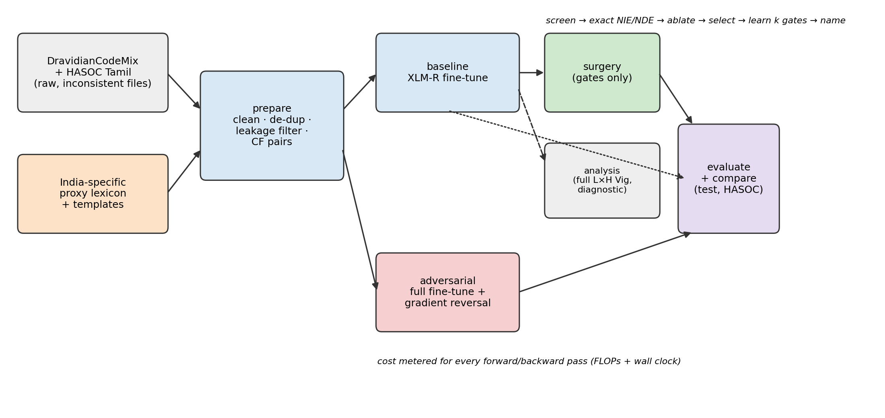
Figure 3.1: End-to-end H5 pipeline. Surgery starts from the trained baseline and learns only head gates; adversarial debiasing is a full fine-tune; the full L×H analysis is diagnostic only
Table 3.1: Pipeline stages
Stage | Purpose | Main outputs
prepare | parse, clean, de-duplicate, leakage-filter, tag proxies, build CF pairs | data/.jsonl, cf/_pairs.jsonl
baseline | fine-tune XLM-R base for offensive detection | baseline/model, cost.json
analysis | full Vig TE/NIE/NDE for all 144 heads, two mediators | mediation_tables.npz
surgery | screen → exact → ablate → select → learn gates → name | gates.pt, surgery_report.json
adversarial | full fine-tune with gradient-reversal adversaries | adversarial/model
evaluate | task, fairness and leakage metrics on test and HASOC | <method>/eval.json
compare | recovery, cost ratio, bootstrap CIs, verdict | comparison.json, REPORT.md

3.2 Datasets and Preparation
The primary task is binary offensive-language detection on the Tamil part of DravidianCodeMix [17]: Not_offensive maps to 0 and all five Offensive_* labels map to 1; not-Tamil rows are dropped. The HASOC Tamil validation set [18] is the second, out-of-distribution evaluation. The raw files are inconsistent (tab- and semicolon-separated lines, reversed columns), so the parser detects the separator and label position per line against the known label vocabulary. Training data is de-duplicated. The two datasets share YouTube comments, so every HASOC text whose normalised form occurs in the training set is removed: 6,037 of 6,969 HASOC texts were dropped, leaving 932 genuinely unseen comments.
Table 3.2: Dataset statistics after cleaning and leakage filtering
Split | Source | Comments | Offensive | Offensive %
train | DravidianCodeMix | 33,348 | 8,221 | 24.7
dev | DravidianCodeMix | 4,216 | 1,023 | 24.3
test | DravidianCodeMix | 4,232 | 1,042 | 24.6
hasoc_val | HASOC Tamil (val) | 932 | 210 | 22.5

3.3 India-Specific Proxy Lexicon
The lexicon (resources/proxy_lexicon.seed.json) lists only identity terms and contains no slurs. Each row aligns forms that fill the same slot in the same script, so a swap replaces a deity with a deity or a community name with a community name, and agglutinative suffixes are kept (Nadars → Iyers). Ambiguous forms are excluded and documented, for example pillai (also "child"), alla ("not") and siva (a common personal name). Script and transliteration style are rule-based: a Tamil-to-Roman transliterator produces the script twin, and a long-to-short respelling (vaazhthukkal → valtukkal) produces the style twin.
Table 3.3: Proxy categories in the seed lexicon
Category | Groups | Mechanism
caste | thevar, gounder, nadar, vanniyar, brahmin, dalit, chettiar, mudaliar | lexical (Roman and Tamil script)
religion | hindu, muslim, christian (deity, identity noun, place of worship) | lexical
region | chennai, madurai, kongu, nellai, jaffna | lexical
dialect | standard, Madras Bashai, Kongu, Jaffna (aligned word variants) | lexical, low confidence
script | Tamil script ↔ Roman | rule-based transliteration
translit_style | long phonetic ↔ short casual Roman spelling | rule-based respelling

The lexicon is marked provisional. The package includes an export of an annotation sheet with corpus counts and a majority-vote merge for two or three native annotators (slur flags veto an entry); once a validated lexicon exists every stage uses it automatically.
3.4 Counterfactual Augmentation Protocol
Natural pairs. For every real comment, the first matched proxy of each category is swapped to at most two other groups from the same lexicon row, so each pair differs in exactly one proxy and keeps its label. Mostly-Tamil-script comments also get a transliterated script twin and long-style Roman comments get a short-style twin. Template pairs. Neutral, non-offensive comments with an {X} slot are filled with every group of the matching row, in the style of Vig et al.'s templates. Templates are split round-robin within each (slot, script), so test templates are never seen by localisation, selection or gate training. Pairs are capped per category so that frequent categories such as script do not dominate.
Table 3.4: Counterfactual pairs in the test split
Category | Natural pairs | Template pairs | Total
caste | 236 | 84 | 320
religion | 32 | 18 | 50
region | 86 | 30 | 116
dialect | 205 | 12 | 217
script | 762 | 0 | 762
translit_style | 1500 | 0 | 1500
all | 2821 | 144 | 2965

In total 12,832 train, 2,958 dev, 2,965 test and 953 HASOC pairs were built. Data hygiene is strict: localisation uses train pairs, selection uses dev pairs and every reported number uses test pairs.
3.5 Model and Head Gates
The classifier is XLM-R base (12 layers × 12 heads, about 278 M parameters) with a linear head on the [CLS] representation, trained with class-weighted cross-entropy. Every head has a gate g ∈ [0, 1], stored as a 12 × 12 buffer and passed to the encoder as the Hugging Face head_mask, which multiplies the head's attention probabilities and therefore scales its contribution (Figure 3.2a). g = 1 leaves the model unchanged, g = 0 ablates the head and intermediate values re-weight it. Eager attention is forced because fused SDPA kernels ignore head_mask.
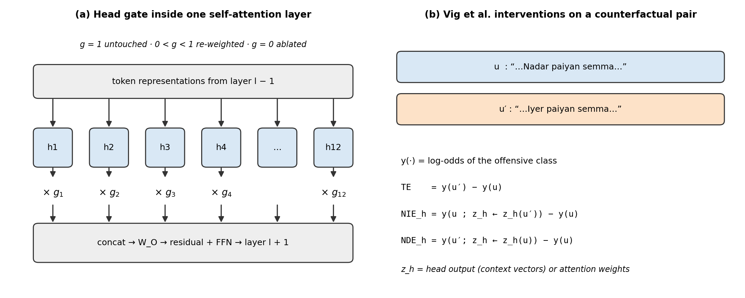
Figure 3.2: (a) Head gates inside a self-attention layer. (b) The three Vig et al. quantities computed for each counterfactual pair
3.6 Causal Mediation Analysis
For a counterfactual pair (u, u′) the effect measure y(·) is the log-odds of the offensive class, the additive analogue of Vig et al.'s p(anti)/p(stereo) ratio. For each head h with mediator value z_h:
TE = y(u′) − y(u)
NIE_h = y(u; z_h ← z_h(u′)) − y(u) NDE_h = y(u′; z_h ← z_h(u)) − y(u)
Two mediators are used: head_output, the head's context vectors (exactly what surgery scales), and attention, the head's attention weights (Vig et al.'s attention intervention). Because u and u′ tokenise to different lengths, mediator values are carried across with a monotone character alignment projected onto sub-word offsets, and attention maps are re-normalised after alignment. Effects are oriented by sign(TE) and summarised per category as the mean oriented NIE/NDE and the share of TE carried by each head; categories are normalised by their mean |TE| before being combined.
3.7 Head Surgery
1. Screen: attribution patching [10] gives a first-order NIE estimate for all 144 heads with one forward and backward pass per pair (64 train pairs per category).
2. Exact: exact Vig NIE and NDE are computed for the top 24 heads by batched interventions.
3. Ablate: each candidate is zero-ablated on dev pairs, recording the change in CF gap and macro-F1.
4. Select: heads are ranked by 0.5·z(NIE) + 0.5·z(ablation benefit); heads whose solo ablation hurts F1 or increases bias are dropped. Prefixes k = 1…10 are evaluated and the smallest set that reaches 90 % of the best bias reduction within a 0.01 F1 budget is kept.
5. Re-weight: only the k gates are optimised (150 Adam steps, learning rate 0.05) with the loss CE(task) + λ·(y(a) − y(b))² on train counterfactual pairs; encoder weights stay frozen.
6. Name what was removed: for every selected head the report lists its gate, primary proxy category, per-category NIE/NDE and share of TE, the dev ablation effect, the proxy-attention ratio (attention mass on proxy tokens relative to uniform; above 1 means the head reads the proxy word), its top mediated group swaps and example pairs.
3.8 Adversarial Debiasing Baseline
The reference method is a full fine-tune from the pretrained encoder with one MLP adversary (width 256) per proxy category. Each adversary predicts the proxy group from [CLS] through a gradient-reversal layer [11] with the DANN λ ramp; adversary batches (24 examples) are balanced across categories and groups. All training hyper-parameters are identical to the baseline so that the adversarial run is a fair "full debiasing" reference.
3.9 Cost Accounting
Every forward and backward pass of every method is metered, including dev evaluation inside training and all of surgery's localisation and selection passes. The primary, hardware-independent cost is approx_flops = 2·P·(forward tokens) + 4·P·(backward tokens), where P is the number of encoder parameters and only non-padding tokens are counted. CUDA-synchronised wall-clock time is also recorded per phase. The cost ratio is surgery / adversarial; the ratio including the optional full analysis stage is reported as well.
3.10 Evaluation Metrics and Verdict
- Task: accuracy, macro-F1 and offensive-class F1 on test and HASOC.
- Primary bias score B: the counterfactual (CF) gap, the mean |P(off|u) − P(off|u′)| over all test pairs (natural and template), with a 95 % paired bootstrap CI (1,000 resamples).
- Secondary bias scores: CF flip rate; template FPED (Σ_g |FPR_g − FPR|) and template range; group FPED/FNED across proxy groups in real test comments; and a linear leakage probe that predicts each proxy category from [CLS].
- Claim quantities: gain G(m) = B(baseline) − B(m), recovery = G(surgery)/G(adversarial) and the FLOP cost ratio, checked against the thresholds in Table 1.1.
3.11 Experimental Setup
Table 3.5: Hyper-parameters of the full run
Setting | Value
Encoder | xlm-roberta-base (12 × 12 heads)
GPU | NVIDIA GeForce GTX 1650 (4 GB), configs/gpu4gb.yaml
Max length / epochs / lr | 128 tokens / 3 / 2e-5, warm-up 6 %, weight decay 0.01
Batch | 8 × 4 gradient accumulation (effective 32), fp16
Memory settings | frozen word embeddings, gradient checkpointing (all methods)
Surgery | head_output mediator, top-24 exact, k_max 10, F1 budget 0.01, 150 gate steps
Adversarial | λ = 1.0 (DANN ramp), adversary weight 1.0, width 256
Evaluation | 1,000 bootstrap resamples, seed 42

CHAPTER 4
EXPERIMENTAL RESULTS
All results below come from one full run of the pipeline and are computed on held-out test data unless stated otherwise. Figures were produced from the saved artefacts by scripts/make_claim_plots.py; nothing was retrained for the report.
4.1 Verdict
Table 4.1: Automatic verdict from comparison.json
Check | Result | Status
Recovery of the adversarial gain (CF gap) | −308.6 % (95 % CI −1133.7 % to −165.8 %) | FAIL
Adversarial gain positive | CF gap 0.0980 → 0.1033 (worse) | FAIL
Cost ≈ 5 % of adversarial (FLOPs) | 4.7 % (wall clock 1.5 %) | PASS
Task quality preserved | macro-F1 +0.006 vs baseline | PASS
Names what was removed | 8 heads with categories, swaps, examples | PASS

The claim as stated is not supported, but for a specific reason: the adversarial reference did not reduce the primary bias score, so "recovering" its gain is meaningless (a negative denominator). The remaining sections show the evidence for each part of the claim.
4.2 Fairness
Table 4.2: Bias metrics on the test split
Metric (lower is better) | Baseline | Surgery | Adversarial | Recovery
CF gap (all pairs) | 0.0980 | 0.0816 | 0.1033 | −308.6 %
CF gap (natural pairs) | 0.1012 | 0.0846 | 0.1077 | −254.1 %
CF gap (template pairs) | 0.0347 | 0.0222 | 0.0162 | 67.4 %
CF flip rate | 0.1157 | 0.1130 | 0.1170 | −200.0 %
Template FPED | 0.1889 | 0.0556 | 0.0000 | 70.6 %
Template range | 0.0852 | 0.0544 | 0.0447 | 76.0 %
Group FPED (real comments) | 0.1565 | 0.1335 | 0.1477 | 261.8 %
Group FNED (real comments) | 0.4034 | 0.3702 | 0.3934 | 331.4 %

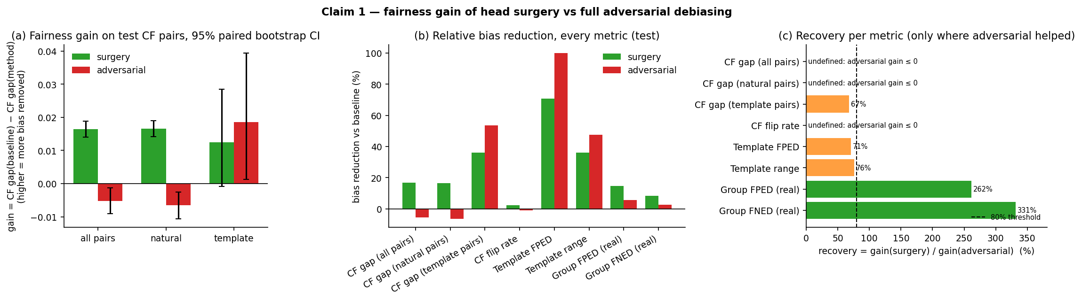
Figure 4.1: Fairness gain over the baseline with 95 % paired bootstrap CIs (a), recovery per metric against the 80 % line (b, c)
Surgery lowered the CF gap on all pairs by 17 % (0.098 → 0.082) and on natural pairs by 16 %, with bootstrap intervals clear of zero, whereas the adversarial model raised both. Surgery also had the lowest group FPED and FNED on real comments. Adversarial debiasing was better only on the small, synthetic template set: it brought template FPED to zero and had the lowest template gap and range. On those metrics surgery recovered 67–76 % of the adversarial gain, close to but below the 80 % threshold. Recoveries above 100 % on group FPED/FNED come from dividing by a very small adversarial gain and should be read as "surgery is better", not as a precise ratio.
Table 4.3: CF gap per proxy category (test)
Pairs / category | n | Baseline | Surgery | Adversarial
natural / caste | 236 | 0.0101 | 0.0143 | 0.0133
template / caste | 84 | 0.0012 | 0.0114 | 0.0032
natural / religion | 32 | 0.0557 | 0.0417 | 0.0481
template / religion | 18 | 0.0929 | 0.0790 | 0.0310
natural / region | 86 | 0.0333 | 0.0317 | 0.0426
template / region | 30 | 0.1007 | 0.0198 | 0.0276
natural / dialect | 205 | 0.0474 | 0.0423 | 0.0559
template / dialect | 12 | 0.0173 | 0.0186 | 0.0563
natural / script | 762 | 0.1951 | 0.1625 | 0.1852
natural / translit_style | 1500 | 0.0800 | 0.0658 | 0.0953

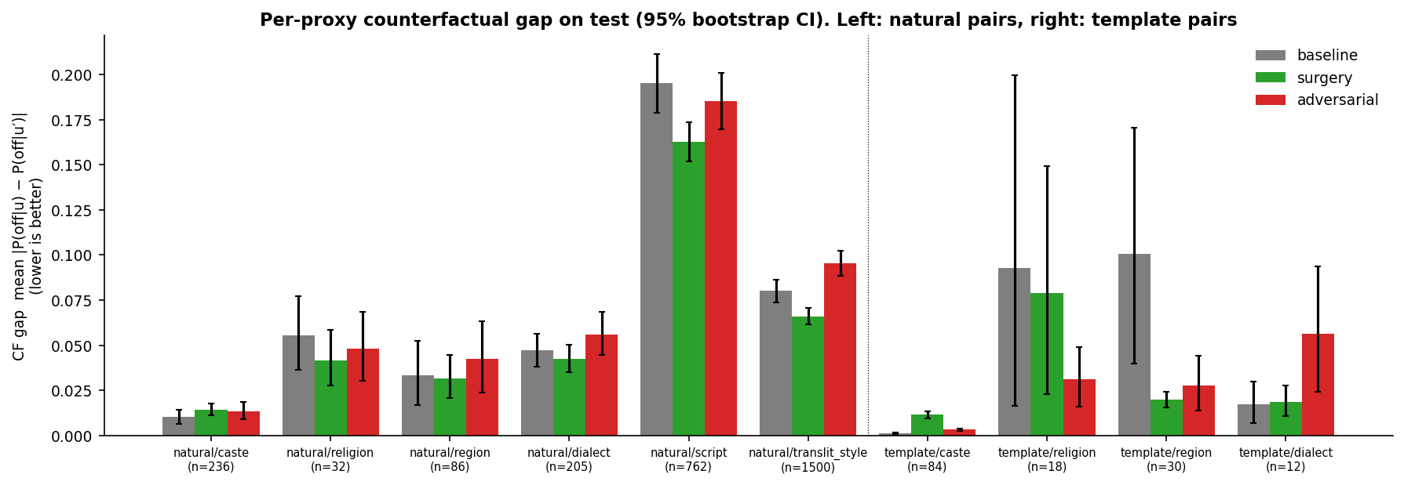
Figure 4.2: CF gap per proxy category for natural and template pairs, with 95 % bootstrap CIs
Per category, surgery reduced the natural-pair gap for script (0.195 → 0.163), transliteration style (0.080 → 0.066), religion, dialect and region, and increased it slightly for caste, whose baseline gap was already the smallest (0.010). Script and transliteration style, the two categories with the most pairs, are where the improvement is clearest; the template categories have only 12–84 pairs and wide intervals. The adversarial model increased the natural gap for transliteration style, dialect, region and caste.
4.3 Cost
Table 4.4: Metered compute
Quantity | Value
Baseline training FLOPs | 4.03e+15
Adversarial training FLOPs | 2.05e+16 (24.9 h)
Surgery FLOPs | 9.68e+14 (22.5 min)
Surgery / adversarial (FLOPs | wall clock) | 4.7 % | 1.5 %
Incl. full L×H analysis (FLOPs | wall clock) | 16.4 % | 4.7 %
Surgery / baseline training (FLOPs) | 24.0 %
Surgery phases (FLOPs) | screen 3.0e+13, exact 1.2e+14, ablate 4.4e+14, select 2.0e+14, gates 1.7e+14, report 3.2e+12

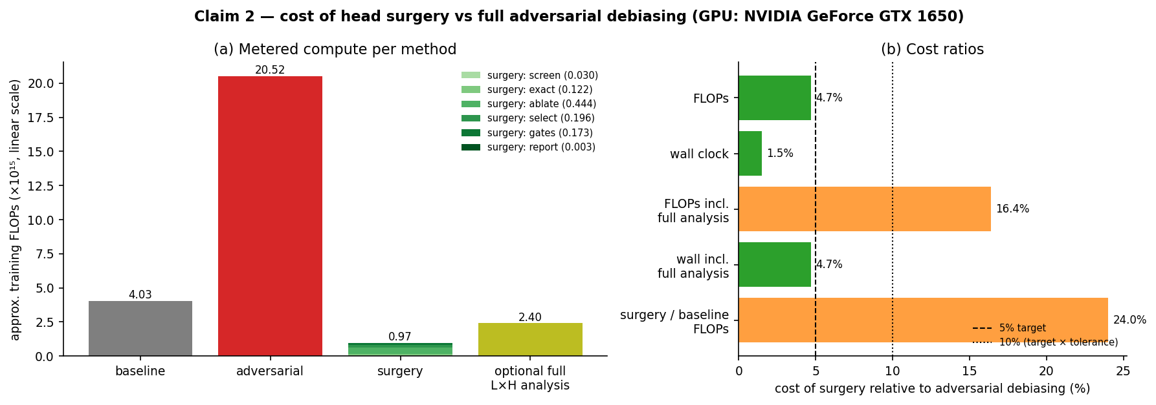
Figure 4.3: Compute per method on a linear scale, with surgery split into phases and the 5 % and 10 % lines
Surgery cost 4.7 % of the adversarial FLOPs, inside the 5 % target, and 1.5 % of its wall-clock time (about 23 minutes against 25 hours on the GTX 1650). Adversarial training was about five times as expensive as the baseline because every step also runs the balanced adversary batches. The most expensive surgery phase is the dev ablation of candidate heads, not gate training. The ratio only holds if the baseline model already exists, which is the deployment scenario assumed by H5; surgery itself is 24 % of the baseline's training cost, and including the optional full analysis raises the ratio to 16.4 %.
4.4 Task Quality
Table 4.5: Task metrics
Split | Method | Accuracy | Macro-F1
test | baseline | 0.8162 | 0.7747
test | surgery | 0.8277 | 0.7810
test | adversarial | 0.8143 | 0.7716
hasoc_val | baseline | 0.8369 | 0.7879
hasoc_val | surgery | 0.8466 | 0.7951
hasoc_val | adversarial | 0.8380 | 0.7867

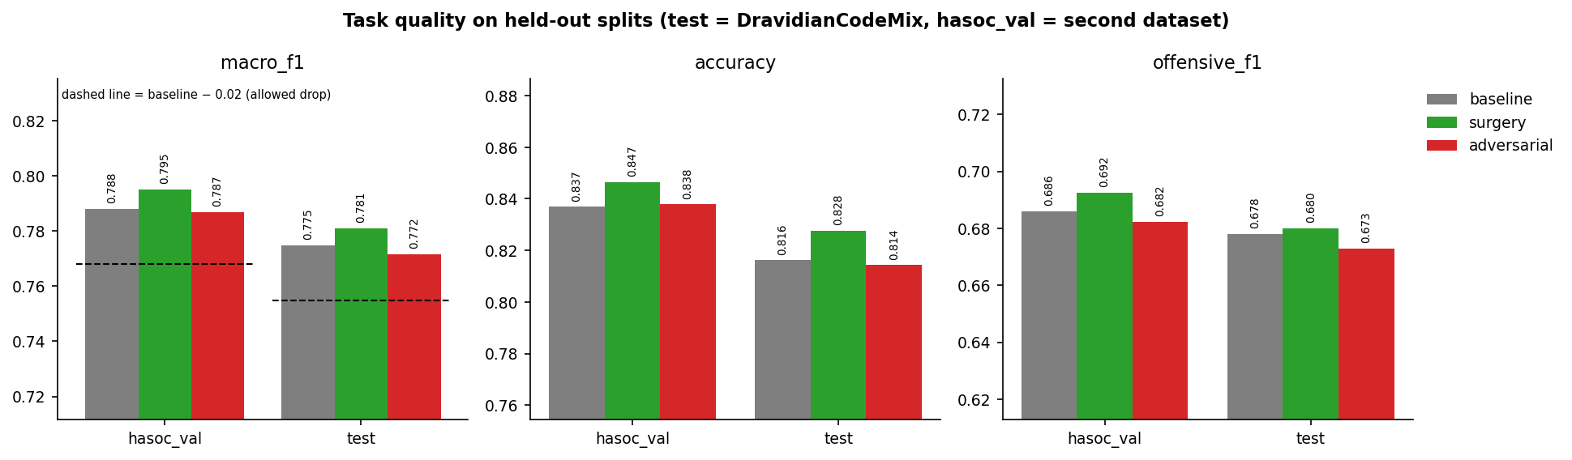
Figure 4.4: Macro-F1 per method on the DravidianCodeMix test set and the leakage-filtered HASOC set, with the baseline − 0.02 tolerance line
Surgery did not cost task quality: macro-F1 rose slightly on both test sets (+0.006 on test, +0.007 on HASOC), and the adversarial model was within 0.003 of the baseline. The small gain from surgery is consistent with the gate loss including a task cross-entropy term.
4.5 Localisation of Bias to Attention Heads
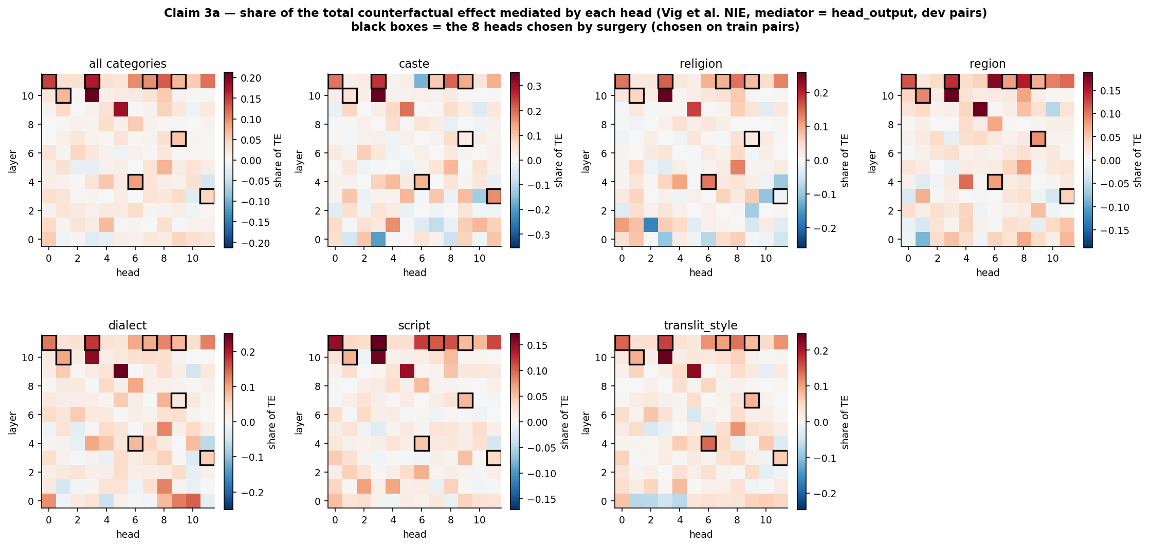
Figure 4.5: Share of the total effect mediated by each of the 144 heads (head_output mediator, dev pairs); boxes mark the eight surgery heads
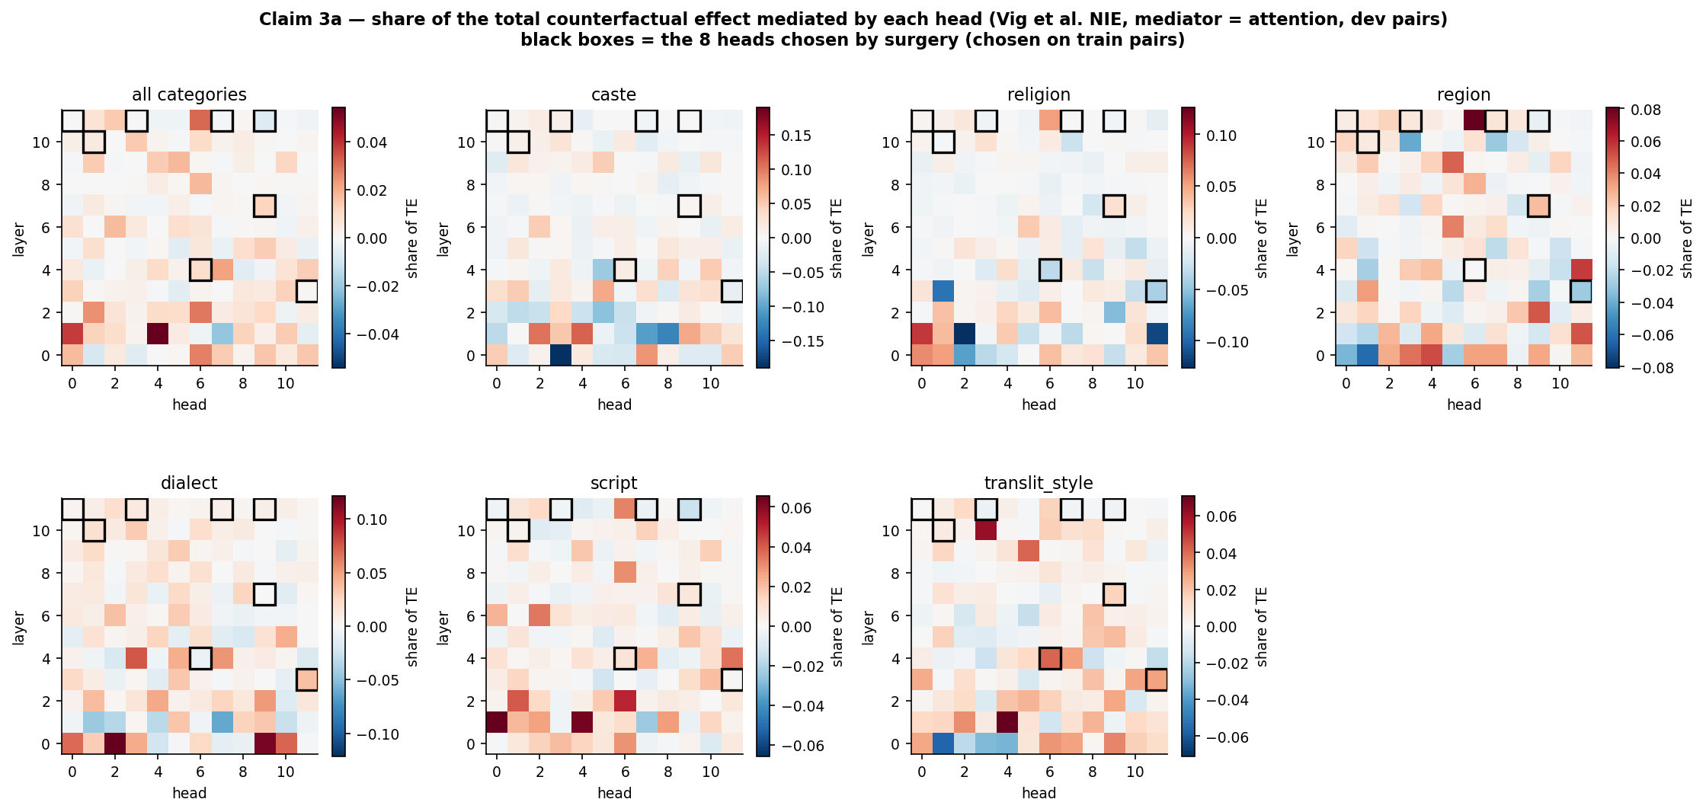
Figure 4.6: The same analysis with Vig et al.'s attention-weight mediator
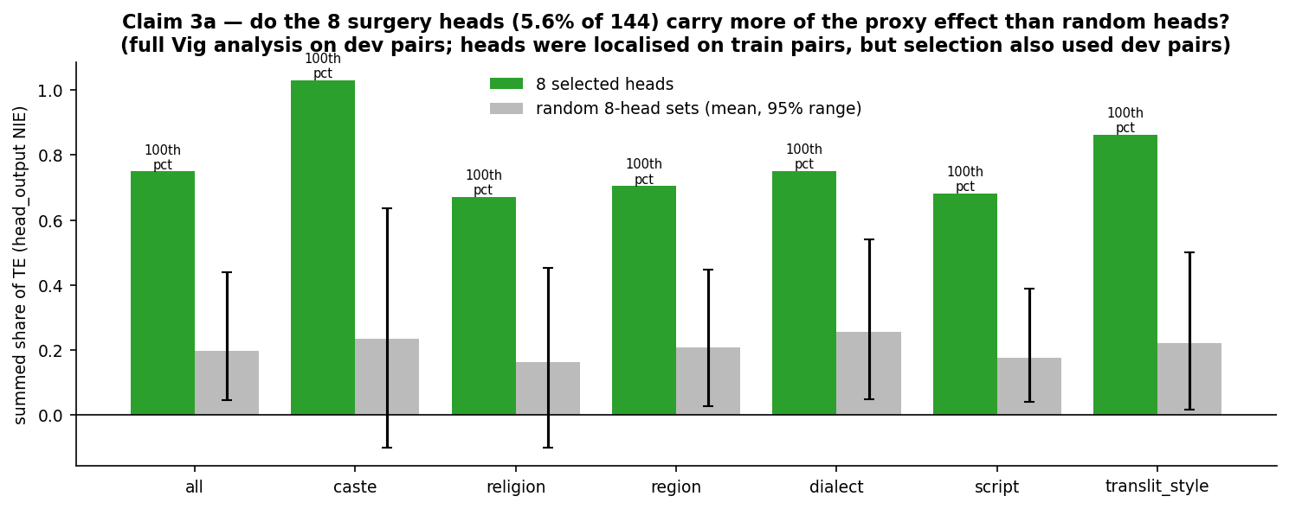
Figure 4.7: Summed share of TE carried by the eight selected heads compared with 5,000 random eight-head sets, per category
The eight heads are 5.6 % of the 144 heads but carry a summed share of 0.75 of the total effect across categories, against 0.20 expected for random eight-head sets (3.8×). In every category the selected set lies above all 5,000 random sets (100th percentile), with ratios from 2.9× to 4.5×. Per-head shares are not additive (they sum to more than one because heads overlap), so these numbers measure concentration rather than a fraction of the bias. The localisation is clear in the head_output maps and much weaker in the attention maps, which matches the moderate agreement between the two mediators (Section 4.8). One caveat: the heads were localised on train pairs, but both the selection step and this analysis used dev pairs.
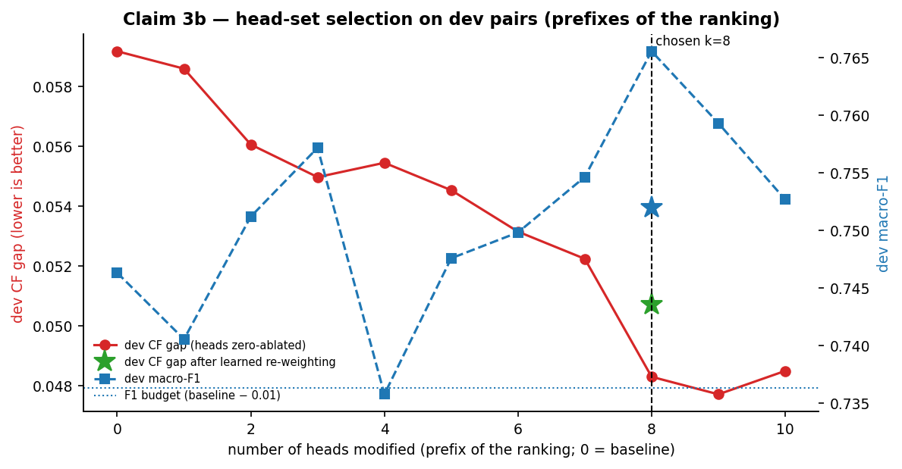
Figure 4.8: Dev CF gap and macro-F1 as heads are ablated in rank order (prefix k = 1…10); k = 8 was selected
Ablating heads in rank order lowers the dev CF gap from 0.0592 to 0.0586 with one head and 0.0483 with eight, with one small bump at k = 4. The ninth and tenth heads add almost nothing, so the rule picked k = 8. After the gates were learned, the dev CF gap was 0.0507 with macro-F1 0.752.
4.6 What the Surgery Removed
Table 4.6: Heads modified by surgery (from surgery_report.json)
Head | Gate | Primary category | Proxy-attn ratio | Top mediated swaps
L11.H3 | 0.055 | region | 0.07 | script:tamil_script->roman; religion:christian->hindu
L4.H6 | 0.096 | dialect | 0.40 | religion:christian->hindu; script:tamil_script->roman
L3.H11 | 0.562 | translit_style | 0.95 | translit_style:long_style->short_style; region:madurai->chennai
L11.H0 | 0.064 | caste | 0.06 | script:tamil_script->roman; religion:christian->hindu
L11.H7 | 0.063 | caste | 0.24 | script:tamil_script->roman; religion:christian->hindu
L7.H9 | 0.186 | translit_style | 0.31 | religion:christian->hindu; script:tamil_script->roman
L10.H1 | 0.069 | dialect | 1.09 | script:tamil_script->roman; religion:christian->hindu
L11.H9 | 0.062 | translit_style | 0.82 | script:tamil_script->roman; religion:christian->hindu

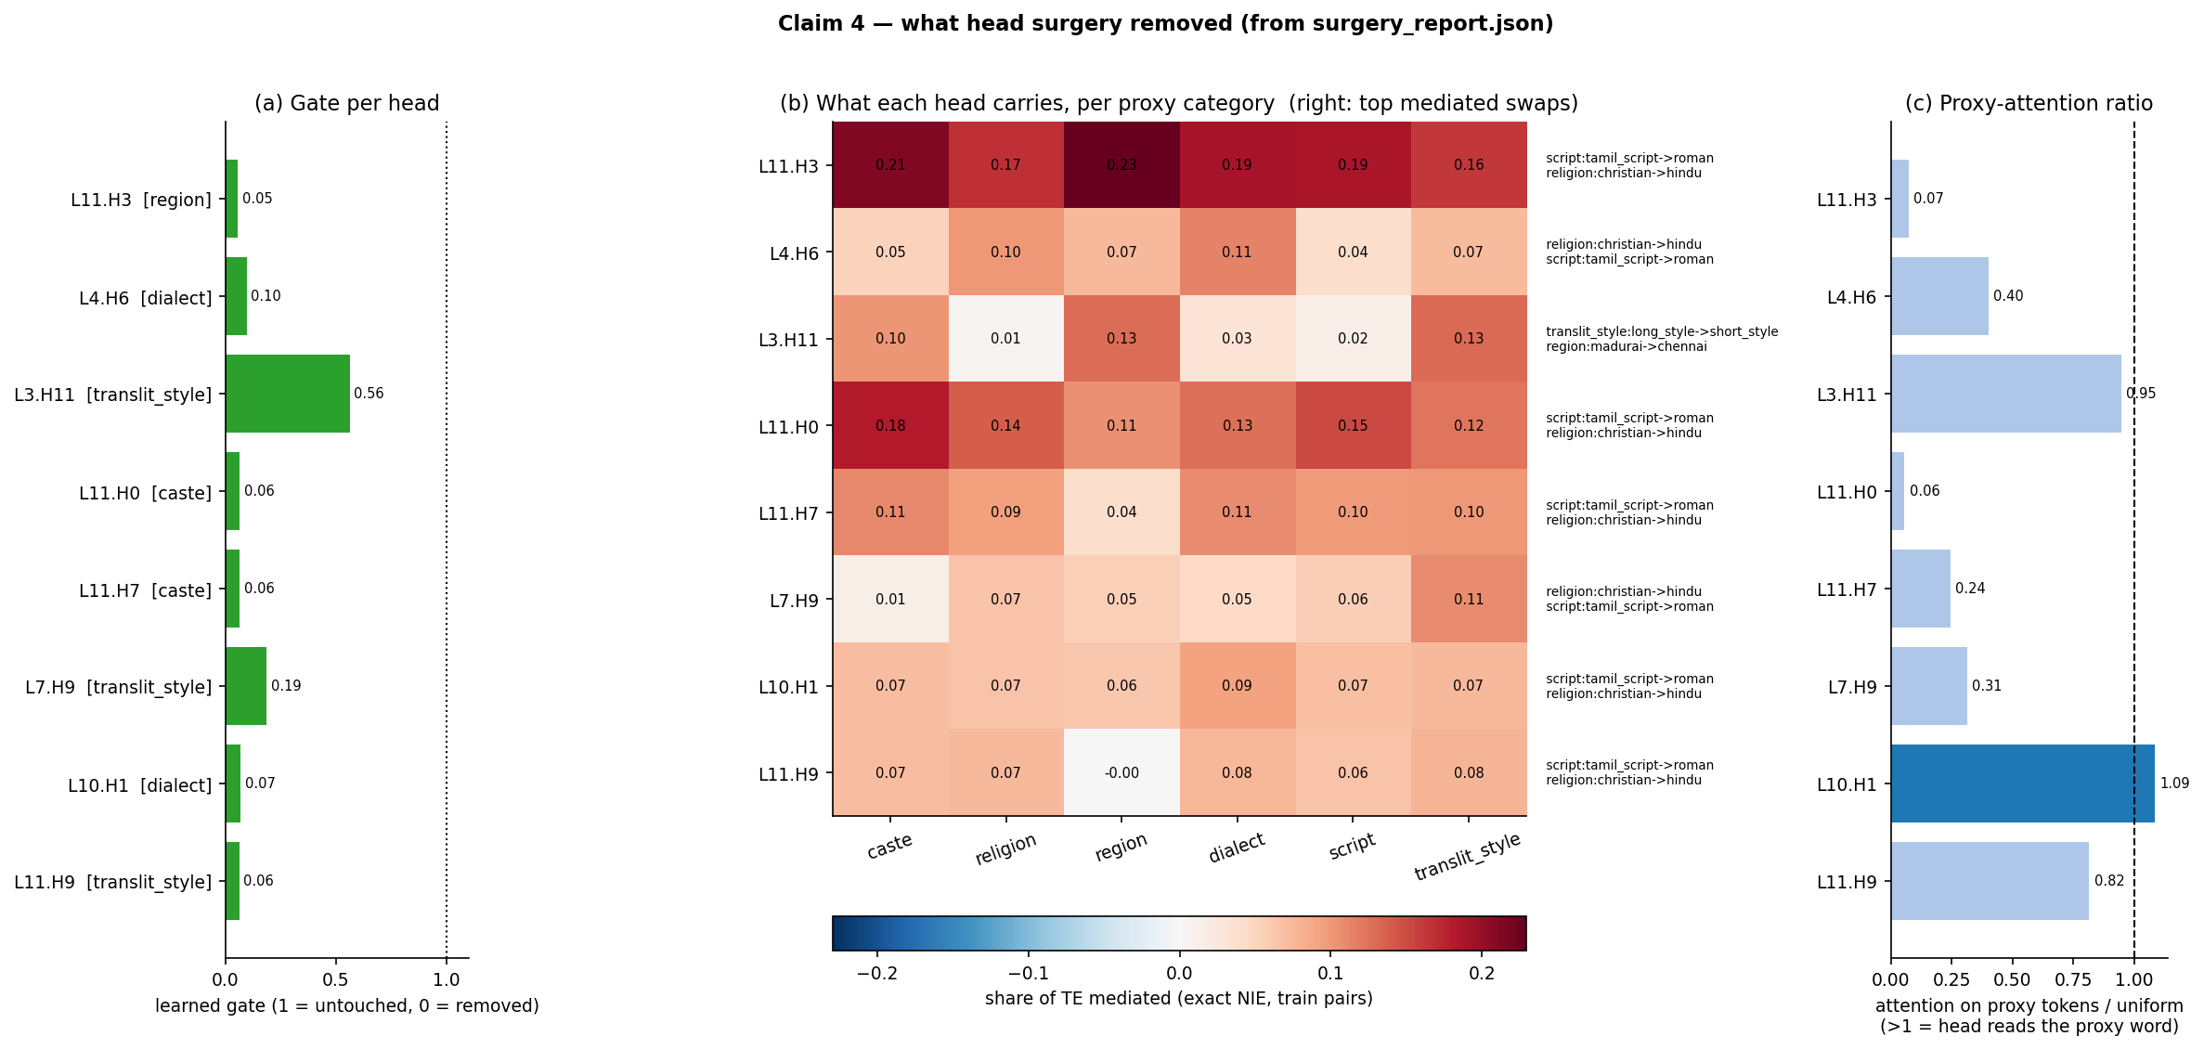
Figure 4.9: Learned gate (a), share of TE per proxy category (b) and proxy-attention ratio (c) for each modified head
The whole intervention is eight numbers. Six heads were turned down to gates of 0.05–0.10 (effectively removed), L7.H9 to 0.19 and L3.H11 only to 0.56. Five of the eight heads sit in the last two layers (10–11), with the others in layers 3, 4 and 7. Every head comes with its per-category effect, its strongest swaps (most often script: tamil_script → roman and religion: christian → hindu) and example pairs, so an auditor can see what was taken out.
The report also shows the limits of that naming. Each head carries a similar share of the effect in every category (L11.H3 carries 0.16–0.23 in all six), so the "primary category" is often a near-tie and the heads are shared rather than category-specific. Only L10.H1 has a proxy-attention ratio above 1 (1.09); for the other seven the ratio is 0.06–0.95, which means most of them do not attend to the proxy word itself and probably carry its effect through representations that have already mixed it into the sentence.
4.7 Proxy Leakage Probe
Table 4.7: Linear-probe accuracy for the proxy group from [CLS]
Category | Baseline | Surgery | Adversarial | Chance
script | 0.983 | 0.967 | 1.000 | 0.500
translit_style | 0.533 | 0.500 | 0.600 | 0.500
dialect | 0.405 | 0.365 | 0.311 | 0.333
caste | 0.265 | 0.258 | 0.288 | 0.125
region | 0.521 | 0.479 | 0.146 | 0.200
religion | 0.150 | 0.250 | 0.150 | 0.333

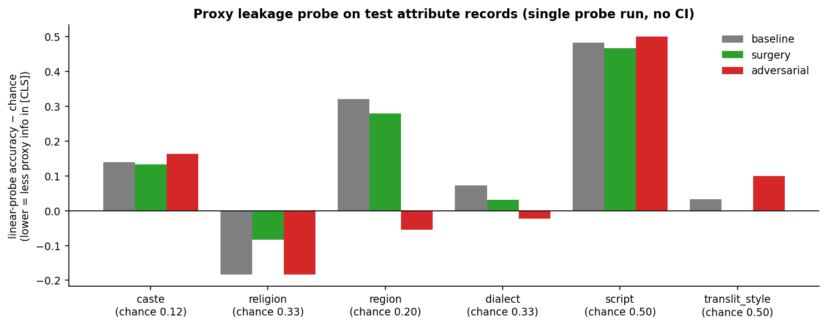
Figure 4.10: Leakage probe accuracy per proxy category against chance
Surgery barely changed how much proxy information the [CLS] vector holds; it changes how the information is used, not whether it is present. The adversarial model removed region information (0.15 against 0.52 for the baseline, below chance) and some dialect information, which is what its objective optimises, yet its predictions still changed more under proxy swaps. Script remained almost perfectly decodable for all three models, in line with Elazar and Goldberg's finding that adversarial removal is incomplete [13]. The probe is a single run without confidence intervals.
4.8 Training and Mediator Checks
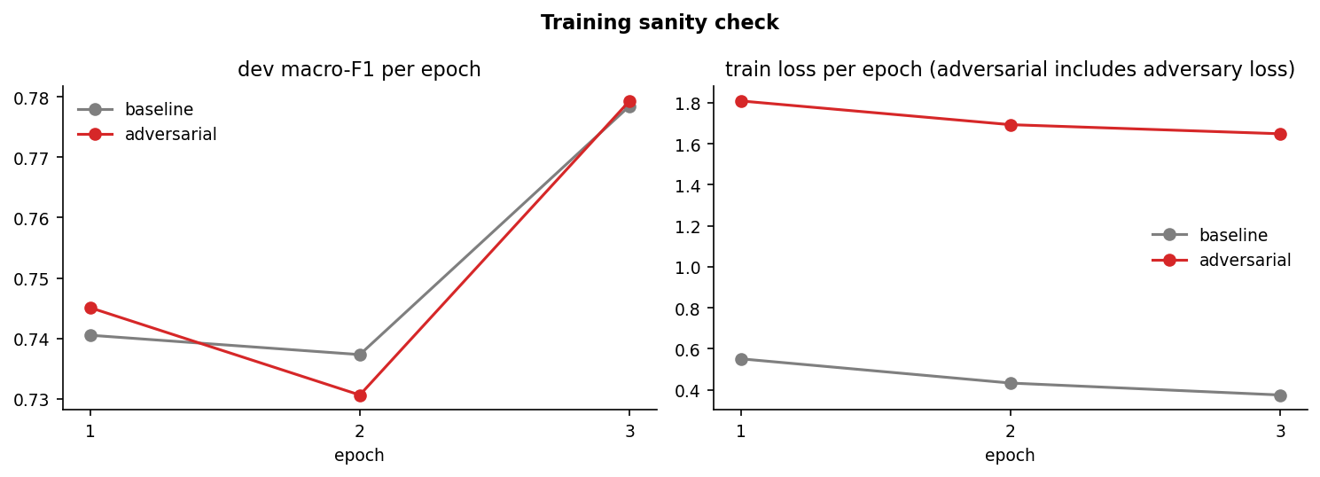
Figure 4.11: Dev macro-F1 and training loss per epoch for the baseline and adversarial runs
Both full fine-tunes followed the same path to a dev macro-F1 of about 0.78 (0.7785 baseline, 0.7793 adversarial after three epochs), so the adversarial run converged and the comparison is not distorted by an under-trained model. The adversarial loss stayed high (about 1.65) because the reversal layer keeps the adversaries from winning, as intended.
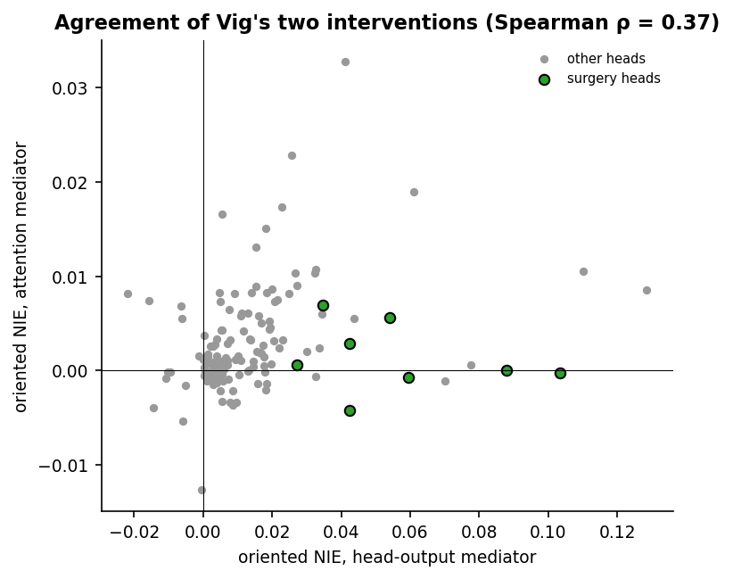
Figure 4.12: Per-head share of TE under the head_output and attention mediators
The two mediator types agree only moderately (Spearman ρ = 0.373). Changing a head's attention weights and changing its output vectors are different interventions, and for this model most of the proxy effect travels through what the heads write, not where they look. Surgery scales head outputs, so the head_output mediator is the one aligned with the intervention.
4.9 Discussion
Table 4.8: Claim-by-claim assessment
Part of the claim | Evidence | Assessment
Recovers ≥ 80 % of the adversarial gain | Adversarial gain negative on the CF gap; 67–76 % on template metrics | Not testable / not met
Reduces bias at all | CF gap −17 %, CI clear of 0; group FPED/FNED lowest | Supported
About 5 % of the cost | 4.7 % FLOPs, 1.5 % wall clock; 16.4 % with full analysis | Supported (given a trained baseline)
Task quality kept | macro-F1 +0.006 (test), +0.007 (HASOC) | Supported
Bias is localised to a few heads | 8 heads ≈ 3.8× random, 100th percentile in every category | Supported
Names what was removed | Heads, gates, swaps, examples reported; heads shared across categories, low proxy attention | Partly supported

The main negative result concerns the reference method rather than surgery. Adversarial debiasing optimises a different target: it makes the proxy group hard to decode from [CLS], which it partly achieved for region and dialect, but this does not force the predicted probability to stay constant when a proxy word is swapped. With λ = 1.0 and one seed the adversary may also be under-tuned. A stronger or differently tuned adversary, or counterfactual data augmentation (which the pipeline supports but this run did not enable), is needed before the recovery claim can be tested properly.
Read on its own terms, the evidence supports a narrower and more useful statement: on code-mixed Tamil-English offensive-language detection, editing eight attention heads with eight learned scalars reduced counterfactual proxy bias where full adversarial debiasing did not, at under 5 % of its compute, without hurting accuracy, and produced an inspectable record of the change. The named heads are better described as late, shared "bias-carrying" heads than as detectors of particular caste or religion words.
CHAPTER 5
CONCLUSION AND FUTURE WORK
5.1 Conclusion
This project studied India-specific proxy bias in a code-mixed Tamil-English offensive-language classifier and tested whether causal mediation analysis can turn bias localisation into a cheap debiasing method. It contributed a provisional proxy lexicon and counterfactual protocol for caste, religion, region, dialect, script and transliteration style; a complete, cost-metered pipeline that extends Vig et al.'s TE/NIE/NDE analysis to encoder classifiers and code-mixed text; and head surgery, which edits only the gates of the heads that mediate the proxy effect.
On held-out data, surgery on eight of 144 heads reduced the counterfactual gap by 17 % and the group-level error disparities, kept macro-F1 and cost 4.7 % of the FLOPs of adversarial debiasing. The selected heads carry far more of the proxy effect than random heads, confirming that the bias is localised. The original claim of recovering at least 80 % of the adversarial gain could not be confirmed, because the adversarial reference made the main bias score worse; where it did help (template metrics) surgery recovered 67–76 %. The "names what was removed" part holds at the level of heads and swaps, but the heads are shared across categories and mostly do not attend to the proxy word, so the explanation is coarser than hoped.
5.2 Future Work
1. Validate the lexicon: run the native-speaker annotation round-trip with two or three annotators, especially for the dialect rows, and re-run the pipeline from the prepare stage.
2. Strengthen the reference: sweep the adversarial λ and adversary weight, and enable the CDA baseline, so that recovery is measured against a method that actually lowers the CF gap.
3. Multiple seeds: repeat the full run with 3–5 seeds and report the spread of every metric.
4. Other encoders: compare XLM-R with mBERT and MuRIL, which is trained on Indian languages and transliterated text.
5. Finer localisation: move from heads to neurons or to joint (multi-head) mediation, and test category-specific gates instead of one shared set.
6. Larger and more natural test sets: add more template pairs and human-written counterfactuals, and extend the protocol to Malayalam and Kannada code-mixing.
REFERENCES
[1] J. Vig, S. Gehrmann, Y. Belinkov, S. Qian, D. Nevo, Y. Singer, and S. Shieber, “Investigating gender bias in language models using causal mediation analysis,” in Advances in Neural Information Processing Systems 33 (NeurIPS), 2020, pp. 12388–12401.
[2] J. Pearl, “Direct and indirect effects,” in Proc. 17th Conf. Uncertainty in Artificial Intelligence (UAI), 2001, pp. 411–420.
[3] N. Sambasivan, E. Arnesen, B. Hutchinson, T. Doshi, and V. Prabhakaran, “Re-imagining algorithmic fairness in India and beyond,” in Proc. ACM Conf. Fairness, Accountability, and Transparency (FAccT), 2021, pp. 315–328.
[4] S. Bhatt, S. Dev, P. Talukdar, S. Dave, and V. Prabhakaran, “Re-contextualizing fairness in NLP: The case of India,” in Proc. AACL-IJCNLP, 2022, pp. 727–740.
[5] L. Dixon, J. Li, J. Sorensen, N. Thain, and L. Vasserman, “Measuring and mitigating unintended bias in text classification,” in Proc. AAAI/ACM Conf. AI, Ethics, and Society (AIES), 2018, pp. 67–73.
[6] S. Garg, V. Perot, N. Limtiaco, A. Taly, E. H. Chi, and A. Beutel, “Counterfactual fairness in text classification through robustness,” in Proc. AAAI/ACM Conf. AI, Ethics, and Society (AIES), 2019, pp. 219–226.
[7] K. Clark, U. Khandelwal, O. Levy, and C. D. Manning, “What does BERT look at? An analysis of BERT's attention,” in Proc. ACL Workshop BlackboxNLP, 2019, pp. 276–286.
[8] E. Voita, D. Talbot, F. Moiseev, R. Sennrich, and I. Titov, “Analyzing multi-head self-attention: Specialized heads do the heavy lifting, the rest can be pruned,” in Proc. ACL, 2019, pp. 5797–5808.
[9] P. Michel, O. Levy, and G. Neubig, “Are sixteen heads really better than one?” in Advances in Neural Information Processing Systems 32 (NeurIPS), 2019.
[10] A. Syed, C. Rager, and A. Conmy, “Attribution patching outperforms automated circuit discovery,” arXiv:2310.10348, 2023.
[11] Y. Ganin, E. Ustinova, H. Ajakan, P. Germain, H. Larochelle, F. Laviolette, M. Marchand, and V. Lempitsky, “Domain-adversarial training of neural networks,” Journal of Machine Learning Research, vol. 17, no. 59, pp. 1–35, 2016.
[12] B. H. Zhang, B. Lemoine, and M. Mitchell, “Mitigating unwanted biases with adversarial learning,” in Proc. AAAI/ACM Conf. AI, Ethics, and Society (AIES), 2018, pp. 335–340.
[13] Y. Elazar and Y. Goldberg, “Adversarial removal of demographic attributes from text data,” in Proc. EMNLP, 2018, pp. 11–21.
[14] K. Lu, P. Mardziel, F. Wu, P. Amancharla, and A. Datta, “Gender bias in neural natural language processing,” in Logic, Language, and Security, LNCS 12300, Springer, 2020, pp. 189–202.
[15] S. Ravfogel, Y. Elazar, H. Gonen, M. Twiton, and Y. Goldberg, “Null it out: Guarding protected attributes by iterative nullspace projection,” in Proc. ACL, 2020, pp. 7237–7256.
[16] B. R. Chakravarthi, V. Muralidaran, R. Priyadharshini, and J. P. McCrae, “Corpus creation for sentiment analysis in code-mixed Tamil-English text,” in Proc. SLTU-CCURL Workshop (LREC), 2020, pp. 202–210.
[17] B. R. Chakravarthi, R. Priyadharshini, V. Muralidaran, N. Jose, S. Suryawanshi, E. Sherly, and J. P. McCrae, “DravidianCodeMix: Sentiment analysis and offensive language identification dataset for Dravidian languages in code-mixed text,” Language Resources and Evaluation, vol. 56, pp. 765–806, 2022.
[18] B. R. Chakravarthi et al., “Overview of the HASOC-DravidianCodeMix shared task on offensive language detection in Tamil and Malayalam,” in Working Notes of FIRE 2021, CEUR Workshop Proceedings, 2021.
[19] A. Conneau, K. Khandelwal, N. Goyal, V. Chaudhary, G. Wenzek, F. Guzmán, E. Grave, M. Ott, L. Zettlemoyer, and V. Stoyanov, “Unsupervised cross-lingual representation learning at scale,” in Proc. ACL, 2020, pp. 8440–8451.
[20] J. Devlin, M.-W. Chang, K. Lee, and K. Toutanova, “BERT: Pre-training of deep bidirectional transformers for language understanding,” in Proc. NAACL-HLT, 2019, pp. 4171–4186.
APPENDICES
GitHub link: https://github.com/dheepakshakthi/Attention-Head-Surgery-for-Bias-in-Code-Mixed-Tamil-English-Transformers
A. Reproducing the experiment
python3.11 -m venv h5env && source h5env/bin/activate
pip install -r requirements.txt && pip install -e .
pytest -q # offline unit tests
bash scripts/run_all.sh configs/gpu4gb.yaml # full run on a ~4 GB GPU
cat outputs/REPORT.md # verdict and tables
python scripts/make_claim_plots.py # figures in outputs/claim_plots/
python scripts/make_report.py # this report

B. Gated forward pass (src/h5/modeling.py)
def forward(self, input_ids, attention_mask, head_mask=None, ...):
if head_mask is None:
hm = self.gates # [L, H] learned gates
elif head_mask.dim() == 2:
hm = self.gates * head_mask # extra ablation mask
elif head_mask.dim() == 5: # per-example interventions
hm = self.gates[:, None, :, None, None] * head_mask
if not hm.requires_grad and bool(torch.all(hm == 1)):
hm = None # identical to the unmodified encoder
out = self.encoder(input_ids=input_ids, attention_mask=attention_mask,
head_mask=hm, return_dict=True)
logits = self.classifier(self.dropout(out.last_hidden_state[:, 0]))
return {"logits": logits}

C. Effect measure and gate training (src/h5/mediation.py, src/h5/surgery.py)
def effect_measure(logits): # y(.) = log-odds of "offensive"
logits = logits.float()
return logits[:, POS] - logits[:, 1 - POS]

# learn_gates: only the k selected gates are trainable; encoder frozen
for step in range(steps): # 150 steps, Adam lr 0.05
hm = gp() # current gates
lt = ce(model(**xb, head_mask=hm)["logits"], labels) # task loss
ea = effect_measure(model(**ya, head_mask=hm)["logits"]) # pair side a
eb = effect_measure(model(**yb, head_mask=hm)["logits"]) # pair side b
loss = lt + lam * ((ea - eb) ** 2).mean() # CE + lambda * CF consistency
opt.zero_grad(); loss.backward(); opt.step()

D. Example entry from surgery_report.json (L11.H3)
{
"head": "L11.H3",
"gate": 0.055,
"primary_proxy_category": "region",
"proxy_attention_ratio": 0.073,
"dev_single_ablation": {
"d_cf_gap": -0.0006,
"d_macro_f1": -0.0058
},
"nie_share_of_te": {
"caste": 0.212,
"dialect": 0.19,
"region": 0.229,
"religion": 0.168,
"script": 0.186,
"translit_style": 0.162
},
"top_mediated_swaps": [
"script:tamil_script->roman",
"religion:christian->hindu",
"caste:thevar->dalit",
"region:kongu->nellai"
]
}

