Last Sunday millions of Americans congregated around their televisions to share in the monolithic cultural event of the year—the Super Bowl. During the big game people dipped, crunched, and munched their way to a waistline that grew with the score. February is the month that diets go to die, and the Super Bowl is a large part of that. Examining google trends, we can easily spot online enthusiasm for abandoning dietary resolutions from the new year.

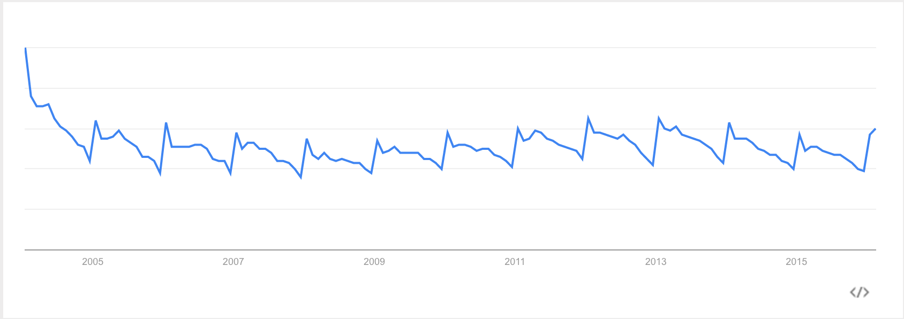

To examine this trend at a deeper level, we bit into hundreds of Pinterest recipes to figure out what football viewing public ate during Super Bowl Sunday.

These results certainly won’t come as a shock to those who stepped on the scales on Monday morning:

* Bacon is the top ingredient, found in the second most repinned-recipes and has the second highest number of average repins per recipe.
* Cheese is popular ingredient in 40% of the top recipes.
* Cheesy dips, wings, sausages and bacon are popular foods in the recipes people choose to prepare for the big game.
* Even in recipes that are healthier, ingredients like shredded cheese and cream cheese can ramp up the calories.

Top Recipes Types

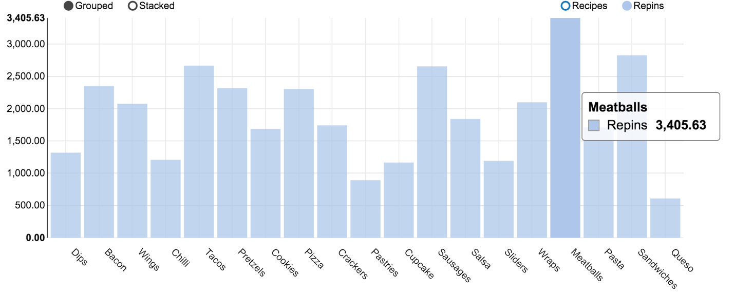

* Dips of various kinds are the #1 category of recipe by volume
* America's bacon obsession comes out clear—an average recipe with Bacon has 2350 repins and the second most recipes
* Meatballs are also very popular and have the most repins on average (less recipes)
* Desserts are decidedly less popular and only Cupcakes and Cookies make the top list
* Cheese dips are definitely the main attraction when looking at pins, which is no surprise. In second place is black-bean dip, followed by Chicken dip.

Ingredients Analysis

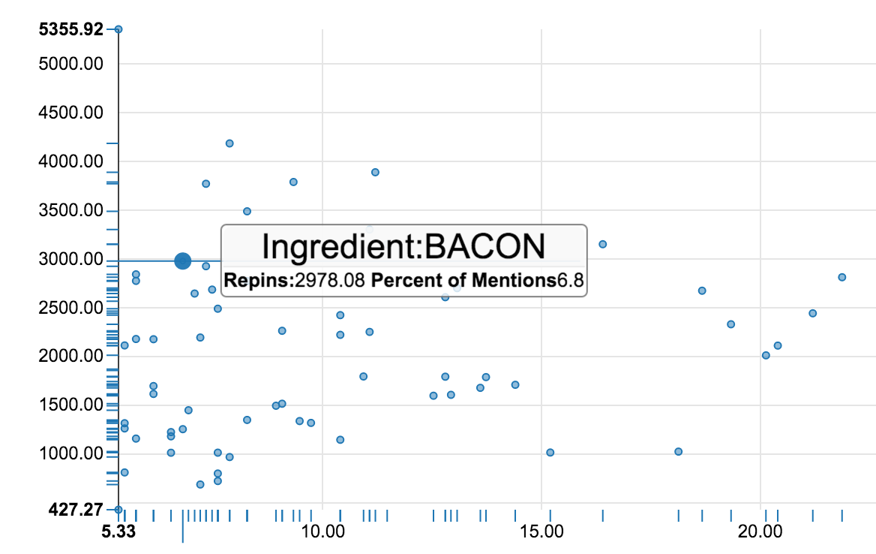

* Super Bowl recipes tend to be incredibly unhealthy
* Cheese consists of the 40% of the top recipes (cream cheese or plain cheese)
* The second most common main ingredient is bacon
* Cumin & Cayenne were popular spices which points to the preponderance of Tacos in the pins
* Even for initially healthy recipes large amounts of cheese and sour cream rack up the calorie counts
* Both unhealthy and healthy recipes use similar amounts of meat (near 50%)

Recipe Type Comparison

|  |  |  |  |
| --- | --- | --- | --- |
| **Recipe** | **Regular Recipes** | **Healthy Recipes** | **Comparison** |
| **Dips** | 21% | 16% | 27% |
| **Wings** | 8% | 8% | -1% |
| **Tacos** | 8% | 7% | 7% |
| **Chili** | 6% | 9% | -36% |
| **Pizza** | 5% | 3% | 79% |
| **Bacon** | 4% | 8% | -43% |
| **Salsa** | 4% | 3% | 59% |
| **Pastries** | 4% | 2% | 61% |
| **Pasta** | 3% | 3% | 9% |
| **Meatballs** | 3% | 3% | -17% |
| **Wraps** | 3% | 3% | -17% |

* Dips are much more commonly seen in unhealthier recipes
* Chili is frequently found in healthy recipes (-35% less often in regular recipes)
* Pizza is most often found in unhealthy recipes (78% more common)
* Surprisingly, different pastry options show up more often in healthy recipes

Calorie Counts

* The average top Super Bowl recipe clocks in at 331 calories on average per serving.
* It’s easy to see how people can overindulge given that most people have several servings at a party.
* Healthy recipes are a little better, averaging 140.5 calories per serving. However, given that many of these recipes still hold high amounts of cheese many of these recipes are still high in fat.

Despite increased public awareness of nutrition and the detrimental health effects of indulging in salt, saturated fats, and red meat, the most searched Super Bowl recipes on Pinterest were overwhelmingly stuffed with cheese, sour cream, and bacon. Perhaps most surprising was the lack of sugary desserts seen in this year's repinned recipes. Our data suggests that less people were baking cupcakes and pastries and more people were crafting dips and cheesy appetizers to munch on while rooting for their favorite team. This year's Super Bowl rep-ins may indicate that America is taking a break from its traditional sweet tooth in favor of a cheesier and fattier future.