DA Lab 3
Time Series Analysis of Death Due to Lung Cancer Dataset

Name: Dheeraj Chaudhary

Roll: 17BCS009

library(ggplot2)
library(Metrics)
library(forecast)
library(reshape)
data("mdeaths")
mdeaths
######## OUTPUT > mdeaths
Jan Feb Mar Apr May Jun Jul Aug Sep Oct Nov Dec
1974 2134 1863 1877 1877 1492 1249 1280 1131 1209 1492 1621 1846
1975 2103 2137 2153 1833 1403 1288 1186 1133 1053 1347 1545 2066
1976 2020 2750 2283 1479 1189 1160 1113 970 999 1208 1467 2059
1977 2240 1634 1722 1801 1246 1162 1087 1013 959 1179 1229 1655
1978 2019 2284 1942 1423 1340 1187 1098 1004 970 1140 1110 1812
1979 2263 1820 1846 1531 1215 1075 1056 975 940 1081 1294 1341

start(mdeaths)
######## OUTPUT

1974 1

end(mdeaths)
######## OUTPUT

1979 12

############ Q.2) TIME SERIES OBJECT OF THE DATA ###############
my_Object <- ts(mdeaths, start=1974 ,frequency = 12)
Object
###### Check whether it is an object or not ############
is.ts(my_Object)
###### OUTPUT
[1] TRUE

###### PLOT OF MY DATA ########
ts.plot(my_Object, main="Deaths From lung disease",ylab ="Monthly Total mean Deaths")
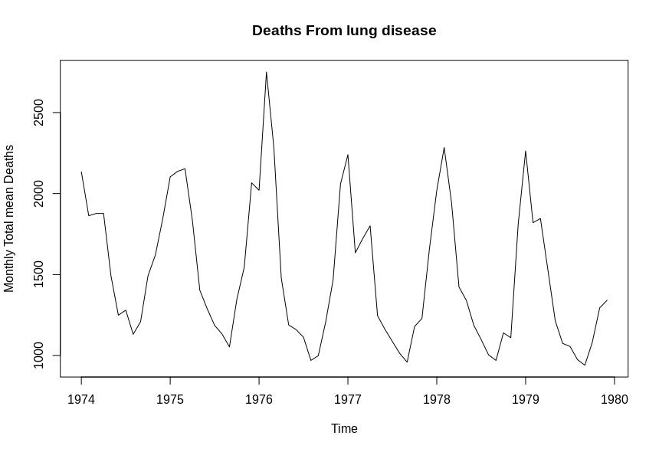

###### PLOT OF MY DATA with adding a horizontal regression line in the plot ########
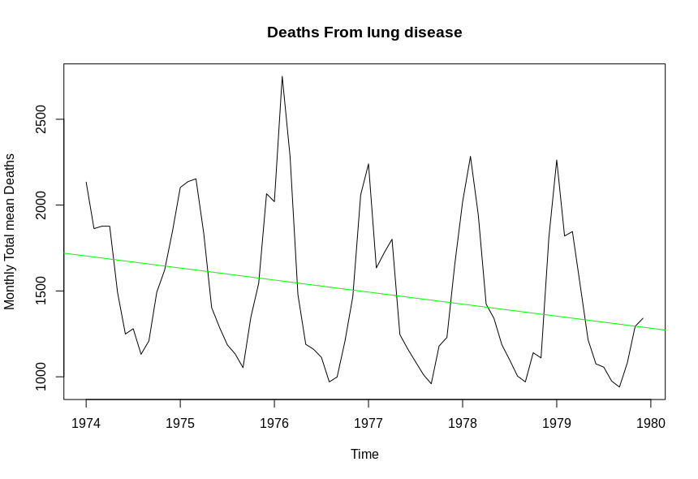
abline(reg = lm(my_Object~time(my_Object)),col="green")

#################### Q.3) PLOT OF YEARLY MEAN VALUES ARE #############
plot(aggregate(my_Object,FUN = mean))
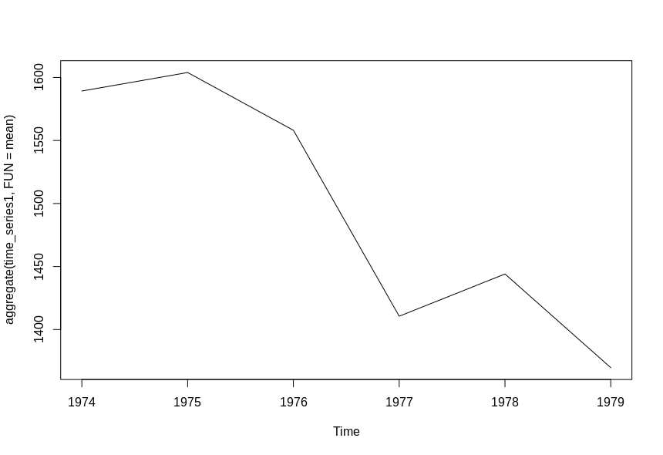
################### Q.4) PLOT OF MONTHLY BOX PLOTS ARE #################
boxplot(my_Object~cycle(my_Object),xlab="Month",ylab = "Deaths",main = "Death from lung disease")
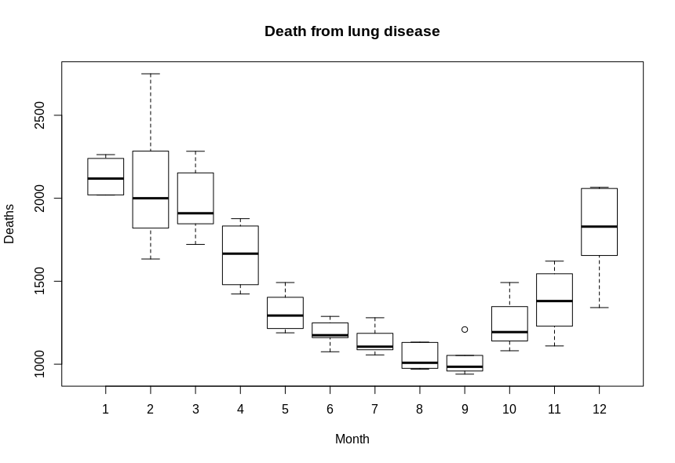

################ Q.5) DECOMPOSING THE ABOVE TIME SERIES USING STL FUNCTIONS ##########

decomp_STL <- stl(my_Object, s.window = "periodic")
plot(decomp_STL)
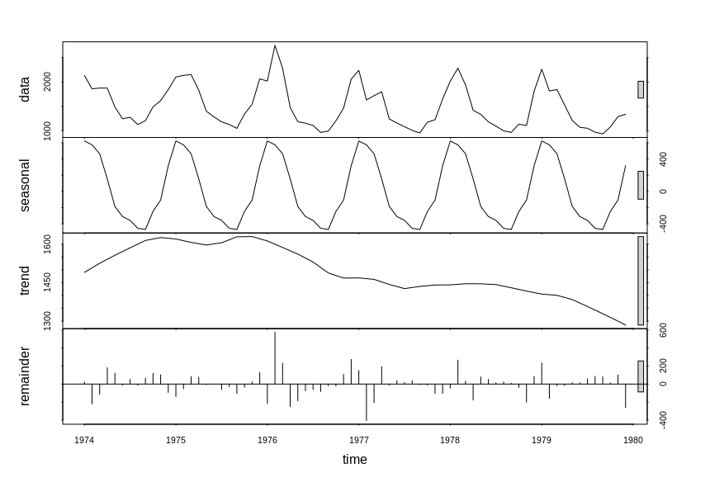
############### PLOTTING TREND GRAPH SEPARATELY #################
decomp_STL$trend <- decomp_STL$time.series[,2]
plot(decomp_STL$trend) ## We can see Trend is Decreasing
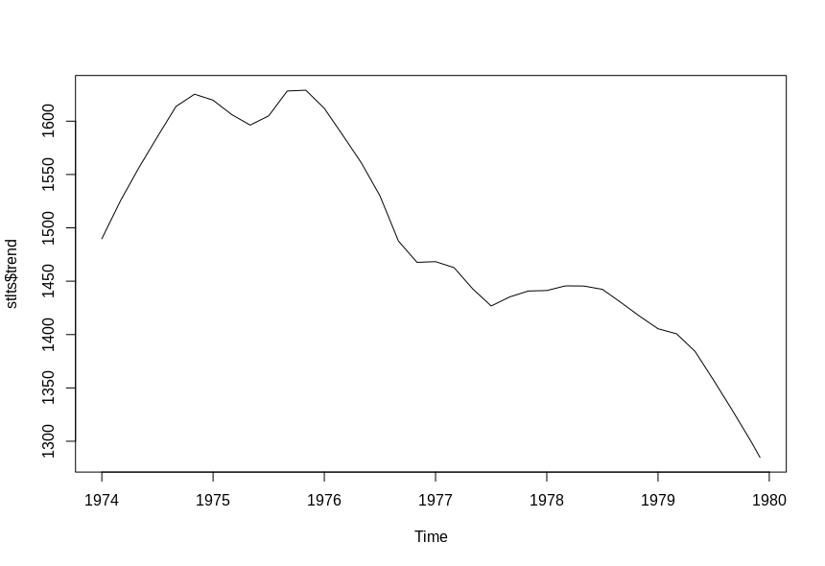
################# Q.6) TO CHECK SEASONALITY ######################
decomp_STL$seasonal <- decomp_STL$time.series[,1]
plot(decomp_STL$seasonal) # We can see seasonality is Uniform in the plot
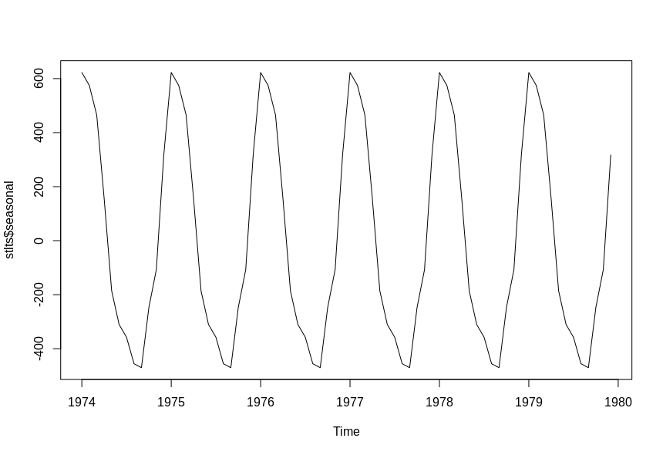
############## Q.7) RESIDUE AFTER REMOVING THE TREND AND SEASONALITY ##########

decomp_STL$residue <- (my_Object-(decomp_STL$trend + decomp_STL$seasonal))
plot(decomp_STL$residue,main = "Residue after removing trend and seasonality",col = "green")
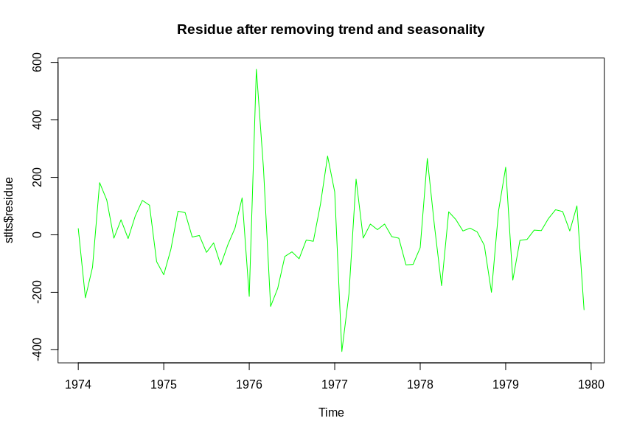
############## Q.8) MODEL OF THE DATA USING HOLTWINTER METHOD FOR 75% OF DATA ########
holt_model <- window(mdeaths,start = c(1974,1) ,end=c(1978,6))
holt_model

###### OUTPUT
Jan Feb Mar Apr May Jun Jul Aug Sep Oct Nov Dec
1974 2134 1863 1877 1877 1492 1249 1280 1131 1209 1492 1621 1846
1975 2103 2137 2153 1833 1403 1288 1186 1133 1053 1347 1545 2066
1976 2020 2750 2283 1479 1189 1160 1113 970 999 1208 1467 2059
1977 2240 1634 1722 1801 1246 1162 1087 1013 959 1179 1229 1655
1978 2019 2284 1942 1423 1340 1187
########### SUMMARY of MODEL AND PLOT FOR NEXT 25% DATA FOR ABOVE HOLTWINTER MODEL ######
Pred_data <- hw(holt_model, seasonal = "additive", h = 18)
summary(Pred_data)
###### OUTPUT
Forecast method: Holt-Winters' additive method

Model Information:
Holt-Winters' additive method

Call:
hw(y = train, h = 18, seasonal = "additive")

Smoothing parameters:
alpha = 1e-04
beta = 1e-04
gamma = 2e-04

Initial states:
l = 1618.6168
b = -3.2349
s = 369.3278 -68.9199 -225.7441 -502.8133 -474.9254 -366.2004
-307.6114 -236.3283 158.7177 504.9388 617.2867 532.2718

sigma: 192.1291

AIC AICc BIC
798.3117 815.3117 832.1245

Error measures:
ME RMSE MAE MPE MAPE MASE ACF1
Training set 4.543167 161.1714 110.868 -0.3603639 6.606394 0.572891 0.192809

Forecasts:
Point Forecast Lo 80 Hi 80 Lo 95 Hi 95
Jul 1978 1076.0085 829.7852 1322.232 699.4424 1452.575
Aug 1978 964.0788 717.8555 1210.302 587.5127 1340.645
Sep 1978 932.9994 686.7760 1179.223 556.4332 1309.565
Oct 1978 1206.8411 960.6177 1453.064 830.2749 1583.407
Nov 1978 1360.4591 1114.2357 1606.683 983.8929 1737.025
Dec 1978 1795.5011 1549.2776 2041.725 1418.9348 2172.067
Jan 1979 1955.2547 1709.0312 2201.478 1578.6884 2331.821
Feb 1979 2037.0099 1790.7863 2283.234 1660.4434 2413.576
Mar 1979 1921.4300 1675.2063 2167.654 1544.8634 2297.997
Apr 1979 1572.0339 1325.8100 1818.258 1195.4670 1948.601
May 1979 1173.8253 927.6013 1420.049 797.2582 1550.392
Jun 1979 1099.2835 853.0594 1345.508 722.7162 1475.851
Jul 1979 1037.4852 791.2608 1283.710 660.9174 1414.053
Aug 1979 925.5555 679.3308 1171.780 548.9874 1302.124
Sep 1979 894.4761 648.2511 1140.701 517.9075 1271.045
Oct 1979 1168.3178 922.0925 1414.543 791.7488 1544.887
Nov 1979 1321.9358 1075.7102 1568.161 945.3663 1698.505
Dec 1979 1756.9778 1510.7518 2003.204 1380.4076 2133.548

############### Q.9) FORECAST PLOT FOR NEXT 25% DATA ################
autoplot(Pred_data)

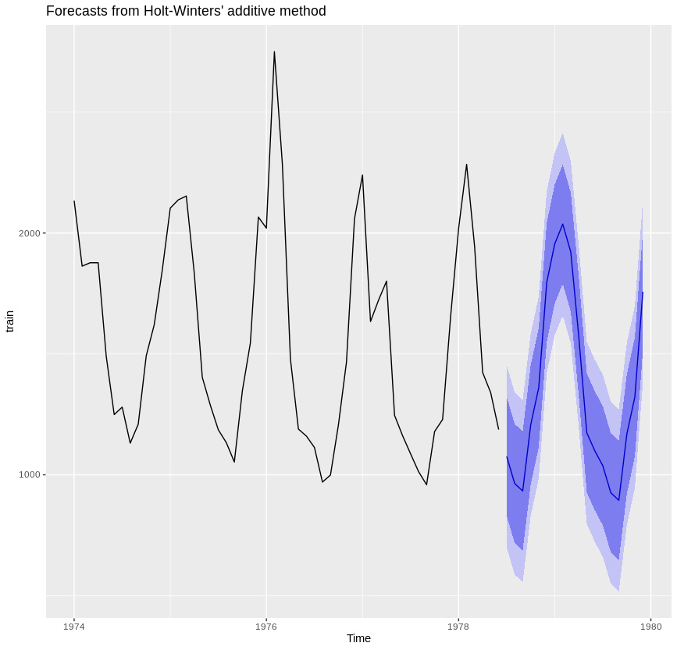
############### PREDICTED Plot And VALUE ALONG WITH THE ACTUAL VALUE #########
act_value = tail(my_Object,18)
df = data.frame( Pred_data , tail(my_Object,18))
X = time(act_value)
fore_cast = df$Point.Forecast
fore_cast
##### OUTPUT
[1] 1076.0085 964.0788 932.9994 1206.8411 1360.4591 1795.5011 1955.2547 2037.0099 1921.4300 1572.0339 1173.8253 1099.2835 1037.4852
[14] 925.5555 894.4761 1168.3178 1321.9358 1756.9778

actu_data = df$tail.my_Object..18.
actu_data
###### OUTPUT
Jan Feb Mar Apr May Jun Jul Aug Sep Oct Nov Dec
1978 1098 1004 970 1140 1110 1812
1979 2263 1820 1846 1531 1215 1075 1056 975 940 1081 1294 1341

Pred_actual = as.data.frame(data.frame(fore_cast,actu_data))
Pred_actual
###### OUTPUT
fore actu
1 1076.0085 1098
2 964.0788 1004
3 932.9994 970
4 1206.8411 1140
5 1360.4591 1110
6 1795.5011 1812
7 1955.2547 2263
8 2037.0099 1820
9 1921.4300 1846
10 1572.0339 1531
11 1173.8253 1215
12 1099.2835 1075
13 1037.4852 1056
14 925.5555 975
15 894.4761 940
16 1168.3178 1081
17 1321.9358 1294
18 1756.9778 1341

ggplot(Pred_actual,aes(X))+
geom_line(aes(y=dfpPred_actuallt$fore_cast),colour = "blue")+
geom_line(aes(y=Pred_actual$actu_data),colour = "black") + xlab("Time") + ylab("Deaths") +
ggtitle("Predicted(blue) and actual (black) values graph")
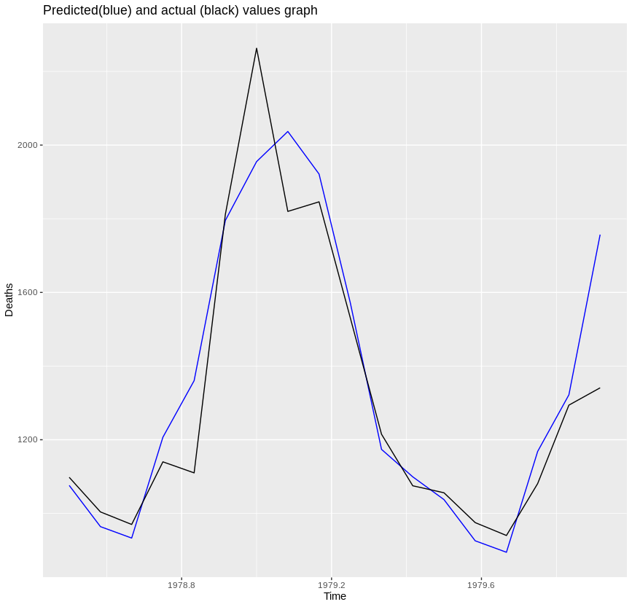
############### Q.11) RMS ERROR BETWEEN PREDICTED AND ACTUAL VALUE #############
rmse(df$Point.Forecast,df$tail.my_Object..18.)
#### OUTPUT

[1] 150.6795

######### Q.12 )TUNING THE MODEL BY MODIFYING THE VALUE OF ALPHA, BETA, AND GAMMA ######
hw_modelt <- HoltWinters(train,alpha = "0.1" ,beta = "0.1" ,gamma = "0.4" )
model.predict <- predict(hw_modelt,n.ahead = 18)
round(model.predict)
##### OUTPUT
Jan Feb Mar Apr May Jun Jul Aug Sep Oct Nov Dec
1978 1032 927 917 1164 1313 1749
1979 1982 2048 1873 1508 1203 1088 995 889 880 1126 1276 1712

p_values= model.predict
act_value = tail(time_series1,18)
rmse(act_value,p_values)
#### OUTPUT
[1] 138.5872

############## Q.13) MODEL OF THE DATA USING ARIMA METHOD FOR 75% OF DATA ########

arima_model <- window(mdeaths,start = c(1974,1) ,end=c(1978,6))
arima_model
######## OUTPUT
Jan Feb Mar Apr May Jun Jul Aug Sep Oct Nov Dec
1974 2134 1863 1877 1877 1492 1249 1280 1131 1209 1492 1621 1846
1975 2103 2137 2153 1833 1403 1288 1186 1133 1053 1347 1545 2066
1976 2020 2750 2283 1479 1189 1160 1113 970 999 1208 1467 2059
1977 2240 1634 1722 1801 1246 1162 1087 1013 959 1179 1229 1655
1978 2019 2284 1942 1423 1340 1187

new_model = auto.arima(arima_model)
new_model

######## OUTPUT
Series: train
ARIMA(0,0,2)(1,1,0)[12] with drift

Coefficients:
ma1 ma2 sar1 drift
0.2757 -0.3298 -0.5996 -4.7405
s.e. 0.1750 0.1997 0.1195 1.8286

sigma^2 estimated as 47385: log likelihood=-286.47
AIC=582.95 AICc=584.62 BIC=591.64

############# Q.14) PREDICTED OUTPUT FOR NEXT 25% DATA #######################
pred_arima <- forecast(new_model, h = 18)
pred_arima
######## OUTPUT
Point Forecast Lo 80 Hi 80 Lo 95 Hi 95
Jul 1978 937.5533 658.5834 1216.523 510.9057 1364.201
Aug 1978 889.9089 600.5321 1179.286 447.3453 1332.472
Sep 1978 891.9903 588.3411 1195.639 427.5990 1356.382
Oct 1978 1105.3951 801.7460 1409.044 641.0038 1569.786
Nov 1978 1280.7029 977.0538 1584.352 816.3116 1745.094
Dec 1978 1806.2297 1502.5805 2109.879 1341.8384 2270.621
Jan 1979 2060.5104 1756.8613 2364.160 1596.1191 2524.902
Feb 1979 1803.2946 1499.6455 2106.944 1338.9033 2267.686
Mar 1979 1719.1050 1415.4558 2022.754 1254.7137 2183.496
Apr 1979 1558.6412 1254.9920 1862.290 1094.2499 2023.032
May 1979 1192.6494 889.0002 1496.299 728.2581 1657.041
Jun 1979 1081.0189 777.3698 1384.668 616.6276 1545.410
Jul 1979 936.1633 612.6171 1259.710 441.3421 1430.985
Aug 1979 872.7172 547.7086 1197.726 375.6594 1369.775
Sep 1979 841.1745 514.0845 1168.264 340.9336 1341.415
Oct 1979 1058.5335 731.4436 1385.623 558.2926 1558.774
Nov 1979 1158.7119 831.6220 1485.802 658.4710 1658.953
Dec 1979 1624.5665 1297.4766 1951.656 1124.3256 2124.807

plot(mdeaths)
plot(pred_arima)
predicted = data.frame(pred_arima)
arima_act_values = tail(my_Object,18)
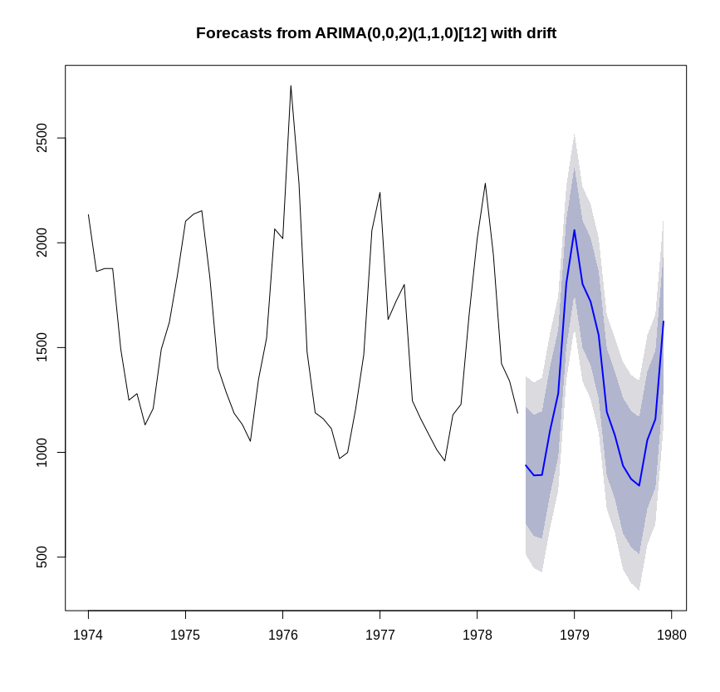

################# Q.15) PLOTTING PREDICTED AND ACTUAL VALUES ##############
X = time(arima_act_values)
arima_df <- as.data.frame(data.frame(X,predicted$Point.Forecast,arima_act_values))
ggplot(arima_df,aes(X))+
geom_line(aes(y=predicted$Point.Forecast),colour="green")+
geom_line(aes(y=arima_act_values),colour = "black") + xlab("Time") + ylab("Deaths")+
ggtitle("Predicted(green) and actual (black) values graph")
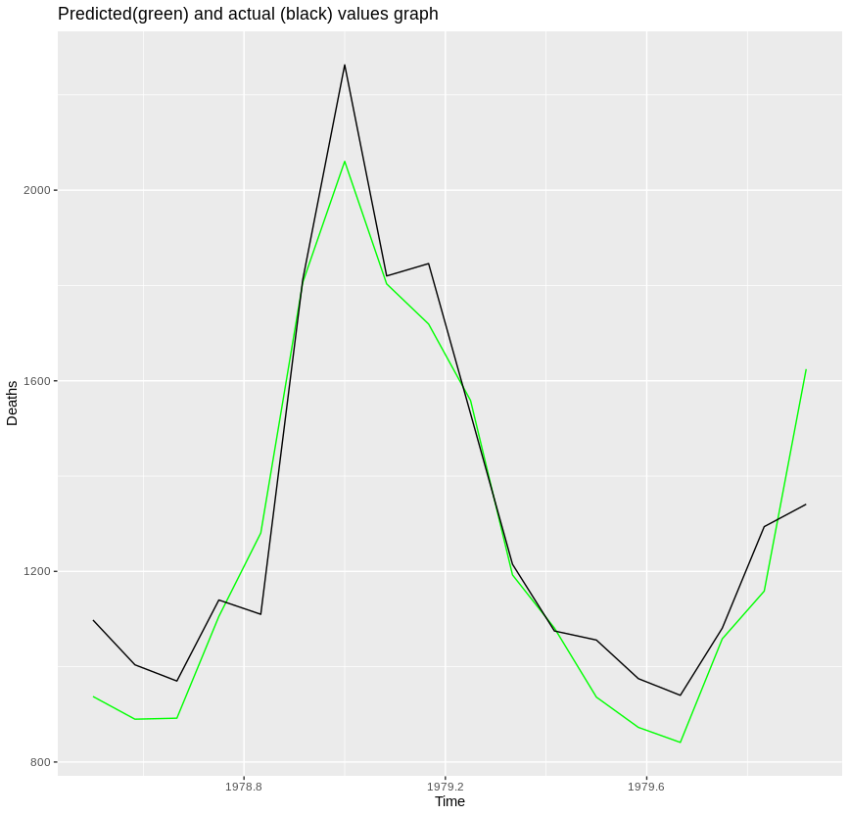
############ Q.16) RMS ERROR BETWEEN PREDICTED AND ACTUAL VALUE USING ARIMA MODEL ###########
rmse(arima_act_values,predicted$Point.Forecast)
###### OUTPUT
[1] 121.953

####### Q.17) NOT POSSIBLE IN THIS MODEL

####### Q.18) ARIMA MODEL IS GOOD AS ARIMA HAVE RMS ERROR VALUE OF (121.95) whereas HOTWINTER MODEL HAVE ERROR VALUE OF (138.58)

####### Q.19) BELOW ARE THE PLOTS WITH AND WITHOUT CLEANING THE DATA

################# Q.20) CLEANING THE DATA ###############
Cleaned <- tsclean(my_Object)
modelcl <- HoltWinters(Cleaned)
model_without_cleaning <- HoltWinters(my_Object)
plot(model_without_cleaning, main = "Original with Fitted time series : Raw Data")
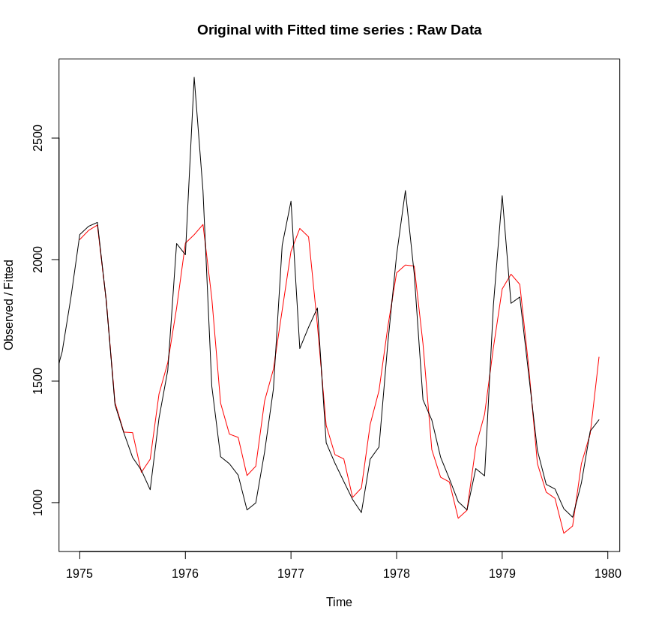

plot(modelcl, main = "Original with Fitted time series : Cleaned Data")
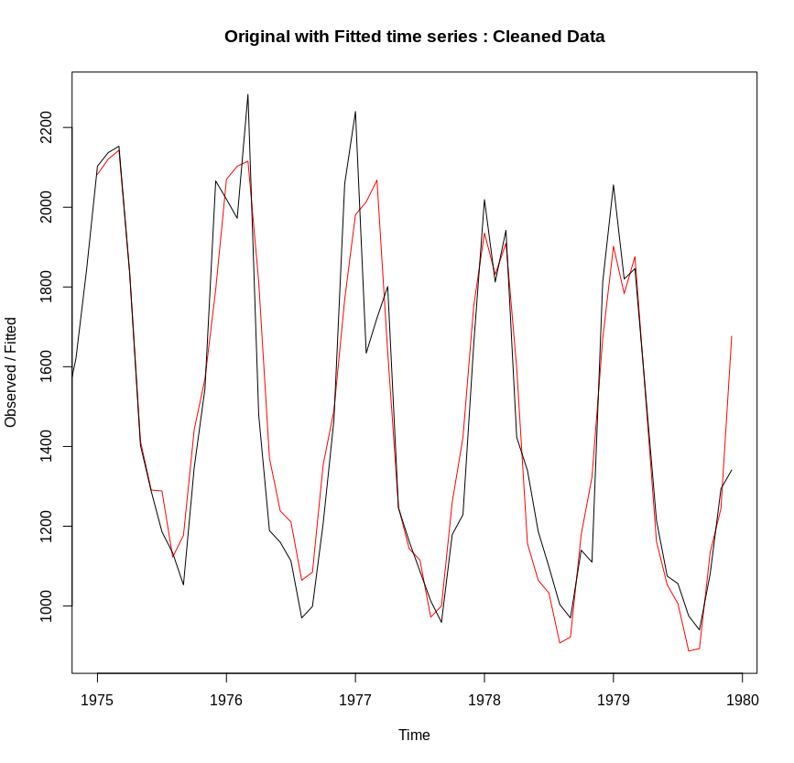
modelcl$SSE
######## OUTPUT
[1] 1186927

model_without_cleaning$SSE
######## OUTPUT
[1] 2005186

