**Figure1:** Forecasting of Tomato, Potato

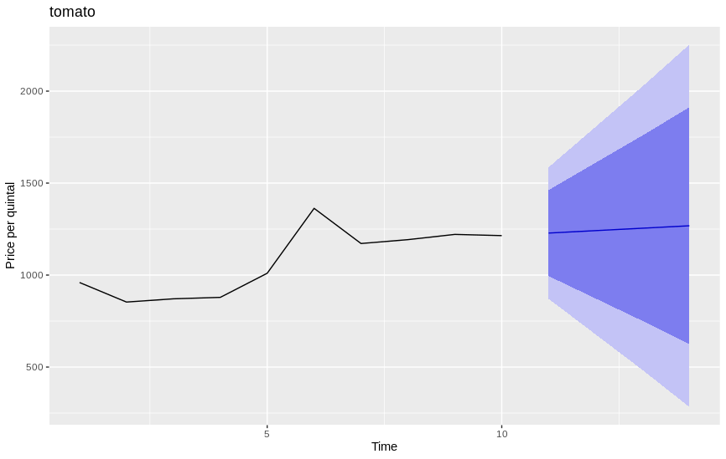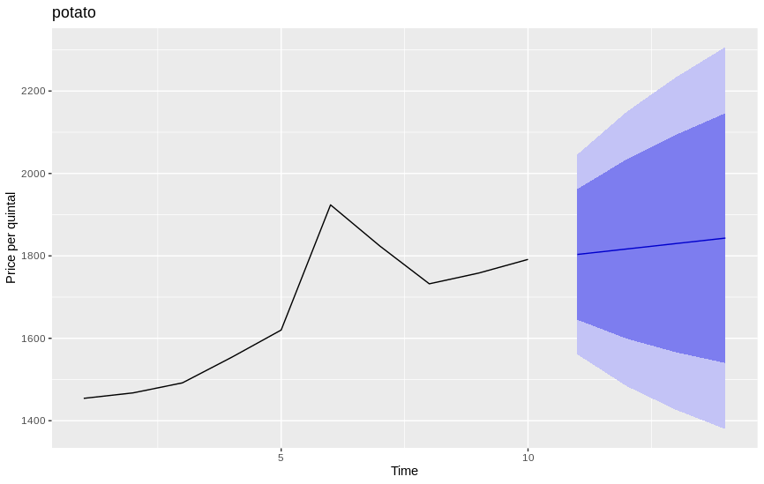

**Figure 2:** Forecasting of Cabbage, Brinjal

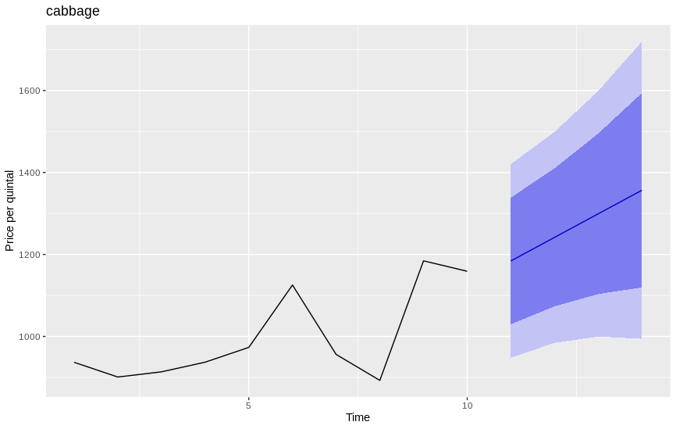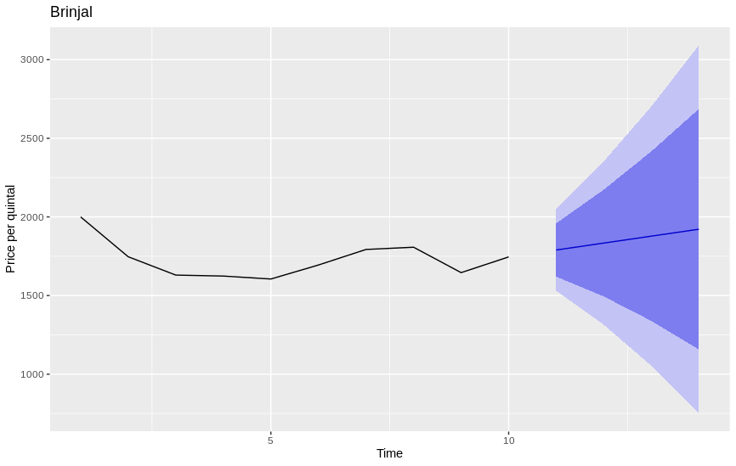

**Figure 3:** Forecasting of Lady’s Finger, Onion

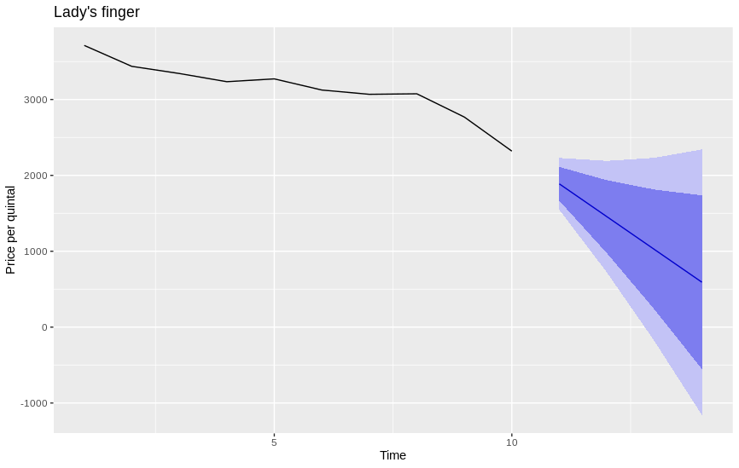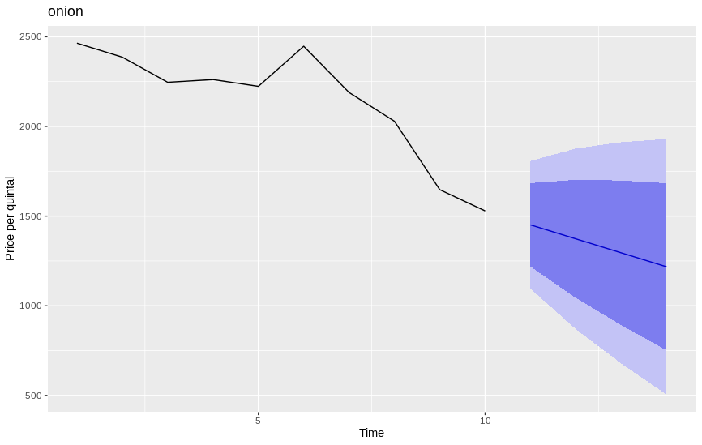

**Figure 5:** Forecasting of Cauliflower

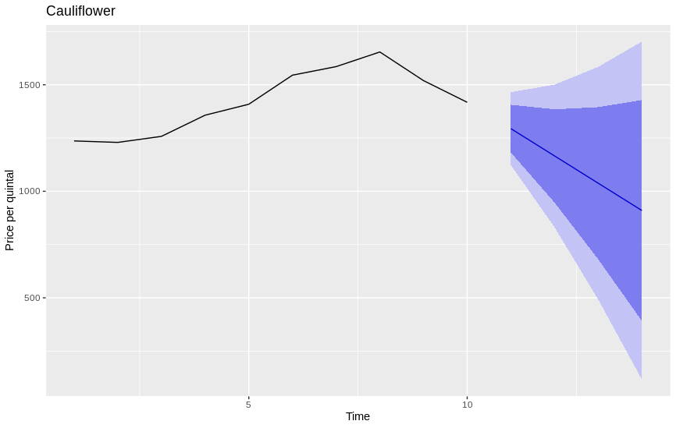

# Abstract:

On 30th January 2020, India reported its first case affected by Coronavirus[4]. Considering the condition of the countries due to the spreading rate and other factors of this disease, the World Health Organisation (WHO) declared Coronavirus Disease (COVID19) a pandemic. With increasing the number of suspects in India, the government of India decided to take strict actions towards this, so that it can be controlled before spreading in the country.

As a result of this, educational institutions, various commercial establishments, restaurants, bars have been shut down, and the government banned most of the public transportation in the country during this lockdown. due to this export and import business also gets stopped. These sudden changes in the country affected every sector of business and supply chain of products including various agricultural products like fruits, vegetables, etc. This study aims to forecast the weekly Average Prices of various Vegetables like Onion, Tomato, Potato, Cauliflower, Lady’s finger, Brinjal and Cabbage in India considering various states that we’ll see later. The data which we have used to forecast the prices of above-mentioned vegetables have been obtained from Indian Government official website [www.data.gov.in](http://www.data.gov.in) which is a secondary source of data where prices of various vegetables are updated corresponding to their state prices on a regular basis, based on the availability of data from primary sources. We have used the Holt-Winters method to predict the future prices of each individual vegetable, along with this we’ll see the trend of the weekly average prices that have changed in a duration of 10 weeks starting from 20th February, 2020 up to 29th April 2020. Taking 95% of Confidence Interval, it is observed that in Onion, Lady’s finger, Cauliflower the predicted Prices of next 4 weeks are significantly seems to be decreasing, while in Tomato, Potato, Cabbage, and Brinjal, the weekly average prices seem to significantly increase in the country. It is suggested that, by keeping in view about the low-income workers who were earning on a daily basis, or any low budget income family who are not able to make money due to the lockdown throughout the country, and the accurate forecasting of agricultural products or any necessary product, the government should make sure that at least vegetables and such product is in reach of the last person of the country.

Keywords: Coronavirus Disease (COVID-19), Lockdown, weekly average prices, India

# Introduction

[2]The impact of Covid-19 across the world has been as unprecedented as it has been devastating. Equally unprecedented has been the response of the nations of the world, with bans on travel, closure of borders, closure of businesses, and in several cases, complete lockdowns. The attempts at “flattening the curve” seems increasingly likely to lead to an international recession.

Considering the impact an exponential spread of Covid-19 can have on a country with high population density and relatively limited healthcare infrastructure as India, the Government of India found itself compelled to impose a 14 hrs public curfew on 22nd March 2020 India that followed up with lockdown in 75 districts that were most suspicious, which again extended as a 21 days lockdown throughout the country from 24th March 2020 to 14th April 2020. The outbreak has been declared an epidemic among the majority of the Indian states and Union territories, under the Epidemic Diseases Act, 1897 (Dikid et al, 2013). All the tourist visas have been suspended, along with the closure of all educational institutions, modes of transportation, and a majority of commercial establishments have been shut down to avoid the spread. Due to the situation of spreading the virus the First lockdown was extended upto 3rd May 2020 and Currently, the third phase of lockdown has been rolled out and again this ongoing lockdown has been extended again upto 17th May 2020.

It is important to note that Agriculture is the largest employer in the country, which is largely informal, is severely affected by distortions in the food supply chain induced by the pandemic. In the wake of the nationwide lock-down, empty aisles of stores and out-of-stock images of essential food items on online portals give the appearance of the country running out of supply. As of now, it seems like there is no shortage of material lying in the supply chain, but temporary bottlenecks in the flow of goods will distort supply chains for a brief period. [2]The supply is more with the arrival of the rabi crops, while the retail demand is yet to come back. The closure of several mandis and hiccups in the movement of goods will have a significant impact on farmers’ realization, especially small and marginal farmers who can’t hold the product for a longer time.

Farmers who grow perishables, especially fruits and vegetables, are already facing the heat of the situation with prices plummeting, reduction in bulk demand from hotels and restaurants, and uncertainty over exports. Due to less demand there is also the case that farmers have reduced the production of various vegetables, as a result the prices of those vegetables are going to be affected for sure. Considering the families having low income and poor sectors of the country, it’s government responsibility to make sure that the necessary things are available to them at suitable or preferably at low prices as their earnings get affected due to ongoing lockdown. It is therefore important to forecast the precise increase or decrease in the prices of different vegetables and other products in the country. Accurate forecasting of the prices of vegetables can play an important role in apprising the government, farmers and public to take decisions accordingly. In this paper, we are estimating the best possible weekly average predicted vegetable prices from the publicly available secondary source of data of different vegetable prices across various states in the country, using Holt-Winters method. We assume that publicly available dataset of vegetable prices are legitimate subject to certain reporting biases if any, and taking the average price if any weeks data is not updated in the secondary source. The objective is not to attempt for meticulous precision but to merely provide useful insight on vegetable prices in India.

# 

# Material and Methods

## Data Collection

The data is collected from the publically available secondary sources of Indian government official website i.e [www.data.gov.in](http://www.data.gov.in) (open data platform) for vegetables, which we have considered are, Onion, Tomato, Potato, Cabbage, Cauliflower, Lady’s finger and Brinjal. Each category of vegetable has an individual dataset, and in raw data of each vegetable, there are many columns like various States of India, few districts and markets corresponding to each state, minimum price, maximum price and an estimated model price column in each vegetable dataset.

## Preprocessing on Dataset/ Inclusion and Exclusion criteria

After getting the raw data files of each seven categories of vegetables, we had to make this data suitable for the analysis on the prices of the vegetables. Since in the raw dataset all seven categories of vegetables have a varied number of states for which data is provided by the government, we need to find out and select the States which are common in all seven vegetables. And we finally selected Twelve such states Chhattisgarh, Gujarat, Haryana, Himachal Pradesh, Karnataka, Kerala, Madhya Pradesh, Odisha, Punjab, Rajasthan, Uttar Pradesh, West Bengal) which are present in all the categories and considered them for our analysis. Also, since we want to predict the prices of vegetables in this ongoing lockdown due to COVID'19, we've included a total of around 10 weeks of data in the final dataset, in which first week starts from 20th Feb 2020 and 10th week ends at 29th April 2020, which includes around 5 weeks of data before the 1st lockdown that is before 24th March 2020 and around 5 weeks of data after the lockdown starts in the country.

We have also created a weekly average dataset from the formerly prepared dataset for each state, and taken the average value if data of any week is not updated by the primary sources. Further, we have created a country wise weekly dataset, where for each individual vegetable we have taken week 1 average price for each of 12 states and taken the whole average of it, that represents the modal average price of that vegetable in the country in the 1st week considering 12 states. Similarly we have done for all 10 weeks, to see the overall weekly average price of each vegetable throughout the country at a glance, and we can forecast for future weeks using this data..

## 

## Analysis/Method

Our main objective is to forecast the weekly average prices of each vegetable in the country after 29th April 2020. So the final processed data, which contains weekly prices of each vegetable, considering all 12 states for a duration of 10 weeks, includes the prices from 20th Feb 2020 to 29th April 2020 can now be used for our analysis.

[3] Exponential smoothing has proven through the years to be very useful in many forecasting situations. It was first suggested by C. C. Holt in 1957 and was meant to be used for non-seasonal time series showing no trend. He later offered a procedure (1958) that does handle trends. Winters (1960) generalized the method to include seasonality, hence the name "Holt-Winters Method" or Triple Exponential Smoothing. So we have used Triple Exponential Smoothing (Holt-Winters method), a family of forecasting models. Using this method, we can model and predict the behaviour of a sequence of values over a period of time. Main idea here is to give more priority on prices of recent weeks in the series. As an observation gets older (in terms of time), the importance of value decreases, that’s why we have taken up the latest available dataset. [4] Application of Triple Exponential method requires the following equations.

Ft+m = (*Lt* + *mTt*) * *St* + *m* −*p*

Where Ft+m represents the forecast for m-steps ahead period

Level at time t= *Lt* = *α* (*Yt* / *St–p* ) + (1 – *α*) [*Lt–1* + *Tt–1* ]

Trend at time t = *Tt* = *γ* [*Lt* – *Lt–1* ] + (1 – *γ*) *Tt–1*

Seasonal component at time t *=* St = δ (Yt / Lt ) + (1 – δ) St–p

Where *α,*  *γ, δ*  and are smoothing constants between 0 and 1 that must be estimated in such a way that the MSE of the error is minimized, and Y is the prices of each vegetable taken while it’s estimation.

Forecasting in R software is done with Triple exponential smoothing (Holt-Winters methods) using the forecast package which is available in base R.

# 

# Results

The study estimates suggested that, while taking 95% of Confidence Interval, it is observed that in Onion, Lady’s finger, Cauliflower the predicted Prices of next 4 weeks are significantly seems to be decreasing, while in Tomato, Potato, Cabbage, and Brinjal, the weekly average prices seem to significantly increase in the country. The base data of all seven Vegetables i.e, Onion, Tomato and Potato, Lady’s finger, Cauliflower, Cabbage and Brinjal has been taken from 20th feb, 2020 to 29th April 2020, to predict the weekly average prices of each for next 4 weeks i.e, week starting from 30th April 2020 to the week that ends at 20th May, 2020. You can see Point estimated value along with the value at 95% Confidence Interval in the below tables, along with the original final dataset of 10 weeks of weekly average price table which have been used for the forecasting that is given in **Table 4**.

**Table 1:** For Onion we can observe that, estimated weekly average prices are decreasing from Rs 1451.015 and went down to Rs 1217.303 in the fourth week. Also, if we look at the available price of Onion for 10 weeks i.e, before 30th April 2020, we can observe that most of the time weekly prices keep on decreasing which is continued in our prediction of next 4 weeks. In the same way we can see in Tomato and Potato that the predicted prices are significantly increasing that goes from Rs 1228.445 upto Rs 1268.033 and Rs 1803.509 upto Rs 1843.226 respectively.

**Table 2:** And in this table for Lady’s Finger, we can observe that, estimated weekly average prices are decreasing from Rs 1887.6113 and went down Rs592.0212 in the fourth week. Also, if we look at the available price of Lady’s Finger for 10 weeks i.e, before 30th April 2020, we can observe here also that, most of the time weekly prices keep on decreasing which is continued in our prediction of next 4 weeks. Similarly, in Cauliflower also we can see the predicted prices are significantly decreasing from Rs 1293.9984 and went down to Rs 909.6058.

**Table 3:** In this table we can observe the predicted value for Cabbage and Brinjal. In Cabbage we can see that, estimated weekly average prices are increasing from Rs 1184.249 and goes upto Rs 1356.704 in the 4th week. And similarly for Brinjal also we can see that predicted prices are significantly increasing from Rs 1789.756 to Rs 1921.850.

**Table 1:** Forecasting weekly average prices for Onion, Tomato, Potato from Holt-Winters method at 95% of confidence interval

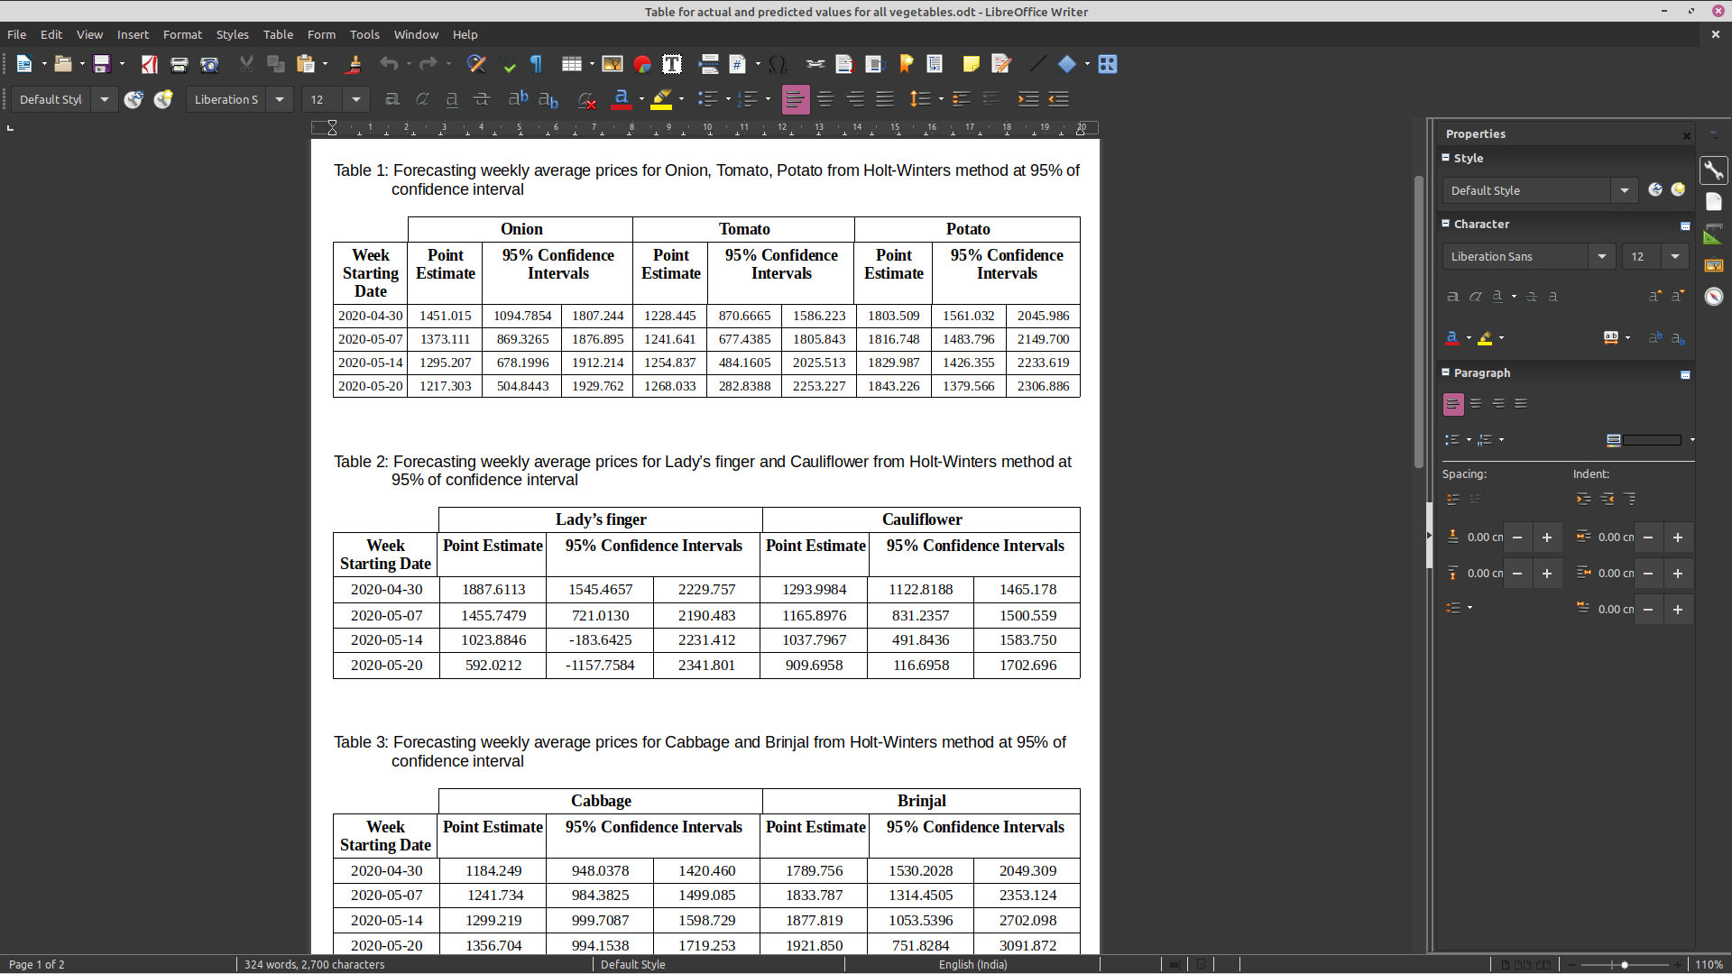

|  |  |  |  |  |  |  |  |  |  |
| --- | --- | --- | --- | --- | --- | --- | --- | --- | --- |
| 2020-04-30 | 1451.015 | 1094.7854 | 1807.244 | 1228.445 | 870.6665 | 1586.223 | 1803.509 | 1561.032 | 2045.986 |
| 2020-05-07 | 1373.111 | 869.3265 | 1876.895 | 1241.641 | 677.4385 | 1805.843 | 1816.748 | 1483.796 | 2149.700 |
| 2020-05-14 | 1295.207 | 678.1996 | 1912.214 | 1254.837 | 484.1605 | 2025.513 | 1829.987 | 1426.355 | 2233.619 |
| 2020-05-20 | 1217.303 | 504.8443 | 1929.762 | 1268.033 | 282.8388 | 2253.227 | 1843.226 | 1379.566 | 2306.886 |

**Table 2:** Forecasting weekly average prices for Lady’s finger and Cauliflower from Holt-Winters method at 95% of confidence interval



|  |  |  |  |  |  |  |
| --- | --- | --- | --- | --- | --- | --- |
| 2020-04-30 | 1887.6113 | 1545.4657 | 2229.757 | 1293.9984 | 1122.8188 | 1465.178 |
| 2020-05-07 | 1455.7479 | 721.0130 | 2190.483 | 1165.8976 | 831.2357 | 1500.559 |
| 2020-05-14 | 1023.8846 | -183.6425 | 2231.412 | 1037.7967 | 491.8436 | 1583.750 |
| 2020-05-20 | 592.0212 | -1157.7584 | 2341.801 | 909.6958 | 116.6958 | 1702.696 |

**Table 3:** Forecasting weekly average prices for Cabbage and Brinjal from Holt-Winters method at 95% of confidence interval



|  |  |  |  |  |  |  |
| --- | --- | --- | --- | --- | --- | --- |
| 2020-04-30 | 1184.249 | 948.0378 | 1420.460 | 1789.756 | 1530.2028 | 2049.309 |
| 2020-05-07 | 1241.734 | 984.3825 | 1499.085 | 1833.787 | 1314.4505 | 2353.124 |
| 2020-05-14 | 1299.219 | 999.7087 | 1598.729 | 1877.819 | 1053.5396 | 2702.098 |
| 2020-05-20 | 1356.704 | 994.1538 | 1719.253 | 1921.850 | 751.8284 | 3091.872 |

**Table 4:** Actual weekly prices for all above seven Vegetables for a duration of 10 weeks, which is generated from given dataset

|  |  |  |  |  |  |  |  |
| --- | --- | --- | --- | --- | --- | --- | --- |
| **Week**  **Starting**  **Date** | **Onion** | **Tomato** | **Potato** | **Cabbage** | **Lady's**  **finger** | **Cauliflower** | **Brinjal** |
| 2020-02-20 | 2464.187583 | 959.4900833 | 1454.350192 | 936.8611167 | 3712.567417 | 1236.271817 | 1999.940475 |
| 2020-02-27 | 2386.283667 | 853.3392833 | 1467.589292 | 900.9563417 | 3436.793667 | 1229.3631 | 1746.650833 |
| 2020-03-05 | 2246.09125 | 870.921625 | 1491.964283 | 913.6626917 | 3342.53975 | 1257.768842 | 1630.15475 |
| 2020-03-12 | 2261.250083 | 878.8154667 | 1554.166667 | 937.1726167 | 3234.535833 | 1357.1865 | 1623.876917 |
| 2020-03-19 | 2223.54827 | 1009.934517 | 1620.140441 | 973.3075 | 3271.72225 | 1408.517833 | 1605.170642 |
| 2020-03-26 | 2447.033123 | 1362.777775 | 1923.769842 | 1125.422856 | 3124.763089 | 1544.956342 | 1694.321583 |
| 2020-04-02 | 2189.184189 | 1171.627975 | 1823.799667 | 956.0161313 | 3068.387885 | 1585.080689 | 1793.138883 |
| 2020-04-09 | 2028.878975 | 1192.589275 | 1732.25795 | 892.746025 | 3075.10325 | 1653.726192 | 1807.4445 |
| 2020-04-16 | 1647.1627 | 1221.10367 | 1758.283733 | 1184.42212 | 2768.579417 | 1519.306331 | 1645.823417 |
|  |  |  |  |  |  |  |  |

# Discussion

From the above results It is observed that in Onion, Lady’s finger, Cauliflower the predicted Prices of next 4 weeks seems to significantly decrease, while in Tomato, Potato, Cabbage, and Brinjal, the weekly average prices seem to significantly increase in the country. It is suggested that, by keeping in view about the low-income workers who were earning on a daily basis, or any low budget income family who are not able to make money due to the lockdown throughout the country, using the accurate forecasting of agricultural products or any necessary product, the government should make sure that at least vegetables and such product is in reach of the last person of the country.

Also, since the farmers who grow perishables, especially fruits and vegetables, are already facing the heat of the situation with prices plummeting, reduction in bulk demand from hotels and restaurants, and uncertainty over exports. Due to less demand there is also the case that farmers have reduced the production of various vegetables, as a result the prices of those vegetables are going to be affected for sure. Considering the families having low income and poor sectors of the country, it’s government responsibility to make sure that the necessary things are available to them at suitable or preferably at low prices as their earnings get affected due to ongoing lockdown.

# References

1. <https://en.m.wikipedia.org/wiki/2020_coronavirus_pandemic_in_India>
2. <https://www.thehindubusinessline.com/opinion/covid-19-exposes-indian-industrys-supply-chain-vulnerabilities/article31224928.ece>
3. <http://sbear.in/V2(1)-04.pdf>
4. <https://support.minitab.com/en-us/minitab/18/help-and-how-to/modeling-statistics/time-series/how-to/winters-method/methods-and-formulas/methods-and-formulas/>