

Report on
Google Bigtable

Course: Databse Management System (DBMS CS502)

Under the Guidence of: Dr Uma S

Name: Dheeraj Chaudhary
Roll No: 17BCS009

Contents

1. Introduction...........................................................................3
1.1 Scope...........................................................................3
1.2 Literature Study...........................................................4
2. New Proposed Solution – Reasearch paper..........................5
2.1 Paper 1.........................................................................5
2.2 Paper 2.........................................................................7
2.3 Paper 3.........................................................................8
3. References.............................................................................9

1. Introduction

1.1 Scope:
Bigtable is a distributed storage system for managing structured data and it is also scalable to a very large size of data e.g, we can handle even petabytes of data across thousand of servers across the world. Now a days various applocation and projects in google uses bigtable to handle its huge data. After getting various demands from these application in form of data size and latency requirement, bigtable fulfills the demand of these google product with a very high performance. Here i’ll disuss about the data model, buillding blocks, design and implementation etc. of Bigtable.
The problem that came across was to handle large amount of data that’s increasing data by day. Although google was already capable of handling a huge amount of data that we can’t even imagine, but they know that with the rate of growing data the will definetely need some different architechtural system to handle those data.
So they came across with this system known as Bigtable, it has achieved several goal like wide applicability, scalability, high per-formance, and high availability. Google uses bigtable in more than it’s sixty products and projects Google Analytics, Google Finance, Orkut, Person-alized Search, Writely, and Google Earth. Some of the popular products are Google Analytics, Google Finance, Orkut, Person-alized Search, Writely, and Google Earth.
These applications uses Bigtable to handle various demands and workload like throughput-oriented batch-processing jobs to latency-sensitive serving of data to end users. These products span bigtable to a wide range of configurations, from handful to thousand of servers, and store hundreds terabytes of data.

1.2 Literature Study:
If we talk about bigtable, it was built by the google for its own use and never been released outside of Google. So bigtable was built on several other pieces of google infrastructure. Before bigtable was released google uses different separate products for handling it’s different areas of database requirements like Google File System (GFS) and Google SSTable, Chubby distributed lock system etc.
So combining these various infrastructures of google bigtable was developed. So worked were already done on these products, like Earlier to bigtable, research were done on Google File System that met the requirements of generation and processing of data, if it is deployed on storage platform and it’s the main building block of Google Bigtable.
An atomic append operation was introduced in GFS so that multiple clients can append concurrently to a file without extra synchronization between them.
This file system have been guided by various assumptions that offers both challenges and opprotunities, as one assumptions was like the system was built from many inexpensive commodity component that may often get fail. It must constantly monitor itself and detect, tolerate, and recover promptly from component failures on a routine basis.
One more important infrastructure used in developing bigtable was, Chubby lock service, which consist of five active replicas out of which one is elected to be the master and actively serve requests. And it’s important to be active of one replicas all the time, and to handle this limitation do this Chubby uses an algorithm know as Paxos algorithm.
Many instances of the service have been used to handle a few tens of thousands of clients concurrently.

2. New proposed Solution – Research papers

2.1 Paper 1: Bigtable: A Distributed Storage System for Structured Data, 7th Symposium on Operating Systems Design and Implementation (OSDI ’06)
The problem of handling several hundreds of terebytes of data was tried to be solved. A solution was proposed by “Fay Chang, Jeffrey Dean, Sanjay Ghemawat, Wilson C. Hsieh, Deborah A. Wallach Mike Burrows, Tushar Chandra, Andrew Fikes, Robert E. Gruber” to use Bigtable to get rid of the problem of storing such a huge amount of data.
Bigtable shares many implementation strategies with database, so it remebles a database in many ways. Parallel database and main-memory database have achieved scalability and high performance, but the interface provided by Bigtable is different then such systems. As Bigtable doesn’t support a full relational data model, instead it provides instead, it provides clients with a simple data model that supports dynamic control over data layout and format, and allows clients to reason about the locality properties of the data represented in the underlying storage.
Data model: A Bigtable is distributed, sparse, persistent multidimensonal sorted map. This sorted map is indexed by a row key, column key, and a timestamp and the value in the map, each value in the map is an uninterpreted array of bytes.
(row:string, column:string, time:int64) → string
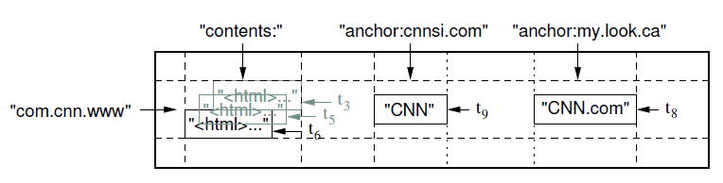

Bigtable have it’s own API and it provides function like creating and deleting tables and coloumn families, also we can change cluster, table and column family metadata, such as access control rights.
The major components that bigtable uses for it’s implemention are a library which is linked with every client, one is master server, and many other tablet servers. Tablet server can be dynamically added or removed from a cluster to accomodate changes in the workloads.
The master server is responsible for assigning tablets to tablet server,
The clusters of a bigtable is capable of storing a number of tables, and every set of tables contains set of tablets and these tablets contains all data associated with a row range. As i discussed bigtable is scalable, so initially each table contains just one tablet and automatically split into multiple tablets as the table it grows.
Bigtable uses three level hierarchy
Level 1 is Chubby file containing the location of the root tablet
Level 2 is Root tablet which contains the location of METADATA tablets
Level 3 is Each METADATA tablet that contains the location of user tablets

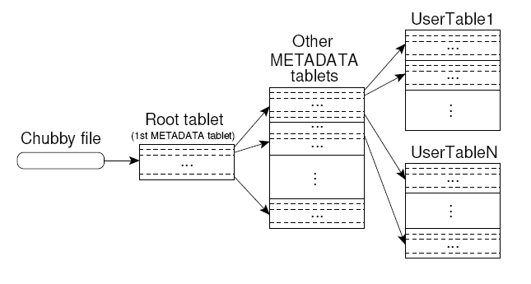

2.2 Paper 2: The Google File System, 19th ACM SOSP (2003)
Google File System(GFS) was designed and implemented to meet the rapidly growing demand of google’s data processing. It’s a scalable distributed file system for large distributed data-intensive application. Google File System has met the requirements of generation and processing of data, if it is deployed within the google on storage platform.
Multiple GFS clusters are currently deployed for many different purposes, the largest cluster have over 1000 storage nodes, over 300 TB of diskstorage, and are heavily accessed by hundreds of clients on distinct machines on a continuous basis.
Though GFS doesn’t implement a standard API such as POSIX, but it provide a familiar file system interface. It supports the usual operations to create, to delete, to open, close, read, and write files.
Model: A GFS cluster consist of a single master and multiple chunkservers and is accessed by multiple client as shown
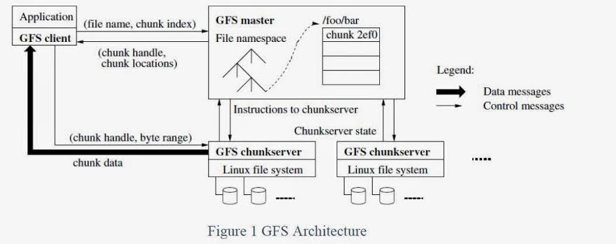

GFS also have relaxed consistency model that supports our highly distributed appllication well but relatively simple and efficient to implement

2.3 Paper 3: The Chubby lock service for loosely-coupled distributed systems, 7th Symposium on Operating Systems Design and Implementation (OSDI ’06)
Chubby lock service system is used within a loosely-coupled distributed systems consisting of moderately large numbers of small machines connected by a high-speed network. It helps to deal with coarse-grained synchronization within the system e.g, Google file system uses a Chubby lock to appoint a GFS master server.
Also Bigtable uses Chubby service in several ways like to elect a master, to allow the master to discover the servers it controls, and to permit clients to find the master. So basically bigtable and GFS uses chubby as root of their distributed data structure.
Model/Structure: Chubby system consist of five active replicas, out of these five one is elected as master and actively serve request. The service is live when majority of these replicas are live and able to communicate with each other.
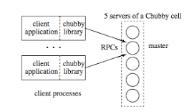

Chubby uses Paxos algorithm to keep it’s replicas consistent in face of failure, and the two main components in the system are chubby master and chubby client library.

3. References

1.https://static.googleusercontent.com/media/research.google.com/en//archive/bigtable-osdi06.pdf
2.https://ai.google/research/pubs/pub51
3.https://static.googleusercontent.com/media/research.google.com/en//archive/gfs-sosp2003.pdf
4.https://static.googleusercontent.com/media/research.google.com/en//archive/chubby-osdi06.pdf
5.https://medium.com/coinmonks/chubby-a-centralized-lock-service-for-distributed-applications-390571273052

