Vayu Air — Warehouse Design Challenge
Final Submission

Task 7(a): Medallion Layer Mapping
Table | Layer | Why it sits there
bronze_airports | Bronze | Raw, untouched copy of the source system's airport master data — no transformation applied.
bronze_aircraft | Bronze | Raw, untouched copy of aircraft reference data from source.
bronze_passengers | Bronze | Raw, untouched current-state snapshot of passengers as delivered from source.
bronze_flights | Bronze | Raw, untouched flight schedule data from source.
bronze_bookings | Bronze | Raw, untouched transactional booking records — the source of the sales fact, before any modeling.
stg_passenger_updates | Bronze | The raw daily change feed, exactly as delivered from source, before any lookup, translation, or comparison logic is applied.
staging_passenger_upd | Silver | Intermediate, transient table — resolves staging's business-key airport code into the warehouse's surrogate home_airport_key, and trims tier values. Not queried by reports; exists only to prepare data for the SCD2 comparison.
dim_aircraft | Gold | Modeled dimension with a surrogate key (aircraft_key) and retained business key (aircraft_code) — ready for direct use in joins and reports.
dim_flight | Gold | Modeled dimension with surrogate key, retained business key, and resolved foreign keys to dim_airport/dim_aircraft — the final, query-ready shape.
dim_date | Gold | Fully generated calendar dimension with a meaningful YYYYMMDD surrogate key — a conformed dimension reused across every date reference in the warehouse.
dim_airport (flat) | Gold | Original flat modeled dimension, kept for comparison against the snowflaked version — still surrogate-keyed and business-key-retaining.
dim_airport_sf, dim_city, dim_country | Gold | The snowflaked geography chain — fully modeled, surrogate-keyed, resolvable from airport all the way up to country.
dim_passenger | Gold | Modeled SCD Type 1 (pre-history) dimension — surrogate key, business key retained, initial load only, no history tracking yet applied.
dim_passenger_scd_typ2 | Gold | The final SCD Type 2 passenger dimension — surrogate key per version, business key retained, effective_from/effective_to/is_current tracking full history.
FactTicketSales | Gold | The final, partitioned, fully surrogate-keyed fact table — the object analysts and BI tools query directly for revenue reporting.

Note on design choice: no separate, permanent silver tables were built for aircraft, airport, flight, or the initial passenger load — cleaning and key-resolution happened inline as part of the load-into-gold step, a valid simplification for a project at this scale. The one genuine silver-layer artifact is staging_passenger_upd, used to prepare the SCD2 comparison.

Task 7(b): Data Contract — bronze_bookings
Owner: Vayu Air Booking Systems team (source system owner)
Consumer: Vayu Air Analytics Engineering team (this warehouse)
Grain: One row per ticket booked (booking_id is unique per row).

Schema and types
Column | Type | Nullable | Description
booking_id | INT | No | Unique booking identifier (business key)
passenger_id | INT | No | FK to bronze_passengers
flight_id | INT | No | FK to bronze_flights
booking_date | DATE | No | Date the ticket was booked
travel_date | DATE | No | Date of the flight travelled
fare_class | VARCHAR(20) | No | Enumerated — see allowed values
fare_amount | DECIMAL(10,2) | No | Base fare in INR
tax_amount | DECIMAL(10,2) | No | Taxes and fees in INR
booking_status | VARCHAR(20) | No | Enumerated — see allowed values
miles_earned | INT | No | Loyalty miles credited

Allowed values
fare_class: Economy, Premium Economy, Business, First
booking_status: Confirmed, Cancelled, NoShow

Freshness / delivery SLA
The feed is delivered as a full daily batch, landing in the bronze area by 6:00 AM IST, containing every booking transaction (new, and status updates such as cancellations) recorded in the source system as of the previous day's close.

Breaking change (requires coordination before release)
Renaming fare_class to cabin_class, or removing a currently-allowed value the pipeline depends on (e.g., dropping NoShow from booking_status) — either would cause the warehouse's load and business-rule logic (booking_status = 'Confirmed' for revenue) to silently fail or misclassify data. Must be communicated and coordinated in advance.

Non-breaking change (safe without prior warning)
Adding a new optional column (e.g., seat_number or payment_method) to the feed. Existing load scripts select only the columns they know about, so the pipeline continues to function unaffected; the new column can be adopted into the model later, on the warehouse team's own schedule.

Full T-SQL Script
-- ============================================================
-- CREATING NEW DATABASE
-- ============================================================
CREATE DATABASE VayuAir;
USE VayuAir;

SELECT 'bronze_airports' AS table_name, COUNT(*) AS rows FROM bronze_airports
UNION ALL SELECT 'bronze_aircraft', COUNT(*) FROM bronze_aircraft
UNION ALL SELECT 'bronze_passengers', COUNT(*) FROM bronze_passengers
UNION ALL SELECT 'bronze_flights', COUNT(*) FROM bronze_flights
UNION ALL SELECT 'bronze_bookings', COUNT(*) FROM bronze_bookings
UNION ALL SELECT 'stg_passenger_updates', COUNT(*) FROM stg_passenger_updates;

-- ============================================================
-- TASK 1: Grain statement + column classification (fact_bookings)
-- ============================================================
-- GRAIN:
-- One row in fact_bookings represents one ticket booked (one row per booking_id
-- in bronze_bookings). Each row is a single passenger's single booking on a
-- single flight. booking_id is unique per row - no fan-out.

-- COLUMN CLASSIFICATION (bronze_bookings joined to bronze_flights)
-- booking_id | bronze_bookings | Dimension key (grain key / degenerate dimension)
-- passenger_id | bronze_bookings | Dimension key -> dim_passenger
-- flight_id | bronze_bookings | Dimension key -> dim_flight
-- booking_date | bronze_bookings | Dimension key -> dim_date (role: booked)
-- travel_date | bronze_bookings | Dimension key -> dim_date (role: travelled)
-- fare_class | bronze_bookings | Dimension key (degenerate dimension)
-- booking_status | bronze_bookings | Dimension key (degenerate dimension)
-- fare_amount | bronze_bookings | Measure
-- tax_amount | bronze_bookings | Measure
-- miles_earned | bronze_bookings | Measure
-- flight_number | bronze_flights | Dimension attribute (belongs to dim_flight)
-- origin_airport_code | bronze_flights | Dimension key -> dim_airport (role: origin)
-- dest_airport_code | bronze_flights | Dimension key -> dim_airport (role: destination)
-- aircraft_code | bronze_flights | Dimension key -> dim_aircraft
-- flight_date | bronze_flights | Dimension attribute (redundant with travel_date --
-- travel_date drives the fact's date key)

-- ADDITIVITY NOTE:
-- fare_amount, tax_amount, and miles_earned are additive -- safe to SUM across
-- any dimension (passenger, route, fare class, time). A non-additive example:
-- load factor (seats sold / seat capacity) -- summing this ratio across flights
-- or time produces a meaningless number and must instead be recalculated from
-- its components.

-- ============================================================
-- TASK 2: dw schema + star schema DDL
-- ============================================================
GO
-- CREATE SCHEMA vayuair_dw;

CREATE TABLE vayuair_dw.dim_aircraft (
aircraft_key INT IDENTITY(1,1) PRIMARY KEY,
aircraft_code VARCHAR(20) NOT NULL UNIQUE,
model VARCHAR(50) NOT NULL,
manufacturer VARCHAR(50) NOT NULL,
seat_capacity INT NOT NULL
);

CREATE TABLE vayuair_dw.dim_airport (
airport_key INT IDENTITY(1,1) PRIMARY KEY,
airport_code CHAR(3) NOT NULL UNIQUE,
airport_name VARCHAR(100) NOT NULL,
city VARCHAR(50) NOT NULL,
country VARCHAR(50) NOT NULL,
region VARCHAR(50) NOT NULL
);

CREATE TABLE vayuair_dw.dim_flight (
flight_key INT IDENTITY(1,1) PRIMARY KEY,
flight_id INT NOT NULL UNIQUE,
flight_number VARCHAR(20) NOT NULL,
origin_airport_key INT NOT NULL,
dest_airport_key INT NOT NULL,
aircraft_key INT NOT NULL,
flight_date DATE NOT NULL,
CONSTRAINT FK_flight_origin FOREIGN KEY (origin_airport_key)
REFERENCES vayuair_dw.dim_airport(airport_key),
CONSTRAINT FK_flight_dest FOREIGN KEY (dest_airport_key)
REFERENCES vayuair_dw.dim_airport(airport_key),
CONSTRAINT FK_flight_aircraft FOREIGN KEY (aircraft_key)
REFERENCES vayuair_dw.dim_aircraft(aircraft_key)
);

CREATE TABLE vayuair_dw.dim_passenger (
passenger_key INT IDENTITY(1,1) PRIMARY KEY,
passenger_id INT NOT NULL,
passenger_name VARCHAR(100) NOT NULL,
home_airport_key INT NOT NULL,
frequent_flyer_tier VARCHAR(20) NOT NULL,
signup_date DATE NOT NULL,
effective_from DATE NOT NULL,
effective_to DATE NULL,
is_current BIT NOT NULL,
CONSTRAINT FK_passenger_airport FOREIGN KEY (home_airport_key)
REFERENCES vayuair_dw.dim_airport(airport_key)
);

CREATE TABLE vayuair_dw.dim_date (
date_key INT PRIMARY KEY,
full_date DATE NOT NULL UNIQUE,
year INT NOT NULL,
month INT NOT NULL,
quarter INT NOT NULL,
day_name VARCHAR(10) NOT NULL,
is_weekday BIT NOT NULL
);

CREATE TABLE vayuair_dw.FactTicketSales (
booking_id INT NOT NULL PRIMARY KEY,
passenger_key INT NOT NULL,
flight_key INT NOT NULL,
booking_date_key INT NOT NULL,
travel_date_key INT NOT NULL,
fare_class VARCHAR(20) NOT NULL,
booking_status VARCHAR(20) NOT NULL,
fare_amount DECIMAL(10,2) NOT NULL,
tax_amount DECIMAL(10,2) NOT NULL,
miles_earned INT NOT NULL,
CONSTRAINT FK_fact_passenger FOREIGN KEY (passenger_key)
REFERENCES vayuair_dw.dim_passenger(passenger_key),
CONSTRAINT FK_fact_flight FOREIGN KEY (flight_key)
REFERENCES vayuair_dw.dim_flight(flight_key),
CONSTRAINT FK_fact_booking_date FOREIGN KEY (booking_date_key)
REFERENCES vayuair_dw.dim_date(date_key),
CONSTRAINT FK_fact_travel_date FOREIGN KEY (travel_date_key)
REFERENCES vayuair_dw.dim_date(date_key)
);

-- ============================================================
-- TASK 3: Load dimensions and fact
-- ============================================================

INSERT INTO vayuair_dw.dim_aircraft (aircraft_code, model, manufacturer, seat_capacity)
SELECT aircraft_code, model, manufacturer, seat_capacity
FROM bronze_aircraft;

INSERT INTO vayuair_dw.dim_airport (airport_code, airport_name, city, country, region)
SELECT airport_code, airport_name, city, country, region
FROM bronze_airports;

INSERT INTO vayuair_dw.dim_flight (flight_id, flight_number, origin_airport_key, dest_airport_key, aircraft_key, flight_date)
SELECT
bf.flight_id,
bf.flight_number,
origin.airport_key,
dest.airport_key,
ac.aircraft_key,
bf.flight_date
FROM bronze_flights bf
JOIN vayuair_dw.dim_airport origin ON bf.origin_airport_code = origin.airport_code
JOIN vayuair_dw.dim_airport dest ON bf.dest_airport_code = dest.airport_code
JOIN vayuair_dw.dim_aircraft ac ON bf.aircraft_code = ac.aircraft_code;

-- Checking range for date dimension
SELECT MIN(booking_date) AS min_booking, MAX(booking_date) AS max_booking,
MIN(travel_date) AS min_travel, MAX(travel_date) AS max_travel
FROM bronze_bookings;

-- Loading dim_date
DECLARE @StartDate DATE = '2024-01-01';
DECLARE @EndDate DATE = '2026-12-31';

;WITH DateSequence AS (
SELECT @StartDate AS full_date
UNION ALL
SELECT DATEADD(DAY, 1, full_date)
FROM DateSequence
WHERE full_date < @EndDate
)
INSERT INTO vayuair_dw.dim_date (date_key, full_date, year, month, quarter, day_name, is_weekday)
SELECT
CAST(FORMAT(full_date, 'yyyyMMdd') AS INT),
full_date,
YEAR(full_date),
MONTH(full_date),
DATEPART(QUARTER, full_date),
DATENAME(WEEKDAY, full_date),
CASE WHEN DATEPART(WEEKDAY, full_date) IN (1, 7) THEN 0 ELSE 1 END
FROM DateSequence
OPTION (MAXRECURSION 1100);

INSERT INTO vayuair_dw.dim_passenger (passenger_id, passenger_name, home_airport_key, frequent_flyer_tier, signup_date, effective_from, effective_to, is_current)
SELECT
bp.passenger_id,
bp.passenger_name,
da.airport_key,
bp.frequent_flyer_tier,
bp.signup_date,
bp.signup_date AS effective_from,
NULL AS effective_to,
1 AS is_current
FROM bronze_passengers bp
JOIN vayuair_dw.dim_airport da ON bp.home_airport_code = da.airport_code;

-- ============================================================
-- TASK 4: Snowflake the geography
-- ============================================================

CREATE TABLE vayuair_dw.dim_country (
country_key INT IDENTITY(1,1) PRIMARY KEY,
country_name VARCHAR(50) NOT NULL UNIQUE,
region VARCHAR(50) NOT NULL
);

CREATE TABLE vayuair_dw.dim_city (
city_key INT IDENTITY(1,1) PRIMARY KEY,
city_name VARCHAR(50) NOT NULL,
country_key INT NOT NULL,
CONSTRAINT FK_city_country FOREIGN KEY (country_key)
REFERENCES vayuair_dw.dim_country(country_key)
);

INSERT INTO vayuair_dw.dim_country (country_name, region)
SELECT DISTINCT country, region
FROM vayuair_dw.dim_airport;

INSERT INTO vayuair_dw.dim_city (city_name, country_key)
SELECT DISTINCT a.city, dc.country_key
FROM vayuair_dw.dim_airport a
JOIN vayuair_dw.dim_country dc ON a.country = dc.country_name;

CREATE TABLE vayuair_dw.dim_airport_sf (
airport_key INT IDENTITY(1,1) PRIMARY KEY,
airport_code CHAR(3) NOT NULL UNIQUE,
airport_name VARCHAR(100) NOT NULL,
city_key INT NOT NULL,
CONSTRAINT FK_city_airport FOREIGN KEY (city_key)
REFERENCES vayuair_dw.dim_city(city_key)
);

INSERT INTO vayuair_dw.dim_airport_sf (airport_code, airport_name, city_key)
SELECT
ba.airport_code,
ba.airport_name,
dc.city_key
FROM bronze_airports ba
JOIN vayuair_dw.dim_city dc ON ba.city = dc.city_name;

-- Validation: resolve airport all the way up to country
SELECT
a.airport_code,
a.airport_name,
c.city_name,
co.country_name,
co.region
FROM vayuair_dw.dim_airport_sf a
JOIN vayuair_dw.dim_city c ON a.city_key = c.city_key
JOIN vayuair_dw.dim_country co ON c.country_key = co.country_key;

-- TRADE-OFF NOTE:
-- Snowflaking geography into dim_airport -> dim_city -> dim_country removes
-- data redundancy and keeps country/region facts consistent in one place, at
-- the cost of needing two extra joins (instead of reading flat columns
-- directly) whenever a report wants an airport's city or country.

-- ============================================================
-- Loading the fact table
-- ============================================================

INSERT INTO vayuair_dw.FactTicketSales (booking_id, passenger_key, flight_key, booking_date_key, travel_date_key, fare_class, booking_status, fare_amount, tax_amount, miles_earned)
SELECT
bb.booking_id,
dp.passenger_key,
df.flight_key,
bd.date_key AS booking_dt_key,
td.date_key AS travel_dt_key,
bb.fare_class,
bb.booking_status,
bb.fare_amount,
bb.tax_amount,
bb.miles_earned
FROM bronze_bookings bb
JOIN vayuair_dw.dim_passenger dp ON bb.passenger_id = dp.passenger_id
JOIN vayuair_dw.dim_flight df ON bb.flight_id = df.flight_id
JOIN vayuair_dw.dim_date bd ON bb.booking_date = bd.full_date
JOIN vayuair_dw.dim_date td ON bb.travel_date = td.full_date;

-- ============================================================
-- TASK 5: SCD Type 2 for dim_passenger
-- ============================================================

SELECT
s.passenger_id,
s.passenger_name,
s.home_airport_code,
a.airport_key AS home_airport_key,
TRIM(s.frequent_flyer_tier) AS frequent_flyer_tier
INTO vayuair_dw.staging_passenger_upd
FROM stg_passenger_updates s
INNER JOIN vayuair_dw.dim_airport a ON s.home_airport_code = a.airport_code;

SELECT * INTO vayuair_dw.dim_passenger_scd_typ2 FROM vayuair_dw.dim_passenger;

-- STEP 1 -- MERGE: expire the row whose attribute changed
MERGE INTO vayuair_dw.dim_passenger_scd_typ2 AS tgt
USING vayuair_dw.staging_passenger_upd AS src
ON tgt.passenger_id = src.passenger_id AND tgt.is_current = 1
WHEN MATCHED AND (tgt.home_airport_key <> src.home_airport_key
OR tgt.frequent_flyer_tier <> src.frequent_flyer_tier) THEN
UPDATE SET tgt.is_current = 0, tgt.effective_to = CAST(GETDATE() AS DATE)
WHEN NOT MATCHED BY TARGET THEN
INSERT (passenger_id, passenger_name, home_airport_key, frequent_flyer_tier, signup_date, effective_from, effective_to, is_current)
VALUES (src.passenger_id, src.passenger_name, src.home_airport_key, src.frequent_flyer_tier,
CAST(GETDATE() AS DATE), CAST(GETDATE() AS DATE), NULL, 1);
GO

-- STEP 2 -- INSERT the new current version for every passenger just expired above
INSERT INTO vayuair_dw.dim_passenger_scd_typ2
(passenger_id, passenger_name, home_airport_key, frequent_flyer_tier, signup_date, effective_from, effective_to, is_current)
SELECT
src.passenger_id, src.passenger_name, src.home_airport_key, src.frequent_flyer_tier,
CAST(GETDATE() AS DATE), CAST(GETDATE() AS DATE), NULL, 1
FROM vayuair_dw.staging_passenger_upd AS src
JOIN vayuair_dw.dim_passenger_scd_typ2 AS expired
ON expired.passenger_id = src.passenger_id
AND expired.is_current = 0
AND expired.effective_to = CAST(GETDATE() AS DATE)
WHERE NOT EXISTS (
SELECT 1 FROM vayuair_dw.dim_passenger_scd_typ2 cur
WHERE cur.passenger_id = src.passenger_id AND cur.is_current = 1
);
GO

SELECT * FROM vayuair_dw.dim_passenger_scd_typ2 ORDER BY passenger_id;

-- ============================================================
-- TASK 6: Partitioning FactTicketSales
-- ============================================================

CREATE PARTITION FUNCTION PF_TravelDate (INT)
AS RANGE LEFT FOR VALUES (
20240131, 20240229, 20240331, 20240430, 20240531, 20240630,
20240731, 20240831, 20240930, 20241031, 20241130, 20241231,
20250131, 20250228, 20250331, 20250430, 20250531, 20250630,
20250731, 20250831, 20250930, 20251031, 20251130, 20251231,
20260131, 20260229, 20260331
);

CREATE PARTITION SCHEME PS_TravelDate
AS PARTITION PF_TravelDate
ALL TO ([PRIMARY]);

-- Confirm existing PK is the clustered index before rebuilding
SELECT i.name AS IndexName, i.type_desc AS IndexType, i.is_primary_key
FROM sys.indexes i
WHERE i.object_id = OBJECT_ID('vayuair_dw.FactTicketSales');

-- Drop the non-partitioned clustered PK, rebuild it on the partition scheme
ALTER TABLE vayuair_dw.FactTicketSales DROP CONSTRAINT PK__FactTick__5DE3A5B1C1404803;

ALTER TABLE vayuair_dw.FactTicketSales
ADD CONSTRAINT PK_FactTicketSales PRIMARY KEY CLUSTERED (booking_id, travel_date_key)
ON PS_TravelDate(travel_date_key);

-- Confirm the fact table is now on the scheme, with rows distributed by month
SELECT
t.name AS TableName,
ps.name AS PartitionScheme,
p.partition_number,
p.rows
FROM sys.tables t
JOIN sys.indexes i ON t.object_id = i.object_id AND i.index_id <= 1
JOIN sys.partition_schemes ps ON i.data_space_id = ps.data_space_id
JOIN sys.partitions p ON i.object_id = p.object_id AND i.index_id = p.index_id
WHERE t.name = 'FactTicketSales'
ORDER BY p.partition_number;

-- Query A: filters on the partition key
SELECT SUM(fare_amount)
FROM vayuair_dw.FactTicketSales
WHERE travel_date_key BETWEEN 20250301 AND 20250331;

-- Query B: filters on a non-partition column
SELECT SUM(fare_amount)
FROM vayuair_dw.FactTicketSales
WHERE fare_class = 'Business';

Task 6: Partitioning — Execution Plan Comparison
Both queries were run with Actual Execution Plan enabled in SSMS. The Clustered Index Scan operator's properties were inspected for each.
Metric | Query A (travel_date_key) | Query B (fare_class)
Actual Partition Count | 1 | 28
Actual Number of Rows Read | 2,745 | 40,000
Seek Predicates present? | Yes — seeks against partition boundary list | No — plain post-scan filter only
Partitioned | True | True
Ordered | True | False

Query A — filters on the partition key (prunes)
SELECT SUM(fare_amount) FROM vayuair_dw.FactTicketSales WHERE travel_date_key BETWEEN 20250301 AND 20250331;
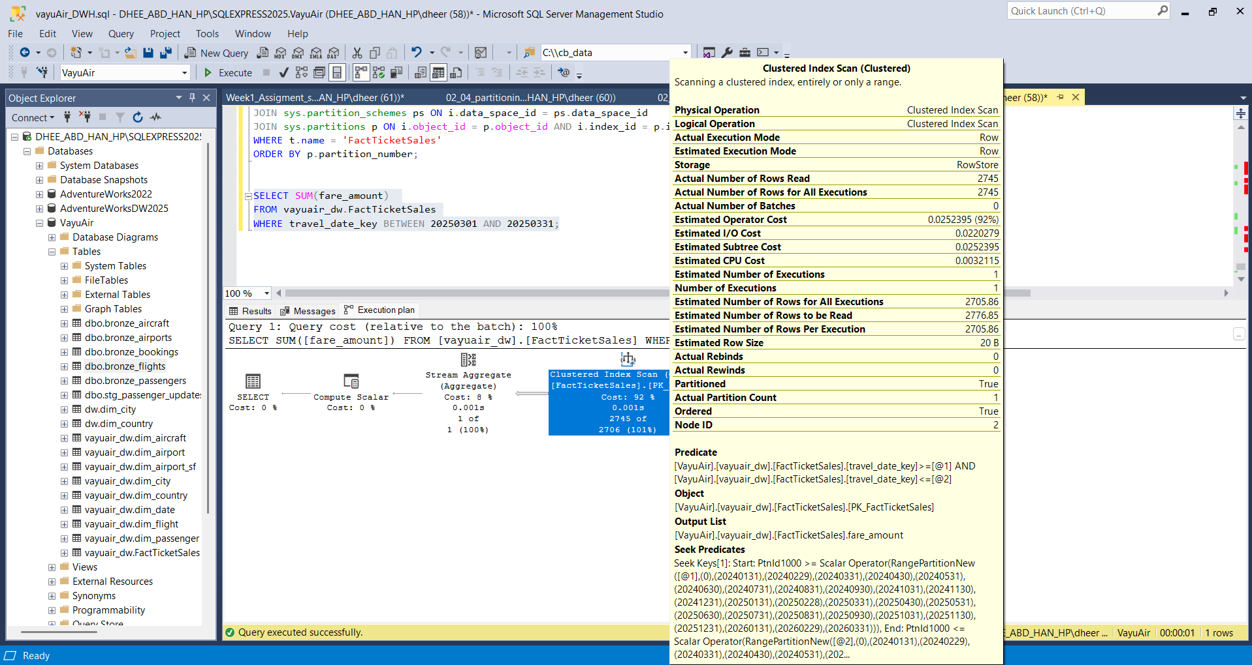
Figure 1 — Query A execution plan: Actual Partition Count = 1
Query A filters on travel_date_key, the exact column FactTicketSales is partitioned on. SQL Server's optimizer compares the filter range (>= 20250301 AND <= 20250331) directly against the 27 boundary values defined in PF_TravelDate, and mathematically determines that only the partition covering March 2025 can contain matching rows. Every other partition — including the 12 empty 2024 partitions and every other month in 2025–2026 — is skipped entirely without being opened. This is visible directly in the plan's Seek Predicates, which show the comparison against the partition boundary list, and confirmed by Actual Partition Count = 1.

Query B — filters on a non-partition column (no pruning)
SELECT SUM(fare_amount) FROM vayuair_dw.FactTicketSales WHERE fare_class = 'Business';
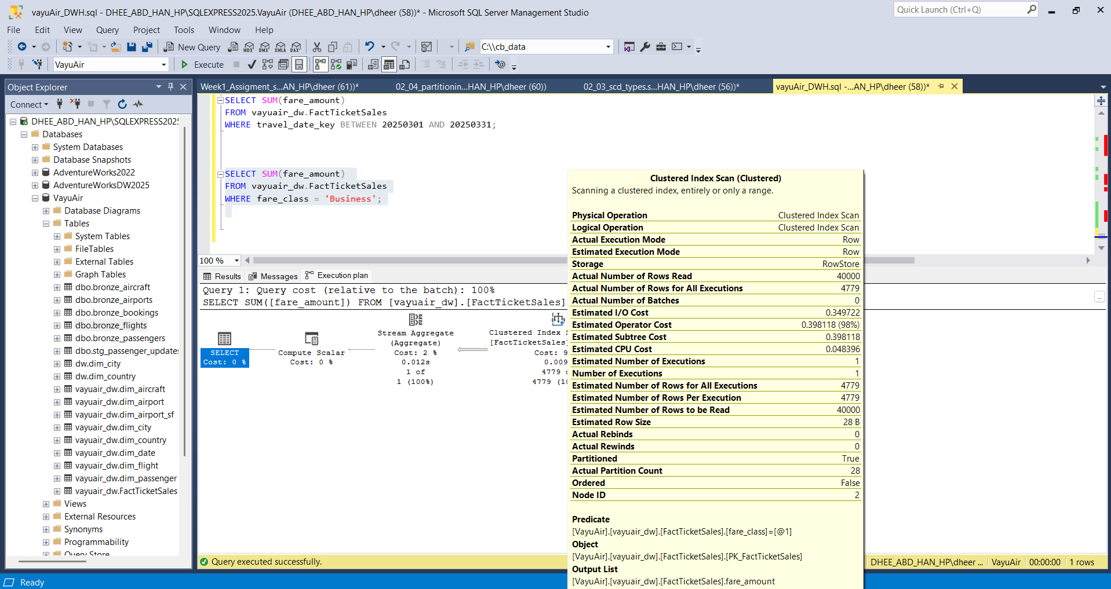
Figure 2 — Query B execution plan: Actual Partition Count = 28
Query B filters on fare_class, a column that has no relationship to how rows are physically distributed across partitions — a Business class booking can exist in any month, so no partition can be ruled out mathematically. SQL Server has no boundary comparison available for this filter and must scan every one of the 28 partitions, reading all ~40,000 rows before applying the filter as a plain predicate. This is confirmed by Actual Partition Count = 28 and the absence of any Seek Predicates in the plan.

Conclusion
The partition function and scheme exist, FactTicketSales sits on PS_TravelDate, and the two queries demonstrate — using actual execution plan evidence, not estimates — that filtering on the partitioning column enables partition elimination while filtering on an unrelated column forces a full partition scan.

