The Prisoners Dilemma Recap
1. Introduction: The Prisoners Dilemma Recap
To understand Nash Equilibrium, we first look at the Prisoners Dilemma , a game involving two players (Prisoner 1 and Prisoner 2).
Actions: Each prisoner can either Confess (C) or Deny (D) .
The Results (Payoffs):
If both Confess , they each get 3 years in prison (Payoff: -3, -3).
If both Deny , they each get 1 year in prison (Payoff: -1, -1).
If one Confesses and the other Denies , the one who confesses walks free ( 0 years ) while the one who denies gets 4 years in prison.
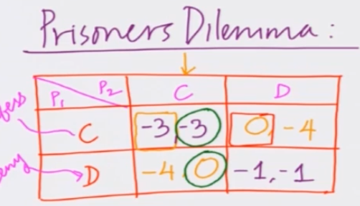
INTERSECTION OF BEST RESPONSE GIVE RISE TO NASH EQUILIBRIUM.
NASH EQUILIBRIUM
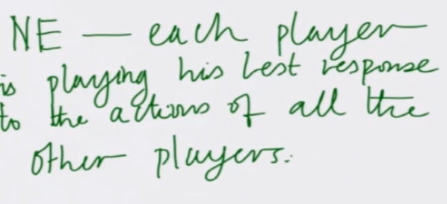
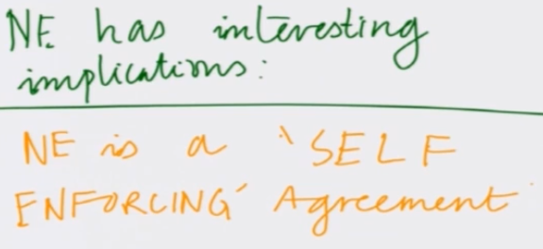

2. What is a "Best Response" (BR)?
A Best Response is the best move a player can make if they assume the other player’s move is fixed. It is the "thinking process" of a player trying to get the best possible outcome for themselves.

Prisoner 1's Perspective:
"If I think Prisoner 2 will Confess , my best move is to Confess (-3 is better than -4)".
"If I think Prisoner 2 will Deny , my best move is still to Confess (0 is better than -1)".
Prisoner 2's Perspective: Because the game is symmetric, Prisoner 2 has the exact same logic and finds that Confessing is always their best response.

3. Understanding Nash Equilibrium (NE)

A Nash Equilibrium occurs at the intersection of best responses . It is the specific outcome where every player is playing their best response to the actions of everyone else at the same time.

In the Prisoners Dilemma, the Nash Equilibrium is (Confess, Confess) because:
Prisoner 1 is playing their best response to Prisoner 2's confession.
Prisoner 2 is playing their best response to Prisoner 1's confession.

4. Key Characteristics of Nash Equilibrium

The sources describe three main ways to think about why a Nash Equilibrium is important:

It is a Self-Enforcing Agreement: If players agreed beforehand to play the Nash Equilibrium, they would actually stick to it because they have no reason to change their minds. In contrast, an agreement to "Deny, Deny" is not self-enforcing because both players would have a secret incentive to switch to "Confess" to try and walk free.
No Unilateral Incentive to Deviate: "Unilateral" means "by oneself". In a Nash Equilibrium, no single player can get a better result by changing their move while everyone else stays the same. If a prisoner switches from Confessing to Denying while the other keeps Confessing, their sentence actually gets worse (from 3 years to 4 years).
SO, (C,C) is a "No Regret" Outcome: Once the game is over, no player looks back and feels they should have chosen a different action to get a better result. In any other outcome (like Deny, Deny), players would regret not confessing.

5. The Mathematical Definition
