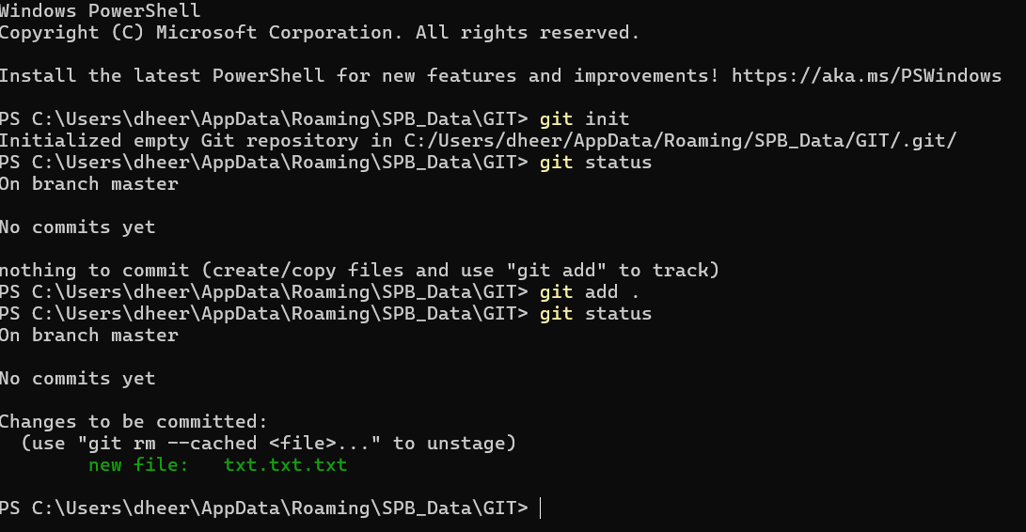

https://education.github.com/git-cheat-sheet-education.pdf

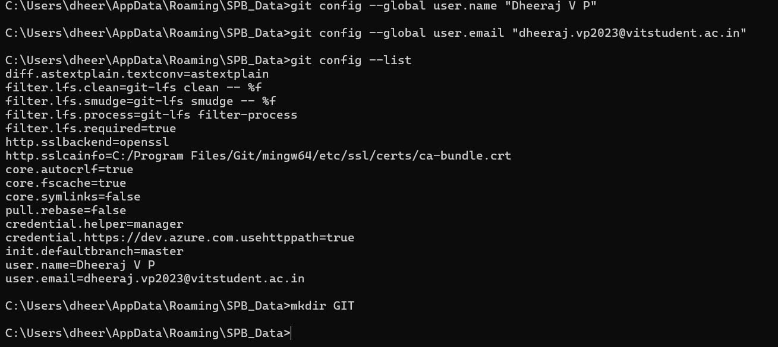

Git push used to push the changes from local rep to global rep

Commits ar checkpoints, changes made

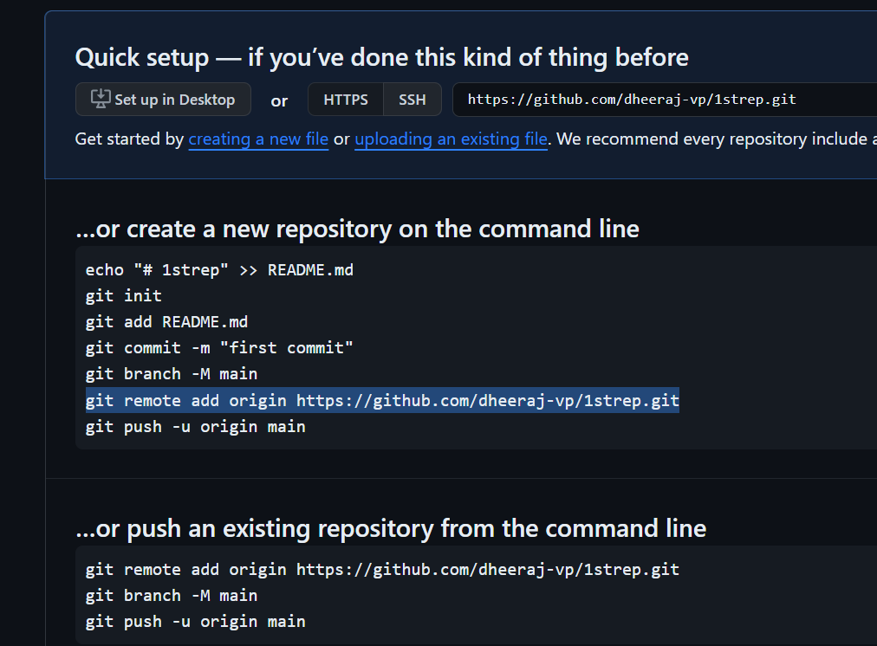

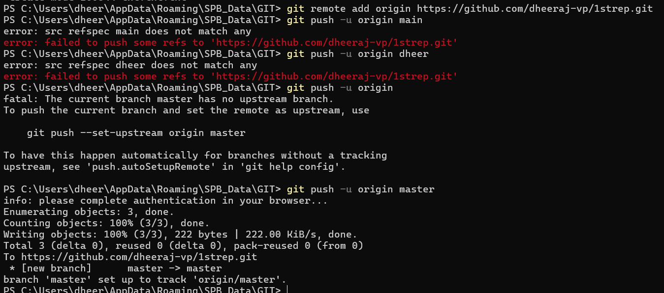

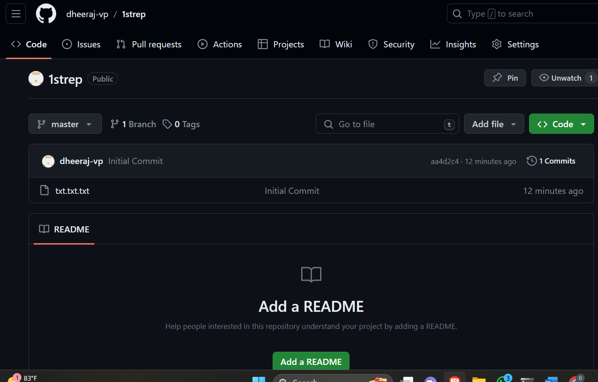

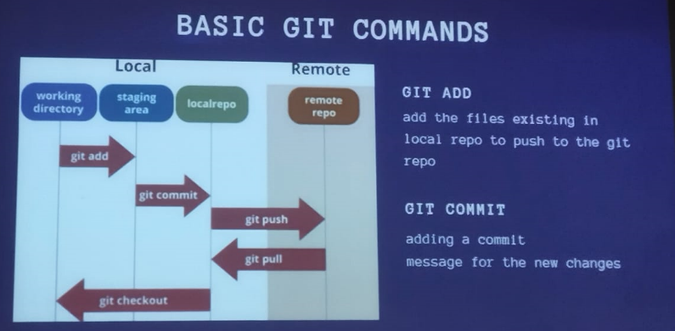

Needed in hackathons/projects:

Fork – create a copy of rep for u to work on it

Clone- create a local copy of the git rep

Git pull- syncs all the changes made in the rep, updating each time

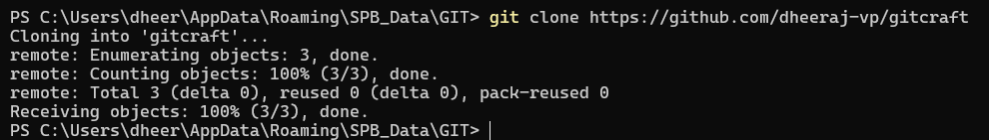

Downloading the rep to the local folder

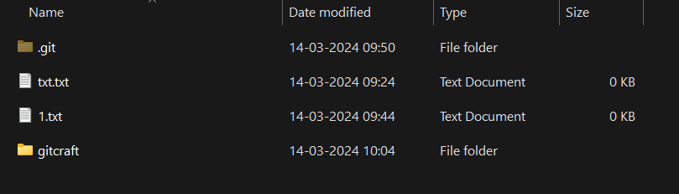

Ex:

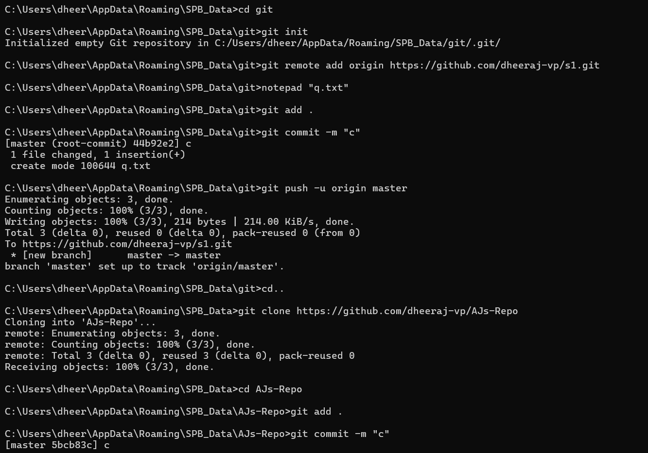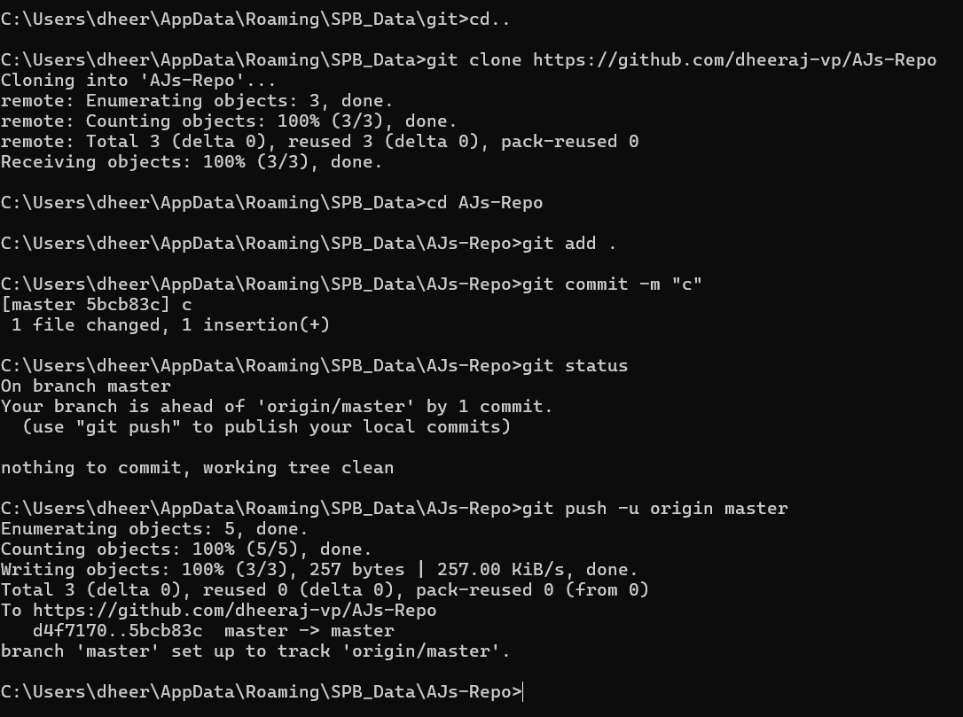

World Quant  
an alpha is an algorithm that transform  
  
ts_rank- operator (time series)  
takes the input value and ranks them from ascending order (returns a value from 0-1)

trade_when(ts_rank(ts_std_dev(returns,22),252)>0.55,ts_zscore(vwap/close,252),-1)

