**Html**

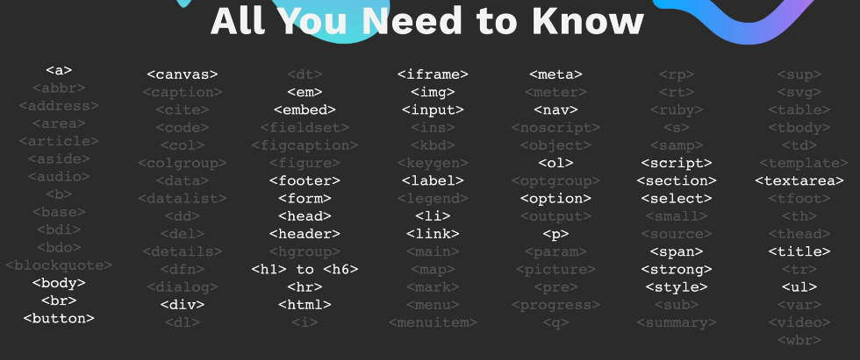Different elements and its uses- <https://developer.mozilla.org/en-US/docs/Web/HTML/Element/Heading_Elements>

CSS  
<https://www.csfieldguide.org.nz/en/interactives/rgb-mixer/>

<https://developer.mozilla.org/en-US/docs/Web/CSS/named-color>

<https://colorhunt.co/>

pesticide extension for figuring out divisions  
  
media query: <https://developer.mozilla.org/en-US/docs/Web/CSS/CSS_media_queries/Using_media_queries>

FLEXBOX:

Flex-Layout : justify content, flex wrap, align items, align content  
<https://appbrewery.github.io/flex-layout/>

<https://css-tricks.com/snippets/css/a-guide-to-flexbox/>

flexbox froggy answers: from level 18 its nice <https://gist.github.com/lukasrudnik/c72cafebd0db5bae4aa5563b24e73fd2>

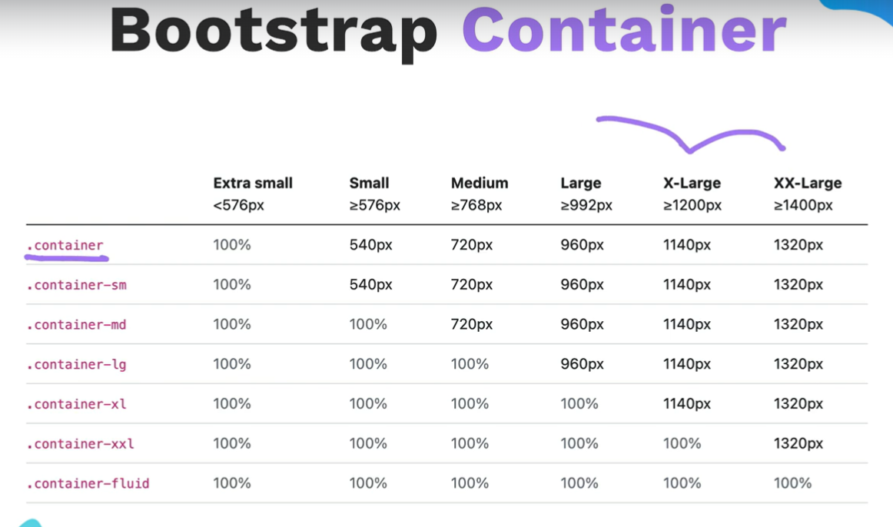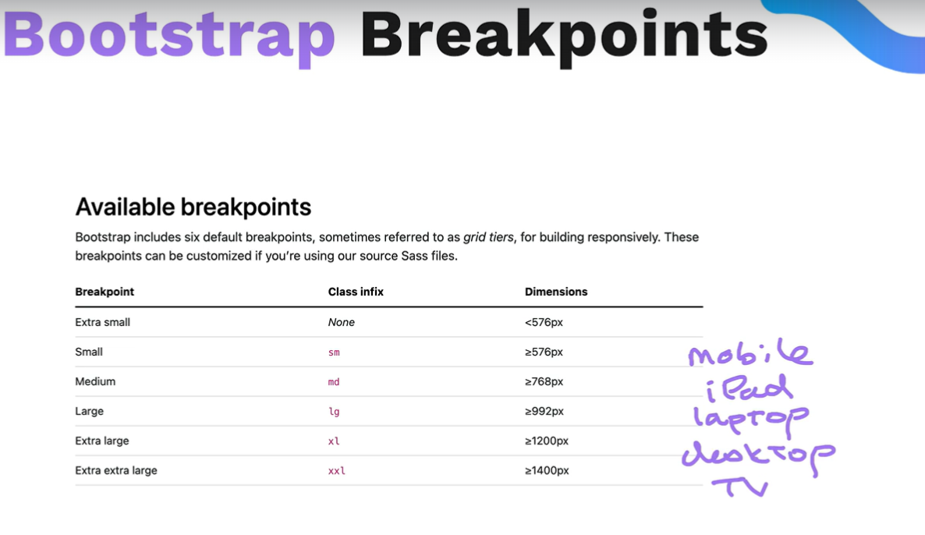

Var.length- length of the string  
console.log() – for the programmers to see on the console

Math.random()  
arr_var.includes() – returns true or false

Event Listeners: <https://developer.mozilla.org/en-US/docs/Web/API/EventTarget/addEventListener>

This – identity of the button clicked, probably workslike this pointer

setTimeout(func,milli sec, para…)  
  
  
GIT  
~ = highest level directory  
ls = list all items  
cd = change directory  
cd . . = goes back 2 levels

press on alt to navigate to the place where u want to type  
ctlr + u = clears the entire line

touch = to create the file

touch filename.txt

start = opebs the file  
code = opens the file in vs code  
rm= removes the file  
rm filename

rm -r = removes directory (rm -r directoryname/)  
pwd = print working directory

GITHUB:

1.Create a rep.

2.transfering commits from local rep to remote rep(on internet)

Git remote add origin(name) (paste the link of remote URL)

3. push the local rep to remote rep



Git push -u origin main  
git branch, git checkout -b main

Git rm –cached -r . = removes all the files in the stagging area, . denotes all files

Pattern.monster – for nice backgrounds which has patterns  
  
API-  
 axios documentiation  
Rapid APIs – has various kinds of APIs, refer the blog api from course

Databases:

SQL- <https://www.w3schools.com/sql/>  
Postgres datatypes- <https://www.postgresql.org/docs/current/datatype.html>

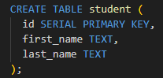 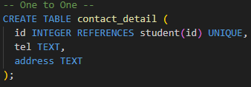 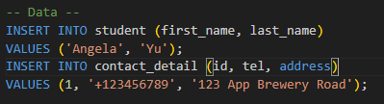

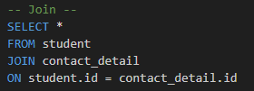

JOIN – performs INNER JOIN, It's going to join two tables together based on some sort of criteria,  
and the criteria is determined by this keyword ON.

One to Many: many to one:

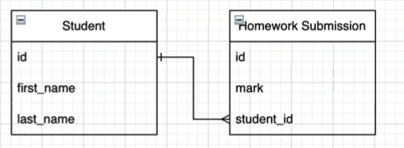 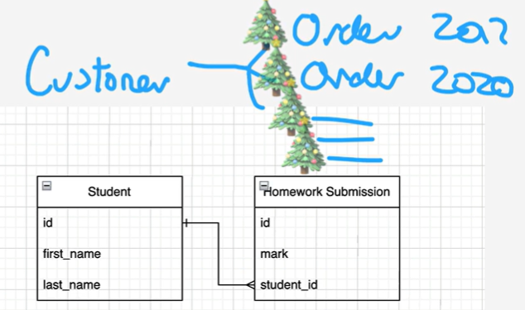

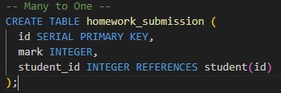 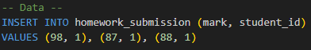

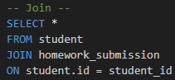 Many to one

Many to Many

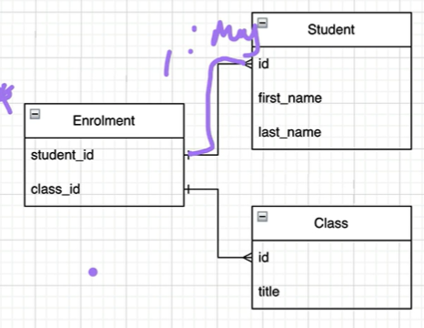 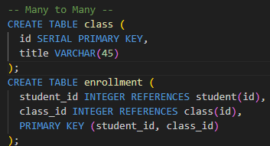

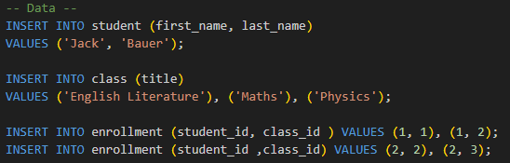 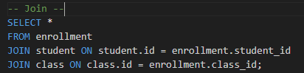

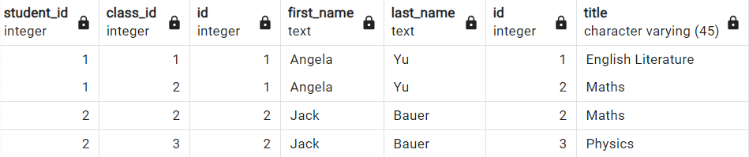

Aliases – takes the given column and renames it as something in the resultant table, also used to shorten and simplify queries

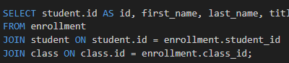 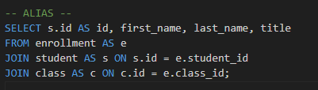

We can

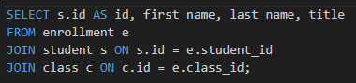

ALTER

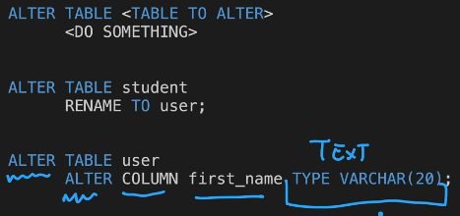 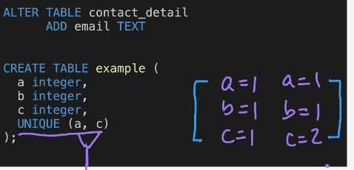

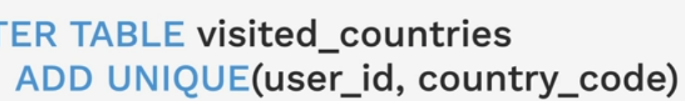 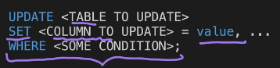

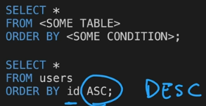 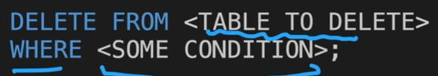

Authentication:

Passport: <https://www.passportjs.org/docs/>

app.post(

  "/login",

  passport.authenticate("local", {

    successRedirect: "/secrets",

    failureRedirect: "/login",

  })

);

React:

<https://github.com/airbnb/javascript/tree/master/react>

Advance Backend

Caching: