**TASK – 4**

1. MISTAKES- WE DIDN’T FIXED IR IN THE MID OF THE ROBOT , THAT’S WHY ITS TAKE MORE TIME TO TURN , AND IT HAVE TO GO FORWARD .
2. **METALLIC PEBBLE –** Make metallic peblle , total = 5*3=15 . diameter=2.5cm weight=4 to 5g
3. **Crow robot ID-** crow robot ID should be 10;
4. **BUZZER-** After all pebbles have been deposited, robot has to sound buzzer for 5 seconds continuous until the end of the run.
5. **AR PART**

Teams have to write a python script which:

1. Is run at the start of the run.

2. Identifies ID and position Of AR_Objects placed in the Arena.

3. Projects 3D models of pebbles on the Pebble AR_Objects.

4. Projects 3D models of Water Pitcher/Crow on Water Pitcher AR_Objects/Crow.

5. 3D Models are animated to depict pickup and drop of magnetic pebbles in the arena

6.

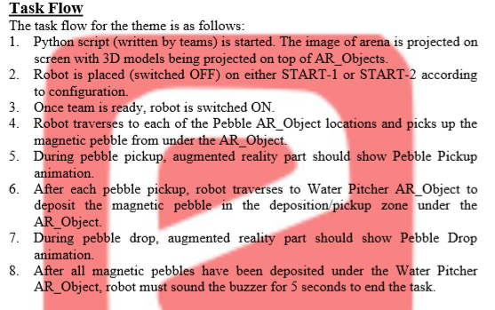

1. **FINAL ARENA SETUP**

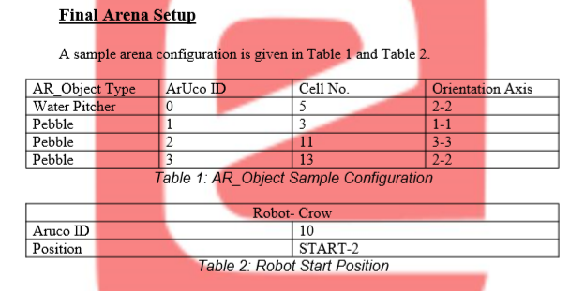

1. SAMPLE ARENA CONFIG

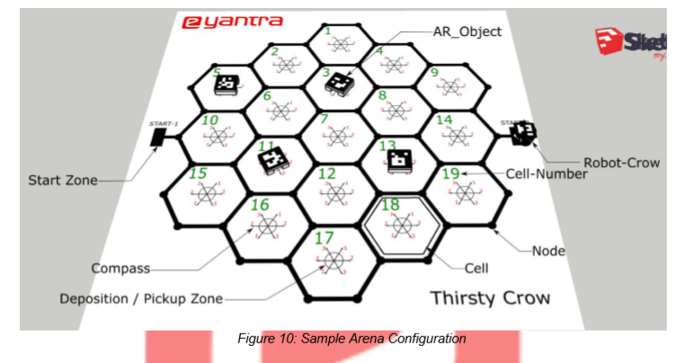

1. **INPUT OF ARENA CONFIGURATION IN THE PYTHON SCRIPT**

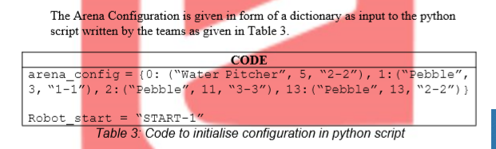

1. **REPOSITIONING**

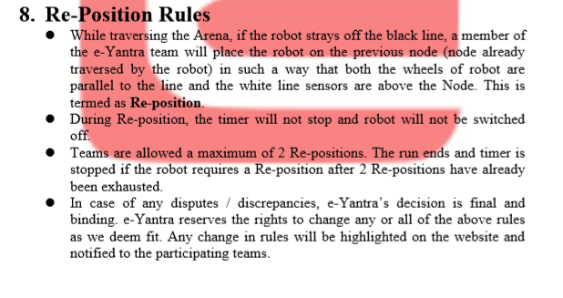

1. 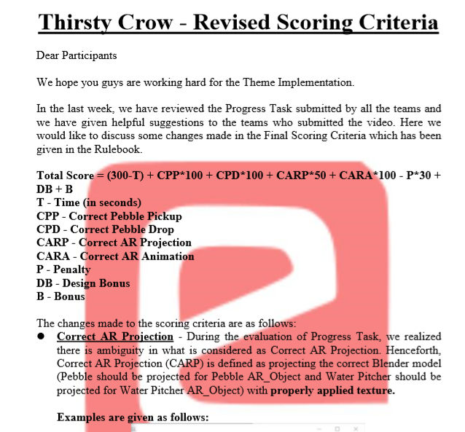

**BEST OF PIAZZA**

1. IF ENCODER NOT WORK

If your robot is not stopping when the desired pulse count is reached, there must be something wrong with the code or the hardware connections

1) Check if you are supplying 5V and Gnd correctly to the motors. The internal position encoder circuitry requires those.

2) Make sure you are connecting the A and B ports to the correct interrupt pins

3) Double check all the wire connections. 60-70% of cases its because the faulty jumper wires or badly done circuit connections that problems develop in the circuit.

On the code side,

1) Make sure the interrupts are initialised properly

2) Use the volatile keyword for the pulse count variable that you are incrementing in ISR

If it still doesnt work, please share your code, we will have to go through it. (**BUT ONLY THE INTERRUPT CODE**).

1. FOR CAMERA MATRIX AND GOOD PROJECTION

Try the camera calibration for a larger number of images and from a greater number of angles.

<https://opencv-python-tutroals.readthedocs.io/en/latest/py_tutorials/py_calib3d/py_pose/py_pose.html>

This tutorial might be helpful if you want to undistort the camera frame

As far as i can see, there is a minor offset where your models are being projected. That also might be if the blender models you have created are not placed at origin in the blender scene.