

**e-Yantra Robotics Competition - 2018**

**Theme and Implementation Analysis – Thirsty Crow**

**3704**

|  |  |
| --- | --- |
| **Team leader name** | Akash Yadav |
| **College** | National Institute of Technology, Patna |
| **Email** | akashjnvlko@gmail.com |
| **Date** | 01-01-2019 |

**Scope**

**Q1 a. State the scope of the theme assigned to you. (5)**

Theme assigned to our team is ‘Thirsty Crow’. As we know that drought affect large population in India. This theme is based on famous story of crow and pitcher where segments in arena represent drought affected field and robot acts as crow. I think purpose of this theme is introduced to outline problem of droughts in India. Such type of robots can also be implemented in warehouses, in sorting parcels or any repetitive sorting work of picking and placing. I think using augmented reality can provide an immersive experience also using augmented reality can make monitoring of work easier and fun.

**Testing your knowledge (theme and rulebook analysis)**

**Q2. a) What is considered a correct pebble pick-up? (2.5)**

**b) What is considered a correct pebble drop? (2.5)**

**a)** If robot picks up magnetic pebble from under the Pebble AR Object correctly using the electromagnetic pickup mechanism and AR animation is shown during pebble pick-up then it’ll be considered a correct pebble pick-up.

**b)** If robot drops magnetic pebble under the Water Pitcher AR Object correctly and AR animation is shown during pebble drop then it’ll be considered a correct pebble drop.

**Mechanism**

**Q3. Explain the mechanism that you would use to pick and drop the pebbles. (10)**

We’re using electromagnetic pick and drop mechanism. For implementing this mechanism, we have mounted electromagnet on an arm that is attached to the servo. We are using servo for up-down lifting of arm.

Using servo is required to make sure that pebble is lifted up at appropriate height, otherwise it may lose electromagnet contact due to friction of the ground.

**Process**: Once we are ready to pick pebble servo moves the electromagnet down and after establishing contact with pebble electromagnet turns on and servo moves up, thus pebble is lifted at appropriate height and same process is repeated during dropping the pebble.

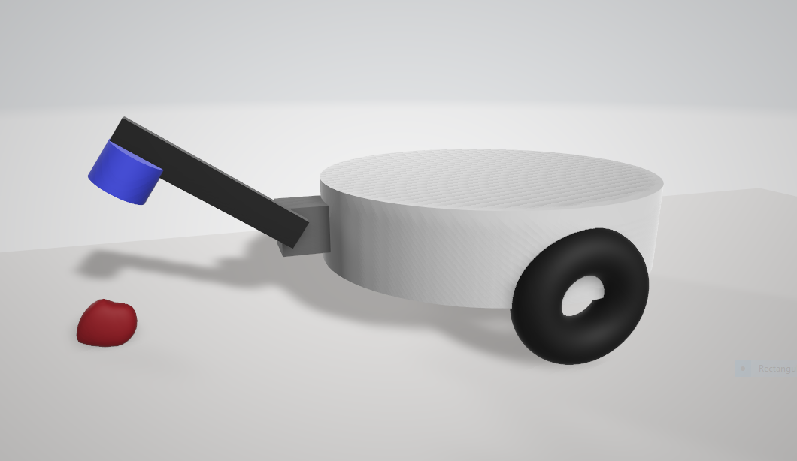

**Diagram:** *Showing pickup mechanism*

**Algorithm Analysis**

**Q4. Draw a flowchart illustrating the algorithm you propose to use for theme implementation. (10)**

***Description of functions used in theme implementation:***

1. Arena_config() :This function takes AR objects location and Markers -ID to configure arena. This data is further used for path planning and 3D model projections on the arena .
2. Location_selector ( ) : This function selects the location of the destination for the crow robot. This target location will be further used by path planning algorithm.
3. Path_opt ( ) : This function is basically path planning algorithm. This function takes source and destination location and destination orientation (axis ie,’1-1’) as argument. This function also optimizes the path for the shortest distance and time.
4. Robo_locator ( ) :This function provides current location of the robot based on the data received from optical encoder motors.
5. Aruco_location( ): This function provides current location of the robot on the arena based on the data received from webcam using aruco marker on the robot.

***Some other functions used for robot movement and actuators :***

1. Magnet_on()
2. Magnet_off()
3. Forward()
4. Backward()
5. Left()
6. Right()
7. Soft_left()
8. Soft right()
9. Stop()
10. Buzzer()
11. Servo_up()
12. Servo_down()

***FLOW CHART ILLUSTRATING THEME IMPLEMENTATION***

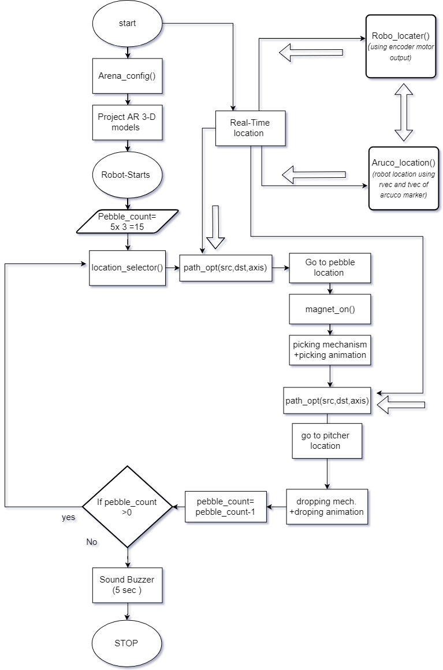

**Q5. What kind of path planning algorithm will you use in order to navigate your robot inside the arena? (10)**

For path planning we have decided to use two sources of data for maintaining the accuracy of the location of the robot as that is most essential part for path planning :

Realtime location will be generated using data received by both sources --

1. Position of robot from webcam using OpenCV.

*Aruco_location ( id, …) :*

*rvec, tvec = aruco.estimatePoseSingleMarkers( …. )*

*…*

*…*

*return rvec ,tvec*

1. Position of robot from motor encoders:

*Robo_locator ( rotation A, Rotation B, whl_radius) :*

*…*

*…*

*…*

*return (x,y)*

*we’ll choose virtual Cartesian coordinate system (x,y) as follow;*

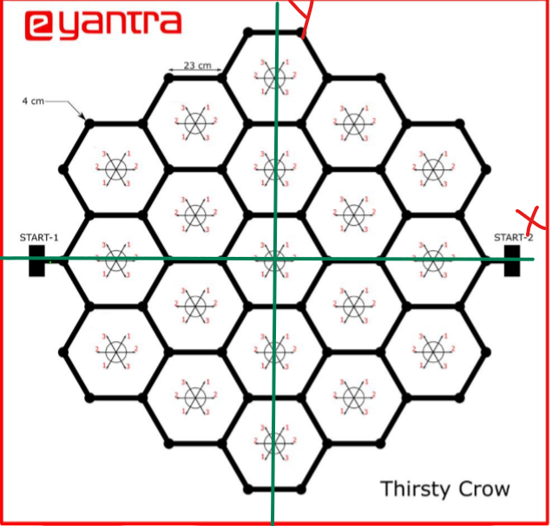

1. Path planning source to destination:

We’ll be using path_opt function for path optimization :

*Pseudo code :*

*Path_opt( src, dst, dst_axis):*

*//this is rough idea we may change as this may not work during implementation of theme …*

*X_robo, Y_robo = Robo_locator( ….)*

*Cell_length = … // set cell length*

*X_dst ,Y_dst = dst (x,y)*

*Distance_src_dst = abs(tvec_robo – tvec_dst) // from web cam*

*On_node :*

*If ( Y_dst > Y_robo ):*

*Choose_left()*

*Else :*

*Choose_right()*

*…….*

*…….*

*…….*

*If (Distance_src_dst < Cell_length):*

*//orient along destination axis*

*…..*

*……*

**Challenges**

**Q6. What are the major challenges that you can anticipate in addressing this theme and how do you propose to tackle them? (10)**

1. **Projecting 3D models on AR objects with accurate position and orientation:**

We are using OpenCV for aruco marker detection and getting translation and rotation vectors of aruco markers. During previous task we faced problem in accurately posing 3D marker over aruco markers due to error in translation vectors.

**Solution**: In order tackle this problem we’ll need to adjust offset values of translation vectors and rotation vectors if required.

1. **Animating 3D models during pick up and drop of pebbles:**

Animating 3D models in blender and animating models during pick up and dropping is a challenge as we don’t have good idea of blender.

**Solution:** We’re thinking to create to create multiple models with slight variations during theme play we can set those models in a time frame in OpenGL. This may be one way to animate models.

1. **Path planning to reach to the pebbles and pitcher in shortest way and shortest time:**

Robot is expected to complete the given task in shortest possible time. Path planning is a challenging task, also knowing real time location of robot on arena is essential for path planning algorithm to work.

**Solution:** In order to optimize the time, we have planned to design our algorithm in such a way that the decided path has shortest distance from source to destination also it has least turns to reduce the time.