Ex No: 1a BASICS OF UNIX COMMANDS Date :

AIM
To study and execute the basics of UNIX commands

pwd
Display the full path of the current working directory user@sys246:~$ pwd
/home/user

ls
This command displays the list of files in current working directory $ls -l list the files in long format
$ls -t list in order of last modification time
$ls -d Lists directory instead of contents
$ls -u Lists in order of last access user@sys246:~$ ls
f1.c f2.c f3.txt f4.txt CSEal

cd
This command is used to change from working directory to any other directory specified $cd directoryname
user@sys107:~$ cd Desktop user@sys107:~/Desktop$

cd..
This command is used to come out of the current working directory. $cd..
user@sys107:~/Desktop $ cd user@sys107:~$

mkdir
This command helps us to make a directory
$mkdir directoryname user@sys246:~$ mkdir cse.

rmdir
This command is used to remove a directory specified in command line. $rmdir directoryname
user@sys246:~$ rmdir cse user@sys246:~$ ls
f1.c f2.c f3.txt f4.txt f4.c f5.c

cat
This command helps us to list the contents of the file we specify.
$cat[option][file]
cat>filename - This is used to create a new file

cat>>filename - This is used to append the contents of the file user@sys246:~$ cat f4.c
India is good country

cp
This command helps us to create duplicate copies of ordinary files. $cp source destination
user@sys246:~$ cp f1.c f5.c user@sys246:~$ ls
f1.c f2.c f3.txt f4.txt f5.c CSEal

mv
This command is used to move or rename the files.
$mv source destination user@sys246:~$ mv f1.c f4.c user@sys246:~$ ls
f2.c f3.txt f4.txt f5.c f4.c CSEal user@sys246:~$

ln
This command is to establish an additional filename for the same ordinary file. $ln firstName secondName
user@sys246:~$ ls
f1.c f2.c f4.c f5.c f3.txt f4.txt IT user@sys246:~$ ln -t CSE f5.c user@sys246:~$ cd CSE user@sys246:~$ ls
F5.c

rm
This command is used to delete one or more files from the directory. $rm [option] filename
$rm -i : Asks the user if he wants to delete the file mentioned.
$rm -r : Recursively delete the entire contents of directory as well as the directory itself user@sys246:~$ rm f3.txt
user@sys246:~$ ls
f2.c f4.txt f5.c f4.c CSEal user@sys246:~$

PROCESS AND STATUS INFORMATION COMMANDS:

who
This command gives the details of who all have logged into the UNIX system currently. $who
user@sys246:~$ who
guest-lpdjsy tty7 2023-03-07 08:56 (:0)
user tty8 2023-03-07 09:30 (:1)

who am i
This command tells us as to when we had logged in and the system‟s name for the connection being used. $whoami
user@sys246:~$ whoami user

date
This command displays the current date in different formats.
+%D mm/dd/yy +%w Day of the week
+%H hr-00 to 23 +%a Abbr Weekday

+%M min-00 to 59 +%h Abbr Month
+%S sec-00 to 59 +%r Time in AM/PM user@sys246:~$ date
Tue Mar 7 09:45:00 IST 2023
user@sys246:~$ date +%m 03

echo
This command will display the text typed from keyboard.
$echo
user@sys246:~$ echo SJCE SJCE

TEXT RELATED COMMANDS

head
Displays the initial part of the text file. By default, it displays the first 10 lines of a file. user@sys246:~$ head -1 f3.txt
Hi this is Unix Lab

tail
Displays the last part of he text file. By default, it displays the last 10 lines of a file. user@sys246:~$ tail -1 f3.txt
I am studying B.E CSE in SJCE.

wc
This command is used to count the no.of lines,words, characters in a file.
$wc[-lwc]filename user@sys246:~$ wc f1.txt 8 26 150 f4.txt

find
The find command is used to locate files in a directory and in a subdirectory. user@sys246:~$ find
.
./1.c
./asd.bak
./f1.txt
./file_copy.c
./f2.c
./a.out

FILE PERMISSION COMMANDS

chmod
Change the file/directory permission mode $chmod777 file 1. Give full permission to owner, groups, and others $chmod o-w file 1. Remove write permission for others.
user@sys246:~$chmod777 welcome.txt.

USEFUL COMMANDS:

exit
Ends your work on the UNIX system. user@sys246:~$ exit

clear
Clears the screen user@sys246:~$ clear

Ctrl-z
Pauses the currently running program user@sys246:~$ pause

man COMMAND
Looks up the UNIX command in online manual pages. user@sys246:~$ man
What manual page do you want? user@sys246:~$ man ls
NAME
ls - list directory contents SYNOPSIS
ls [OPTION]... [FILE]...
DESCRIPTION
List information about the FILEs (the current direc-tory by default). Sort entries alphabetically if none of -cftuvSUX nor --sort is specified.
Mandatory arguments to long options are mandatory for short options too.

Ctrl-c
Stops the program currently running

history
Lists all the commands typed so far. user@sys246:~$ history
- mkdir os
- ls
- who
- who am i
- date
- whoami
- echo
- echo hello

more FILE
Display the contents of FILE, pausing after each screenful. There are several keys that control the output once a screenful has been printed. <enter> will advance the output one line at a time. <spacebar> will advance the output by another full screenful. “q” will quit and return you to the UNIX prompt.
user@sys246:~$more message1
Hello Welcome

less FILE
“less” is a program similar to “more”, but which allows backward movement in the file as well as forward movement.
user@sys246:~$less message1
Hello Message
message1(end).

RESULT
Thus, the programs for basics of UNIX commands have been implemented and the output was verified successfully.
Ex No: 1b SIMULATION OF UNIX COMMANDS Date :

AIM:
To write a „C‟ program for implementing ls, cp, grep, cat command

// ls command ALGORITHM:
- Start
- Input directory name to opendir and readdir system call to open and read contents from directory.
- Use exit system call if directory not exists.
- Close directory after reading using closedir()
- Stop. #include <stdio.h> #include <dirent.h> #include <stdlib.h> int main()
{
char buff[100]; DIR *dirp;
struct dirent *dptr;
printf("\nEnter the directory name: "); scanf("%99s", buff); // Prevent buffer overflow dirp = opendir(buff);
if (dirp == NULL)
{
printf("The given directory does not exist\n"); exit(1);
}
while ((dptr = readdir(dirp)) != NULL)
{
printf("%s\n", dptr->d_name);
}
closedir(dirp); return 0;
}

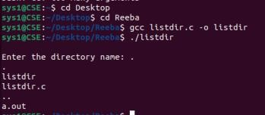
OUTPUT

//cp command ALGORITHM:
Step 1: Get the name of the source and destination file from the command line.
Step 2: Open the source file in read-only mode using the open system call. If the file could not be open, print an error message.
Step 3: Create the destination file using creat system call. If the file could not be open, print an error message. Step 4: Read from the source file using the read system call and store the content in the buffer. Step 5: From the buffer write to the destination file using the write system call.

PROGRAM:
#include <stdio.h> #include <stdlib.h> #include <unistd.h> #include <fcntl.h>
int main(int argc, char *argv[])
{
int f1, f2, n; char buf[512]; if (argc != 3)
{
printf("Usage: %s source_file destination_file\n", argv[0]); exit(1);
}
if ((f1 = open(argv[1], O_RDONLY)) < 0)
{
printf("Can't open %s\n", argv[1]); exit(1);
}
if ((f2 = creat(argv[2], 0644)) <
0) {
printf("Can't create %s\n", argv[2]); exit(1);
}
while ((n = read(f1, buf, sizeof(buf))) >
0) {
write(f2, buf, n);
}
close(f1); close(f2);
printf("File copied successfully\n"); return 0;
}
user@sys246:~$ gcc pg4.c user@sys246:~$ ./a.outsamp.txt s1.txt user@sys246:~$ cat samp.txt
hello welcome to Chennai.
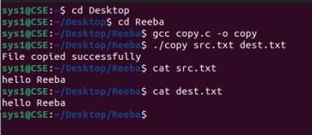

// SIMULATION OF GREP COMMAND
ALGORITHM:
Step 1: Include the header files essential to simulate CAT command. Step 2: Create a file with some contents in it.
Step 3: Give two choices
( i ) To print the similar pattern word.
( ii ) To print the entire line of the specified pattern.
Step 4: Define the two cases using Switch cases.
Step 5: Print the lines of similar pattern depending upon the choice of selection. Step 6: Close the file and exit.

PROGRAM:
#include <stdio.h> #include <string.h> #define bs 1024
int main()
{
FILE *f1;
char file1[bs], str[bs], pat[bs]; printf("Enter the file name: "); scanf("%s", file1);
printf("Enter the pattern to be searched: "); scanf("%s", pat);
f1 = fopen(file1, "r"); if (f1 == NULL)
{
printf("Cannot open file\n"); return 1;
}
while (fscanf(f1, "%s", str) != EOF)
{
if (strstr(str, pat) != NULL)
{
printf("Pattern found in word: %s\n", str);
} }
fclose(f1); return 0; }
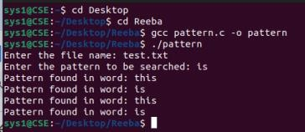

// SIMULATION OF CAT COMMAND ALGORITHM:
Step 1: Include the header files essential to simulate CAT command.
Step 2: Define Buffer size of 1024 which can be used as the standard size for file and buffer. Step 3: Create a source file with some contents in it.
Step 4: Open the source file in READ mode.
Step 5: Print the contents of the file that was opened in READ mode.
Step 6: Close the file and exit.
PROGRAM:
#include <stdio.h> #include <fcntl.h> #include <unistd.h> #define bs 1024
int main()
{
int f;
char file1[bs], buf[bs]; int n;
printf("Enter the filename:\n"); scanf("%s", file1);
f = open(file1, O_RDONLY); if (f < 0)
{
printf("File does not exist\n"); return 1; }
while ((n = read(f, buf, bs)) > 0)
{
write(1, buf, n); // write to stdout } close(f);
return 0; }

OUTPUT
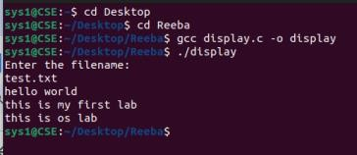

RESULT
Thus, the programs for simulation of UNIX commands have been implemented and the output was verified successfully.

Ex No: 2a SHELL PROGRAMMING-LARGEST OF N NUMBERS Date:

AIM:
To write a shell program to find largest of n numbers.

ALGORITHM:
- Input the total number of elements (n) .
- Let i=0
- Read the elements one by one in an array a$i .
- Initialize large=0 .
- Using a for loop, do the following for all elements in the array: Let temp=a$i ie. Assign the array element to temp.
If temp greater than large, then reassign large=temp
- large displays the largest of all elements.
- Stop.

PROGRAM:
#!/bin/bash
echo "Enter the total number of elements" read n
echo "Enter the elements one by one" for ((i=0; i<n; i++))
do
read a[i] done large=${a[0]}
for ((i=1; i<n; i++)) do
if (( a[i] > large )) then
large=${a[i]}
fi done
echo "The largest of all the elements is: $large"

OUTPUT:
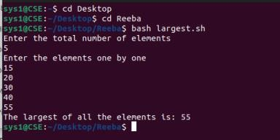

RESULT

Thus, the program to find Largest of N numbers been implemented and the output was verified successfully.
Ex No: 2b IMPLEMENTATION OF UNIX COMMANDS USING CASE Date :

AIM:
To write a shell program using case…esac to execute unix commands.

ALGORITHM:
- Get the choice from the user.
- List the choices for date command, list of users logged in and name of the home directory.
- Date command displays today‟s date.
- Who command displays the users who have logged in.
- $Home command is used to display the home directory.
- Depending upon the choice, any one of the above command is executed using case…esac.
- Stop.

PROGRAM:
while true do
echo "Enter your choice:" echo "Enter w to quit" echo "Menu"
echo "1.Today's date"
echo "2.List of users logged in"
echo "3.Name of the home directory" read choice
case $choice in
  - date;;
  - who;;
  - echo "Home directory is $HOME";; w)break;;
*)echo "Invalid choice"
esac
done

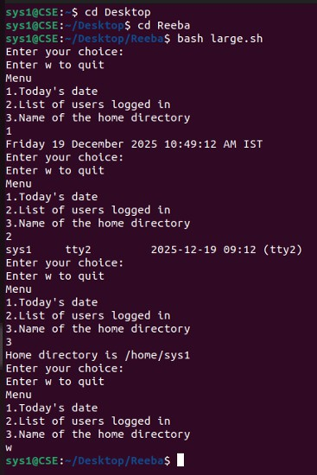
OUTPUT:
RESULT:
Thus, the program for implementation of UNIX commands using case has been implemented and the output was verified successfully.
Ex No: 3A FCFS SCHEDULING Date :

AIM:
To write a „C‟ program to implement FCFS Scheduling.

ALGORITHM:
- Start.
- Include the header files for simulating FCFS scheme.
- Declare the variables to calculate the essential aspects of FCFS.
- Initially get the process time, arrival time and burst time.
- Swap all the processes in such a way that they are arranged in FCFS order. 6. Prepare the gantt chart for each process so that their waiting time, turn around time is calculated. 7. Calculate the average waiting time and average turn around time and display the result. 8. Stop

// FCFS SCHEDULING ALGORITHM

PROGRAM:
#include<stdio.h> void main()
{
int i,n,br[10],wt[10],wat[10],tr[10],ttr=0,twt=0,twat=0; float awat,atur;
printf("Enter no. of process:"); scanf("%d",&n); for(i=0;i<n;i++)
{
printf("Enter the burst time for process %d: ",(i+1)); scanf("%d",&br[i]);
}
printf("\nPROCESS\tBURST TIME\tWAITING TIME\tTURN AROUND TIME\n"); wt[0]=0;
for(i=0;i<n;i++)
{
wt[i+1]=wt[i]+br[i];
tr[i]=wt[i]+br[i]; printf("\n%d\t\t%d\t\t%d\t\t%d\n",i+1,br[i],wt[i],tr[i]);
}
for(i=0;i<n;i++)
{
ttr=ttr+tr[i];
twat=twat+wt[i];//wat i changed to wt
}
printf("\nGAANT CHART\n\n"); for(i=0;i<n;i++)
{
printf(" ");
}
printf("\n"); for(i=0;i<n;i++)
{
printf(" P%d |",i+1);
}
printf("\n"); for(i=0;i<n;i++)
{
printf(" ");
}
printf("\n"); for(i=0;i<=n;i++)
{
printf("%d\t",wt[i]);
}
awat=(float)twat/n; atur=(float)ttr/n;
printf("\n\nTotal waiting time :%d",twat); printf("\nTotal turn around time :%d",ttr); printf("\n\nAverage waiting time :%.2f",awat); printf("\nAverage turn around time :%.2f\n",atur); }

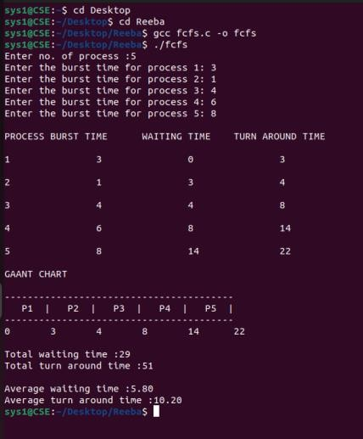
OUTPUT

RESULT:
Thus, the program for FCFS scheduling has been implemented and the output was verified successfully.

Ex No: 3B SJF SCHEDULING Date :

AIM:
To write a „C‟ program to implement SJF Scheduling.

ALGORITHM:
- Include the header files for simulating SJF scheme.
- Declare the variables to calculate the essential aspects of SJF.
- Initially get the process time and burst time.
- Swap all the processes in such a way that they are arranged in shortest job first (SJF) order. 5. Prepare the gantt chart for each process so that their waiting time, turn around time is calculated. 6. Calculate the average waiting time and average turn around time and display the result. // SJF SCHEDULING ALGORITHM

PROGRAM:
#include<stdio.h> void main()
{
int i,j,k,n,p[10],br[10],wt[10],tr[10],ttr=0,twt=0,t; float awat,atur;
printf("\nEnter no. of process :"); scanf("%d",&n); for(i=0;i<n;i++)
{
printf("\nEnter the burst time for process %d: ",(i+1)); scanf("%d",&br[i]);
p[i]=i+1;
}
for(i=0;i<n;i++)
{
for(j=i+1;j<n;j++)
{
if(br[i]>br[j])
{
t=br[i]; br[i]=br[j]; br[j]=t;
t=p[i]; p[i]=p[j]; p[j]=t;
}}}
printf("\nPROCESS\tBURST TIME \t WAITING TIME \t TURN AROUND TIME\n"); wt[0]=0;
for(i=0;i<n;i++)
{
wt[i+1]=wt[i]+br[i];
tr[i]=wt[i]+br[i];
}
for(i=0;i<n;i++)
{
ttr=ttr+tr[i]; twt=twt+wt[i];
} for(i=0;i<n;i++) { printf("\n%d\t\t%d\t\t%d\t\t%d\n",p[i],br[i],wt[i],tr[i]); } printf("\nGAANT CHART\n\n");
for(i=0;i<n;i++)
{
printf(" ");
}
printf("\n"); for(i=0;i<n;i++)
{
printf(" P%d |",p[i]);
}
printf("\n"); for(i=0;i<n;i++)
{
printf(" ");
}
printf("\n"); for(i=0;i<=n;i++)
{
printf("%d\t",wt[i]);
}
awat=(float)twt/n; atur=(float)ttr/n;
printf("\nTotal waiting time :%d\n",twt); printf("\nTotal turnaround time :%d\n",ttr); printf("\nAverage waiting time :%.2f\n",awat); printf("\nAverage turn around time :%.2f\n",atur);
}

OUTPUT
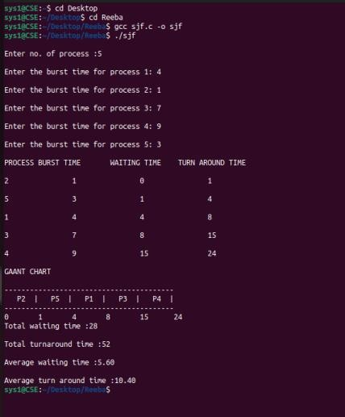

RESULT:
Thus, the program for SJF scheduling has been implemented and the output was verified successfully.

Ex No: 3C PRIORITY SCHEDULING Date :

AIM:
To write a „C‟ program to implement PRIORITY Scheduling.

ALGORITHM:
- Start
- Include the header files for simulating priority scheme.
- Declare the variables to calculate the essential aspects of priority scheme.
- Initially get the process time, arrival time and burst time along with their priorities.
- Execute the process by referring to their priority values.
- Prepare the gantt chart for each process so that their waiting time, turn around time is calculated.
- Calculate the average waiting time and average turn around time and display the result. 8. Stop.

// PRIORITY SCHEDULING ALGORITHM

PROGRAM:
#include<stdio.h> void main()
{
int i,j,k,n,p[10],pri[10],bur[10],wat[10], tur[10],ttur=0,twat=0,t; float awat,atur;
printf("\nEnter no. of process :"); scanf("%d",&n); for(i=0;i<n;i++)
{
printf("\nEnter the burst time for process %d: ",(i+1)); scanf("%d",&bur[i]);
p[i]=i+1;
}
for(i=0;i<n;i++)
{
printf("\nEnter the priority for process %d: ",(i+1)); scanf("%d",&pri[i]);
}
for(i=0;i<n;i++)
{
for(j=i+1;j<n;j++)
{
if(pri[i]>pri[j])
{
t=bur[i]; bur[i]=bur[j]; bur[j]=t;
t=p[i]; p[i]=p[j]; p[j]=t;
t=pri[i]; pri[i]=pri[j]; pri[j]=t;
}}}
printf("\nPROCESS\tBURST TIME \t PRIORITY \t WAITING TIME \tTURNAROUND TIME\n");
wat[0]=0; for(i=0;i<n;i++)
{
wat[i+1]=wat[i]+bur[i];
tur[i]=wat[i]+bur[i]; } for(i=0;i<n;i++)
{
ttur=ttur+tur[i]; twat=twat+wat[i]; }
for(i=0;i<n;i++)
{
printf("\n%d\t\t%d\t\t%d\t\t%d\t\t%d\n",p[i],bur[i],pri[i],wat[i],tur[I ]); } printf("\nGAANT CHART\n\n");
for(i=0;i<n;i++)
{
printf(" --------"); } printf("\n"); for(i=0;i<n;i++)
{
printf(" P%d |",p[i]); } printf("\n"); for(i=0;i<n;i++)
{
printf(" --------"); } printf("\n"); for(i=0;i<=n;i++)
{
printf("%d\t",wat[i]); } awat=(float)twat/n; atur=(float)ttur/n;
printf("\nTotal waiting time :%d\n",twat); printf("\nTotal turnaround time :%d\n",ttur); printf("\nAverage waiting time :%.2f\n",awat); printf("\nAverage turn around time :%.2f\n",atur);
}

OUTPUT
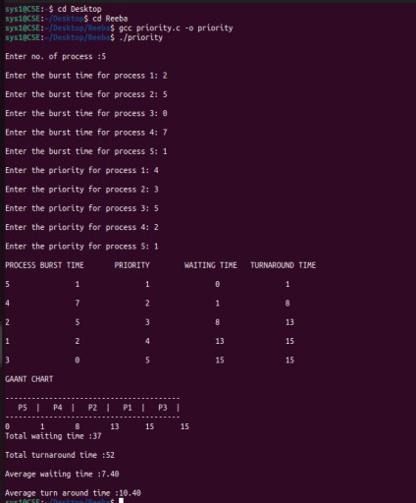

RESULT:
Thus, the program for priority scheduling has been implemented and the output was verified successfully.
Ex No: 3D ROUND ROBIN SCHEDULING Date :

AIM:
To write a „C‟ program to implement ROUND ROBIN Scheduling.

ALGORITHM:
- Include the header files for simulating ROUND ROBIN scheduling scheme.
- Declare the variables to calculate the essential aspects of ROUND ROBIN.
- Initially get the time slice along with process time and burst time.
- Start from the 1st process and execute it for the given time slice and move to 2nd process and so on till all process gets executed for each of the time slice allotted.
- Prepare the gantt chart for each process getting executed within the time slice in a round robin fashion. 6. Calculate the waiting time and turn around time along with their averages display the result. // ROUND ROBIN SCHEDULING ALGORITHM

PROGRAM:
#include<stdio.h> void main()
{
int i,x=-1,k[10],m=0,n,t,s=0;
int a[50],temp,b[50],p[10],bur[10],bur1[10]; int wat[10],tur[10],ttur=0,twat=0,tres=0,j=0; float awat,atur,ares;
printf("Enter no. of process:"); scanf("%d",&n); for(i=0;i<n;i++)
{
printf("Enter the burst time for process %d: ",(i+1)); scanf("%d",&bur[i]);
bur1[i]=bur[i];
}
printf("\nEnter the slicing time :"); scanf("%d",&t);
for(i=0;i<n;i++)
{
b[i]=bur[i]/t;
if((bur[i]%t)!=0)
b[i]=b[i]+1; m=b[i]+m;
}
printf("\nGAANT CHART\n\n"); for(i=0;i<m;i++)
{
printf(" ");
}
printf("\n"); a[0]=0;
while(j<m)
{
if(x==n-1)
x=0;
else
x++;
if(bur[x]>=t)
{
bur[x]=bur[x]-t;
a[j+1]=a[j]+t;
if(b[x]==1)
{
p[s]=x; k[s]=a[j+1]; s++;
} j++;
b[x]=b[x]-1;
printf(" P%d |",x+1);
}
else if(bur[x]!=0)
{
a[j+1]=a[j]+bur[x]; bur[x]=0;
if(b[x]==1)
{
p[s]=x; k[s]=a[j+1]; s++;
} j++;
b[x]=b[x]-1;
printf(" P%d |",x+1);
}
}
printf("\n"); for(i=0;i<m;i++)
printf(" ");
printf("\n"); for(j=0;j<=m;j++)
printf("%d\t",a[j]); for(i=0;i<n;i++)
{
for(j=i+1;j<n;j++)
{
if(p[i]>p[j])
{
temp=p[i]; p[i]=p[j]; p[j]=temp; temp=k[i]; k[i]=k[j]; k[j]=temp;

}}}
for(i=0;i<n;i++)
{
wat[i]=k[i]-bur1[i]; tur[i]=k[i];
}
printf("\nPROCESS\tBURST TIME \t WAITING TIME \t TURN AROUND TIME\t"); printf("RESPONSE TIME\n");
for(i=0;i<n;i++)
{
printf("\n%d\t\t%d\t\t%d\t\t%d\t\t%d\n",p[i]+1,bur1[i],wat[i], tur[i],a[i]);
}
for(i=0;i<n;i++)
{
ttur=ttur+tur[i]; twat=twat+wat[i]; tres=tres+a[i];
}
awat=(float)twat/n; atur=(float)ttur/n; ares=(float)tres/n;
printf("\nTotal waiting time:%d",twat); printf("\nTotal turnaround time:%d",ttur);
// printf("\nTotal response time:%d",tres); printf("\nAverage waiting time :%.2f",awat); printf("\nAverage turn around time :%.2f",atur);
//printf("\nAverage response time:%.2f",ares);
}

OUTPUT
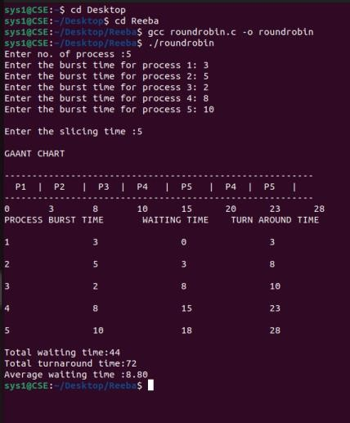

RESULT:
Thus, the program for Round Robin scheduling has been implemented and the output was verified successfully.

Ex No: 4 PRODUCER CONSUMER PROBLEM USING SEMAPHORES Date:

AIM:
To write a program to implement producer consumer problem using semaphore

ALGORITHM:
- Declare the buffer size variable.
- Initialize empty, full and the value of mutex.
- For case 1 , produce the item till the buffer is full after performing the wait operation Of variables empty and mutex.
- Then perform signal of full.
- For case 2, consume the item till the buffer is empty. Perform the wait and signal operation..
- print the contents of the buffer.

PROGRAM:
#include <stdio.h> #include <string.h> #include <stdlib.h>
#define SIZE 3
struct process { char a[5];
} buffer[SIZE];
int mutex = 1, full = 0, empty = SIZE;
/* Function prototypes */ int wait(int);
int signal(int);
int main() { int ch, i;
char item[5];
printf("\n\tProducer Consumer Problem\n"); while (1) {
printf("\n1. Producer"); printf("\n2. Consumer"); printf("\n3. Buffer Contents"); printf("\n4. Exit"); printf("\nEnter your choice: "); scanf("%d", &ch);
switch (ch) {
case 1: /* Producer */ if (empty == 0) {
printf("\nBuffer is Full\n"); break;
}
empty = wait(empty); mutex = wait(mutex);
printf("Enter item to produce: "); scanf("%s", item); strcpy(buffer[full].a, item); full++;
printf("Item Produced Successfully\n"); mutex = signal(mutex);
break;
case 2: /* Consumer */ if (full == 0) {
printf("\nBuffer is Empty\n"); break;
}
full = wait(full); mutex = wait(mutex);
printf("Consumed item: %s\n", buffer[0].a);
/* Shift buffer */
for (i = 0; i < full; i++) strcpy(buffer[i].a, buffer[i + 1].a);
empty = signal(empty); mutex = signal(mutex); break;
case 3: /* Display */ if (full == 0) {
printf("\nBuffer is Empty\n");
} else {
printf("\nBuffer Contents:\n"); for (i = 0; i < full; i++)
printf("%s\n", buffer[i].a);
}
break; case 4:
exit(0); default:
printf("\nInvalid Choice\n");
}
}
}
/* Semaphore operations */ int wait(int s) {
return --s;
}

intsignal(ints) { return ++s;
}

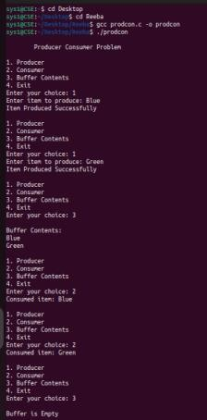
OUTPUT

RESULT:
Thus, the program of producer consumer problem using semaphores has been implemented and the output was verified successfully.

Ex No: 5 INTER PROCESS COMMUNICATION USING SHARED MEMORY Date : AIM:
To write a program to implement inter process communication using shared memory

ALGORITHM:
- Create and shared memory using shmget.
- Attach pointer to a memory using shmat.
- Create child process to write data to memory.
- Print the shared memory data using server process.
- Stop the execution.

PROGRAM:
include <sys/types.h> #include <sys/ipc.h> #include <sys/shm.h> #include <sys/wait.h>
#include <unistd.h> // for fork() #include <stdio.h>
#include <stdlib.h> #define SHMSZ 27
int main() { char c;
intshmid, childpid; key_t key;
char *shm, *s; key = 5679;
// Create shared memory
if ((shmid = shmget(key, SHMSZ, IPC_CREAT | 0666)) < 0) { perror("shmget");
exit(1);
}
// Attach shared memory
if ((shm = shmat(shmid, NULL, 0)) == (char *) -1) { perror("shmat");
exit(1);
}
s = shm;
// Create child process
if ((childpid = fork()) < 0) { perror("Fork Failed"); exit(1);
}
else if (childpid == 0) { // Child process for (c = 'a'; c <= 'z'; c++)
*s++ = c;
*s = '\0'; // Null terminator
exit(0); // Child exits } else { // Parent process
wait(NULL); // Wait for child to finish
// Print content from shared memory for (s = shm; *s != '\0'; s++)
putchar(*s); putchar('\n');
// Detach and remove shared memory shmdt(shm);
shmctl(shmid, IPC_RMID, NULL);
}
return 0;
}

OUTPUT

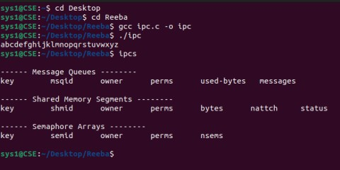

RESULT:
Thus, the program for interprocess communication using shared memory been implemented and the output was verified successfully.

Ex.No:6A DEAD LOCK AVOIDANCE USING BANKERS ALGORITHM Date :
AIM: To implement deadlock avoidance by using Banker‟s Algorithm.

Data structures
- n-Number of process, m-number of resource types.
- Available: Available[j]=k, k – instance of resource type Rj is available.
- Max: If max[i, j]=k, Pi may request at most k instances resource Rj.
- Allocation: If Allocation [i, j]=k, Pi allocated to k instances of resource Rj
- Need: If Need[I, j]=k, Pi may need k more instances of resource type Rj, Need[I, j]=Max[I, j]-Allocation[I, j];

Safety Algorithm
- Work and Finish be the vector of length m and n respectively, Work=Available and Finish[i] =False.
- Find an i such that both
  - Finish[i] =False
  - Need<=Work
If no such I exists go to step 4.
- work=work+Allocation, Finish[i] =True;
- if Finish[1]=True for all I, then the system is in safe state.

ALGORITHM:
- Start the program.
- Get the values of resources and processes.
- Get the avail value.
- After allocation find the need value.
- Check whether its possible to allocate.
- If it is possible then the system is in safe state.
- Else system is not in safety state.
- If the new request comes then check that the system is in safety or not if we allow the request.
- Stop the program.

PROGRAM
#include <stdio.h> int main() {
int allocation[10][5], max[10][5], need[10][5], available[5], flag[10], sq[10]; int n, r, i, j, k, count, count1 = 0;
printf("\nInput the number of processes running (<10): "); scanf("%d", &n);
printf("\nInput the number of resources (<5): "); scanf("%d", &r);
for (i = 0; i < 10; i++) flag[i] = 0;
printf("\nInput the allocation matrix for the processes (row-wise):\n"); for (i = 0; i < n; i++) {
printf("\nProcess %d\n", i); for (j = 0; j < r; j++) {
printf("Resource %d: ", j); scanf("%d", &allocation[i][j]);
}
}
printf("\nInput the maximum matrix for the processes:\n"); for (i = 0; i < n; i++) {
printf("\nProcess %d\n", i); for (j = 0; j < r; j++) {
printf("Resource %d: ", j); scanf("%d", &max[i][j]);
}
}
printf("\nInput the number of available instances of each resource:\n"); for (i = 0; i < r; i++) {
printf("Resource %d: ", i); scanf("%d", &available[i]);
}
// Calculate need matrix printf("\nThe need matrix is:\n"); for (i = 0; i < n; i++) {
for (j = 0; j < r; j++) {
need[i][j] = max[i][j] - allocation[i][j];
printf("\t%d", need[i][j]);
}
printf("\n");
}
// Banker's Algorithm do {
for (k = 0; k < n; k++) { for (i = 0; i < n; i++) {
if (flag[i] == 0) { count = 0;
for (j = 0; j < r; j++) {
if (available[j] >= need[i][j]) count++;
}
if (count == r) { count1++; flag[i] = 1;
sq[count1 - 1] = i; for (j = 0; j < r; j++)
available[j] += allocation[i][j]; break;
}
}
}
}
if (count1 != n && k == n - 1) {
printf("\n---------------IT'S AN UNSAFE STATE---------------
\n"); return 0;
}
} while (count1 != n);
printf("\n*******************IT'S A SAFE STATE*******************\n"); printf("The safe sequence is: ");
for (i = 0; i < n; i++) printf("P%d ",sq[i]);
printf("\nThe available resources after execution: "); for (i = 0; i < r; i++)
printf("%d ", available[i]); printf("\n");
return 0;
}

OUTPUT

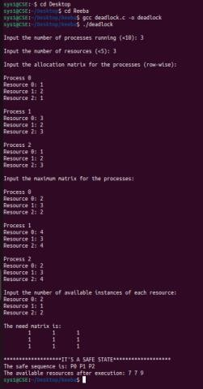

RESULT
Thus, the program for deadlock avoidance by using Banker‟s Algorithm has been implemented and the output was verified successfully.

Ex.No:6B DEAD LOCK DETECTION USING BANKERS ALGORITHIM Date :
AIM: To implement deadlock detection by using Banker‟s Algorithm.

ALGORITHM:
- Start the program.
- Get the values of resources and processes.
- Get the allocation and request matrix value.
- Get the available instances for each resources
- Check whether its possible to allocate using below condition.
- If Need<=Work update work as work=work +allocation
- Else proceed with next process.
- If it is possible to allocate then the system is in safe state.
- Else system is not in safe state.
- Stop the program.

PROGRAM
#include <stdio.h> int main() {
int alloc[10][10], req[10][10], ins[10], avail[10]; int tp, tr, i, j;
int tmp[10] = {0}, finish[10] = {0}; int done, flag;
printf("Enter total no of processes:"); scanf("%d", &tp);
printf("Enter total no of resources:"); scanf("%d", &tr); printf("\nAllocation Matrix:\n"); for(i = 0; i < tp; i++) {
for(j = 0; j < tr; j++) { scanf("%d", &alloc[i][j]);
}
}
printf("\nRequest Matrix:\n"); for(i = 0; i < tp; i++) {
for(j = 0; j < tr; j++) { scanf("%d", &req[i][j]);
}
}
printf("\nResource Instance Vector:\n"); for(i = 0; i < tr; i++) {
scanf("%d", &ins[i]);
}
/* Calculate Availability Vector */ for(j = 0; j < tr; j++) {
tmp[j] = 0;
for(i = 0; i < tp; i++) { tmp[j] += alloc[i][j];
}
avail[j] = ins[j] - tmp[j];
}
printf("\nCalculated Availability Vector:\n");
for(j = 0; j < tr; j++) { printf("%d ", avail[j]);
}
/* Deadlock Detection */ done = 0;
while(done == 0) { flag = 0;
for(i = 0; i < tp; i++) { if(finish[i] == 0) {
int canFinish = 1; for(j = 0; j < tr; j++) {
if(req[i][j] > avail[j]) { canFinish = 0; break; } }
if(canFinish) {
printf("\nProcess %d is transferred to running state and assumed finished", i + 1); for(j = 0; j < tr; j++) {
avail[j] += alloc[i][j];
}
finish[i] = 1; flag = 1; } } }
if(flag == 0) break; }
/* Deadlock Check */ int deadlock = 0;
for(i = 0; i < tp; i++) { if(finish[i] == 0) {
printf("\nOops! Deadlock detected. Causing process: %d", i + 1); deadlock = 1;
} }
if(!deadlock) {
printf("\n\nHurray! Deadlock not detected :-)");
}
return 0; }

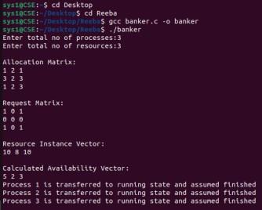
OUTPUT

RESULT
Thus, the program for deadlock detection by using Banker‟s Algorithm has been implemented and the output was verified successfully.

Ex.No: 7 MEMORY ALLOCATION METHODS Date :
AIM: To implement memory allocation methods first fit, best fit & worst fit for fixed partitions.
FIRST FIT ALGORITHM:
- Get no. of Processes and no. of blocks.
- After that get the size of each block and process requests.
- Now allocate processes if(block size >= process size)
//allocate the process else
//move on to next block
- Display the processes with the blocks that are allocated to a respective process.
- Stop.

PROGRAM
#include <stdio.h> #define MAX 10 int main()
{
int bsize[MAX], psize[MAX], bno, pno; int flags[MAX], allocation[MAX];
int i, j;
for(i = 0; i < MAX; i++)
{
flags[i] = 0;
allocation[i] = -1;
}
printf("Enter no. of blocks: "); scanf("%d", &bno);
printf("Enter size of each block:\n"); for(i = 0; i < bno; i++)
scanf("%d", &bsize[i]); printf("Enter no. of processes: "); scanf("%d", &pno);
printf("Enter size of each process:\n"); for(i = 0; i < pno; i++)
scanf("%d", &psize[i]);
// First Fit Allocation for(i = 0; i < pno; i++)
{
for(j = 0; j < bno; j++)
{
if(flags[j] == 0 && bsize[j] >= psize[i])
{
allocation[j] = i; flags[j] = 1; break; } } }
printf("\nBlock No\tBlock Size\tProcess No\tProcess Size"); for(i = 0; i < bno; i++)
{
printf("\n%d\t\t%d\t\t", i+1, bsize[i]); if(flags[i] == 1)
printf("%d\t\t\t%d", allocation[i]+1, psize[allocation[i]]); else
printf("Not Allocated");
}
return 0;
}

OUTPUT

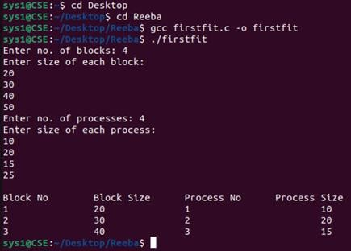

BEST FIT ALGORITHM
- Get no. of Processes and no. of blocks.
- After that get the size of each block and process requests.
- Then select the best memory block that can be allocated using the above definition. 4. Display the processes with the blocks that are allocated to a respective process. 5. Value of Fragmentation is optional to display to keep track of wasted memory. 6. Stop.

PROGRAM
#include<stdio.h> void main()
{
int fragment[20],b[20],p[20],i,j,nb,np,temp,lowest=9999; static int barray[20],parray[20];
printf("\n\t\t\tMemory Management Scheme - Best Fit");
printf("\nEnter the number of blocks:"); scanf("%d",&nb);

printf("Enter the number of processes:"); scanf("%d",&np);
printf("\nEnter the size of the blocks:-\n"); for(i=1;i<=nb;i++)
{
printf("Block no.%d:",i);
scanf("%d",&b[i]);
}
printf("\nEnter the size of the processes :-\n"); for(i=1;i<=np;i++)
{
printf("Process no.%d:",i);
scanf("%d",&p[i]);
}
for(i=1;i<=np;i++)
{
for(j=1;j<=nb;j++)
{
if(barray[j]!=1)
{
temp=b[j]-p[i]; if(temp>=0)
if(lowest>temp)
{
parray[i]=j; lowest=temp;
}
}
}
fragment[i]=lowest; barray[parray[i]]=1; lowest=10000;
}
printf("\nProcess_no\tProcess_size\tBlock_no\tBlock_size\tFragment"
); for(i=1;i<=np && parray[i]!=0;i++) printf("\n%d\t\t%d\t\t%d\t\t%d\t\t%d",i,p[i],parray[i],b[parray[i]],fragment[i
]); }

OUTPUT
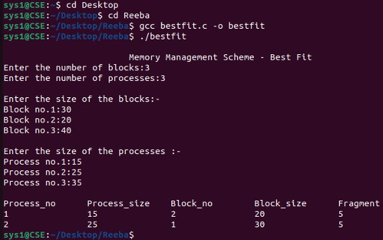

WORST FIT ALGORITHM
- Start
- Input memory blocks and processes with sizes.
- Initialize all memory blocks as free.
- Arrange the partion in desecnding order.
- Start picking each process and allocate to block only if process memory size is less than block size.
- Else leave that process and keep checking other process.
- Allocate process to blocks and calculate the fragment in each block.
- Leave process unallocated if not satisfying above conditions.
- Stop

PROGRAM
#include <stdio.h> int main()
{
int i, j, temp;
int f[10], fp[10];
int no, p[10], part[10];
int pno, pr[10], prmem[10]; printf("\n*******************************************");
printf("\n IMPLEMENTATION OF WORST-FIT ALGORITHM");
printf("\n*******************************************");
printf("\n Enter the number of partitions"); scanf("%d", &no);

for(i = 1; i <= no; i++)
{
p[i] = i;
printf("Enter the memory for partition %d:\t", i); scanf("%d", &part[i]);
}
/* Sort partitions in descending order */ for(i = 1; i <= no; i++)
{
for(j = i + 1; j <= no; j++)
{
if(part[i] < part[j])
{
temp = part[i]; part[i] = part[j]; part[j] = temp;
temp = p[i]; p[i] = p[j]; p[j] = temp;
}
}
}
printf("\nFree memory"); for(i = 1; i <= no; i++)
{
printf("\n partition %d:\t %d", p[i], part[i]); f[i] = 0;
}
printf("\n Enter the number of process"); scanf("%d", &pno);
for(i = 1; i <= pno; i++)
{
pr[i] = i;
printf("Enter the size for process %d:\t", i); scanf("%d", &prmem[i]);
fp[i] = 0;
}
printf("\n ");
printf("\nPROCESS|\t PARTITION|\t FREE_MEMORY|"); printf("\n \n");

j = 1;
for(i = 1; i <= no && j <= pno; i++)
{
if(part[i] >= prmem[j])

{
part[i] = part[i] - prmem[j];

f[i] = 1;
fp[j] = 1;
printf("%d \t %d \t %d\n", pr[j], p[i], part[i]); j++;
}
}
for(i = 1; i <= no; i++)
{
if(f[i] == 0)
{
printf(" \t %d \t %d\n", p[i], part[i]);
}
}
printf("The following process is not allocatted:"); for(i = 1; i <= pno; i++)
{
if(fp[i] == 0)
printf(" %d", pr[i]);
}
return 0;
}

OUTPUT
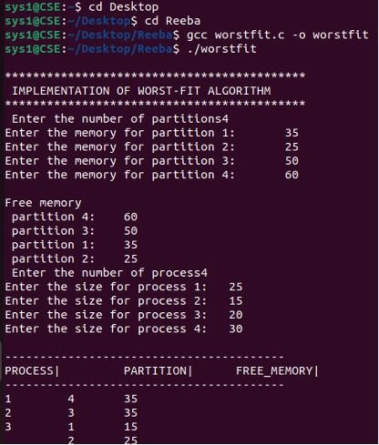

RESULT:
Thus, the program for memory allocation methods has been implemented and the output was verified successfully.

Ex.No:8A FIFO PAGE REPLACEMENT ALGORITHM Date :

AIM
To write a c program to implement FIFO page replacement algorithm

ALGORITHM
- Start the process
- Declare the size with respect to page length
- Check the need of replacement from the page to memory 4. Check the need of replacement from old page to new page in memory 5. Forma queue to hold all pages
- Insert the page require memory into the queue
- Check for bad replacement and page fault
- Get the number of processes to be inserted
- Display the values
- Stop the process

PROGRAM:

#include<stdio.h> int main()
{
int i,j,n,a[50],frame[10],no,k,avail,count=0; printf("\n ENTER THE NUMBER OF PAGES:\n");
scanf("%d",&n);
printf("\n ENTER THE PAGE NUMBER :\n");
for(i=1;i<=n;i++) scanf("%d",&a[i]);
printf("\n ENTER THE NUMBER OF FRAMES :");
scanf("%d",&no); for(i=0;i<no;i++) frame[i]= -1;
j=0;
printf("\trefstring\t page frames\n"); for(i=1;i<=n;i++)
{
printf("%d\t\t",a[i]); avail=0; for(k=0;k<no;k++)
if(frame[k]==a[i])
avail=1; if (avail==0)
{
frame[j]=a[i]; j=(j+1)%no; count++; for(k=0;k<no;k++)
printf("%d\t",frame[k]);
}
printf("\n"); } printf("Page Fault Is %d",count); return 0; }

OUTPUT
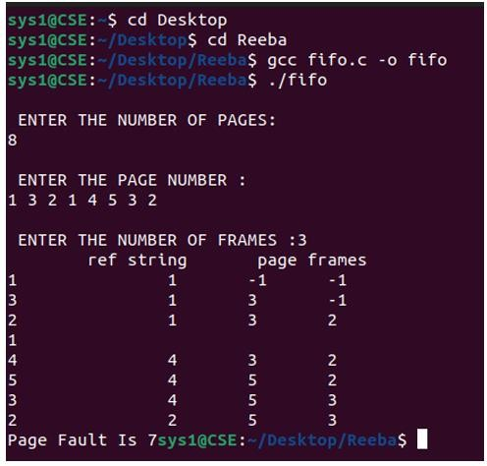

RESULT
Thus, the program for FIFO page replacement algorithm has been implemented and the output was verified successfully.

Ex No:8B LRU PAGE REPLACEMENT ALGORITHM Date :

AIM:
To implement LRU page replacement technique.

ALGORITHM:
- Start the process
- Declare the size
- Get the number of pages to be inserted
- Get the value
- Declare counter and stack
- Select the least recently used page by counter value
- Stack them according the selection.
- Display the values
- Stop the process

PROGRAM
#include<stdio.h> int main()
{
int q[20],p[50],c=0,c1,d,f,i,j,k=0,n,r,t,b[20],c2[20];

printf("Enter no of pages:"); scanf("%d",&n);
printf("Enter the reference string:"); for(i=0;i<n;i++) scanf("%d",&p[i]);
printf("Enter no of frames:"); scanf("%d",&f);
q[k]=p[k]; printf("\n\t%d\n",q[k]); c++;
k++;
for(i=1;i<n;i++)
{
c1=0;
for(j=0;j<f;j++)
{
if(p[i]!=q[j]) c1++;
}
if(c1==f)
{
c++;
if(k<f) {
}
else
{
}
q[k]=p[i];
k++;
for(j=0;j<k;j++
)
printf("\t%d",q [j]);
printf("\n"); for(r=0;r<f;r++)
{ c2[r]=0;
if(q[r]!=p[j]) c2[r]++;
else
for(j=i-1;j<n;j- break;
-) }
{
for(r=0;r<f;r++) b[r]=c2[r]; for(r=0;r<f;r++)
{
for(j=r;j<f;j++)
{
if(b[r]<b[j])
{
t=b[r]; b[r]=b[j]; b[j]=t;
}
}
}
for(r=0;r<f;r++)
{
if(c2[r]==b[0])
q[r]=p[i]; printf("\t%d",q[r]);
}
printf("\n");
} } }
printf("\nThe no of page faults is %d",c);

return 0;
}

OUTPUT
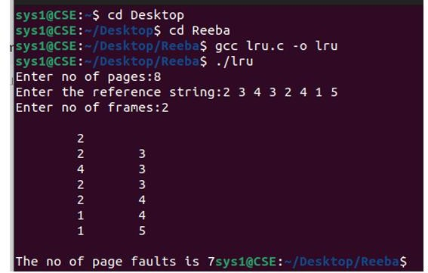

RESULT
Thus, the program for LRU page replacement alogrithm has been implemented and the output was verified successfully.

Ex No:8C OPTIMAL PAGE REPLACEMENT ALGORITHM Date:

AIM:
To implement optimal page replacement technique.

ALGORITHM:
Here we select the page that will not be used for the longest period of time. 1. Start Program
- Read Number Of Pages And Frames
- Read Each Page Value
- Search For Page In The Frames
- If Not Available Allocate Free Frame
- If No Frames Is Free Repalce The Page With The Page That Is Not Used In Next N Pages(N Is Number Of Frames)
- Print Page Number Of Page Faults
- Stop process.

PROGRAM
#include<stdio.h> int findmax(int*); int n;
int main()
{
intseq[30],fr[5],pos[5],find,flag,max,i,j,m,k,t,s,pf=0; int count=1,p=0;
float pfr;
printf("enter max limit of the sequence:"); scanf("%d",&max);
printf("enter the sequence:"); for(i=0;i<max;i++) scanf("%d",&seq[i]); printf("enter the no of frames:"); scanf("%d",&n);
fr[0]=seq[0]; pf++;
printf("%d\t",fr[0]); i=1;
while(count<n)
{
flag=1; p++;
for(j=0;j<i;j++)
{
if(seq[i]==seq[j])
flag=0;
}
if(flag!=0)
{
fr[count]=seq[i]; printf("%d\t",fr[count] ); count++;
pf++;
} i++;}
printf("\n"); for(i=p;i<max;i++)
{
flag=1; for(j=0;j<n;j++)
{
if(seq[i]==fr[j]) flag=0;
}
if(flag!=0)
{
for(j=0;j<n;j++)
{
m=fr[j]; for(k=i;k<max;k++
) {
if(seq[k]==m)
{
pos[j]=k; break;} else pos[j]=-1;
}}
for(k=0;k<n;k++)
{
if(pos[k]==-1) flag=0;
}
if(flag!=0) s=findmax(pos); if(flag==0)
{
for(k=0;k<n;k++)
{
if(pos[k]==-1)
{
s=k; break; }}}
pf++; fr[s]=seq[i]; for(k=0;k<n;k++)
printf("%d\t",fr[k]); printf("\n");
}}
pfr=(float)pf/(float)max;
printf("\n theno of page faults are:%d",pf); printf("\n page fault rate:%f",pfr); }
int findmax(int a[])
{
int max,i,k=0; max=a[0]; for(i=0;i<n;i++)
{
if(max<a[i])
{
max=a[i]; k=i;
}}
return k;
}

OUTPUT
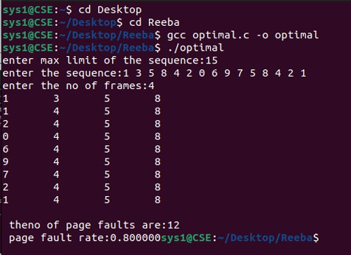

RESULT
Thus, the program for Optimal page replacement algorithm has been implemented and the output was verified successfully.

Ex No: 9A CONTIGUOUS FILE ALLOCATION STRATEGIES Date :

AIM:
To write a C program to implement contiguous file allocation techniques.

ALGORITHM:
Step 1: Start.
Step 2: Memory before allocation is displayed. Step 3: The file Id is entered by the user.
Step 4: the number of blocks memory required and the starting address of the file is given by the user.. Step 5: If starting address and length of block is greater than 20 print error message. Else , the memory address is replaced by the id.
Display memory after allocation.
Step 6: Stop.

PROGRAM:
#include<stdio.h> #include<stdlib.h> int a[20],num=0;
int fid[10],length[10],start[10]; void filedescriptor();
void display();
void filedescriptor()
{
int i;
printf("\n file id \t starting address \t length \n"); for(i=0;i<num;i++)
printf("%d\t\t\t %d\t\t%d\n",fid[i],start[i],length[i]);
}
void display()
{
int i; for(i=0;i<20;i++) printf("%2d",i);
printf("\n"); for(i=0;i<20;i++) printf("%2d", a[i]);
}
void main()
{
int i,n,k,temp,st,l,id,flag=0,cho; for(i=0;i<20;i++)
a[i]=0;
printf("\n memory before allocation:\n"); display();
while(1)
{
printf("\n enter the file id:"); scanf("%d",&id);
printf("\n enter the number of blocks the file occupies:"); scanf("%d", &l);
fid[num]=id; length[num]=l;
l:printf("\n enter the starting address:"); scanf("%d", &st);
flag=0; if((st+1)>20)
{
printf("\n sorry the given memory goes out of space:"); goto l; }
for(i=st;i<(st+1);i++)
{
if(a[i]!=0)
{
flag=1; break;
}}
if(flag==0)
{
start[num]=st; for(i=st;i<(st+1);i++)
a[i]=id;
}
else
{
printf("\n sorry the given blocks are already occupied: Enter new starting address"); goto l;
}
flag=0; num++; filedescriptor();
printf("\n memory after allocation \n"); display();
printf("\n want to continue? \n1.yes \n2.no"); scanf("%d",&cho);
if(cho==2)
exit(0);
}}

OUTPUT:
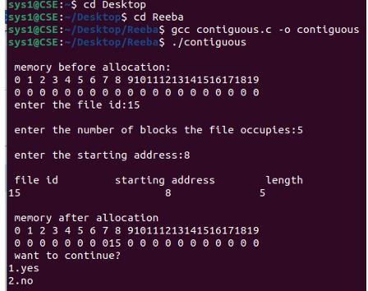

RESULT
Thus, the program for contiguous file allocations strategies has been implemented and the output was verified successfully.

Ex No: 9B LINKED LIST FILE ALLOCATION STRATEGIES Date :

AIM:
To write a C program to implementation linked list file allocation techniques.

ALGORITHM:
- Start.
- Get the number of blocks already allocated and its block numbers as input from user. 3. Add that block numbers to a list as allocated block number list and mark that block numbers are allocated.
- To perform allocation .Get the starting block number and length of the input file 5. From the starting block check whether each block is in allocated block number list 6. If so Print block is already allocated. Else allocate file to the block number.
- Continue the loop if the processes want to be repeated.
- Stop.

PROGRAM
#include <stdio.h> #include <stdlib.h>
int main()
{
int f[50], i, j, p, a, st, len, c; int flag;
// Initialize all blocks as free for(i = 0; i < 50; i++)
f[i] = 0;
printf("Enter how many blocks are already allocated: "); scanf("%d", &p);
printf("Enter the block numbers (0-49): "); for(i = 0; i < p; i++)
{
scanf("%d", &a); f[a] = 1;
}
do
{
printf("\nEnter starting block and length: "); scanf("%d %d", &st, &len);
flag = 0;
for(i = st; i < st + len; i++)
{
if(f[i] == 1)
{
printf("Block %d is already allocated.\n", i); flag = 1;
}
}
if(flag == 0)
{
printf("File allocated at blocks:\n"); for(i = st; i < st + len; i++)
{
f[i] = 1;
printf("%d -> %d\n", i, f[i]);
}
}
else
{
printf("Cannot allocate due to previously allocated block(s).\n");
}
printf("\nDo you want to enter another file? (1 for Yes / 0 for No): "); scanf("%d", &c);
} while(c == 1); return 0;
}

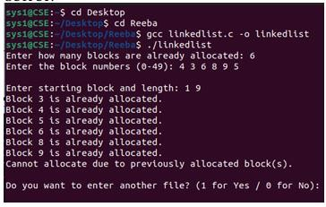
OUTPUT:

RESULT
Thus, the program for Linked list file allocations strategies has been implemented and the output was verified successfully

Ex No: 9C INDEXED FILE ALLOCATION STRATEGIES Date :

AIM:
To write a C program to implementation indexed file allocation techniques.

ALGORITHM:
- Start.
- Get the index block number and number of files in the index block as input from user. 3. Get the file numbers (i.e referred block numbers holding file) as input . 4. Check whether that the input block number is already allocated if so print block allocated a. Else increase the count and allocate the file.
- Continue the loop to enter another index block.
- Stop

PROGRAM
#include <stdio.h>
int main()
{
int f[50], index[50]; int indblk, n, i, j, c; int count;
// Initialize disk blocks for(i = 0; i < 50; i++)
f[i] = 0;
do
{
count = 0;
printf("Enter index block (0-49): "); scanf("%d", &indblk);

if(f[indblk] == 1)
{
printf("Index block already allocated\n");
}
else
{
printf("Enter number of files on index: "); scanf("%d", &n);
printf("Enter file blocks (0-49): "); for(i = 0; i < n; i++)
{
scanf("%d", &index[i]);
if(f[index[i]] == 0) count++;
}
if(count == n)
{
printf("\nAllocated"); printf("\nFile Indexed\n");
f[indblk] = 1;
for(j = 0; j < n; j++)
{
f[index[j]] = 1;
printf("%d -> %d : %d\n", indblk, index[j], f[index[j]]);
}
}
else
{
printf("\nFile block already allocated\n");
}
}
printf("\nDo you want to enter another index block? (1 for Yes / 0 for No): "); scanf("%d", &c);
} while(c == 1);

return 0;
}

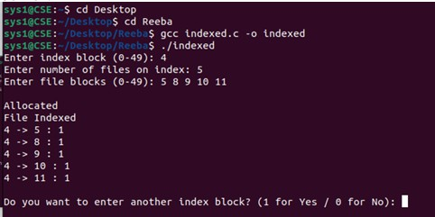
OUTPUT:

RESULT:
Thus, the program for Indexed file allocations strategies has been implemented and the output was verified successfully

Ex. No:10 DISK SCHEDULING ALGORITHMS Date:

AIM
Write a C program to simulate disk scheduling algorithms. a) FCFS b) SCAN c) C-SCAN

a.)FCFS ALGORITHM
- Start the program.
- Input the number of processes n.
- Input the burst time (BT) for each process.
- Assume the processes arrive in the order they are entered (FCFS order).
- Set the waiting time of the first process:
WT[0] = 0
- Calculate the waiting time for the remaining processes:
WT[i] = WT[i-1] + BT[i-1]
- Calculate the turnaround time for each process:
TAT[i] = WT[i] + BT[i]
- Calculate the average waiting time:
Average WT = (Sum of all WT) / n
- Calculate the average turnaround time:
Average TAT = (Sum of all TAT) / n
- Display the process number, burst time, waiting time, and turnaround time.
- Display the average waiting time and average turnaround time.
- Stop the program.

PROGRAM
#include <stdio.h>
#include <stdlib.h>
int main()
{
int t[20], n, i, tohm[20], tot = 0;
float avhm;

printf("Enter the number of tracks: ");
scanf("%d", &n);

printf("Enter the initial head position: ");
scanf("%d", &t[0]);

printf("Enter the tracks to be traversed:\n");
for(i = 1; i <= n; i++)
scanf("%d", &t[i]);

for(i = 0; i < n; i++)
{
tohm[i] = abs(t[i + 1] - t[i]);
tot += tohm[i];
}

avhm = (float)tot / n;

printf("\nTrack Traversed\tHead Movement\n");
for(i = 0; i < n; i++)
printf("%d -> %d\t\t%d\n", t[i], t[i + 1], tohm[i]);

printf("\nTotal Head Movement = %d", tot);
printf("\nAverage Head Movement = %.2f\n", avhm);

return 0;
}
OUTPUT
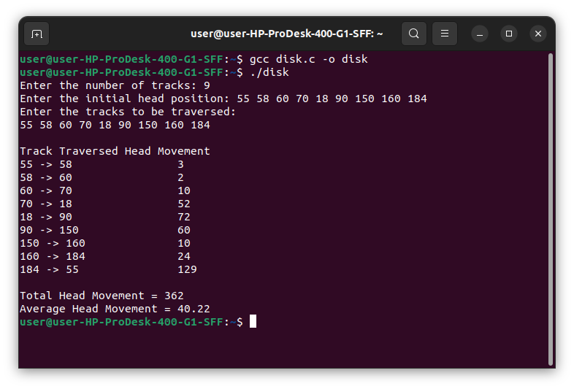

b.)SCAN SCHEDULING ALGORITHM

Algorithm
- Read the following inputs:
  - Number of disk requests (n)
  - Request queue
  - Initial head position (head)
  - Disk size (maximum track number)
  - Initial direction (left or right)
- Sort the request queue in ascending order.
- Divide the requests into two groups:
  - Requests less than the current head position (left)
  - Requests greater than the current head position (right)
- Add the end track of the disk to the side toward which the head is initially moving:
  - If moving left, add track 0.
  - If moving right, add the maximum track number.
- Move the disk head in the chosen direction:
  - Service all requests encountered.
  - Calculate head movement for each service.
- When the end track is reached:
  - Reverse the direction.
  - Continue servicing the remaining requests.
- Compute:
  - Total head movement
  - Average head movement (if required)
- Display the seek sequence and total head movement.
PROGRAM
#include <stdio.h>
int main()
{
int i, j, n;
int d[20];
int disk; // Head position
int temp, max;
int dloc = -1;
int sum;

printf("Enter number of disk requests: ");
scanf("%d", &n);

printf("Enter initial head position: ");
scanf("%d", &disk);

printf("Enter disk queue elements:\n");
for (i = 0; i < n; i++)
{
scanf("%d", &d[i]);
}

/* Insert head position into array */
d[n] = disk;
n++;

/* Sort disk queue */
for (i = 0; i < n - 1; i++)
{
for (j = i + 1; j < n; j++)
{
if (d[i] > d[j])
{
temp = d[i];
d[i] = d[j];
d[j] = temp;
}
}
}

max = d[n - 1];

/* Find head position in sorted array */
for (i = 0; i < n; i++)
{
if (d[i] == disk)
{
dloc = i;
break;
}
}

printf("\nSCAN Service Order:\n");

/* Move towards 0 */
for (i = dloc; i >= 0; i--)
{
printf("%d", d[i]);

if (i > 0)
printf(" --> ");
}

printf(" --> 0");

/* Reverse direction */
for (i = dloc + 1; i < n; i++)
{
printf(" --> %d", d[i]);
}

/* Total head movement */
sum = disk + max;

printf("\n\nTotal Head Movement = %d cylinders\n", sum);

return 0;
}

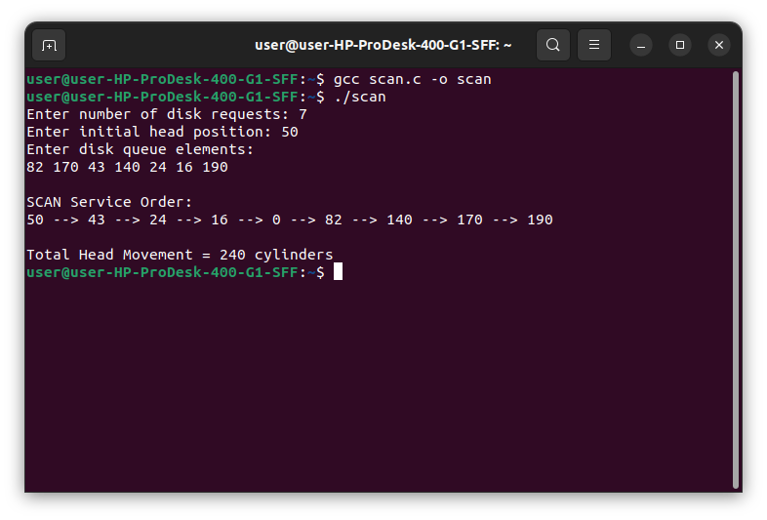
OUTPUT:

C.)C-SCAN SCHEDULING ALGORITHM
ALGORITHM:
Step 1: Start.
Step 2: Read the number of disk requests n.
Step 3: Read the disk request queue and the initial head position.
Step 4: Sort all disk requests in ascending order.
Step 5: Find the position of the head in the sorted queue.
Step 6: Service all requests with cylinder numbers greater than the current head position, moving toward the higher end of the disk.
Step 7: Continue moving the head to the maximum cylinder number (disk end).
Step 8: Jump from the maximum cylinder to cylinder 0 without servicing any requests during the jump.
Step 9: Continue servicing the remaining requests from the beginning of the disk up to the requests that are less than the initial head position.
Step 10: Calculate the total head movement:
- Movement from current head position to the last cylinder.
- Jump from last cylinder to first cylinder.
- Movement from first cylinder to the last pending request.
Step 11: Display the order of service and total head movement.
Step 12: Stop.

PROGRAM:
#include <stdio.h>
#include <stdlib.h>

int main()
{
int queue[50], queue1[50], queue2[50];
int head, max, n;
int i, j, temp;
int temp1 = 0, temp2 = 0;
int seek = 0, diff;
float avg;

printf("Enter maximum disk range: ");
scanf("%d", &max);

printf("Enter initial head position: ");
scanf("%d", &head);

printf("Enter number of requests: ");
scanf("%d", &n);

printf("Enter disk queue requests:\n");
for(i = 0; i < n; i++)
{
scanf("%d", &temp);

if(temp >= head)
queue1[temp1++] = temp;
else
queue2[temp2++] = temp;
}

/* Sort queue1 */
for(i = 0; i < temp1 - 1; i++)
{
for(j = i + 1; j < temp1; j++)
{
if(queue1[i] > queue1[j])
{
temp = queue1[i];
queue1[i] = queue1[j];
queue1[j] = temp;
}
}
}

/* Sort queue2 */
for(i = 0; i < temp2 - 1; i++)
{
for(j = i + 1; j < temp2; j++)
{
if(queue2[i] > queue2[j])
{
temp = queue2[i];
queue2[i] = queue2[j];
queue2[j] = temp;
}
}
}

int k = 0;

queue[k++] = head;

for(i = 0; i < temp1; i++)
queue[k++] = queue1[i];

queue[k++] = max;

queue[k++] = 0;

for(i = 0; i < temp2; i++)
queue[k++] = queue2[i];

printf("\nC-SCAN Disk Scheduling Order:\n");

for(i = 0; i < k - 1; i++)
{
diff = abs(queue[i + 1] - queue[i]);
seek += diff;

printf("%d -> %d (Seek = %d)\n",
queue[i], queue[i + 1], diff);
}

printf("\nTotal Seek Time = %d\n", seek);

avg = (float)seek / n;
printf("Average Seek Time = %.2f\n", avg);

return 0;
}

OUTPUT:
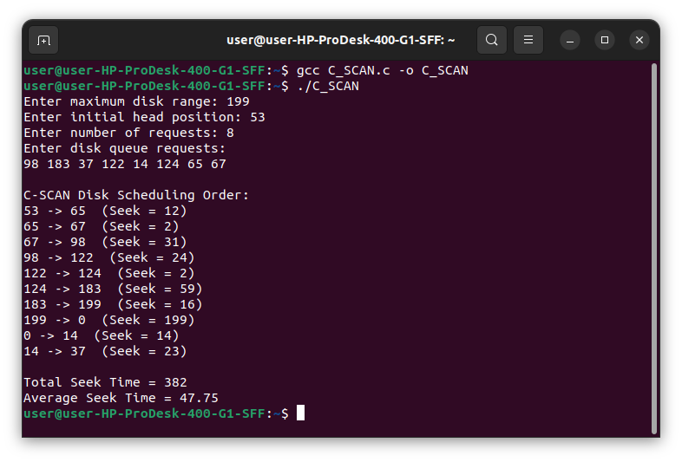

RESULT:
Thus, the program to simulate disk scheduling algorithms. a) FCFS b) SCAN c) C-SCAN have been implemented and the output was verified successfully

VIVA QUESTIONS
- Define Artificial Intelligence.
- What is meant by a Turing Test?
- What are software agents?
- What is a rational agent?
- Why are condition-action rules important in the design of an agent?
- How to measure the performance of an agent?
- Define Omniscience and Information Gathering.
- What is important for task environment?
- List the properties of environments.
- List the ways to formulate a problem?
- List the different types of agents.
- What are the applications of AI?
- Name the elements of an agent and list out the characteristics of an intelligent agent.
- Define Problem Formulation.
- What are the components to define a problem? Define them.
- What is an optimal solution?
- Define abstraction.
- List the criteria to measure the performance of search strategies.
- Differentiate uninformed search and informed search algorithms.
- Define Breadth First Search.
- Define Depth First Search.
- Define Backtracking Search.
- Define Depth-Limited Search.
- Define Iterative Deepening Depth-First Search.
- Define Bi-directional Search.
- Define Best-First Search.
- State the significance of using heuristic functions.
- Define Hill Climbing Search Algorithm.
- Define A* Search Algorithm.
- What do you mean by local maxima with respect to search technique?
- Define Local Search Algorithm.
- List out the advantages of local search algorithms.
- Define Greedy Best-First Search.
- List the disadvantages of Hill Climbing.
- Explain Recursive Best-First Search.
- How can we avoid ridge and plateau in Hill Climbing?
- Define Simulated Annealing.
- Define Quiescence Problem.
- Define Stochastic Beam Search.
- Define Genetic Algorithm.
- Define Local Beam Search.
- Define Alpha-Beta Pruning.
- Define Game.
- List out the classification of CSP with respect to constraints.
- Define Minimax Algorithm.
- Define a CSP.
- Define Forward Pruning.
- What is Skolemization?
- What is First-Order Logic?
- What are the elements and symbols of First-Order Logic?
- What are the three families of First-Order Inference Algorithms?
- What are the four parts of knowledge in First-Order Logic?
- What is the significance of using the unification algorithm?
- Define the First-Order Definite Clause.
- Define Semantic Networks.
- What is Data-Driven Search?
- Compare Forward Chaining and Backward Chaining.
- Define Resolution.
- Define Knowledge Base.
- What is a Pure Symbol?
- What are the basic elements of First-Order Logic?
- What is Classical Planning?
- What is Partial Order Planning?
- What is a Job Shop Scheduling Problem?
- Define Purely Reactive Agents.
- What are the two types of information source?
- What are the characteristics of subsumption architecture?
- State the advantage of vertically layered architecture.
- Explore some interesting properties of agents and perception.
- What are four classes of agents?
- What are logical formulae and logical deduction?
- Define Belief-Desire-Intention (BDI) Architectures.
- State the advantage of horizontal layered architectures.
- Define Agent Communication.
- Define Coherence.
- Define the property of Coordination.
- What are the three aspects to the formal study of communication?
- Define Ontology.
- Define Bargaining.
- List the various applications of Artificial Intelligence.
- Define Language Modeling.
- What is Natural Language Processing (NLP)?
- What is Information Retrieval?
- What are the objectives of NLP?
- What is Information Extraction?
- What are the features of NLP?
- What is an N-gram Language Model?
- What is meant by Machine Translation?
- What are the three main applications of Machine Translation?
- Define Speech Recognition.
- What is a Robot?
- Mention the basic hardware components of a Robot.
- Define Robotic Perception.
- Define Pruning.
- What is Mini-Max Strategy?
- What is Game Playing?
- What is Learning?
- What are the types of Learning?
- What is Adaptive Learning?
- What do you mean by Default Reasoning?

