DbContext class contains methods to add rows,find entity,remove,save changes,update the entities in table.

DbSet is a collection

Migration:commands used to create relations of entities

To sync update database

.NET core 5.0

Webapi is the middleware-only HTTP protocol

--requests using URL and obtain results in the JSON(java script object notation) format

We need nuget packages

Microsoft.entityframeworkcore.sqlserver -version 5.0.13

Microsoft.entityframeworkcore.tools-version 5.0.13

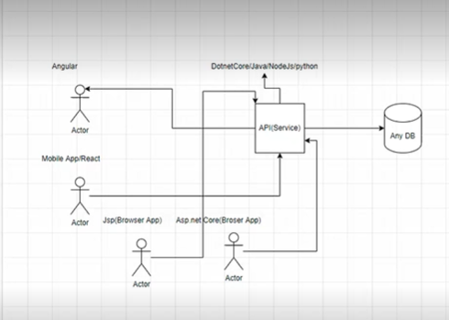

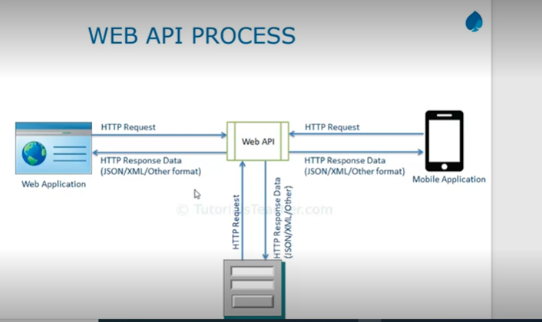

Endpoint methods are there in controller folder

