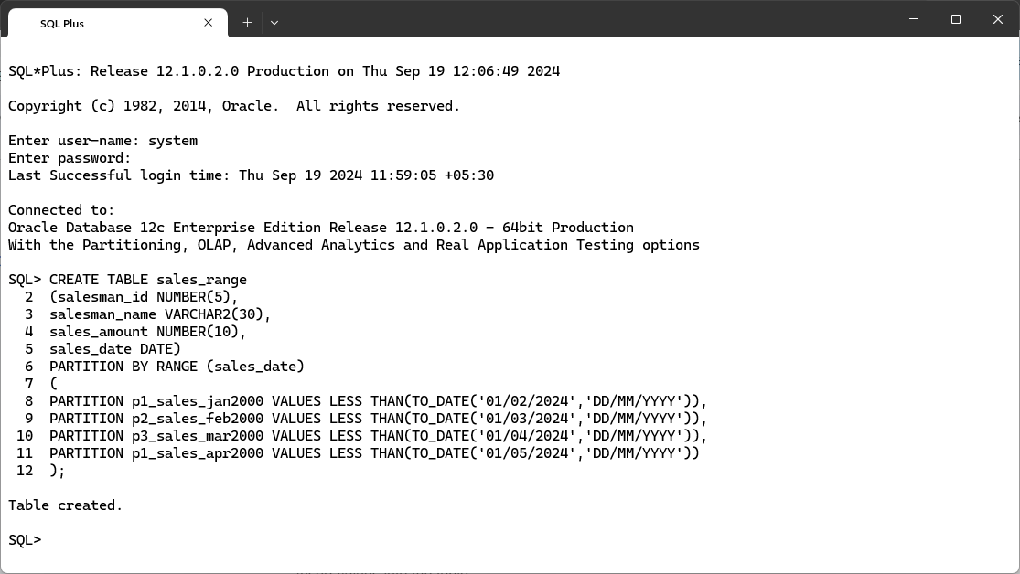
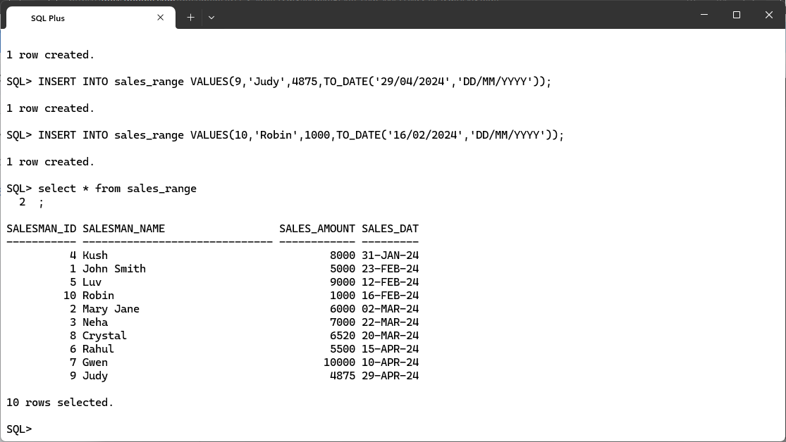
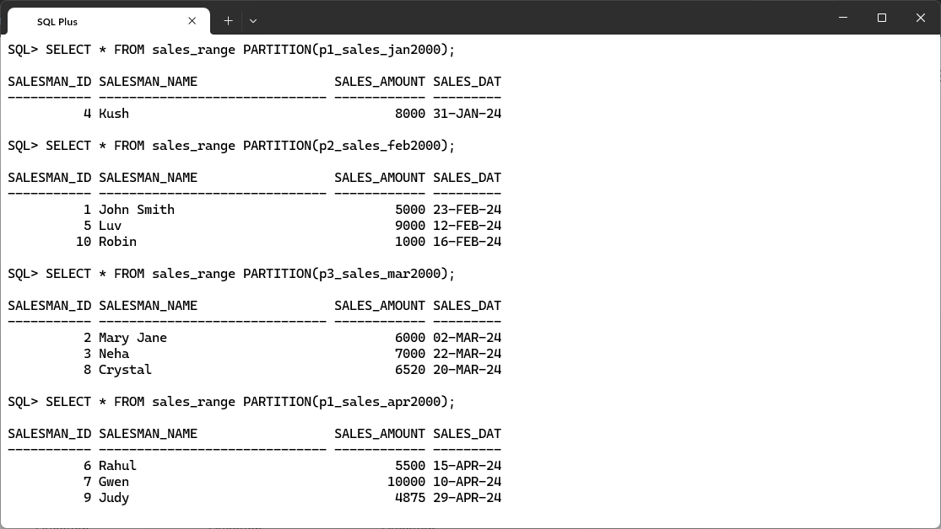
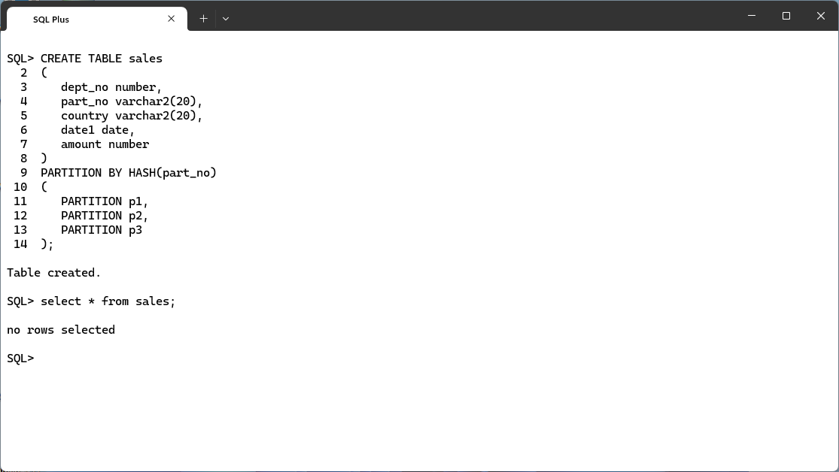
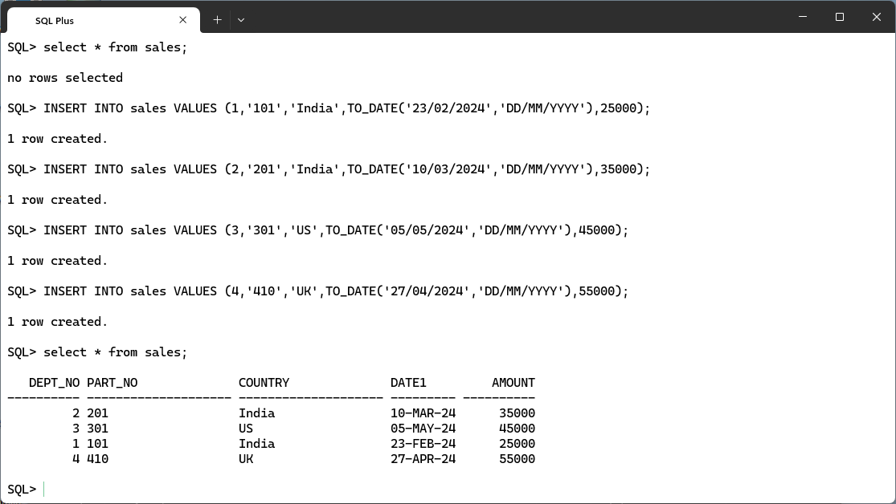
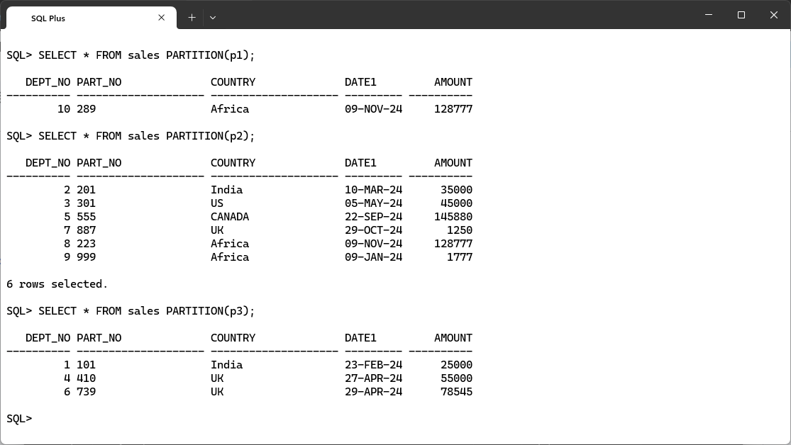
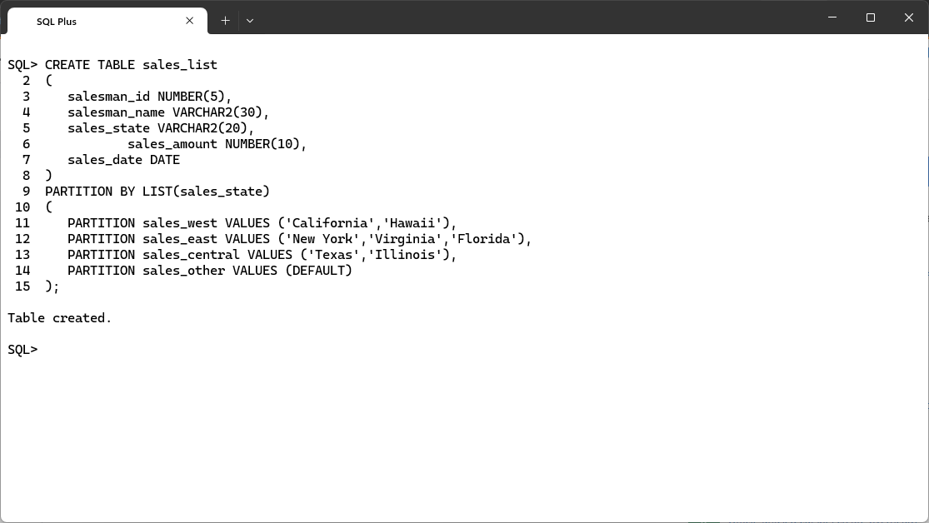
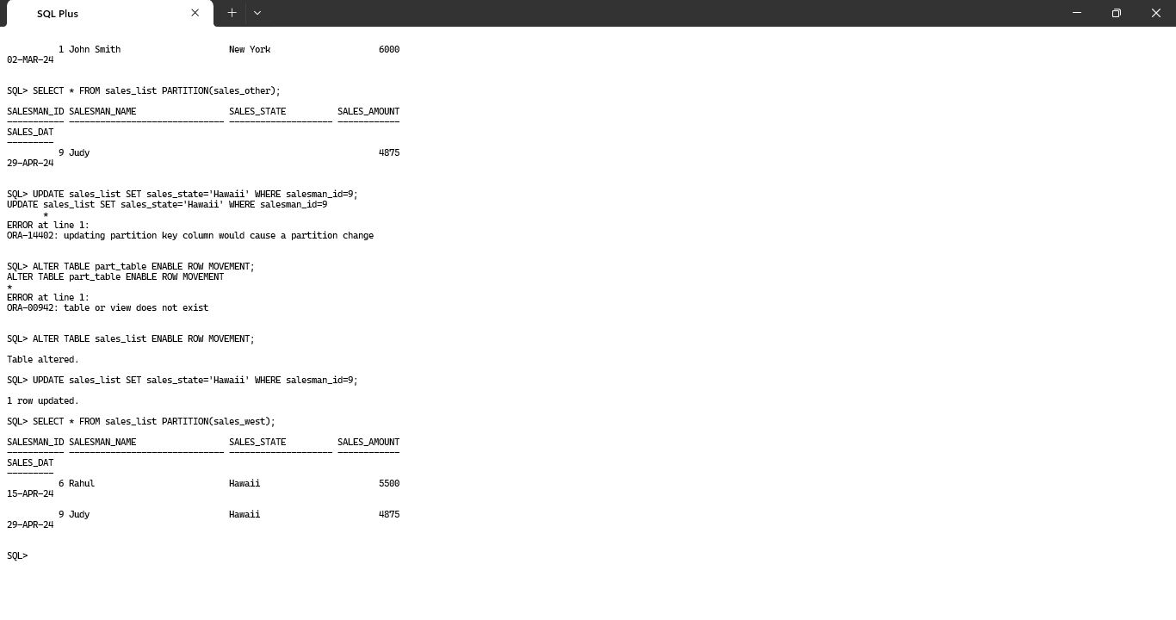
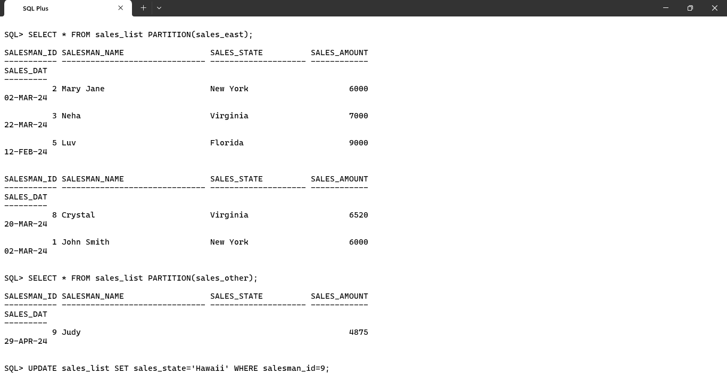


Program No: | 01
Roll No : | 1525
Title of Program : | Partitioning
Objective : | Implementation of Range, Hash and List Partitioning

A. Range Partitioning:
This will be applied to columns.
Partition name-of-partition (criteria)

- Create table
CREATE TABLE sales_range
(salesman_id NUMBER(5),
salesman_name VARCHAR2(30),
sales_amount NUMBER(10),
sales_date DATE)
PARTITION BY RANGE (sales_date)
(
PARTITION p1_sales_jan2000 VALUES LESS THAN(TO_DATE('01/02/2024','DD/MM/YYYY')),
PARTITION p2_sales_feb2000 VALUES LESS THAN(TO_DATE('01/03/2024','DD/MM/YYYY')),
PARTITION p3_sales_mar2000 VALUES LESS THAN(TO_DATE('01/04/2024','DD/MM/YYYY')),
PARTITION p1_sales_apr2000 VALUES LESS THAN(TO_DATE('01/05/2024','DD/MM/YYYY'))
);

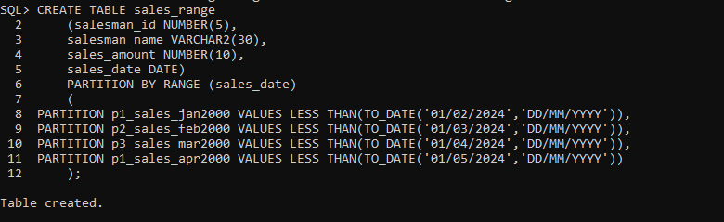

- Insert values into the table
INSERT INTO sales_range VALUES(1,'John Smith',5000,TO_DATE('23/02/2024','DD/MM/YYYY'));
INSERT INTO sales_range VALUES(2,'Mary Jane',6000,TO_DATE('02/03/2024','DD/MM/YYYY'));
INSERT INTO sales_range VALUES(3,'Neha',7000,TO_DATE('22/03/2024','DD/MM/YYYY'));
INSERT INTO sales_range VALUES(4,'Kush',8000,TO_DATE('31/01/2024','DD/MM/YYYY'));
INSERT INTO sales_range VALUES(5,'Luv',9000,TO_DATE('12/02/2024','DD/MM/YYYY'));
INSERT INTO sales_range VALUES(6,'Rahul',5500,TO_DATE('15/04/2024','DD/MM/YYYY'));
INSERT INTO sales_range VALUES(7,'Gwen',10000,TO_DATE('10/04/2024','DD/MM/YYYY'));
INSERT INTO sales_range VALUES(8,'Crystal',6520,TO_DATE('20/03/2024','DD/MM/YYYY'));
INSERT INTO sales_range VALUES(9,'Judy',4875,TO_DATE('29/04/2024','DD/MM/YYYY'));
INSERT INTO sales_range VALUES(10,'Robin',1000,TO_DATE('16/02/2024','DD/MM/YYYY'));

- Create partitions using the range keyword
SELECT * FROM sales_range PARTITION(p1_sales_apr2000);

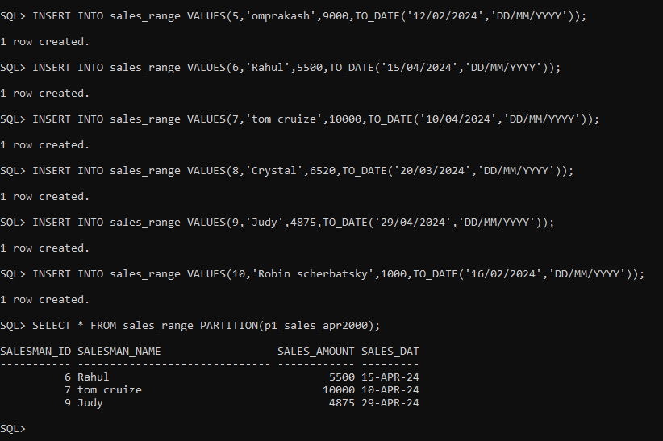

B. Hash Partitioning:

CREATE TABLE
CREATE TABLE sales
(
dept_no number,
part_no varchar2(20),
country varchar2(20),
date1 date,
amount number
)
PARTITION BY HASH(part_no)
(
PARTITION p1,
PARTITION p2,
PARTITION p3
);

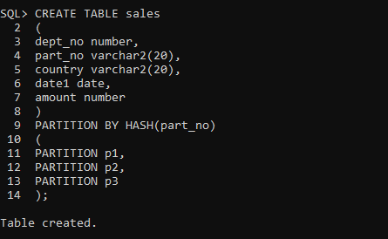

INSERT DATA

INSERT INTO sales VALUES (1,'101','India',TO_DATE('23/02/2024','DD/MM/YYYY'),25000);
INSERT INTO sales VALUES (2,'201','India',TO_DATE('10/03/2024','DD/MM/YYYY'),35000);
INSERT INTO sales VALUES (3,'301','US',TO_DATE('05/05/2024','DD/MM/YYYY'),45000);
INSERT INTO sales VALUES (4,'410','UK',TO_DATE('27/04/2024','DD/MM/YYYY'),55000);
INSERT INTO sales VALUES (5,'551','CANADA',TO_DATE('11/02/2024','DD/MM/YYYY'),65000);

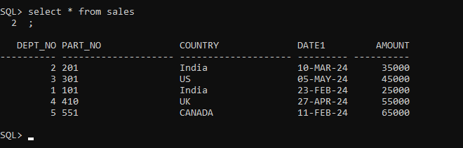
SELECT * FROM sales PARTITION(p1);
SELECT * FROM sales PARTITION(p2);
SELECT * FROM sales PARTITION(p3);

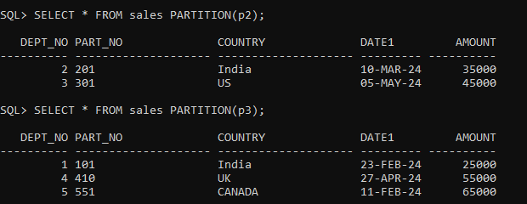

C. List Partitioning:
Enable row movement;
– to move record in case of modification

enable row movement;

INSERT INTO sales_list VALUES(1,'John Smith','New York',6000,TO_DATE('02/03/2024','DD/MM/YYYY'));
INSERT INTO sales_list VALUES(2,'Mary Jane','New York',6000,TO_DATE('02/03/2024','DD/MM/YYYY'));
INSERT INTO sales_list VALUES(3,'Neha','Virginia',7000,TO_DATE('22/03/2024','DD/MM/YYYY'));
INSERT INTO sales_list VALUES(4,'Kush','Texas',8000,TO_DATE('31/01/2024','DD/MM/YYYY'));
INSERT INTO sales_list VALUES(5,'Luv','Florida',9000,TO_DATE('12/02/2024','DD/MM/YYYY'));
INSERT INTO sales_list VALUES(6,'Rahul','Hawaii',5500,TO_DATE('15/04/2024','DD/MM/YYYY'));
INSERT INTO sales_list VALUES(7,'Gwen','Illinois',10000,TO_DATE('10/04/2024','DD/MM/YYYY'));
INSERT INTO sales_list VALUES(8,'Crystal','Virginia',6520,TO_DATE('20/03/2024','DD/MM/YYYY'));
INSERT INTO sales_list VALUES(9,'Judy','',4875,TO_DATE('29/04/2024','DD/MM/YYYY'));
INSERT INTO sales_list VALUES(10,'Robin','Texas',1000,TO_DATE('16/02/2024','DD/MM/YYYY'));

SQL> UPDATE sales_list SET sales_state='Hawaii' WHERE salesman_id=9;
UPDATE sales_list SET sales_state='Hawaii' WHERE salesman_id=9
*
ERROR at line 1:
ORA-14402: updating partition key column would cause a partition change

SQL> ALTER TABLE part_table ENABLE ROW MOVEMENT;
ALTER TABLE part_table ENABLE ROW MOVEMENT
*
ERROR at line 1:
ORA-00942: table or view does not exist

SQL> ALTER TABLE sales_list ENABLE ROW MOVEMENT;
Table altered.

SQL> UPDATE sales_list SET sales_state='Hawaii' WHERE salesman_id=9;
1 row updated.

SQL> SELECT * FROM sales_list PARTITION(sales_west);

