Program No: | 12
Roll No : | 1525
Title of Program :
Objective : | Spring application with singleton scope

SOURCE CODE:

Singer.java
package edu.met.p1;

public class Singer {

int sid;
String sname;

public Singer(int sid, String sname) {
super();
this.sid = sid;
this.sname = sname;
}

public Singer() {
// TODO Auto-generated constructor stub
}

public int getSid() {
return sid;
}

public void setSid(int sid) {
this.sid = sid;
}

public String getSname() {
return sname;
}

public void setSname(String sname) {
this.sname = sname;
}

@Override
public String toString() {
return "Singer [sid=" + sid + ", sname=" + sname + "]";
}

}

appctx.xml
<?xml version="1.0" encoding="UTF-8"?>
<beans
xmlns="http://www.springframework.org/schema/beans"
xmlns:xsi="http://www.w3.org/2001/XMLSchema-instance"
xmlns:p="http://www.springframework.org/schema/p"
xsi:schemaLocation="http://www.springframework.org/schema/beans
http://www.springframework.org/schema/beans/spring-beans-3.0.xsd">
<bean id= "singer" class="edu.met.p1.Singer" >
<constructor-arg value="101"></constructor-arg>
<constructor-arg value="daddy"></constructor-arg>

</bean>

</beans>

SingerImpl.java
package edu.met.p1;
import org.springframework.context.ApplicationContext;
import org.springframework.context.support.ClassPathXmlApplicationContext;

public class SingerImpl {

static ApplicationContext ctx;
public static void main(String[] args) {
// TODO Auto-generated method stub
ctx=new ClassPathXmlApplicationContext("appctx.xml");
Singer s1=(Singer)ctx.getBean("singer");
System.out.println(s1);
}

}

OUTPUT:

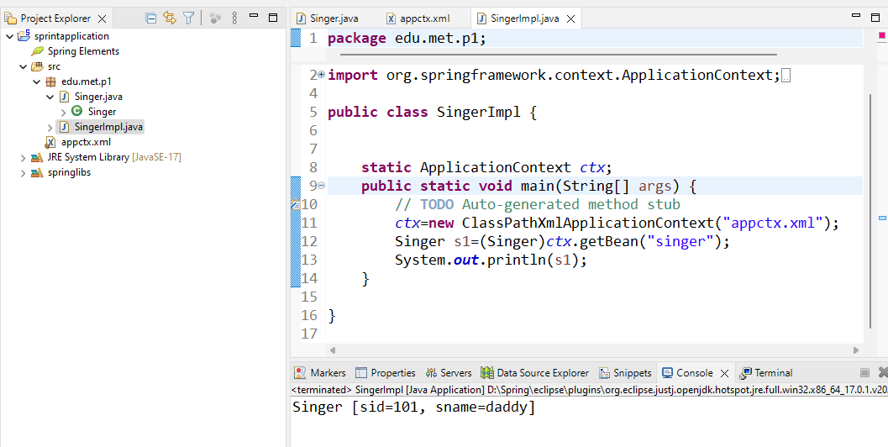

OUTPUT:

