


Program No: | 3
Roll No : | 1525
Title of Program :
Objective : | a.Design generic class to represent a class which cancertain single element of any data type

Source code:

class Box <T>
{

//one data member
T item;

//setter
void setItem(T item)
{
this.item=item;
}

//getter
T getItem()
{
return this.item;
}

}

class BoxImpl
{
public static void main(String[] args)
{
// var b1= Box<Integer>();
Box<String> b1 = new Box<>();
b1.setItem("Book");
System.out.println("Item: "+b1.getItem());

Box<Integer> b2 = new Box<>();
b2.setItem(22);
System.out.println("Item: "+b2.getItem());

Box<Double> b3 = new Box<>();
b3.setItem(20.20);
System.out.println("Item: "+b3.getItem());

}
}

OUTPUT:

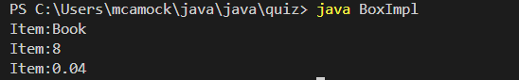

Program No: | 3
Roll No : | 1525
Title of Program :
Objective : | b. design generic stack and perform  >push  >pop  >overflow  >underflow

SOURCE CODE:
import java.util.*;
class MyStack<T>
{
//instance variable to store data
ArrayList<T> data;
//represents size of stack
int size;
//reprsents the pointer
int tos=-1;

MyStack(int size)
{
this.size=size;
data=new ArrayList<>(size);
}

//push element on stack
void push(T ele)
{
//increment tos
tos++;
if(tos<size)
{
data.add(tos,ele);
System.out.println("Pushed!");
}
else
{
System.out.println("Overflow!");
}
}

//pop element
T pop()
{
tos--;
if(tos>=0)
{
return data.remove(tos);
}
else
{
System.out.println("Underflow!");
return null;
}
}

}

class GenericStackImpl
{
public static void main(String[] args)
{
MyStack<Integer> s1=new MyStack<>(3);

for(int i=1;i<=4;i++)
{
s1.push(i*10);
}
for(int i=0;i<=3;i++)
{
System.out.println("Popped: "+s1.pop());
}
}
}

OUTPUT:
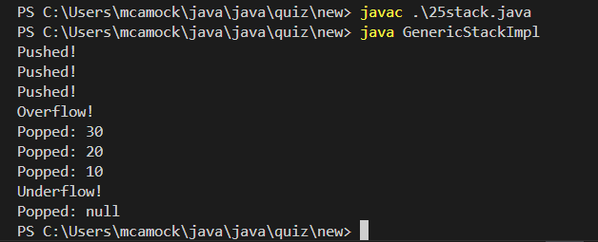

Program No: | 3
Roll No : | 1525
Title of Program :
Objective : | c.design a generic pair class that holds value of different types

SOURCE CODE:
class Pair<T,U>
{
T key;
U value;

Pair(T key,U value)
{
this.key=key;
this.value=value;
}

//setters
void setKey(T key)
{
this.key=key;
}
void setValue(U value)
{
this.value=value;
}

//getter
T getKey()
{
return this.key;
}

U getValue()
{
return this.value;
}

public String toString()
{
return "key:"+key+"-Value:"+value;
}

}

class PairImpl
{

public static void main(String[] args)
{
Pair<Integer,String> p1=new Pair<>(12,"item 1");
Pair<Integer,String> p2=new Pair<>(13,"item 2");
System.out.println(p1);

System.out.println(p2);
}

}

OUTPUT:

