Report
Learning Algorithm:

Our agent uses DDPG(Deep Deterministic Policy Gradient) learning algorithm to train itself. DDPG uses four neural networks: a Q network, a deterministic policy network, a target Q network, and a target policy network.

The Actor directly maps states to actions (the output of the network directly the output) instead of outputting the probability distribution across a discrete action space. The Critic or the Q network predicts the Q value given the state and action values as input. The target networks are time-delayed copies of their original networks that slowly track the learned networks. Using these target value networks greatly improve stability in learning.

As used in Deep Q learning (and many other RL algorithms), DDPG also uses a replay buffer to sample experience to update neural network parameters. During each trajectory roll-out, we save all the experience tuples (state, action, reward, next_state) and store them in a finite-sized cache — a “replay buffer.” Then, we sample random mini-batches of experience from the replay buffer when we update the value and policy networks.

Hyperparameters:

replay buffer size = 100000
minibatch size for training = 128
discount factor GAMMA = 0.99
for soft update of target parameters TAU = 1e-3
LR for the actor = 1e-3
LR for the critic = 1e-3

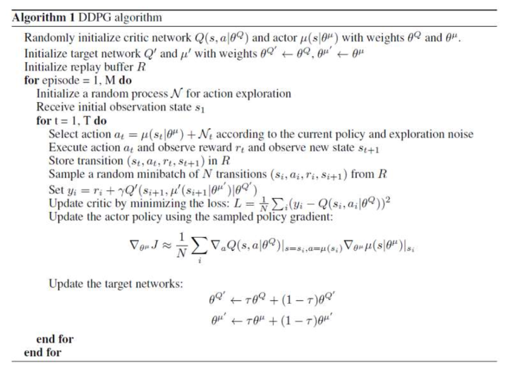

plot of average rewards:

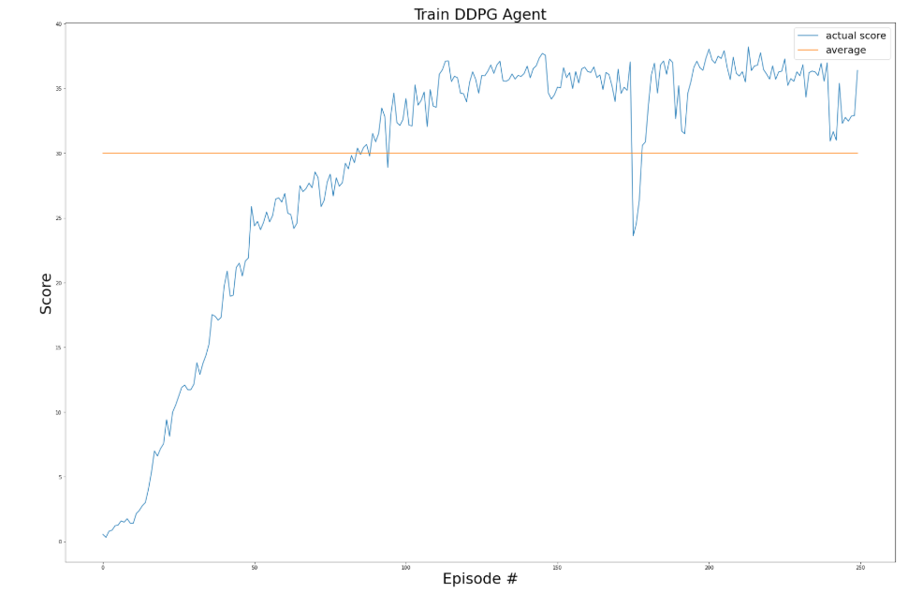

Network deep learning Model:

ACTOR:

First layer: 33 X 256

Second layer: 256 X 128

Final layer: 128 X 4

CRITIC:

First layer: 33 X 256

Second layer: 260 X 128

Third layer: 128 X 64

Final layer: 64 X 1

Ideas for Future Work:
To make training process more efficient we can use multi step boostrap targets which is taught in a3c we can also use dueling dqn to separate the advantage and value functions.
We can also use deep minds rainbow algorithm which incorporates many ideas and said to outperform all these individual ideas.

